Assignment 1
Advanced Solidity Patterns & Security Fundamentals
Name: Iskander Kustayev
Group: SE-2403
PART 1 — Advanced Solidity Design Patterns
Task 2: Proxy Pattern & Upgradeable Contracts
Deliverables:
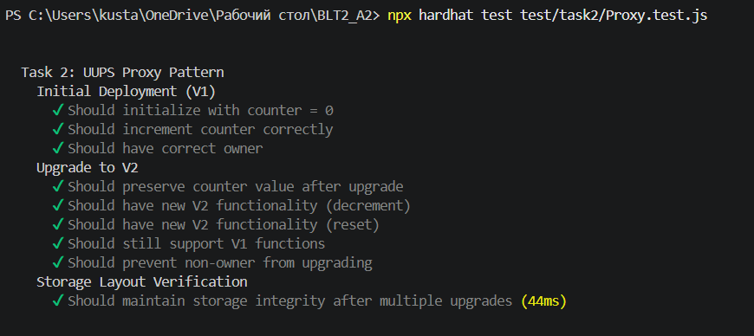
• LogicV1.sol, LogicV2.sol, deployment scripts (in the deployed files)
Test:

• Step-by-step upgrade demonstration with screenshots
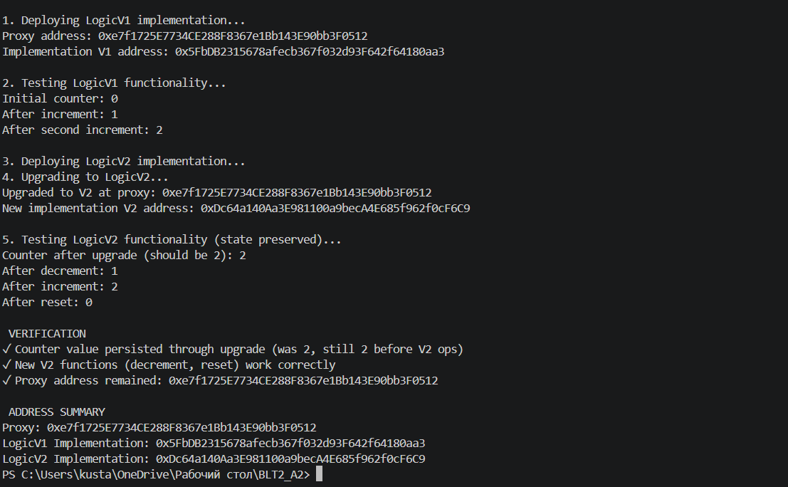

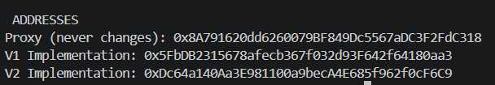
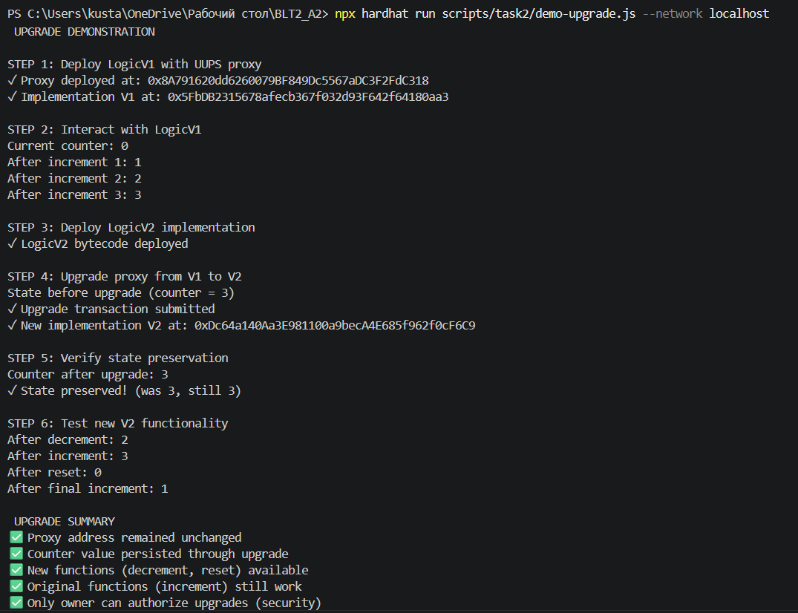
UUPS Proxy Pattern: Technical Explanation
1. How Proxy Delegates Calls
The Core Mechanism
The UUPS (Universal Upgradeable Proxy Standard) pattern relies on a fundamental Ethereum feature called delegatecall. When a user interacts with a proxy contract, the following happens:
Step-by-step flow:
- User calls a function on the proxy contract (e.g., increment())
- Proxy executes delegatecall to the implementation contract
- Implementation contract's code runs
- All storage reads/writes affect the proxy's storage, not the implementation's
- Result is returned to the user
Importance
The proxy contract holds all data (counter value, owner address). The implementation contract only provides the logic. When we upgrade, we simply point the proxy to a new implementation contract with different logic, but the data stays in the proxy

2. Storage Layout Risks
The Problem
Since the proxy and implementation share storage via delegatecall, the order of state variables MUST match between versions. If not, data corruption occurs.

Dangerous Example
Version 1:
contract LogicV1 {
uint256 public counter; // slot 0
}
Version 2 (WRONG):
contract LogicV2 {
uint256 public newValue; // slot 0 (overwrites counter!)
uint256 public counter; // slot 1 (reads wrong data!)
}
Result: When V2 reads counter, it actually reads from slot 1 (empty), and newValue corrupts slot 0.

Safe Example
Version 1:
contract LogicV1 {
uint256 public counter; // slot 0
}
Version 2 (CORRECT):
contract LogicV2 is LogicV1 {
uint256 public newValue; // slot 1 (safe, after counter)
}

The __gap Pattern
OpenZeppelin uses a reserved storage array to prevent collisions:
solidity
contract LogicV1 {
uint256 public counter;
uint256[50] private __gap; // Reserves 50 slots for future use
}

Rules for Safe Upgrades
Rule | Explanation
Never reorder variables | Keeps same slot assignments
Always append new variables | Adds to end, never middle
Don't delete variables | Use __gap instead
Inherit from previous version | Maintains storage structure

3. Why Initializers Replace Constructors
The Constructor Problem
Constructors run ONLY when a contract is first deployed. For upgradeable contracts:
- Implementation contract is deployed once (constructor runs)
- Proxy contract is deployed separately (constructor doesn't run)
- User data lives in proxy, but never gets initialized
How initializer Modifier Works
The initializer modifier:
- Tracks if initialization already happened
- Prevents calling initialize() twice
- Sets a flag in storage after first call

Constructor in Upgradeable Contracts
We still need a constructor to disable initializers:
/// @custom:oz-upgrades-unsafe-allow constructor
constructor() {
_disableInitializers(); // Prevents implementation from being initialized
}
This ensures that if someone calls initialize() on the implementation directly, it will fail.

Comparison Table
Aspect | Constructor | Initializer
When runs | Once at deployment | Called after proxy deployment
Who can call | Only deployer | Anyone (protected by modifier)
In implementation | Runs on implementation | Runs on proxy storage
Can be called multiple times | No | No (initializer prevents)
Used in upgradeable contracts | No (except to disable) | Yes

Security Best Practices
- Always use OpenZeppelin's upgradeable contracts - They handle storage layout correctly
- Test upgrades before deploying - Use Hardhat's upgrade plugin
- Use _gap arrays - Reserve storage for future variables
- Never change variable order - Maintain slot assignments
- Only owner can upgrade - Implement access control in _authorizeUpgrade()

Real-World Impact
Without these patterns: Upgrading a contract would lose all user funds and data
With UUPS pattern:
- Fix bugs without migrating users
- Add features without changing addresses
- Preserve all balances and state
- Save gas compared to other proxy patterns

Summary
Concept | One-line Explanation
delegatecall | Executes implementation code in proxy's storage context
Storage layout | Variable order must be preserved across upgrades
Initializers | Replace constructors to initialize proxy storage
UUPS | Upgrade logic stored in implementation (gas efficient)

