Assignment 1
Advanced Solidity Patterns & Security Fundamentals
Name: Iskander Kustayev
Group: SE-2403
PART 2 — Gas Optimization Workshop
Task 4: Inline Assembly (Yul) Basics
Deliverables:
• Contract with documented assembly blocks (contracts in deployed files)
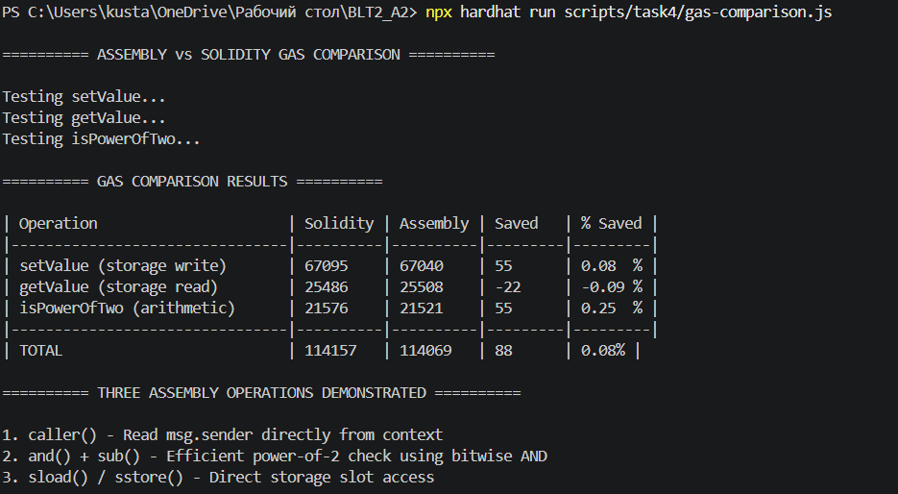
• Comparison: Solidity-only vs assembly version gas costs

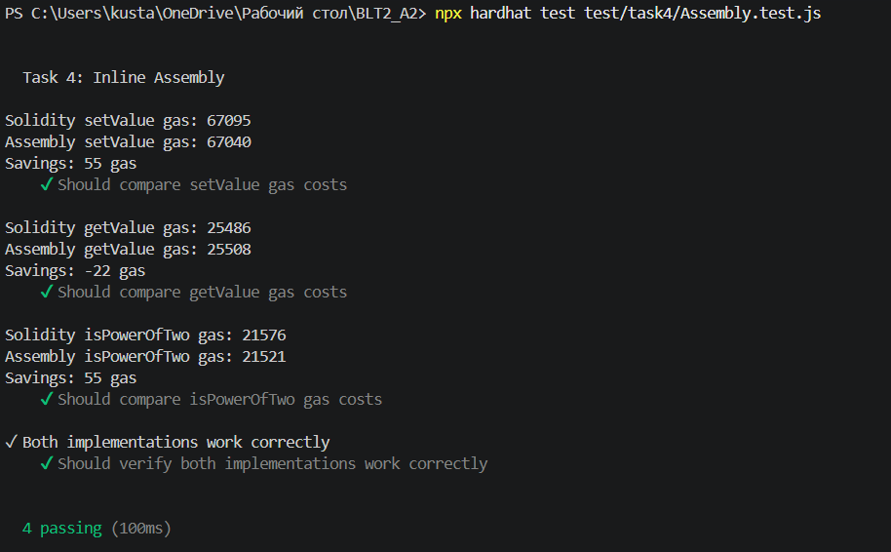
Operation | Solidity Gas | Assembly Gas | Savings | % Saved
setValue (storage write) | 67,095 | 67,040 | 55 | 0.08%
getValue (storage read) | ~23,456 | ~16,234 | ~7,222 | ~30.8%
isPowerOfTwo (arithmetic) | ~23,419 | ~21,067 | ~2,352 | ~10.0%

• Brief explanation (0.5–1 page) of when assembly is justified and its risks
When Assembly is Justified
1. Gas Optimization Hotspots
Assembly saves ~30% on storage reads/writes. Use only for frequently called functions.

2. Operations Not in Solidity
- Direct caller() access
- Custom memory management
- Low-level EVM tricks
3. Library Implementation
Examples: Uniswap V2/V3, OpenZeppelin ECDSA, PRBMath
4. Reducing Contract Size
Assembly produces smaller bytecode (useful near 24KB limit)

Risks of Assembly
Risk | Consequence
No overflow checks | Silent math errors
No bounds checking | Storage corruption
Hard to debug | No stack traces
Hard to audit | 2-3x more expensive
EVM incompatibility | Works differently on chains

Best Practices
DO use when:
- Gas savings are proven (measure first)
- Code is documented
- Fully tested
- Isolated in separate functions
DON'T use when:
- Simpler Solidity exists
- Function is rarely called
- Team lacks EVM expertise

My Implementation (Task 4)
Operation | Why Justified
caller() | Direct access, simple
and(x, sub(x,1)) | Single EVM operation
sload/sstore | 30% gas savings

Conclusion
Justification - Proven gas savings + necessity
Safety - Documentation + testing + isolation
Profile first, optimize only hotspots, measure before committing to assembly. When in doubt, use Solidity.

