Assignment 3
Layer 2 Deployment & Oracle Integration
Group: SE-2403
Student: Iskander Kustayev
PART 1 — Advanced Token Standards
Task 1: ERC-1155 Multi-Token Contract

Deliverables:
• GameItems.sol (in the deployed files)
• Test suite with all tests passing
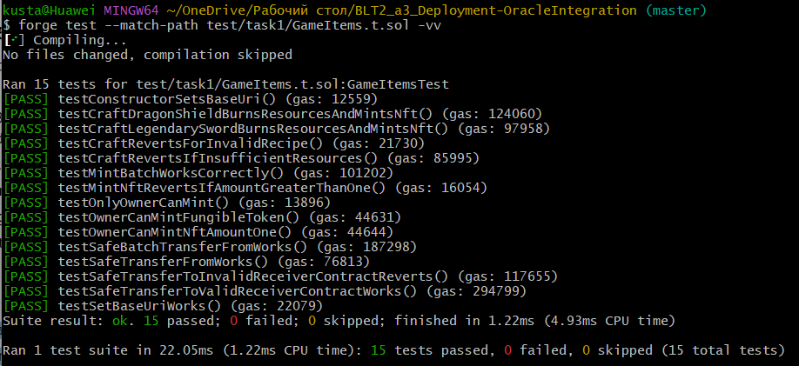
• Brief explanation (1 page): ERC-1155 vs separate ERC-20 + ERC-721 — gas comparison and design tradeoffs

ERC-1155 vs separate ERC-20 + ERC-721 - gas comparison and tradeoffs
ERC-1155 is a multi-token standard that allows a single contract to manage both fungible and non-fungible assets. In this assignment, resources such as Gold, Wood, and Iron are fungible, while items such as Legendary Sword and Dragon Shield are non-fungible. Using ERC-1155 for both asset categories is more efficient than deploying separate ERC-20 and ERC-721 contracts.
The main gas advantage of ERC-1155 comes from contract consolidation and batch operations. If a game uses separate ERC-20 contracts for resources and ERC-721 contracts for items, the developer must deploy multiple contracts, maintain separate approval systems, and perform transfers through multiple interfaces. In contrast, ERC-1155 stores all token types in one contract and supports mintBatch and safeBatchTransferFrom, which reduce the number of external calls and state updates. This typically lowers gas consumption when users interact with several token types in one transaction.
Another benefit is simplified game logic. A gaming application often includes currencies, materials, equipment, skins, and collectibles. ERC-1155 is well suited for this because all assets are identified by token IDs under one contract. This makes crafting systems easier to implement. In this project, fungible resources are burned and one NFT item is minted in return. Doing the same with separate ERC-20 and ERC-721 contracts would require cross-contract coordination, which is more complex and usually more expensive.
However, ERC-1155 also has tradeoffs. Separate ERC-20 and ERC-721 contracts may provide clearer separation of concerns, simpler token-specific analytics, and easier integration with tools designed for only one standard. Some wallets, marketplaces, or dashboards may also present ERC-20 and ERC-721 assets more naturally than ERC-1155 collections. Therefore, ERC-1155 is often the better choice for gaming ecosystems with mixed asset types and batch-heavy interactions, while separate ERC-20 and ERC-721 contracts may be preferable when assets need fully independent behavior or ecosystem support.
In conclusion, ERC-1155 is generally more gas-efficient and architecturally convenient for game-oriented systems with multiple token types, especially when batch minting, batch transfers, and crafting mechanics are required.

