Assignment 3
Layer 2 Deployment & Oracle Integration
Group: SE-2403
Student: Iskander Kustayev
PART 1 — Advanced Token Standards
Task 2: ERC-4626 Tokenized Vault

Deliverables:
• Vault.sol (ERC-4626 compliant) (in the deployed files)
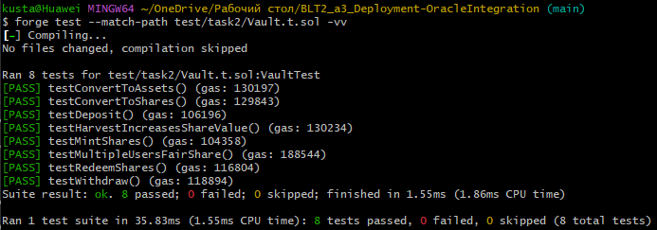
• Test suite

• Explanation (0.5 page): real-world use cases of ERC-4626 (Yearn, Aave aTokens)
ERC-4626 real-world use cases
ERC-4626 standardizes tokenized vaults, making yield-bearing strategies composable across DeFi protocols. Instead of interacting with different vault implementations, integrators can rely on a unified interface.
One major use case is yield aggregators such as Yearn Finance. Users deposit an ERC-20 asset into a vault, and the protocol automatically deploys capital into multiple strategies to generate yield. The user receives vault shares representing their proportional ownership.
Another example is lending protocols like Aave, where interest-bearing tokens (such as aTokens) represent deposited assets. Although not strictly ERC-4626 originally, the standard formalizes this pattern, allowing better interoperability between lending platforms and other DeFi applications.
ERC-4626 also simplifies integrations for wallets, frontends, and analytics tools. Since all vaults expose the same methods (deposit, withdraw, mint, redeem, convertToAssets, convertToShares), developers can build reusable infrastructure instead of handling each protocol separately.
In summary, ERC-4626 improves composability, reduces integration complexity, and provides a standard way to represent yield-generating positions on-chain.

