Assignment 3
Layer 2 Deployment & Oracle Integration
Group: SE-2403
Student: Iskander Kustayev
PART 2 — Layer 2 Deployment
Task 3: Deploy Contracts on an L2 Testnet
I chose Base Sepolia

Deliverables:
• Deployment scripts with L2 configuration (in the deployed files)
• Verified contract links on L2 block explorer

Ethereum Sepolia (L1)
MockERC20
0x218b0Fbf7bE960805E7639716ca73fb423E2Ab69
Address: 0x218b0Fbf...423E2Ab69 | Etherscan Sepolia
Vault
0xB99e81aCf22C8AFc58f7Ac76D46A72F443f41dE2
Address: 0xB99e81aC...443f41dE2 | Etherscan Sepolia

Base Sepolia (L2)
MockERC20
0xBF25983D3ebccF5D5753c7f2A8E33ab93E58f819
Address: 0xBF25983D...93E58f819 | BaseScan Sepolia
Vault
0x5826a7361Ee8C127816ad24936fe11B61AFD73a0
Address: 0x5826a736...61AFD73a0 | BaseScan Sepolia

• Gas comparison table: L1 vs L2 for each operation
Operation | Network | Tx Hash (short) | Gas Used | Gas Price (gwei) | Tx Fee (ETH)
mint | Sepolia (L1) | 0xfca8ac... | 68416 | 0.0157 | 0.0000010719
mint | Base (L2) | 0x93bf0e... | 68416 | 0.006 | 0.0000004105
approve | Sepolia (L1) | 0xfc41fc... | 57621 | 0.0157 | 0.0000009027
approve | Base (L2) | 0x394047... | 57621 | 0.006 | 0.0000003457
deposit | Sepolia (L1) | 0xb83811... | 29279 | 0.0157 | 0.0000004587
deposit | Base (L2) | 0xa02120... | 29279 | 0.006 | 0.0000001757
approve (harvest) | Sepolia (L1) | 0x7ecd9d... | 41505 | 0.0157 | 0.0000006502
approve (harvest) | Base (L2) | 0x20c548... | 41505 | 0.006 | 0.0000002490
harvest | Sepolia (L1) | 0x68a82a... | 46379 | 0.0157 | 0.0000007266
harvest | Base (L2) | 0xfd46a9... | 46379 | 0.006 | 0.0000002783
withdraw | Sepolia (L1) | 0xcfe17b... | 111316 | 0.0157 | 0.0000017440
withdraw | Base (L2) | 0xd07fb3... | 111316 | 0.006 | 0.0000006679

Summary Table:
Network | Total Gas Used | Avg Gas Price | Total Cost (ETH)
Sepolia (L1) | 354516 | ~0.0157 gwei | 0.0000055541
Base (L2) | 354516 | ~0.006 gwei | 0.0000021271

• Screenshots of transactions on block explorer
Ethereum Sepolia (L1)
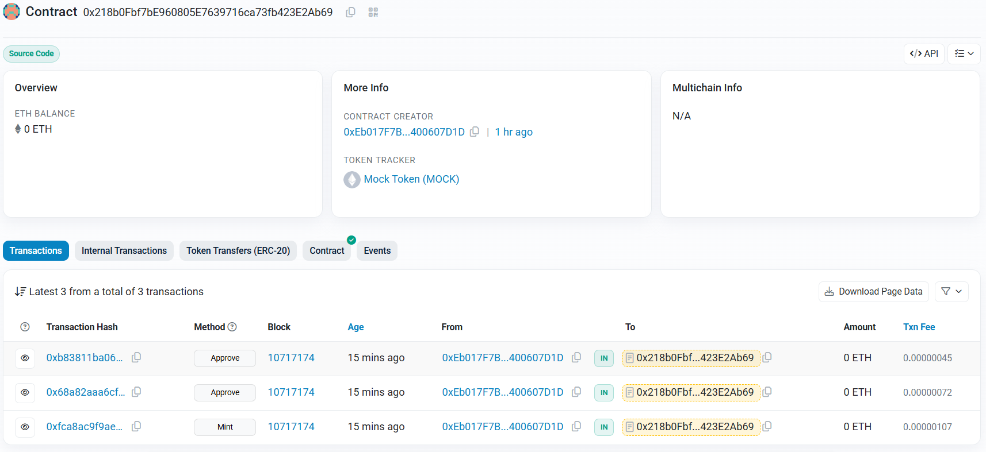
MockERC20: 0x218b0Fbf7bE960805E7639716ca73fb423E2Ab69

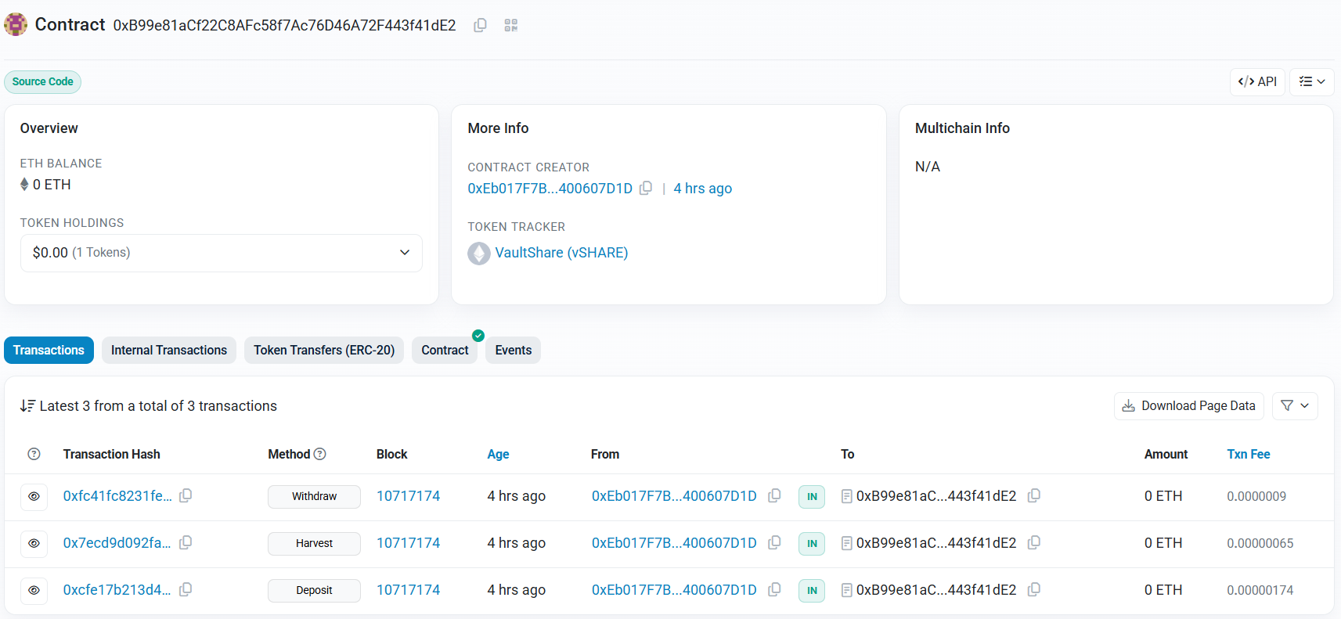
Vault: 0xB99e81aCf22C8AFc58f7Ac76D46A72F443f41dE2

Base Sepolia (L2)
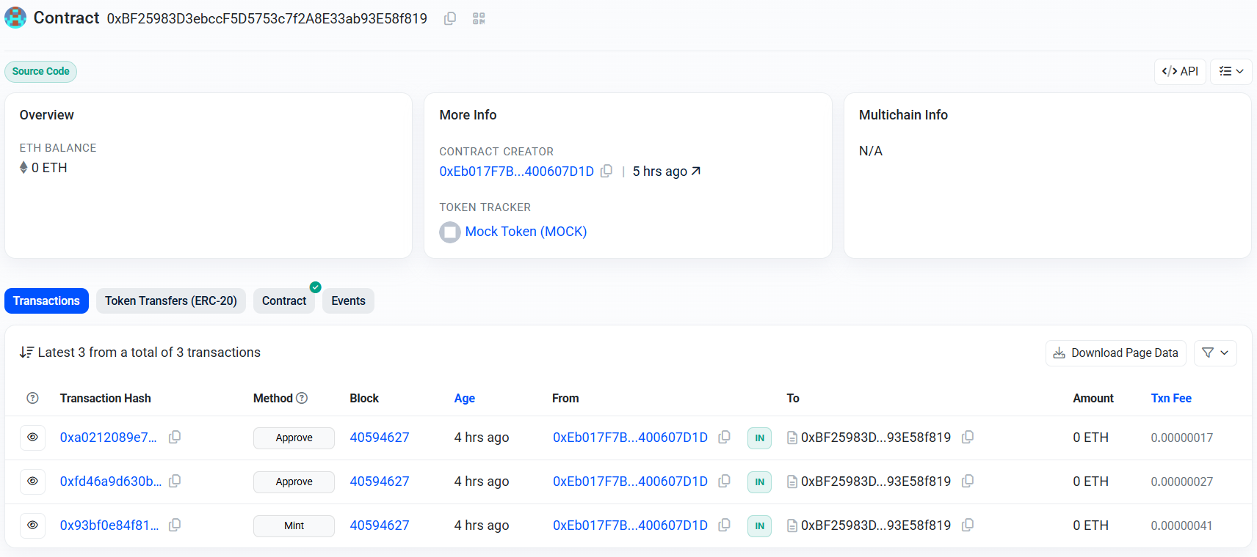
MockERC20: 0xBF25983D3ebccF5D5753c7f2A8E33ab93E58f819

Vault: 0x5826a7361Ee8C127816ad24936fe11B61AFD73a0
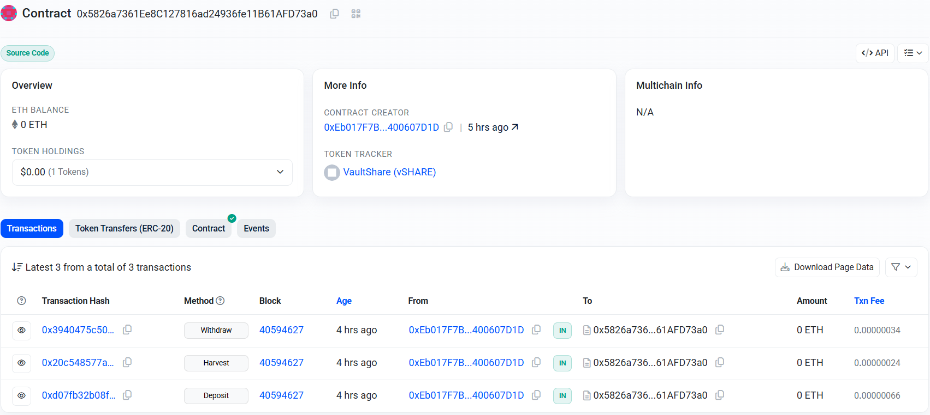

For example, mint in the SepoliaETH (transaction)
