Assignment 3
Layer 2 Deployment & Oracle Integration
Group: SE-2403
Student: Iskander Kustayev
PART 4 — Indexing with The Graph
Task 6: Build a Subgraph
Deliverables:
• subgraph.yaml, schema.graphql, mapping.ts (in the deployed files)
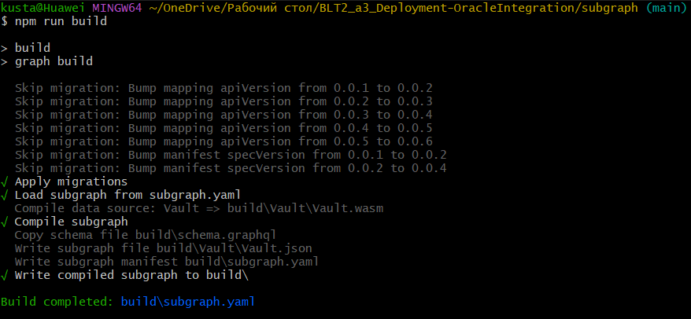
• Sample GraphQL queries and their expected results

• Explanation (1 page): how The Graph decentralizes indexing vs traditional backend approaches
The Graph is a decentralized indexing protocol designed to organize and query blockchain data efficiently. Normally, reading blockchain data directly is difficult and slow, because it requires scanning blocks and decoding events manually.
A subgraph solves this problem by defining which smart contract events should be indexed and how they should be stored. In this project, the subgraph indexes events from the Vault contract deployed on Base Sepolia. It tracks Deposit, Withdraw, and Harvest events and stores them in structured entities such as Deposit, Withdrawal, and VaultStat.
The subgraph.yaml file defines the contract address, network, ABI, and starting block. The schema.graphql file defines the data structure that will be stored. The mapping.ts file processes blockchain events and saves them into entities.
Compared to a traditional backend, The Graph removes the need to build and maintain a centralized server. In a normal backend, developers must listen to blockchain events, store them in a database, and create APIs. This process is complex and requires constant maintenance.
The Graph simplifies this by providing a decentralized and standardized indexing solution. Anyone can verify how data is indexed because the subgraph configuration is public. This increases transparency and reduces trust requirements.
In conclusion, The Graph allows decentralized applications to efficiently access blockchain data using GraphQL queries, replacing many functions of traditional backend systems.

