Assignment 3
Layer 2 Deployment & Oracle Integration
Group: SE-2403
Student: Iskander Kustayev
PART 3 — Oracle Integration
Task 5: Chainlink Price Feed Integration

Deliverables:
• PriceFeedConsumer.sol, PriceDependentVault.sol, MockAggregator.sol (in the deployed files)
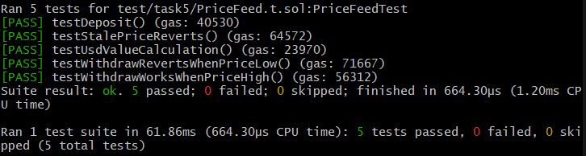
• Test suite with price feed mocking

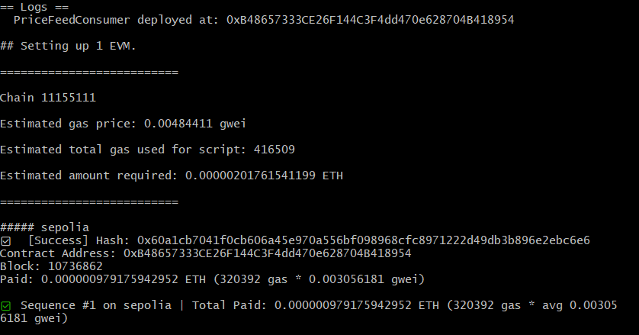
• Screenshots of contract reading real testnet price feed (if deployed on testnet)

