Assignment 4
DAO & On-chain Governance System
Group: SE-2403
Student: Iskander Kustayev
PART 2 — Governor & Timelock
Task 2: Implement Full DAO Governance
Deliverables:
• MyGovernor.sol, TimelockController deployment (in the deployed files)
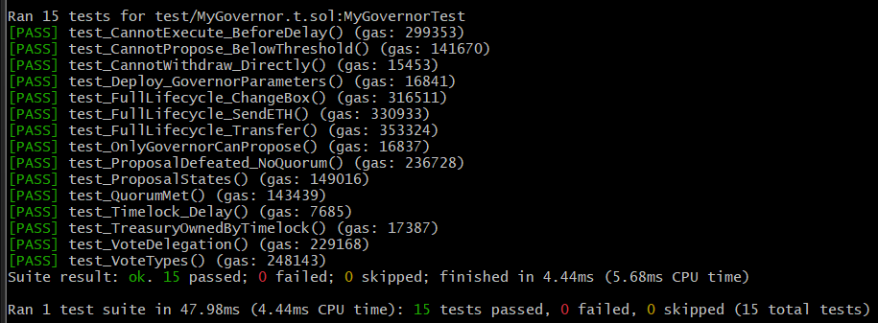
• At least 12 tests covering full governance lifecycle

PART 3 — DAO Treasury & Controlled Contract
Task 3: Treasury Management
Deliverables:
• Treasury.sol, Box.sol (in the deployed files)
• End-to-end governance test: propose → vote → queue → execute → verify
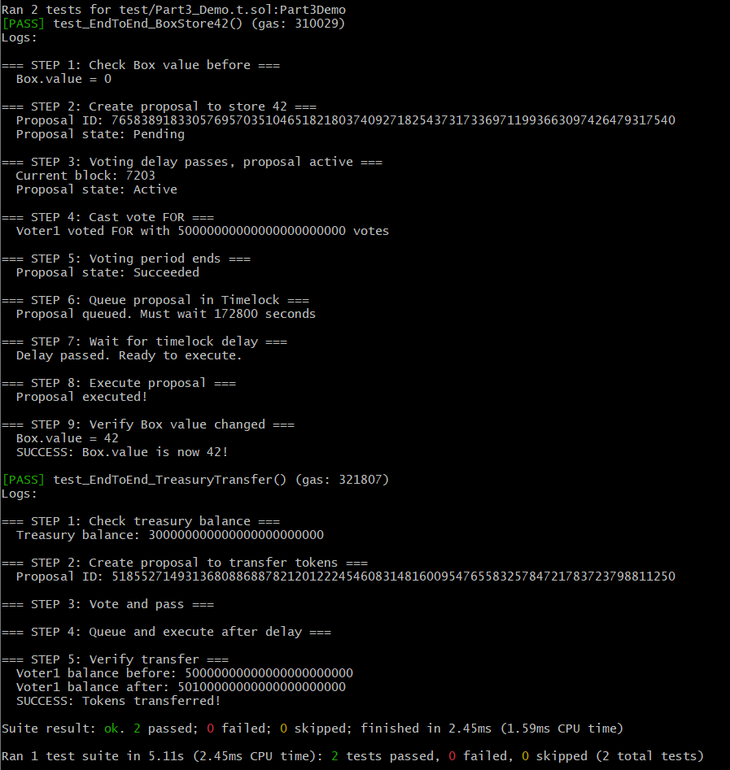
• Screenshots of each step

