Assignment 4
DAO & On-chain Governance System
Group: SE-2403
Student: Iskander Kustayev
PART 4 — DAO Frontend (Minimal)
Task 4: Governance dApp Interface

Deliverables:
• index.html, app.js (or React if preferred) (in the deployed files)
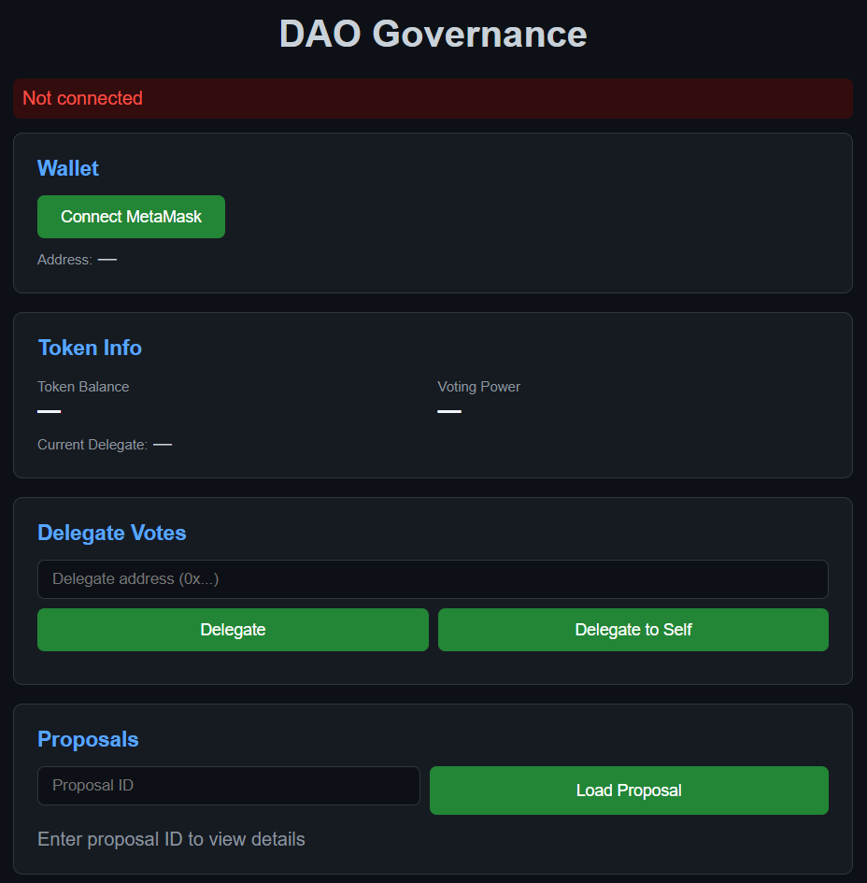
• Screenshots of working UI for each feature

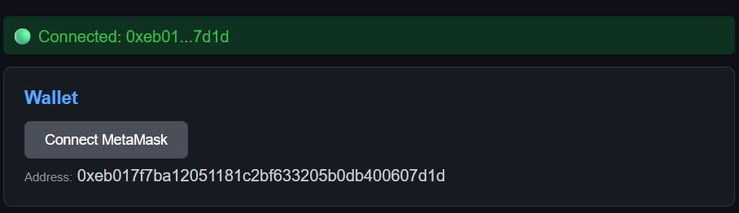
• Proof of successful vote transaction

