Assignment 4
DAO & On-chain Governance System
Group: SE-2403
Student: Iskander Kustayev
PART 1 — Governance Token
Task 1: ERC-20 Votes Token
Deliverables:
• GovernanceToken.sol, TokenVesting.sol (in deployed files)
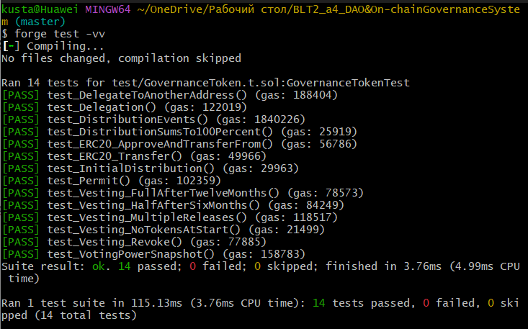
• Test suite

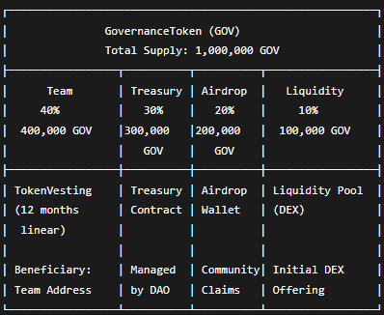
• Token distribution diagram

