Assignment 2
DeFi Protocol Development (AMM / DEX)
Name: Iskander Kustayev
Group: SE-2403
PART 2 — AMM (Automated Market Maker) Development
Task 4: AMM Mathematical Analysis
This document provides a comprehensive mathematical analysis of the Constant Product Automated Market Maker (AMM) implemented in Task 3. We derive the core formula, analyze the effects of fees, quantify impermanent loss and price impact, and compare our implementation with Uniswap V2.

Derivation of the Constant Product Formula
The Basic Formula
The constant product AMM is defined by the equation:
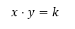
where:
- $x$ = reserve of token A
- $y$ = reserve of token B
- $k$ = invariant (constant)
Why This Formula Works
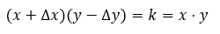
The formula ensures that liquidity is always available on both sides of the pair. For any trade that swaps $\Delta x$ of token A for $\Delta y$ of token B, the following must hold:

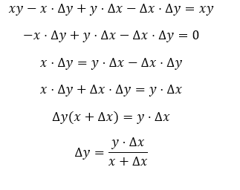
Expanding and solving for $\Delta y$:

The Swap Function
From the derivation, the output amount for a given input is:
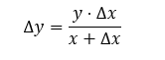

This function has two key properties:
- As $\Delta x \to \infty$, $\Delta y \to y asymptotically. This means the pool approaches depletion of token B, but it can never be fully drained due to the asymptotic nature of the constant product curve
- As $\Delta x \to 0$, $\Delta y \to \frac{y}{x} \cdot \Delta x$ (approaches the spot price)
These properties ensure that the pool never runs out of liquidity - the price approaches infinity as one reserve approaches zero.

Effect of the 0.3% Fee on Invariant $k$
Fee Mechanism
Our AMM charges a 0.3% fee on each swap. Only 99.7% of the input amount is used in the constant product calculation:
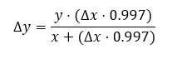

How $k$ Changes Over Time
Without fees, $k$ remains constant. With fees, $k$ increases after each swap because the fee remains in the pool as additional liquidity.
Example:
Initial pool: $x = 1000$ ETH, $y = 1000$ USDC, $k = 1,000,000$
Swap: $\Delta x = 100$ ETH
Without fee: $\Delta y = (1000 \cdot 100) / (1000 + 100) = 90.909$ USDC
With 0.3% fee: $\Delta x_{effective} = 100 \cdot 0.997 = 99.7$ ETH
$\Delta y = (1000 \cdot 99.7) / (1000 + 99.7) = 90.635$ USDC
New reserves:
- $x_{new} = 1000 + 100 = 1100$ ETH
- $y_{new} = 1000 - 90.635 = 909.365$ USDC
New invariant: $k_{new} = 1100 \cdot 909.365 = 1,000,301.5$
The invariant increased by 0.03% - this is the fee accruing to liquidity providers.

3.3 Long-term Effect
In the presence of fees, the invariant k =x * y is no longer strictly constant. Each trade leaves a portion of the input tokens (the 0.3% fee) inside the pool, increasing total reserves.
However, it is incorrect to model this growth as simple exponential compounding
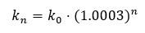

because:
- trades occur in both directions,
- arbitrage continuously rebalances prices,
- the ratio x/y changes over time.
Therefore, fees create an upward pressure on $k$and increase the total pool value, but the exact evolution of k depends on trading activity and market conditions rather than a fixed exponential formula.

Impermanent Loss (IL)
Definition
Impermanent loss is the difference between holding tokens in the pool versus holding them outside the pool, caused by price divergence from the initial deposit ratio.

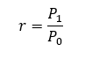
4.2 Derivation of IL Formula
Let the initial price be $P_{0}$, and the new price be $P_{1}$. Define:

Assume an LP initially deposits equal value of both assets. After a price change, arbitrage traders rebalance the pool such that:
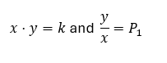

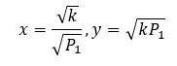
Solving these equations:

The total pool value (in terms of token A) is:
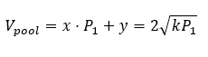

If the LP had simply held the assets, the value would be:
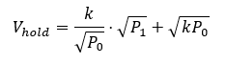

After simplification, the impermanent loss as a function of $r$becomes:
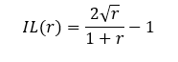

Example: 2x Price Change
For a 2x price increase ($r = 2$):
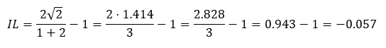

IL = -5.7%
This means the liquidity provider has 5.7% less value than if they had simply held the tokens outside the pool.

IL for Different Price Changes
Price Change ($r$) | Impermanent Loss
1.25x (25% up) | -0.6%
1.5x (50% up) | -2.0%
2.0x (100% up) | -5.7%
3.0x (200% up) | -13.4%
5.0x (400% up) | -25.5%
10.0x (900% up) | -42.6%

Mitigating IL
IL is only realized when withdrawing liquidity. If the price returns to the original ratio, IL becomes zero. Liquidity providers are compensated through trading fees - if fee income exceeds IL, the position remains profitable.

Price Impact
Definition
Price impact is the change in the effective swap price relative to the current market price, caused by the trade size relative to pool reserves.
Formula
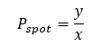
The spot price is:

After swapping $\Delta x$ of token A, the new price is:
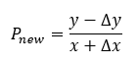

The price impact percentage is:
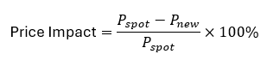

Simplification
Using the swap formula $\Delta y = \frac{y \cdot \Delta x}{x + \Delta x}$:
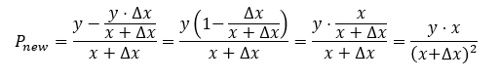

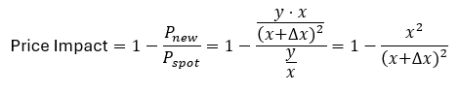
Price impact:

Examples
Trade Size ($\Delta x / x$) | Price Impact
1% | ~1.98%
5% | ~9.3%
10% | ~17.4%
25% | ~36%
50% | ~55.6%
100% | ~75%
Key insight: Price impact grows quadratically with trade size. A 1% trade causes ~2% price impact;
a 10% trade causes ~17% impact.

Comparison with Uniswap V2
Similarities
Feature | Our AMM | Uniswap V2
Constant product formula | $x \cdot y = k$ | $x \cdot y = k$
Fee | 0.3% | 0.3%
LP tokens | ERC-20 | ERC-20
Slippage protection | Min output | Min output

Missing Features
Our implementation lacks several important Uniswap V2 features:
Feature | Description | Why Important
Flash Swaps | Borrow assets without upfront collateral, repay in same transaction | Enables arbitrage, liquidation, and capital efficiency
Tiered Fees | Different pools with 0.05%, 0.3%, 1% fees | Optimizes for different volatility pairs
Price Oracles | Cumulative price tracking for manipulation-resistant pricing | Essential for lending protocols and derivatives
Multi-pool Routing | Swap across multiple pools for best price | Reduces price impact for large trades
Factory Pattern | Deploy new pairs from a factory contract | Enables permissionless pair creation
Meta-transactions | Permit-based approvals | Better UX for LP positions
Emergency Withdraw | Withdraw liquidity in emergency situations | Safety feature

Code-Level Differences
Uniswap V2 additional features:
- skim() - recover accidentally sent tokens
- sync() - synchronize reserves after direct transfers
- mint()/burn() with complex fee calculation
- TWAP (Time-Weighted Average Price) oracles

Gas Efficiency Comparison
Operation | Our AMM | Uniswap V2 (estimated)
Swap | ~80k gas | ~100k gas
Add liquidity | ~270k gas | ~200k gas
Remove liquidity | ~68k gas | ~80k gas
Our implementation is slightly more gas-efficient for swaps but less efficient for adding liquidity.

Conclusion
The constant product AMM provides an elegant solution for decentralized trading with several key properties:
- Infinite liquidity - price never reaches zero or infinity
- Simple pricing - deterministic formula based on reserves
- Fee accrual - fees increase $k$, benefiting LPs
- Transparent economics - impermanent loss and price impact are mathematically predictable

However, our implementation is a minimal viable AMM. Production systems like Uniswap V2
include additional features (flash swaps, oracles, tiered fees) that address real-world needs like
security, capital efficiency, and integration with other DeFi protocols.

The mathematical framework presented here forms the foundation of most modern DEXs, and
understanding these principles is essential for any DeFi developer.

