Assignment 2
DeFi Protocol Development (AMM / DEX)
Name: Iskander Kustayev
Group: SE-2403
PART 3 — Lending Protocol Simulation
Task 5: Build a Basic Lending Pool
Deliverables:
• LendingPool.sol with all functions (in the deployed files)
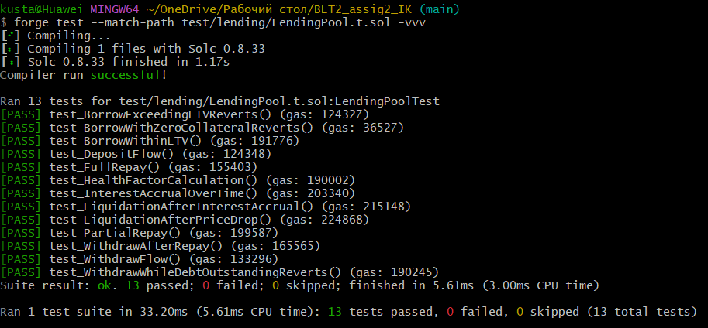
• Complete test suite

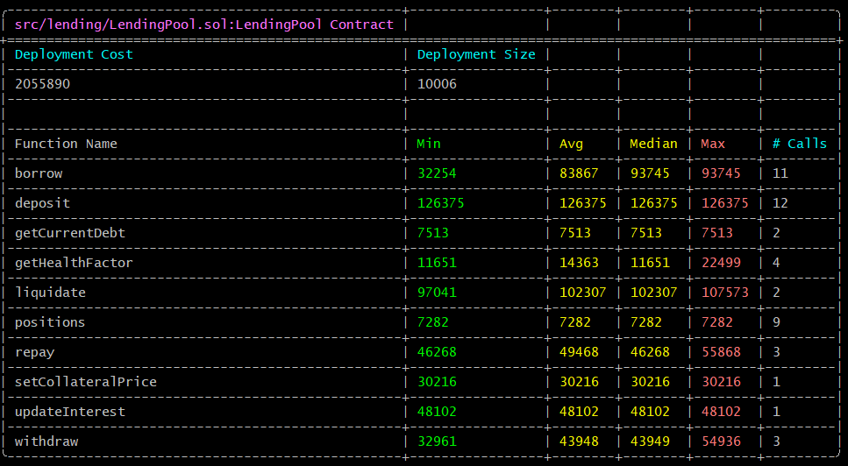
• Gas report
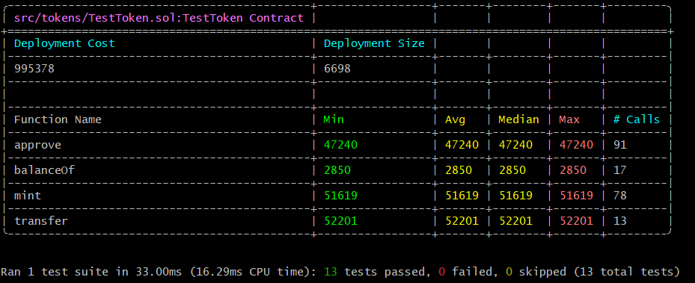

• Workflow diagram (draw.io or similar) showing deposit → borrow → repay → withdraw flow
