Assignment 2
DeFi Protocol Development (AMM / DEX)
Name: Iskander Kustayev
Group: SE-2403
PART 4 — CI/CD Pipeline
Task 6: GitHub Actions for Smart Contracts

Deliverables:
• GitHub Actions YAML file (in the deployed files)
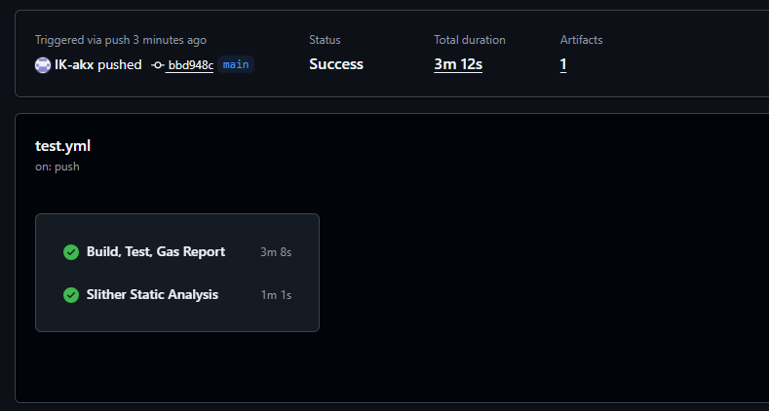
• Screenshot or log of a successful pipeline run (local simulation with act is acceptable)

Brief explanation of pipeline stages
This CI/CD pipeline automates the validation of the smart contract project whenever code is pushed, a pull request is opened, or the workflow is started manually. It consists of two main jobs: Foundry checks and Slither analysis.
The first job installs the Foundry toolchain, verifies the installed version, checks Solidity formatting with forge fmt --check, compiles the contracts using forge build, runs the full test suite with forge test, and then generates a gas report using forge test --gas-report. This stage ensures that the contracts compile successfully, all functionality works as expected, and gas usage is visible for performance evaluation.
The second job performs static security analysis with Slither. The repository is checked out again, Foundry is installed, and the project is compiled before running Slither. The Slither step scans the Solidity codebase for common vulnerabilities, unsafe patterns, and code quality issues. This improves security by catching potential problems early in the development lifecycle.
Together, these stages provide automated quality assurance for the lending protocol project. The pipeline checks code style, correctness, test coverage, gas efficiency, and basic security analysis, which makes development more reliable and reduces the chance of introducing broken or unsafe smart contracts into the repository.

