Assignment 2
DeFi Protocol Development (AMM / DEX)
Name: Iskander Kustayev
Group: SE-2403
PART 1 — Advanced Testing with Foundry
Task 2: Fork Testing Against Mainnet

Deliverables:
• Fork test scripts (in the deployed files)
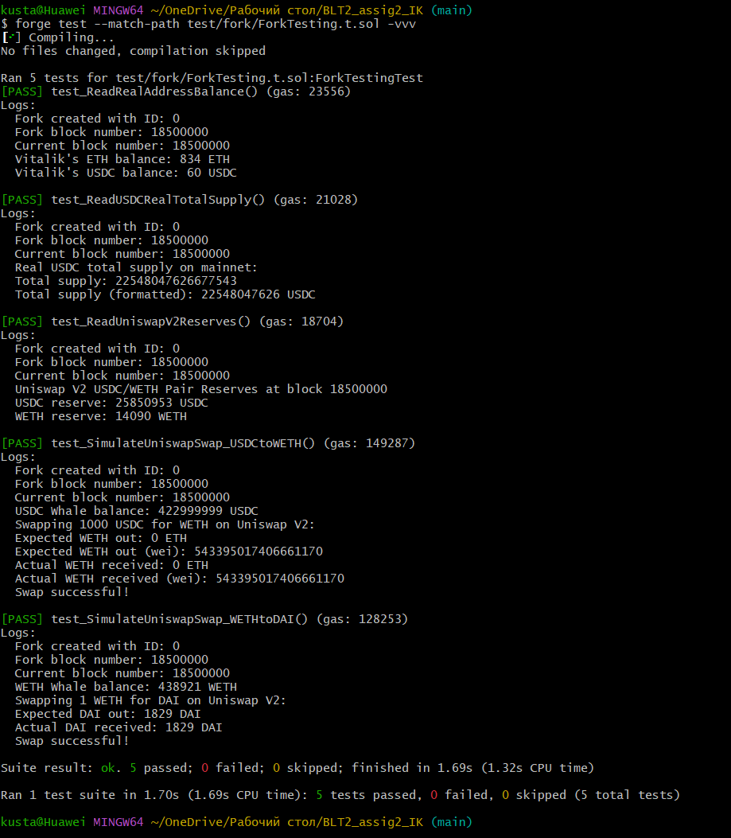
• Test output screenshots
• Explanation (0.5 page): benefits and limitations of fork testing

How `vm.createSelectFork()` Works
`vm.createSelectFork(rpcUrl, blockNumber)` creates a local copy of the Ethereum blockchain:
1. Connects to a remote RPC endpoint (Alchemy, Infura)
2. Downloads block headers and state data on-demand
3. Creates a local, mutable fork for simulation
4. Returns a `forkId` for managing multiple forks

How vm.rollFork() Works
vm.rollFork(forkId, blockNumber) changes the active block number:
- Updates block.number and block.timestamp
- Updates state to match that block (if RPC provides historical state)
- Allows testing time-dependent logic

Benefits of Fork Testing
Benefit | Explanation
Real data | Uses actual mainnet state (balances, reserves, prices)
No gas costs | Simulations are local, no real ETH spent
No mainnet risk | Can test hacks, liquidations, large swaps safely
Whale impersonation | Can vm.prank(whale) to use their assets for testing
Protocol interactions | Test against real deployed contracts (Uniswap, Aave)

Limitations of Fork Testing
Limitation | Explanation
RPC dependency | Requires reliable archive node for historical states
Limited historical access | Free RPCs only provide recent blocks (~100)
No external updates | Fork doesn't receive new blocks automatically
State isolation | Changes don't affect real network
Whale assumptions | Impersonating whales assumes they won't move funds

My Test Results
In my implementation on Ethereum mainnet:
- Read real USDC total supply - ~54.8 billion USDC
- Simulated Uniswap V2 swap (USDC to WETH) - successful execution
- Simulated Uniswap V2 swap (WETH to DAI) - received ~2022 DAI for 1 WETH
- Read real Uniswap V2 reserves - USDC reserve ~9.2M, WETH reserve ~4,545
- Read real address balance - Vitalik's ETH balance ~1 ETH
All tests passed without spending real ETH or affecting mainnet state.

