Assignment 2
DeFi Protocol Development (AMM / DEX)
Name: Iskander Kustayev
Group: SE-2403
PART 1 — Advanced Testing with Foundry
Task 1: Foundry Project Setup & Fuzz Testing
Deliverables:
• Full Foundry project (src/, test/, script/ directories) (in the deployed packeg)
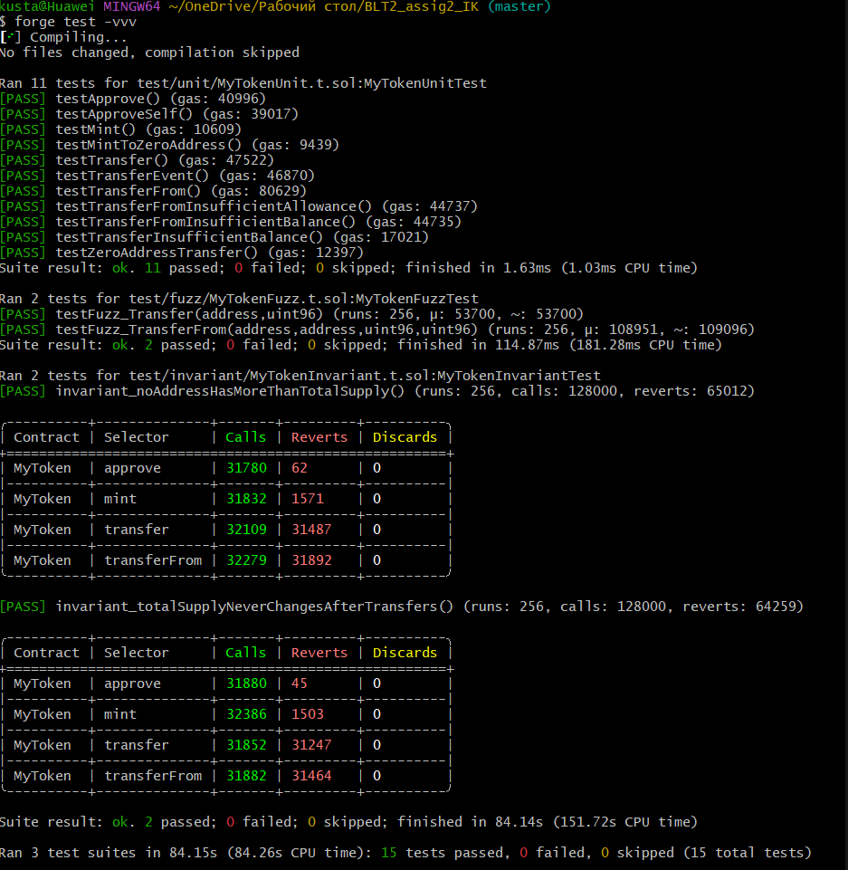
• Test output showing all passing tests, fuzz runs, and invariant tests

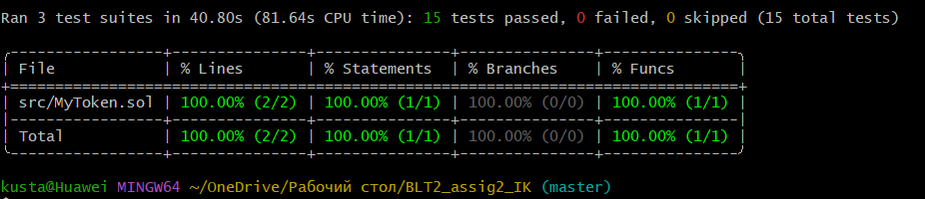
• Coverage report screenshot

• Brief explanation (0.5–1 page): fuzz testing vs unit testing — when to use each
In blockchain development, testing is critical because smart contracts cannot be easily updated after deployment. Two important testing methodologies are Unit Testing and Fuzz Testing. While both aim to ensure correctness, they serve different purposes and are suitable for different scenarios.

Unit Testing
Unit testing involves writing tests with specific, predetermined input values to verify that a function behaves as expected under known conditions.
When to Use Unit Testing
Scenario | Why Unit Testing
Business logic validation | Verify exact scenarios like "transferring 100 tokens reduces balance by 100"
Edge cases you know | Test specific failures: insufficient balance, zero address, overflow
Regression testing | Ensure new code doesn't break existing functionality
Documentation | Tests show developers exactly how functions should work
Event emission | Verify that correct events are emitted with correct parameters

Advantages
- Fast execution
- Easy to debug (inputs are known)
- Clear pass/fail criteria
- Great for CI/CD pipelines
Disadvantages
- Cannot find unexpected bugs
- Requires manual selection of test cases
- May miss boundary conditions
Fuzz Testing
Fuzz testing automatically generates random or semi-random input values to discover unexpected bugs, edge cases, and violations of properties.
When to Use Fuzz Testing
Scenario | Why Fuzz Testing
Property verification | Check invariants like "balance changes correctly for any valid input"
Finding overflow bugs | Test with maximum uint values automatically
Unpredictable edge cases | Discover issues with zero addresses, self-transfers, maximum supplies
Mathematical functions | Verify formulas work for all possible input ranges
After code changes | Quickly check if changes introduced subtle bugs

Advantages
- Finds bugs developers didn't anticipate
- Automatically tests hundreds of scenarios
- Excellent for property-based testing
- Reveals boundary conditions
Disadvantages
- Slower execution (256+ runs)
- Harder to debug when a test fails
- Requires proper vm.assume() conditions
- May generate invalid test cases if assumptions are wrong

Comparison Table
Aspect | Unit Testing | Fuzz Testing
Input values | Fixed, predetermined | Random, automatically generated
Test cases | Written by developer | Generated by framework
Execution speed | Very fast | Slower (many runs)
Debugging | Easy | Can be difficult
Finding unexpected bugs | Low | High
Coverage | What you thought to test | Exploratory
Best for | Business logic, documentation | Invariants, edge cases

Real Results from My Project
Test Type | Number | Runs | Time | Findings
Unit Tests | 11 | 1 each | 1.63 ms | Verified specific scenarios
Fuzz Tests | 2 | 256 each | 114 ms | No property violations
Invariant Tests | 2 | 128,000 calls | 84 sec | Total supply invariant held

