Assignment 2
DeFi Protocol Development (AMM / DEX)
Name: Iskander Kustayev
Group: SE-2403
PART 2 — AMM (Automated Market Maker) Development
Task 3: Build a Constant Product AMM
Deliverables:
• AMM.sol, LPToken.sol, two ERC-20 token contracts (in the deployed files)
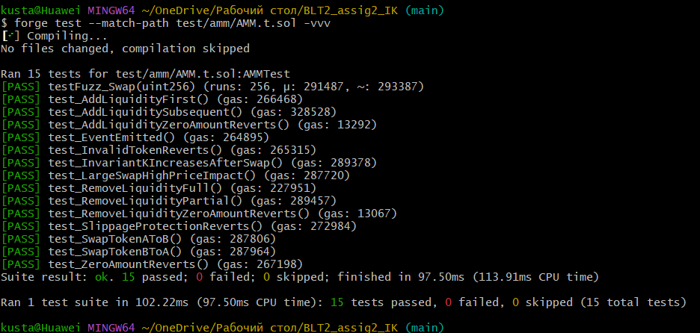
• Complete test suite with all tests passing
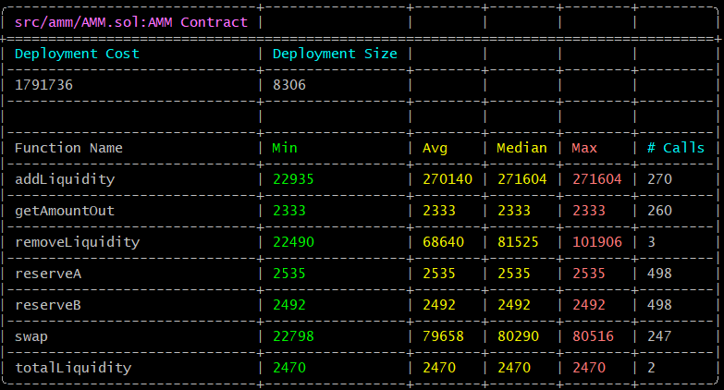
• Gas report for all AMM operations
