**Predicting Car Resale Prices: A Machine Learning Approach**

**1. Project Title:**

Predicting Car Resale Prices: A Machine Learning Approach

**Project Team:**

**- I.Saikumar 21761A0520**

**- B.VenkataPraveen 21761A0511**

**-D.Saikrishna 21761A0515**

**3. Abstract:**

The resale price of used cars is a critical factor for both buyers and sellers in the automotive market. Accurately predicting car resale prices can empower consumers to make informed decisions while assisting sellers in setting competitive prices. In this project, we employ a machine learning approach to tackle the challenge of predicting car resale prices.

**4. Introduction:**

Predicting car resale prices is a problem of considerable significance in the automotive industry. The ability to estimate a car's future value, given its characteristics and historical data, can provide valuable insights to potential buyers and sellers. By leveraging the power of machine learning, we aim to develop a predictive model that can estimate resale prices with a high degree of accuracy.

**Data Collection and Preprocessing**

Data is the backbone of any machine learning project, and this endeavor is no different. We have collected diverse data from various sources, including online car listings, APIs, and databases. However, data is seldom perfect, and we had to employ meticulous preprocessing techniques to ensure data quality. This included handling missing values, encoding categorical features, and standardizing numeric values. The cleanliness and relevance of data are paramount to the success of our prediction model.

**Exploratory Data Analysis (EDA)**

Our initial exploratory data analysis (EDA) revealed valuable insights into the dataset. We examined the distribution of resale prices, explored correlations between features, and detected potential outliers. Visualizations such as histograms, scatter plots, and heatmaps were utilized to make these insights comprehensible. This phase provided a foundational understanding of the data and served as a basis for model selection.

**Methodology**

For our car resale price prediction, we opted for a machine learning approach, specifically utilizing the Random Forest Regressor. Random forests are well-suited for regression tasks, capable of handling both numeric and categorical features. Model training and feature selection played an integral role in our project. We selected features that exhibited strong relationships with resale prices and fine-tuned our model to achieve optimal performance.

**Visulalisation results:**

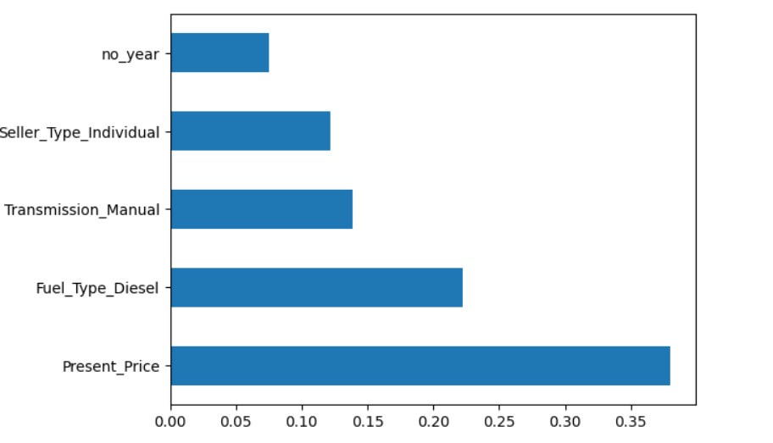

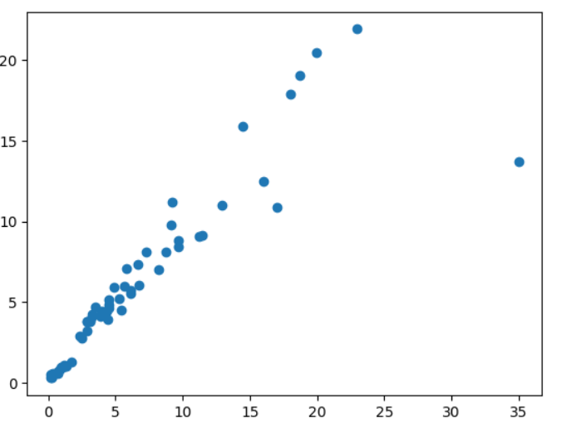

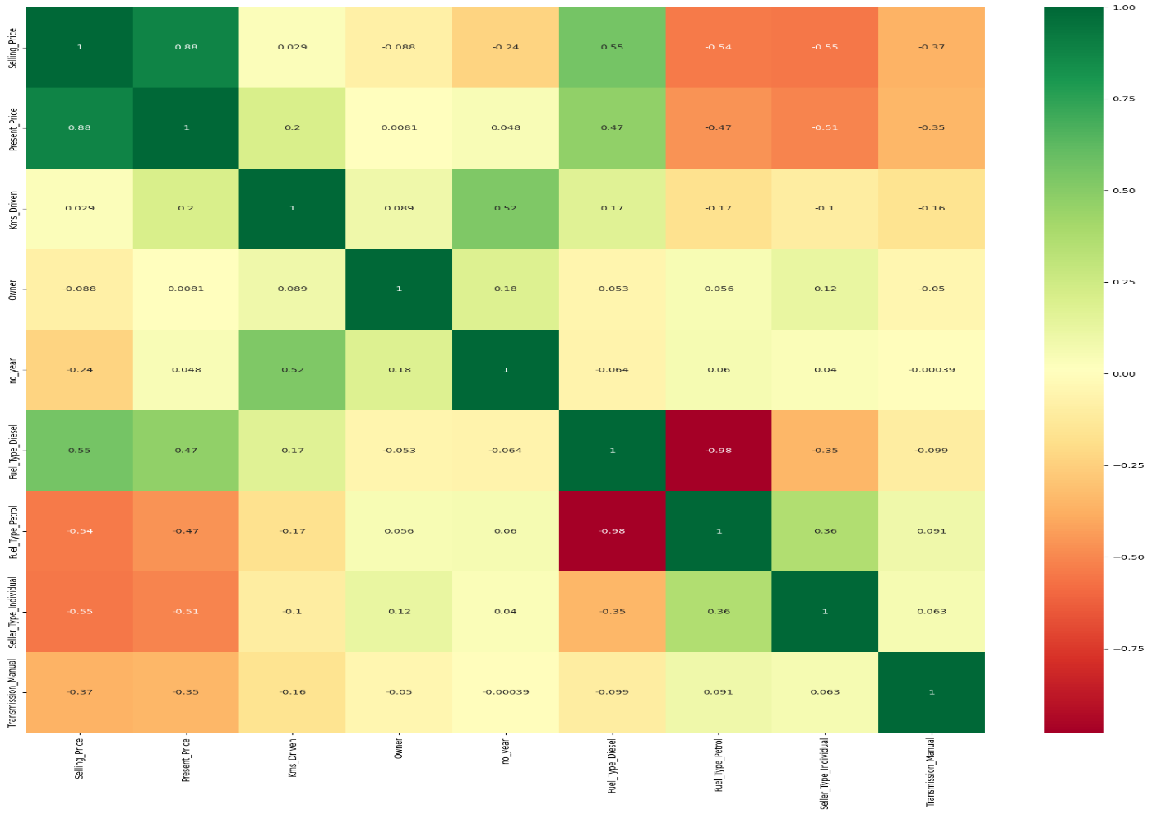

**Results**

The fruits of our labor are revealed through the results of the predictive model. Evaluation metrics such as Mean Absolute Error (MAE), Root Mean Square Error (RMSE), and R-squared (R^2) scores provide quantifiable assessments of our model's performance. Visualizations, including scatter plots and residual plots, help to illustrate how well our model's predictions align with actual resale prices.

