# SCFC_v20.02.1582_info.docx

Settings

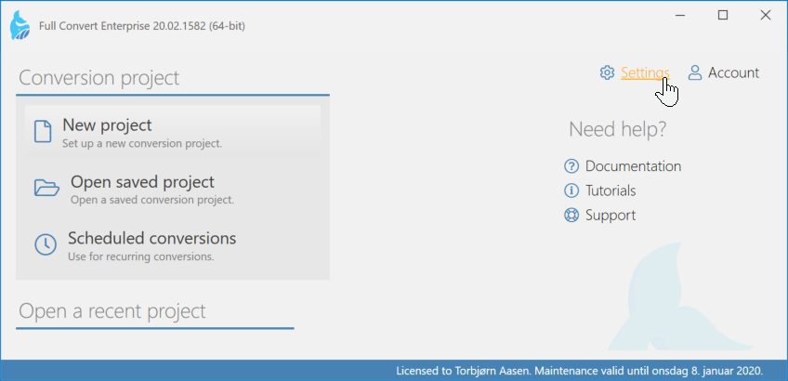

Uncheck for Privacy setting

