Question 1:

1. Copy the diagram of the function *fK* of the Simplified DES Encryption details [figure number] and label each wire with the corresponding variable name from the Sage code that implements SDES Encryption (see example [example number]).
2. Copy the diagram of the Simplified DES Encryption Key Generation [figure number] and label each wire with the corresponding variable names from the Sage code that implements the SDES Key Generation.

Solution:

1. Copy the diagram of the function *fK* of the Simplified DES Encryption details [figure number] and label each wire with the corresponding variable name from the Sage code that implements SDES Encryption (see example [example number]).

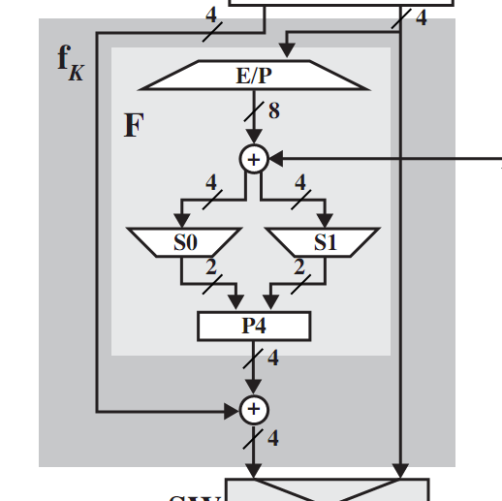

left_block

temp_block5

temp_block4

S1_out

right_block

K

S1_out

right_temp_block2

left_temp_block2

temp_block1

1. Copy the diagram of the Simplified DES Encryption Key Generation [figure number] and label each wire with the corresponding variable names from the Sage code that implements the SDES Key Generation.

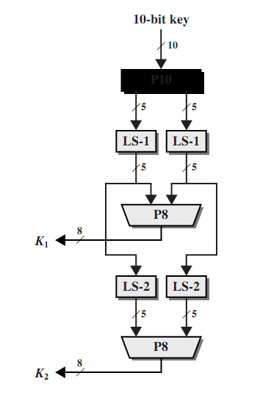

K2right

K2left

K1

K1right

K1left

right_temp_K

left_temp_K

K