**实 验 预 习 报 告**

|  |  |  |  |  |  |  |
| --- | --- | --- | --- | --- | --- | --- |
| **实 验 人** | **陈潇楠** | | **学 号** | **10389418** | **日 期** |  |
| **院（系）：** | **软件学院** | | | **专业（班级）：** | **2010级电子政务2班** | |
| **实验题目** | | **实验六 同步计数器的设计** | | | | |

1. **实验内容**
2. 用J-K触发器和门电路设计一个特殊的12进制计数器，其十进制的状态转换图为：

01→02→03→04→05→06→07→08→09→10→11→12

1. 考虑增加一个变量D，当D = 0时，计数器按顺时针形势运行，当D = 1时，无论计数器当前处于什么状态，计数器按逆时针运行。此处接线复杂，可利用仿真软件进行仿真。
2. **实验设计思路**

按照时序逻辑电路的设计步骤分步进行电路的实现。

原始状态图→最简状态图→状态分配→选触发器，求时钟、输出、状态、驱动方程→画电路图→检查电路是否能自启。

**三、实验具体操作**

1.原始状态图

|  |  |  |  |  |  |  |  |  |  |  |  |
| --- | --- | --- | --- | --- | --- | --- | --- | --- | --- | --- | --- |
| 当前状态 | | | | 次态D=0 | | | | 次态D=1 | | | |
| Q3 | Q2 | Q1 | Q0 | Q3 | Q2 | Q1 | Q0 | Q3 | Q2 | Q1 | Q0 |
| 0 | 0 | 0 | 1 | 0 | 0 | 1 | 0 | 1 | 1 | 0 | 0 |
| 0 | 0 | 1 | 0 | 0 | 0 | 1 | 1 | 0 | 0 | 0 | 1 |
| 0 | 0 | 1 | 1 | 0 | 1 | 0 | 0 | 0 | 0 | 1 | 0 |
| 0 | 1 | 0 | 0 | 0 | 1 | 0 | 1 | 0 | 0 | 1 | 1 |
| 0 | 1 | 0 | 1 | 0 | 1 | 1 | 0 | 0 | 1 | 0 | 0 |
| 0 | 1 | 1 | 0 | 0 | 1 | 1 | 1 | 0 | 1 | 0 | 1 |
| 0 | 1 | 1 | 1 | 1 | 0 | 0 | 0 | 0 | 1 | 1 | 0 |
| 1 | 0 | 0 | 0 | 1 | 0 | 0 | 1 | 0 | 1 | 1 | 1 |
| 1 | 0 | 0 | 1 | 1 | 0 | 1 | 0 | 1 | 0 | 0 | 0 |
| 1 | 0 | 1 | 0 | 1 | 0 | 1 | 1 | 1 | 0 | 0 | 1 |
| 1 | 0 | 1 | 1 | 1 | 1 | 0 | 0 | 1 | 0 | 1 | 0 |
| 1 | 1 | 0 | 0 | 0 | 0 | 0 | 1 | 1 | 0 | 1 | 1 |

1. 最简状态图

|  |  |
| --- | --- |
| Qn Qn+1 | J K |
| 0 0 | 0 X |
| 0 1 | 1 X |
| 1 0 | X 1 |
| 1 1 | X 0 |

**JK转换图**

状态化简：

|  |  |  |  |  |
| --- | --- | --- | --- | --- |
| Q3Q2  Q1Q0 | 00 | 01 | 11 | 10 |
| 00 | X | 1 | 1 | X |
| 01 | X | 1 | 1 | X |
| 11 | X | X | X | X |
| 10 | X | 1 | 1 | X |

**当D=0时：**

|  |  |  |  |  |
| --- | --- | --- | --- | --- |
| Q3Q2  Q1Q0 | 00 | 01 | 11 | 10 |
| 00  **J0** | X | X | X | 1  **K0** |
| 01 | 1 | X | X | 1 |
| 11 | 1 | X | X | X |
| 10 | 1 | X | X | 1 |

|  |  |  |  |  |
| --- | --- | --- | --- | --- |
| Q3Q2  Q1Q0 | 00 | 01 | 11 | 10 |
| 00 | X | X | 1 | 0 |
| 01 | X | X | 1 | 0 |
| 11 | X | X | X | X |
| 10 | X | X | 1 | 0 |

|  |  |  |  |  |
| --- | --- | --- | --- | --- |
| Q3Q2  Q1Q0 | 00 | 01 | 11 | 10 |
| 00 | X | 1 | X | X  **K1** |
| 01  **J1** | 0 | 1 | X | X |
| 11 | 0 | X | X | X |
| 10 | 0 | 1 | X | X |

|  |  |  |  |  |
| --- | --- | --- | --- | --- |
| Q3Q2  Q1Q0 | 00 | 01 | 11 | 10 |
| 00 | X | X | X | X |
| 01 | 0 | 0 | 1 | 0 |
| 11 | 1 | X | X | X |
| 10 | X | X | X | X |

|  |  |  |  |  |
| --- | --- | --- | --- | --- |
| Q3Q2  Q1Q0 | 00 | 01 | 11 | 10 |
| 00 | X | 0 | 1 | 0 |
| 01  **J2** | X | X | X | X  **K2** |
| 11 | X | X | X | X |
| 10 | 0 | 0 | 1 | 0 |

|  |  |  |  |  |
| --- | --- | --- | --- | --- |
| Q3Q2  Q1Q0 | 00 | 01 | 11 | 10 |
| 00 | X | X | X | X |
| 01 | X | X | X | X |
| 11 | 1 | X | X | X |
| 10 | 0 | 0 | 0 | 0 |

|  |  |  |  |  |
| --- | --- | --- | --- | --- |
| Q3Q2  Q1Q0 | 00 | 01 | 11 | 10 |
| 00 | X | 0 | 0 | 0 |
| 01  **J3** | 0 | 0 | 1 | 0  **K3** |
| 11 | X | X | X | X |
| 10 | X | X | X | X |

**当D=1时：**

|  |  |  |  |  |
| --- | --- | --- | --- | --- |
| Q3Q2  Q1Q0 | 00 | 01 | 11 | 10 |
| 00 | X | 1 | 1 | X |
| 01 | X | 1 | 1 | X |
| 11 | X | X | X | X |
| 10 | X | 1 | 1 | X |

|  |  |  |  |  |
| --- | --- | --- | --- | --- |
| Q3Q2  Q1Q0 | 00 | 01 | 11 | 10 |
| 00  **J0** | X | X | X | 1  **K0** |
| 01 | 1 | X | X | 1 |
| 11 | 1 | X | X | X |
| 10 | 1 | X | X | 1 |

|  |  |  |  |  |
| --- | --- | --- | --- | --- |
| Q3Q2  Q1Q0 | 00 | 01 | 11 | 10 |
| 00 | X | 0 | X | X  **K1** |
| 01  **J1** | 1 | 0 | X | X |
| 11 | 1 | X | X | X |
| 10 | 1 | 0 | X | X |

|  |  |  |  |  |
| --- | --- | --- | --- | --- |
| Q3Q2  Q1Q0 | 00 | 01 | 11 | 10 |
| 00 | X | X | 0 | 1 |
| 01 | X | X | 0 | 1 |
| 11 | X | X | X | X |
| 10 | X | X | 0 | 1 |

|  |  |  |  |  |
| --- | --- | --- | --- | --- |
| Q3Q2  Q1Q0 | 00 | 01 | 11 | 10 |
| 00 | X | X | X | X |
| 01 | 1 | 0 | 0 | 0 |
| 11 | 1 | X | X | X |
| 10 | X | X | X | X |

|  |  |  |  |  |
| --- | --- | --- | --- | --- |
| Q3Q2  Q1Q0 | 00 | 01 | 11 | 10 |
| 00 | X | 1 | 0 | 0  **K2** |
| 01  **J2** | X | X | X | X |
| 11 | X | X | X | X |
| 10 | 1 | 0 | 0 | 0 |

|  |  |  |  |  |
| --- | --- | --- | --- | --- |
| Q3Q2  Q1Q0 | 00 | 01 | 11 | 10 |
| 00 | X | X | X | X |
| 01 | X | X | X | X |
| 11 | 0 | X | X | X |
| 10 | 1 | 0 | 0 | 0 |

|  |  |  |  |  |
| --- | --- | --- | --- | --- |
| Q3Q2  Q1Q0 | 00 | 01 | 11 | 10 |
| 00  **J3** | X | 1 | 0 | 0  **K3** |
| 01 | 0 | 0 | 0 | 0 |
| 11 | X | X | X | X |
| 10 | X | X | X | X |

1. 状态分配
2. 当D=0时，

J0 = K0 = 1;J1 = K1 = Q1;J2 = Q1*Q0,K2 = Q3 + Q1*Q0;

J3 = Q2*Q1*Q0,K3 = Q2.

1. 当D=1时，

J0 = K0 = 1;J1 = K1 = ;J2 = +,K2 = ;

J3 = ,K3 = .

1. 时序状态图

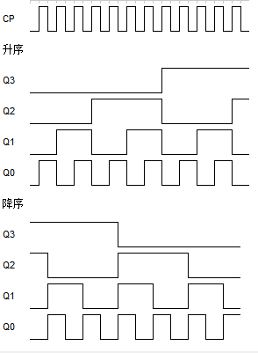

1. 仿真电路图

**升序**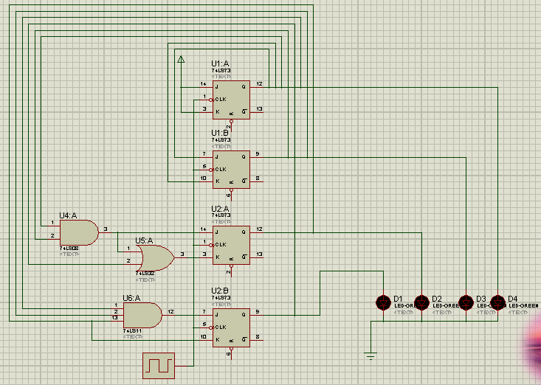

**降序**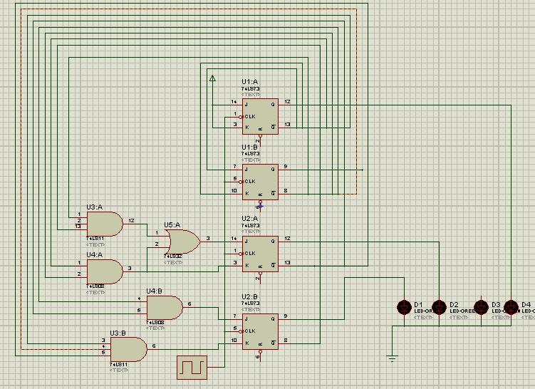

**四、电路效果图**

