Please give us feedback! Tell us how we’re doing and what we can do better. Also, you can sign up for future news. T.I.A

Just point your camera phone below.

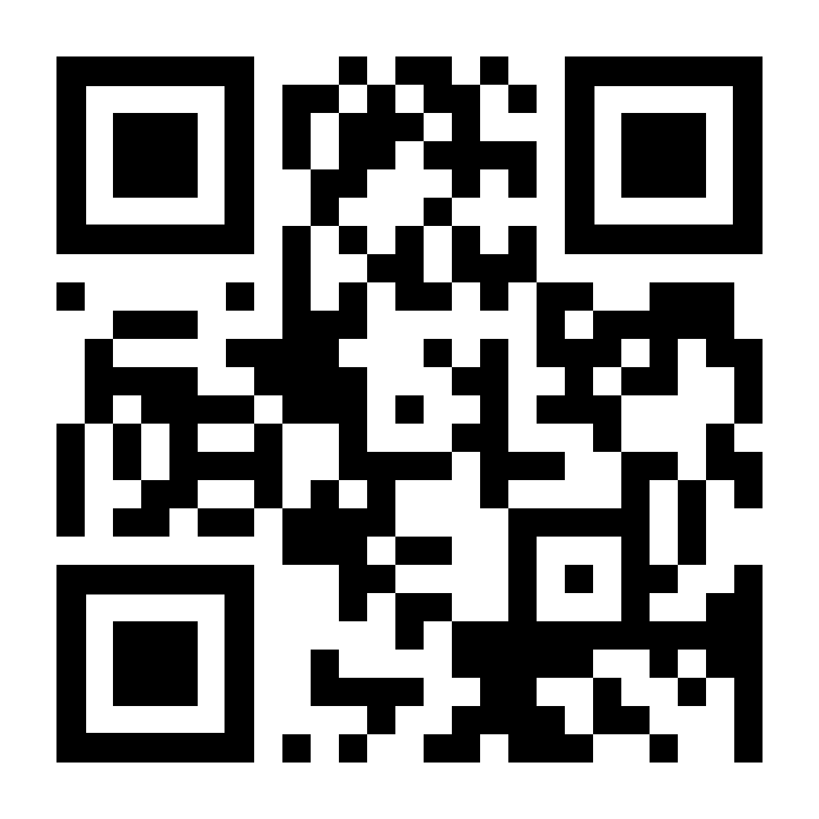

With kind regards, Digital Creativity Workshop team.