**Problem 1a)**

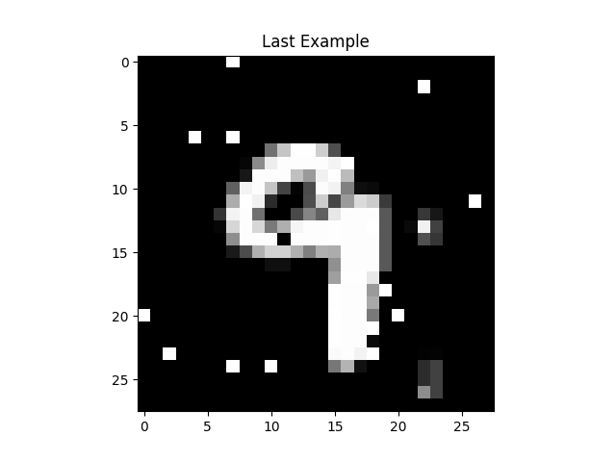

**Problem1b)**

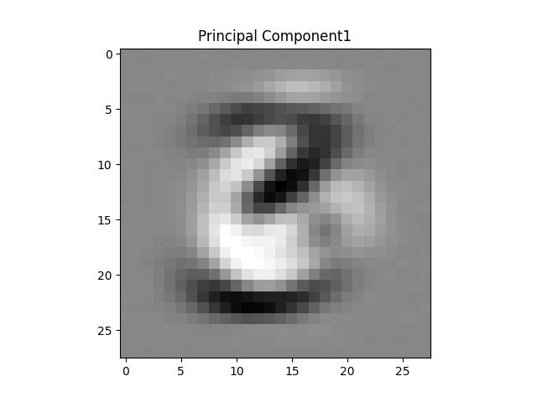

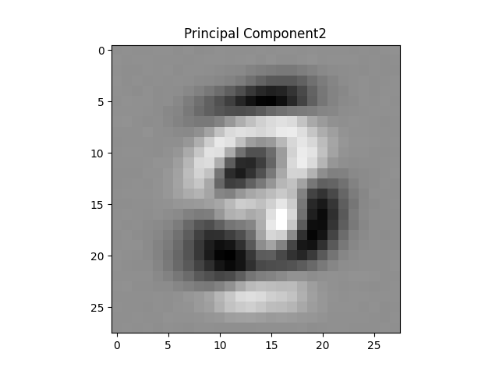

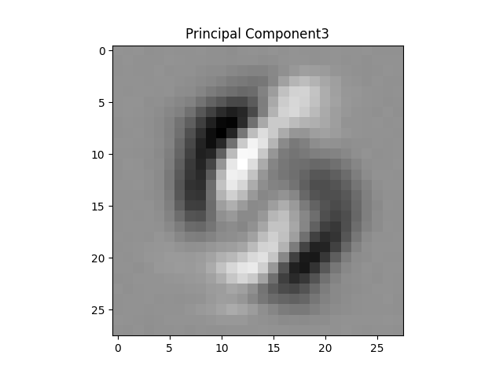

**Problem 1c)**

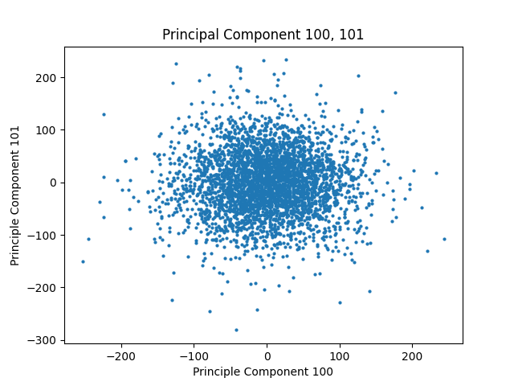

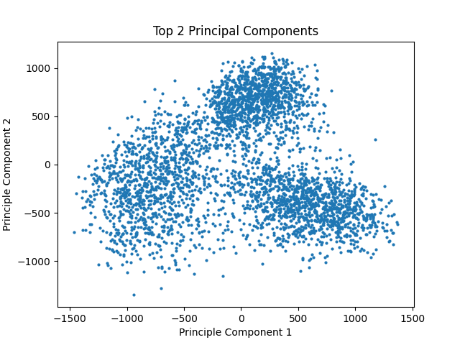

**Problem 1d)**

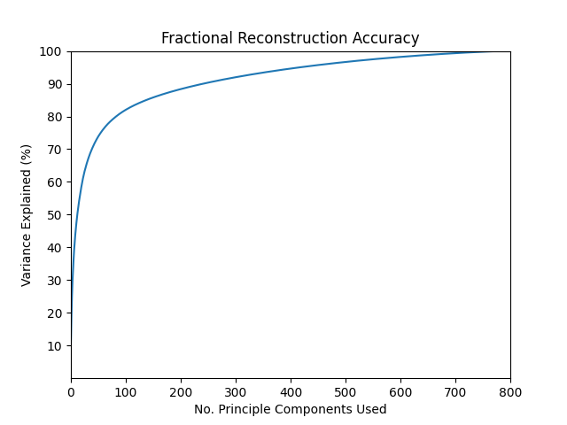

**----------------------- -----------------------------**

**Reconstruction Accuracy No. Principal Components Used**

**10.0% 1**

**20.0% 3**

**30.0% 5**

**40.0% 8**

**50.0% 13**

**60.0% 22**

**70.0% 34**

**80.0% 84**

**90.0% 242**

**----------------------- -----------------------------**

**Problem 1e)**

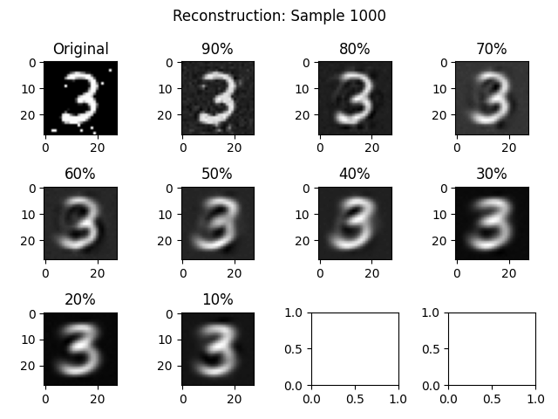

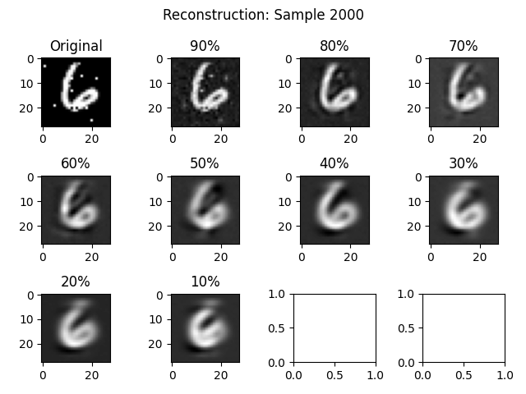

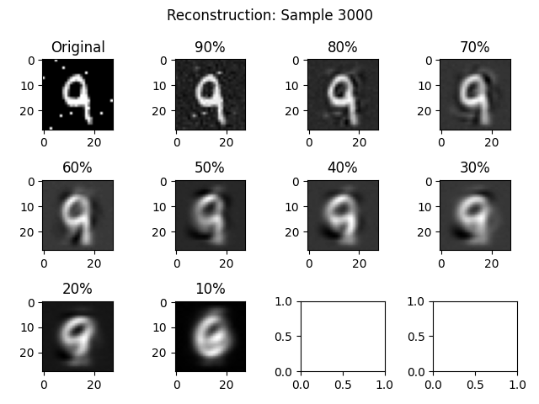

**Problem 3a(i)**

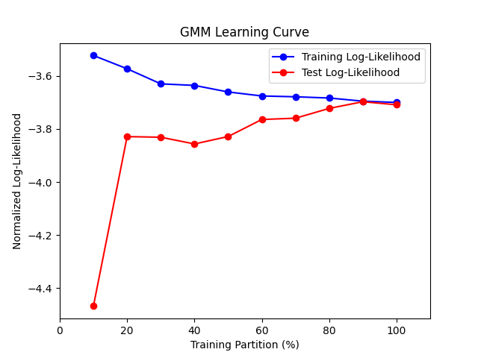

**Problem 3a(ii)**

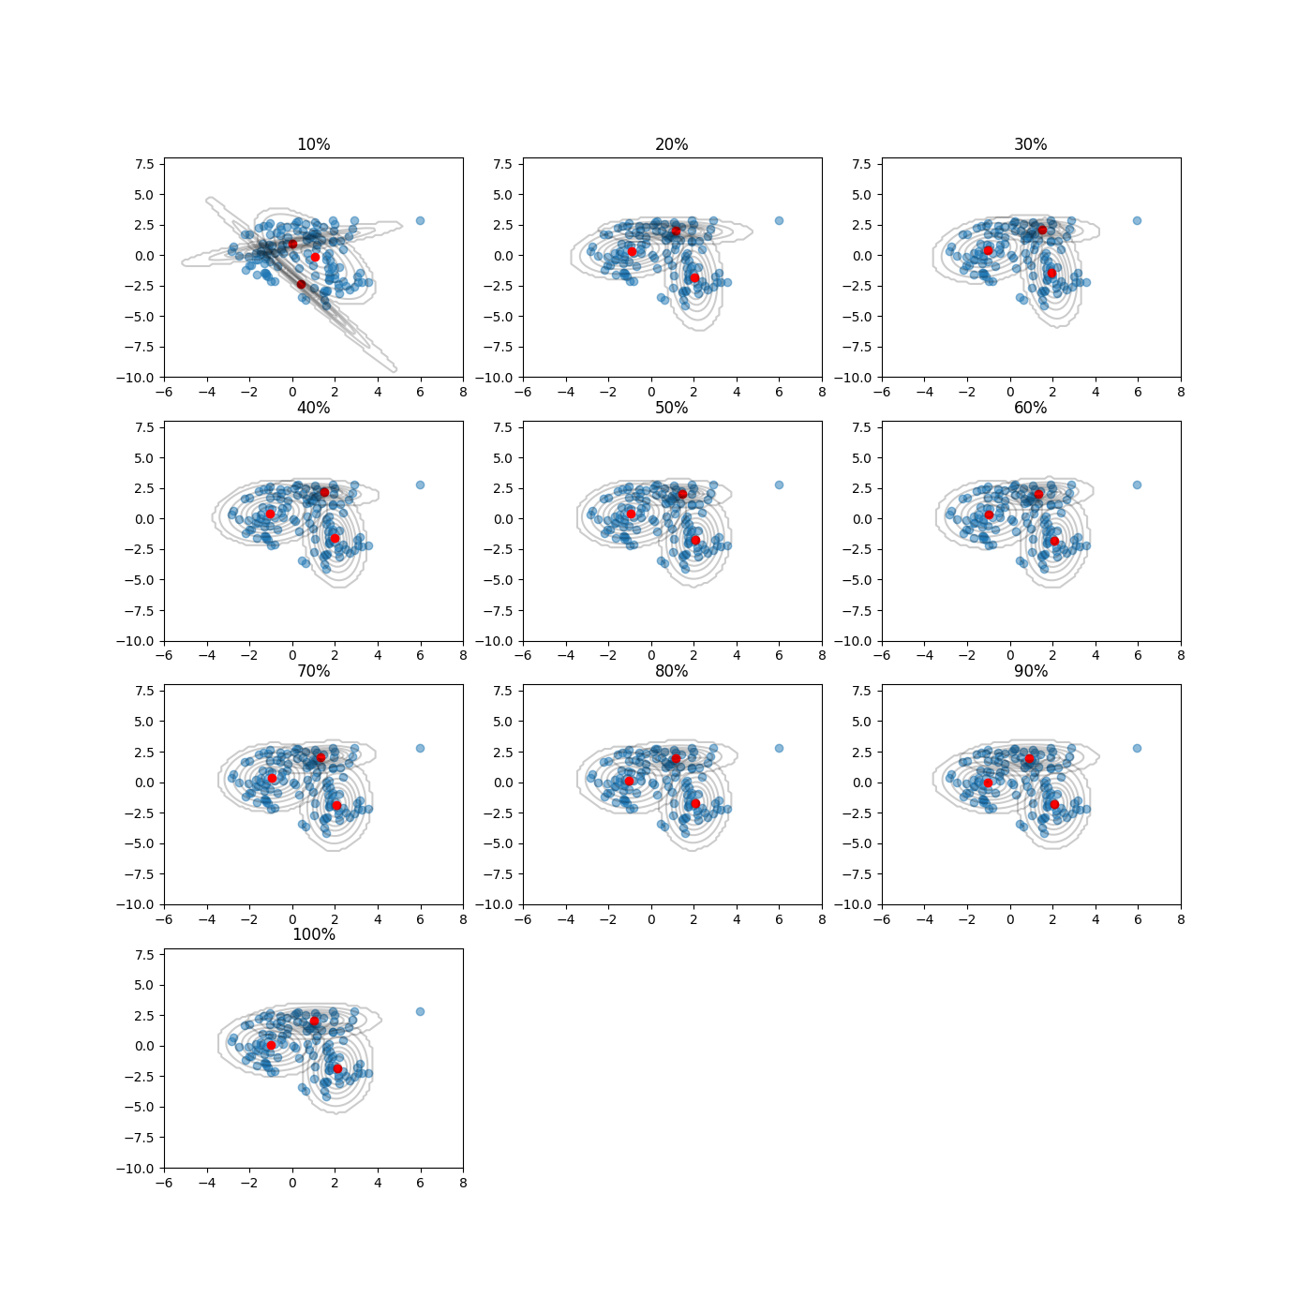

**---------------------------------- -------**

**K 3**

**Permutation 100%**

**Iterations 26**

**Normalized training log-likelihood -3.7002**

**Normalized test log-likelihood -3.709**

**---------------------------------- -------**

**------------ -------------------**

**Covariance 1 [[1.492 0.038 ]**

**[0.038 0.3047]]**

**Covariance 2 [[ 1.159 -0.0773]**

**[-0.0773 1.1899]]**

**Covariance 3 [[0.4924 0.0712]**

**[0.0712 2.4568]]**

**------------ -------------------**

**------ -----------------**

**Mean 1 [1. 2.0435]**

**Mean 2 [-0.9782 0.0651]**

**Mean 3 [ 2.1283 -1.8328]**

**------ -----------------**

**-------------------- ------**

**Mixing coefficient 1 0.2887**

**Mixing coefficient 2 0.3802**

**Mixing coefficient 3 0.3311**

**-------------------- ------**

**Problem 3b**

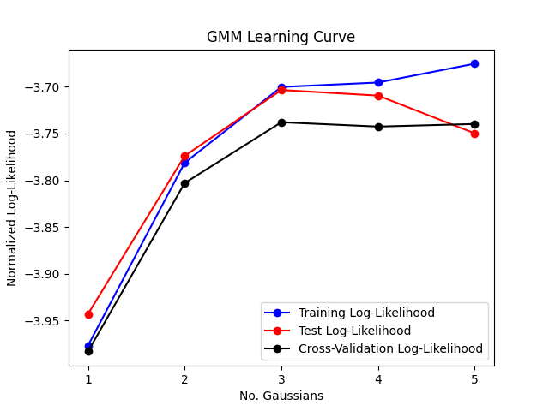

**--------------------------------------- -------**

**Selected value of K: 3**

**Average cross validation log-likelihood -3.7379**

**Normalized training log-likelihood -3.7002**

**Normalized test log-likelihood -3.7034**

**--------------------------------------- -------**

**Problem 4b)**

**E:\Documents\GitHub\Machine-Learning\PS4\ps4-kit\venv\Scripts\python.exe E:/Documents/GitHub/Machine-Learning/PS4/ps4-kit/PS4-P4.py**

**exp(D_log) =**

**[[2.50000000e-01 6.00000000e-02 9.60000000e-03 3.84000000e-03**

**9.21600000e-04 1.47456000e-04 5.89824000e-05 1.41557760e-05**

**2.26492416e-06 9.05969664e-07]**

**[5.00000000e-02 1.00000000e-02 8.40000000e-03 4.20000000e-04**

**1.53600000e-04 1.29024000e-04 6.45120000e-06 2.35929600e-06**

**1.98180864e-06 9.90904320e-08]]**

**exp(D_log) =**

**[[2.50000000e-01 1.00000000e-01 4.00000000e-02 6.40000000e-03**

**1.02400000e-03 1.96000000e-04 6.86000000e-05 2.40100000e-05**

**8.40350000e-06 2.94122500e-06]**

**[5.00000000e-02 5.00000000e-03 2.00000000e-03 5.60000000e-03**

**1.96000000e-03 6.86000000e-04 2.40100000e-04 8.40350000e-05**

**2.94122500e-05 1.02942875e-05]]**

**exp(D_log) =**

**[[2.5000000e-01 6.0000000e-02 9.6000000e-03 3.8400000e-03 1.5360000e-03**

**6.1440000e-04 1.4745600e-04 2.3592960e-05 9.4371840e-06 3.7748736e-06]**

**[5.0000000e-02 1.0000000e-02 8.4000000e-03 4.2000000e-04 7.6800000e-05**

**3.0720000e-05 2.4576000e-05 2.0643840e-05 1.0321920e-06 1.8874368e-07]]**

**Process finished with exit code 0**