**Add/Run Python script to ArcGIS toolbox in ArcGIS Pro**

Step 1: Open ArcGIS Pro, (click on View – click on Catalog Plane).

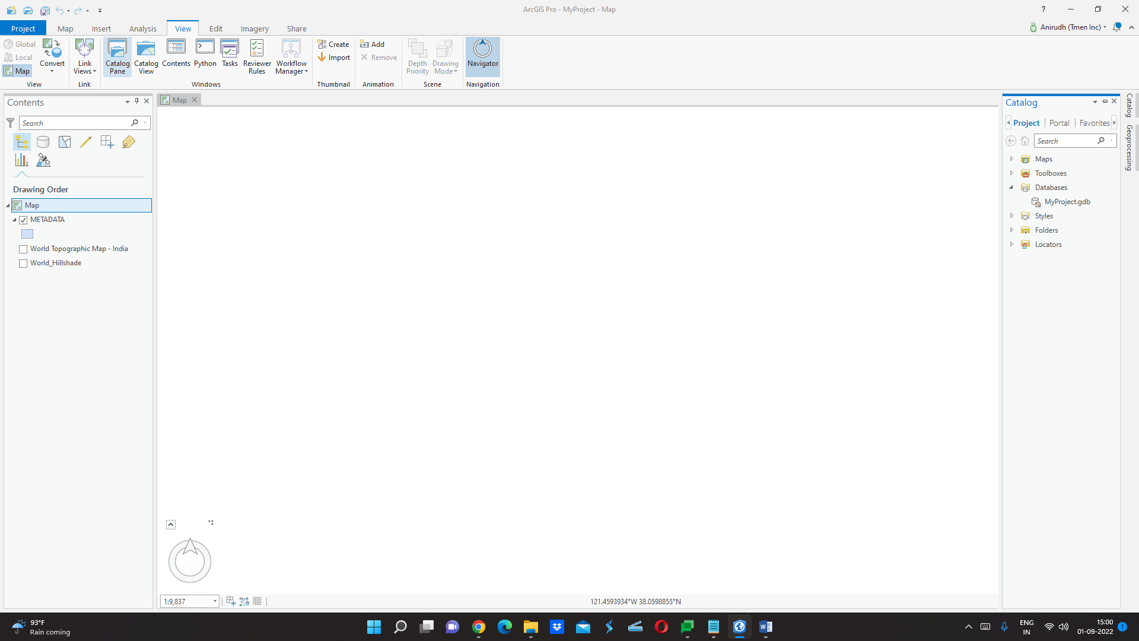

Step 2: Install Pillow (PIL Python Package), click on Project, and then Python.

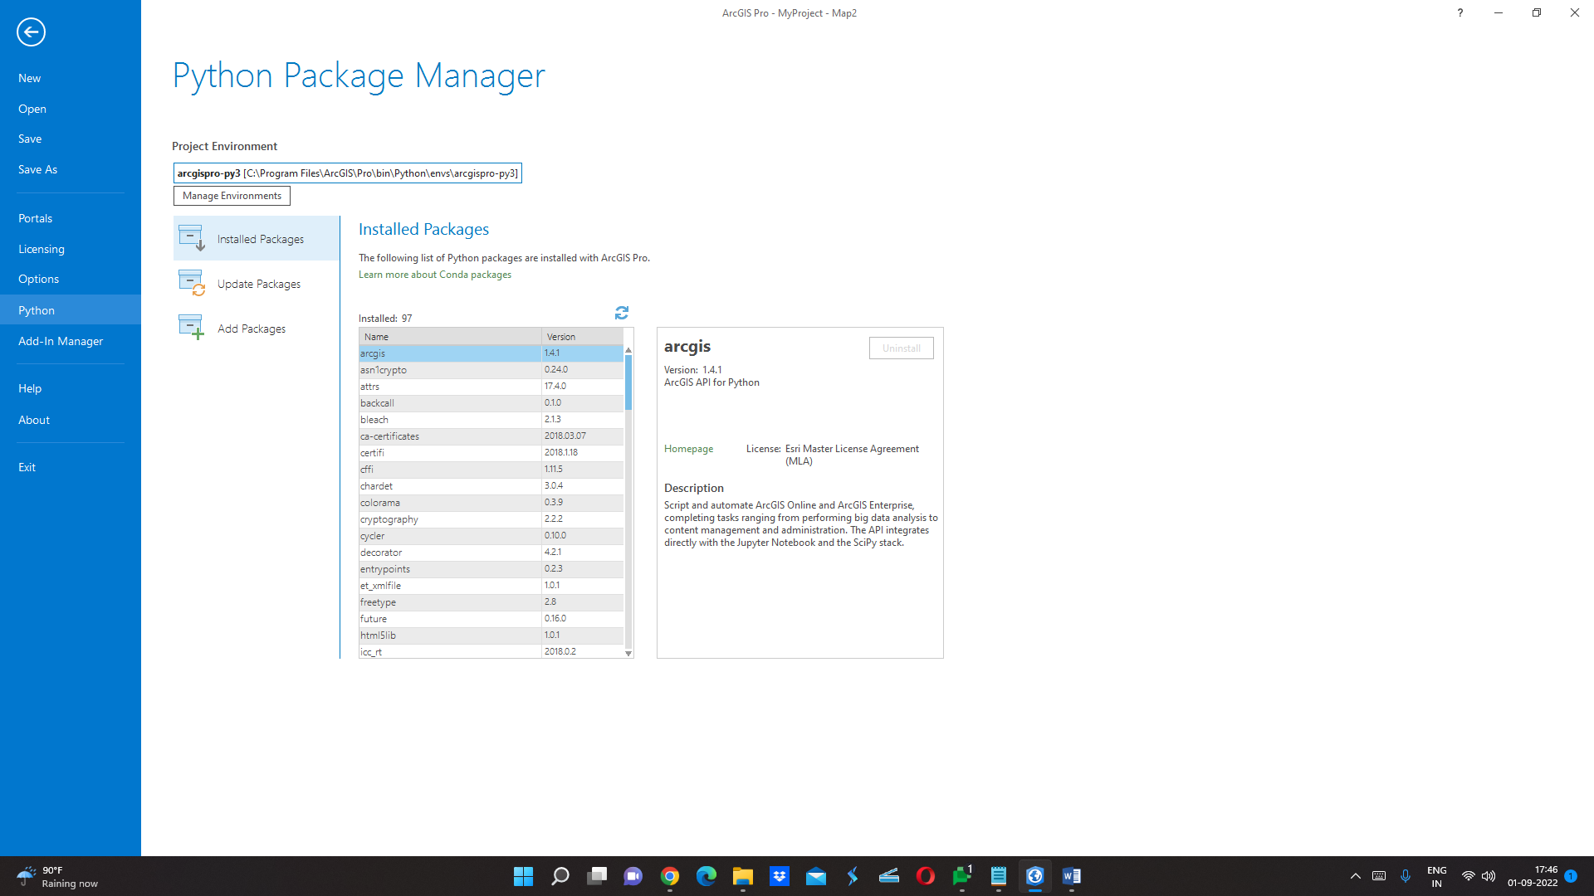

Step 3: Click on Add Packages, and search for Pillow, now in order to install the Pillow Python Package we must modify the default Python environment and need to create a clone to activate a new environment.

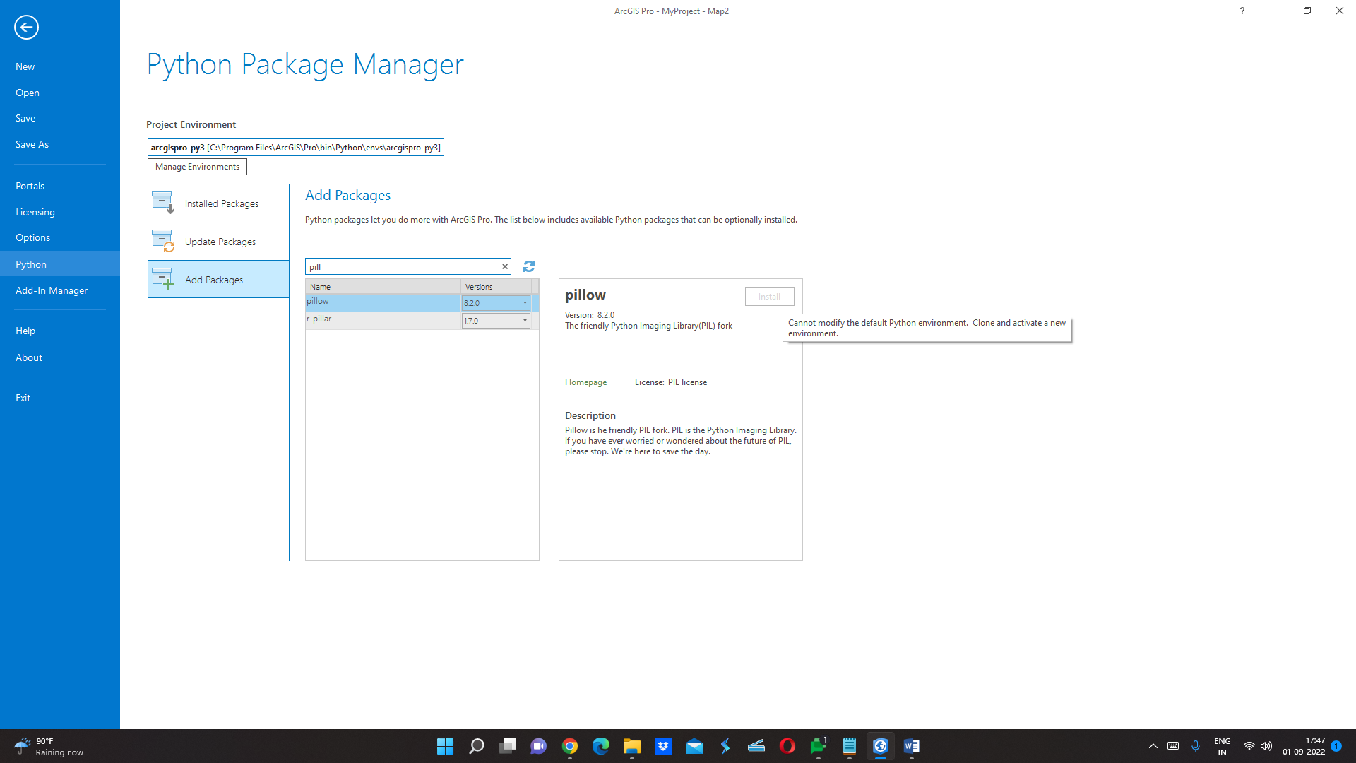

Step 4: Now click on Manage Environment and make a clone or a new Python Environment and click OK.

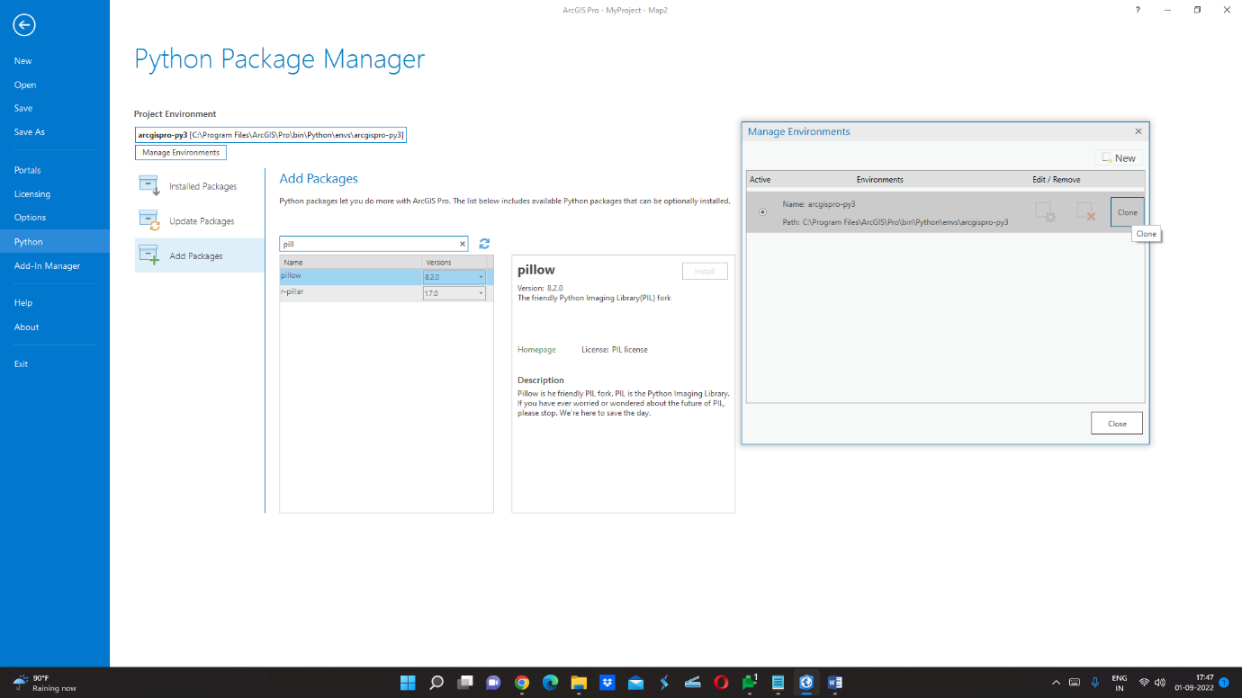

Step 5: Now install Pillow as the install link becomes active.

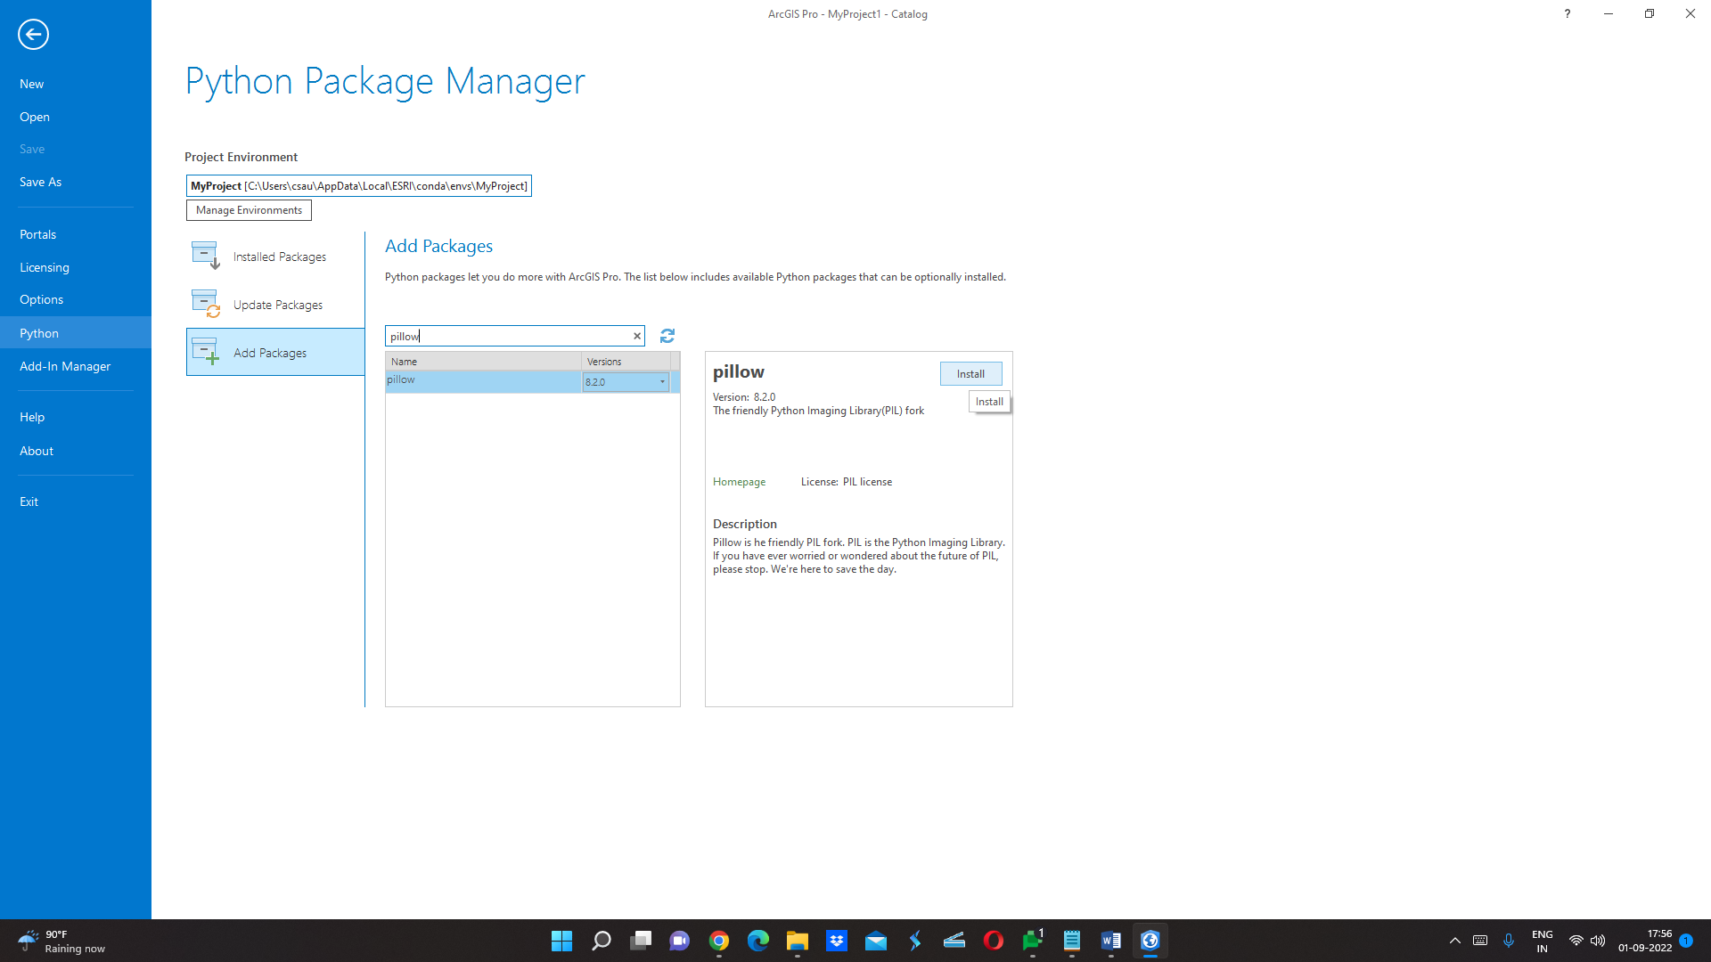

Step 6: Right-click on Toolboxes in Catalog Plane Panel, and click on New Toolbox

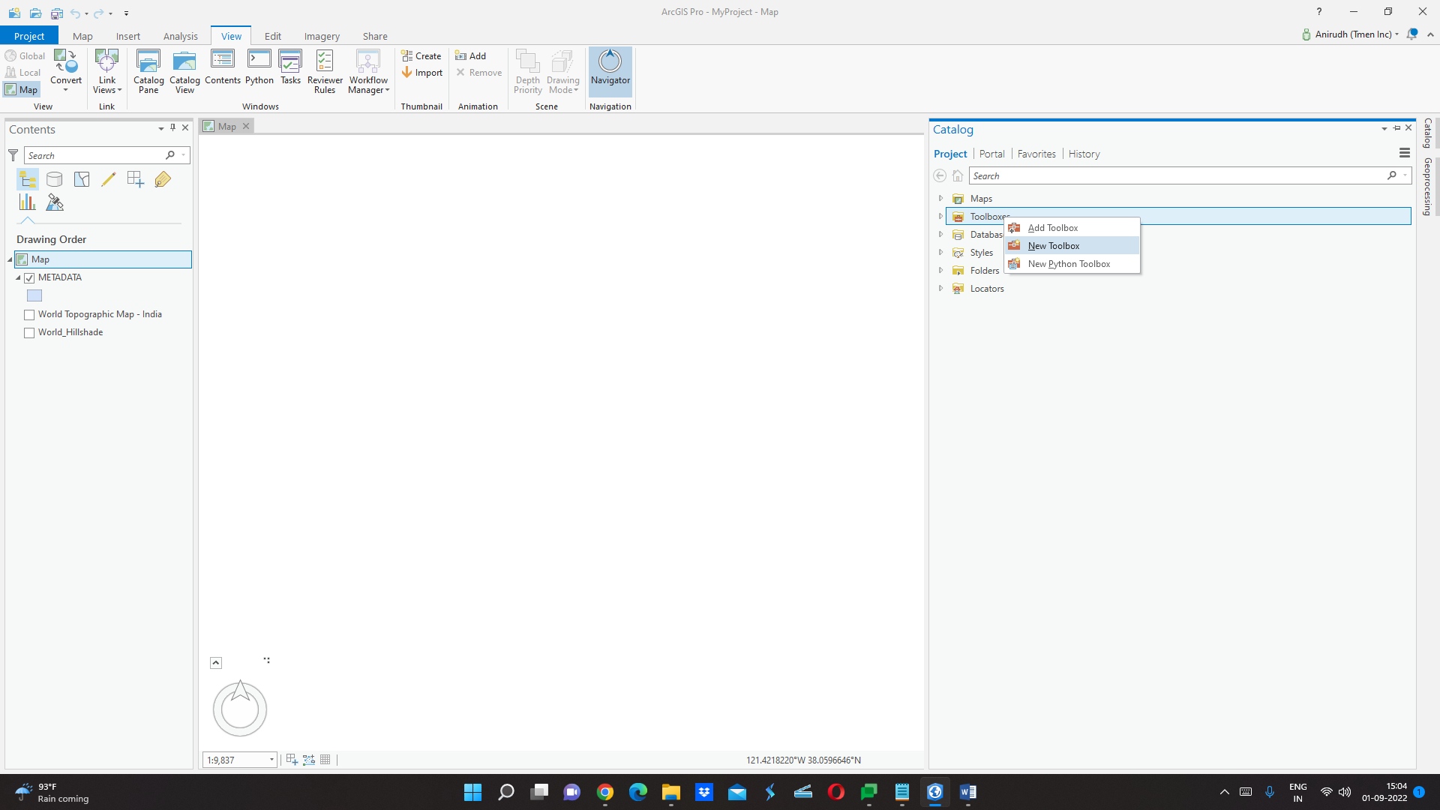

Step 7: Put the name of the Toolbox and browse the location to save it.

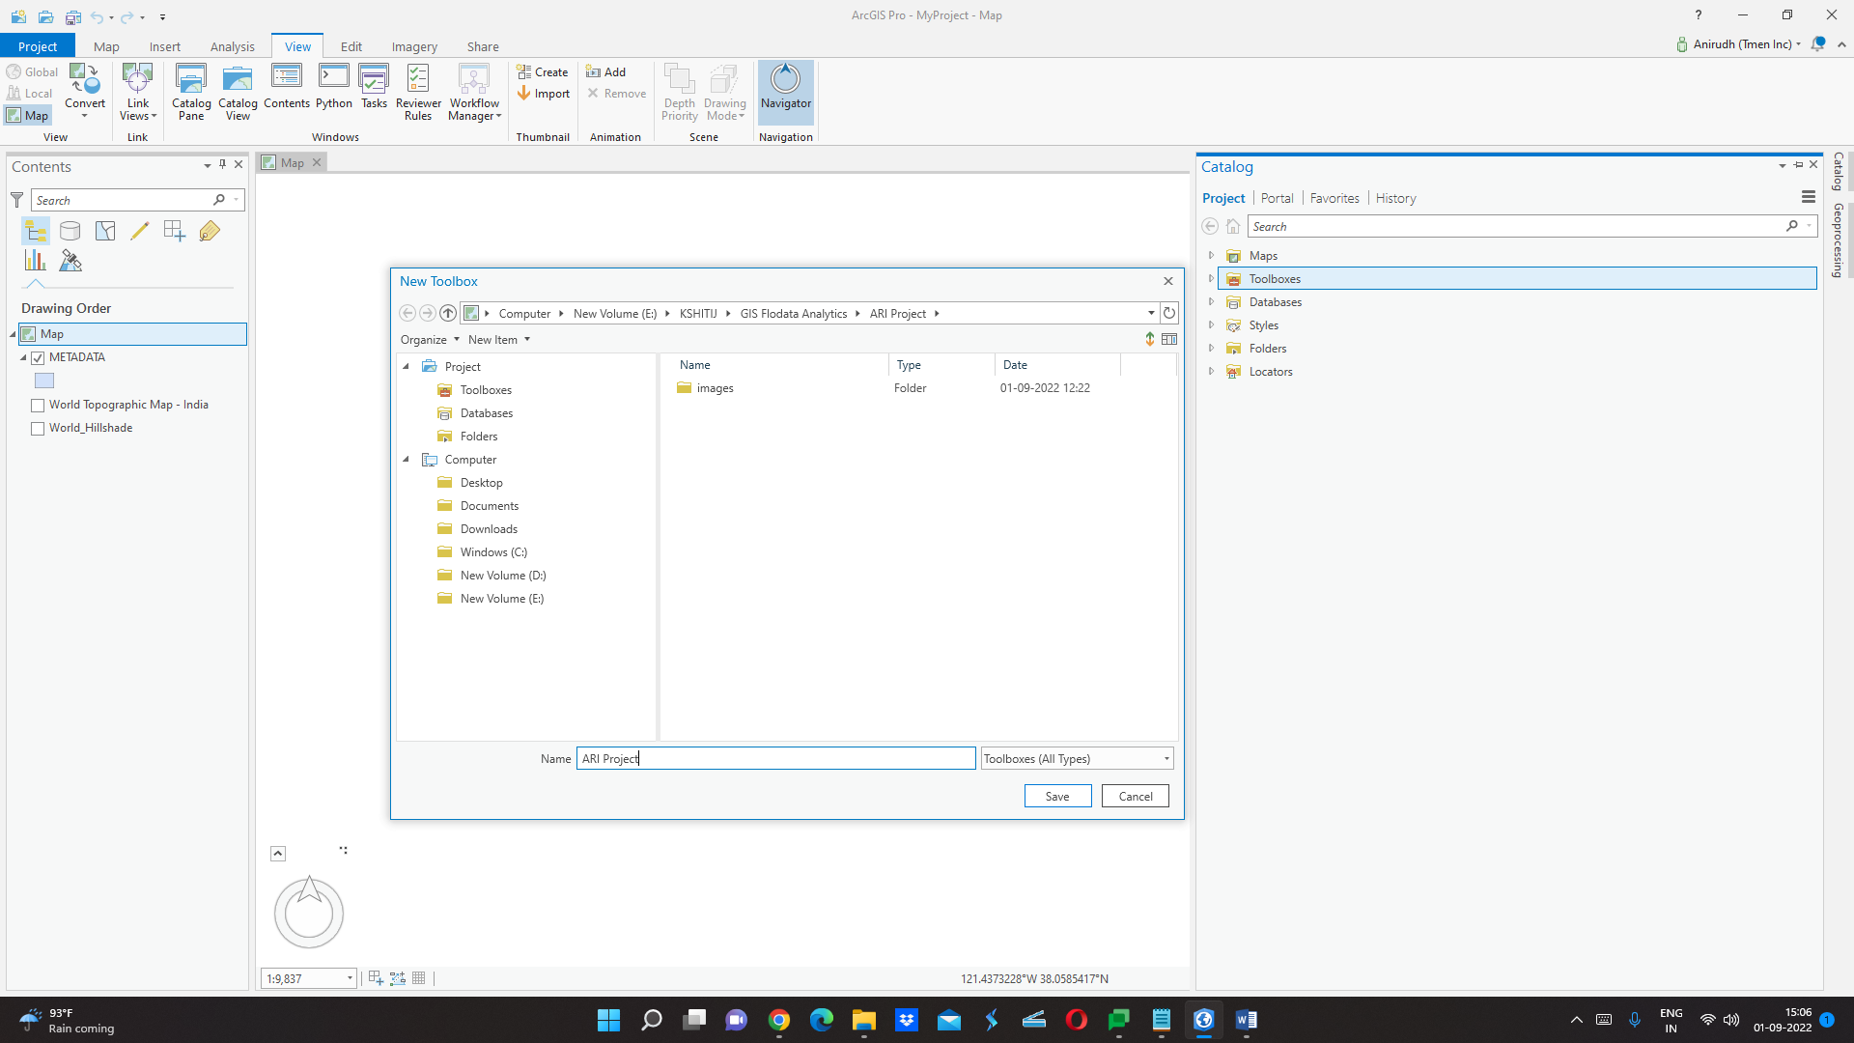

Step 8: Under the Toolboxes, (right-click on the toolbox you have created and click on new – Script).

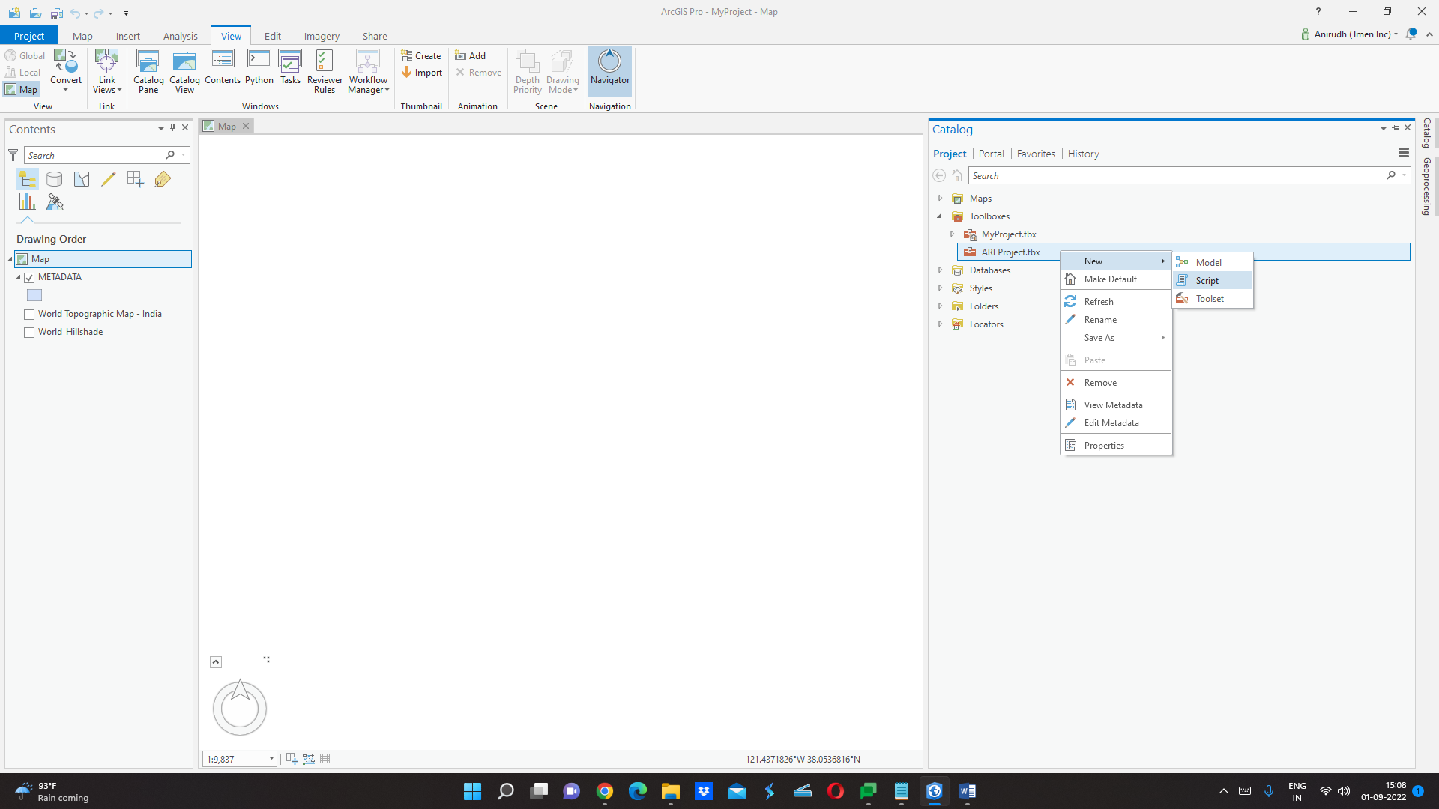

Step 9: A dialogue box will appear, put the name of the script tool *(Spaces are not allowed)*, Put the label of the script tool, and if you have already created the script, browse to the location of the script and select it.

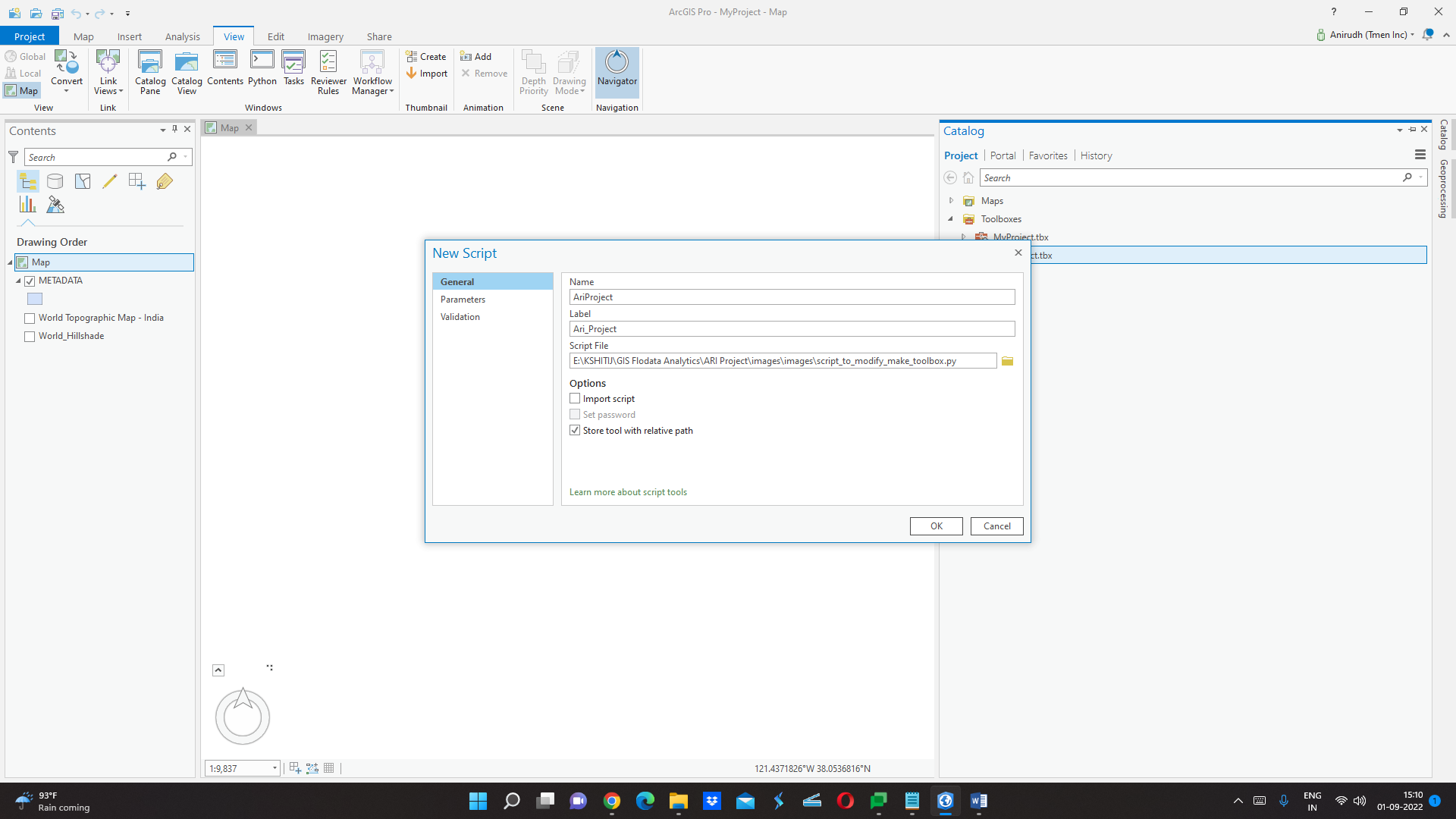

Step 10: Click on Parameters, put the file’s label, select the Parameter Data Type, (you can add multiple parameters), and click on OK.

*(Here we select the Input Shapefile, Direction Column Name - String Input and Path Column Name - String Input)*

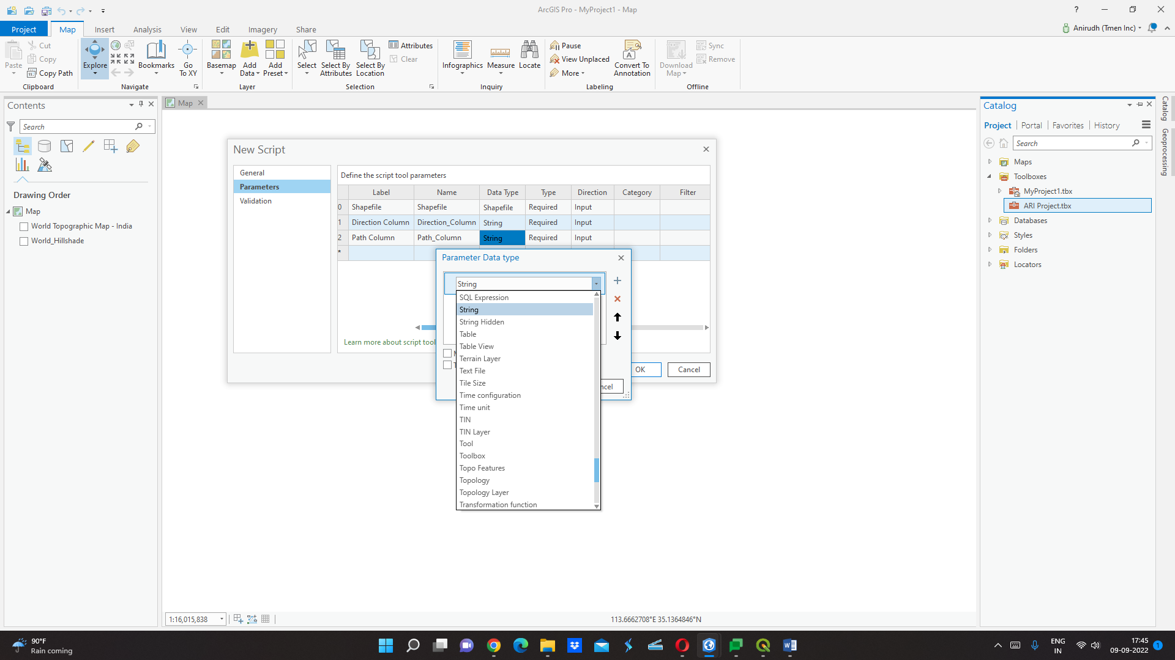

Step 11: Now Right click - open the script - then browse the file and click Run *(Bottom Right)*.

