Steps of analysis of data in RNA Seq

Initial conditions:

* Completion of RNA Seq data (including QC results)
* Creation of Phenoytpe file having sample / block / factor information

Workflow diagram:

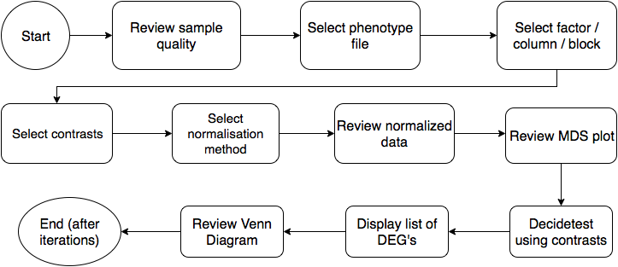

Description:

The RNA Seq portal provides a general pipeline for the analysis and visualization of RNA Seq data.

Home page

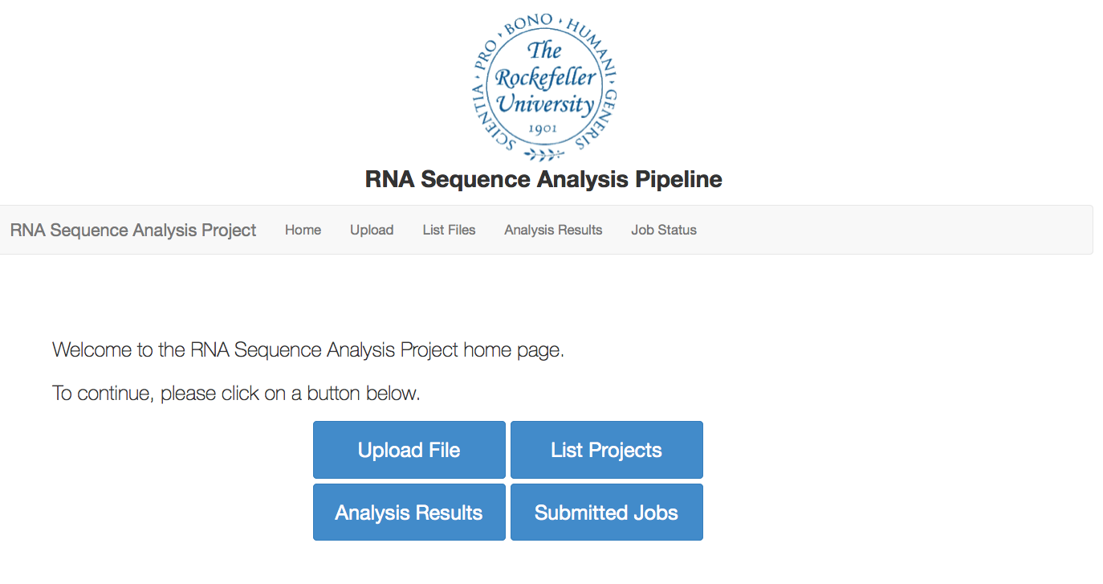

Functions:

*Upload File* allows the user to upload counts matrix files, which are the results of RNA Seq analysis.

*List Projects* allows the user to view the list of different projects