1. If the news vendor buys 100 newspapers, the long-term expected profit is 43.781.

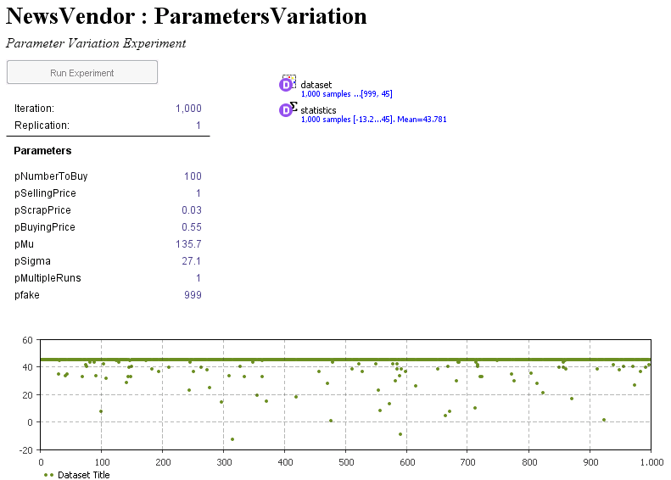

1. If the news vendor buys 200 newspapers, the long-term expected profit is 27.807.

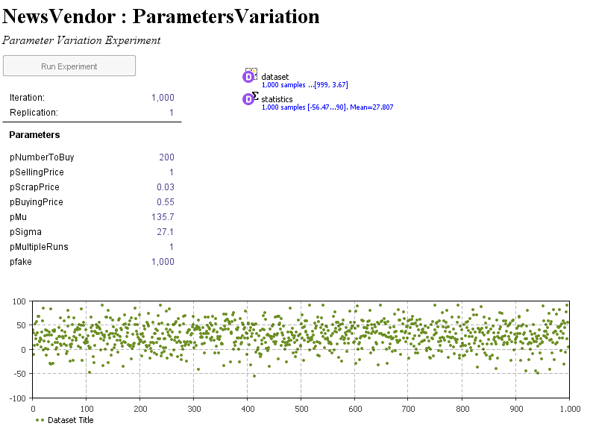

1. Long-term strategy is to buy 135 news papers.

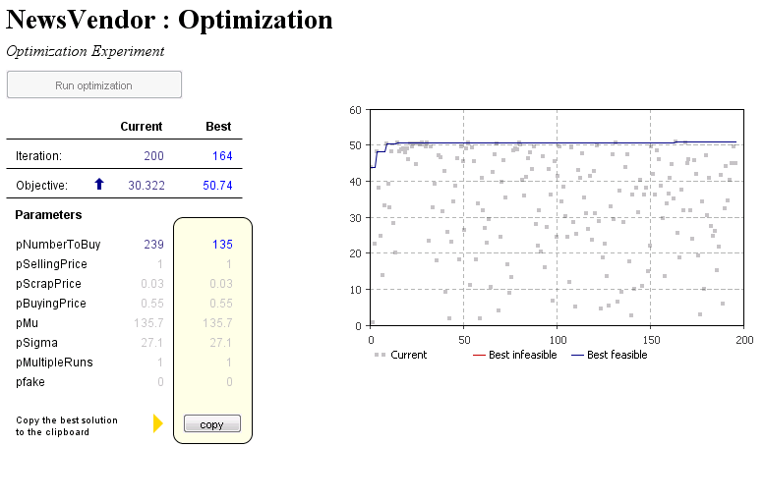

1. EOQ:

