Forward Data Lab Application: Asta vs. Google Scholar Evaluation and Workflow Analysis
Empirical Comparison on a 50-query FinTech Suite, and Asta Workflow Analysis

1. Asta vs. Google Scholar: Empirical Comparison

1.1 Evaluation Goal and Query Suite
The evaluation contrasts Asta Find Papers (Allen AI) with Google Scholar on a controlled FinTech query suite designed to expose the relative strengths of a retrieval-augmented agent and a traditional academic search engine. FinTech is chosen as the test domain because its literature spans both Computer Science venues (DeFi, fraud detection, smart contracts, LLM (Large Language Model)-driven trading) and Economics venues (credit risk, monetary policy, regulation, financial stability), giving the evaluator the prior domain knowledge needed to judge whether each surfaced result is on-topic without requiring external annotators for every query.
The suite contains 50 queries built from 25 curated FinTech papers spanning eight clusters: DeFi & Blockchain, Credit & Lending, Fraud Detection, Algorithmic Trading, CBDC (Central Bank Digital Currency) & Monetary Policy, RegTech, Insurtech & Risk, and Open Banking & Payments. For each curated paper the suite includes two queries (one phrased as the full paper title and one phrased as the three leading domain-tag keywords), and each query carries embedded ground-truth metadata (title, year, abstract, domain tags). Asta returns 12 to 75 candidates per query (median 73) via its internal mabool-demo.allen.ai API; Google Scholar returns up to 10 results via SerpAPI. Both engines are restricted to their Top-10 for symmetric comparison. Total collected: 500 Asta papers and 473 Google Scholar papers.

1.2 Seven-Metric Framework
Comparing a retrieval-augmented agent (Asta) to a lexical search engine (Google Scholar) on a single rubric collapses two structurally different systems into one number. The framework here keeps Google Scholar as the established baseline, assigned 1.0 wherever a ratio applies, and measures Asta's behavior along seven directly inspectable axes: five comparable across both engines and two Asta-only structural diagnostics.
Overlap (1). The fraction of Top-10 papers both engines return for the same query, computed by title fuzzy match at SequenceMatcher ratio at least 0.85. A symmetric measure that exposes how different the two engines' result sets are without privileging either.
Topical Hit Rate (2). The fraction of Top-10 papers whose title falls in the FinTech sub-area intended by the query. Each title is classified against an eight-cluster keyword dictionary of approximately 400 lowercase substrings, built from the curated paper domain pool and augmented with FinTech-specific vocabulary. The intended sub-area for each query is derived from its ground-truth domain tags.
Topical Breadth (3). The number of distinct FinTech sub-areas covered in the Top-10. Indicates whether the engine surfaces a narrow or broad slice of the query area.
Currency (4). The mean publication year of Top-10 papers and the distribution across four bands (2025+, 2023 to 2024, 2020 to 2022, pre-2020). Papers with missing year are excluded from the mean and reported separately.
Citation Influence (5). The mean log(citation_count + 1) across Top-10 papers. The log transformation handles the long-tailed citation distribution. The two engines source citation counts from different databases (Semantic Scholar for Asta, Google Scholar's own crawl), so the absolute comparison reflects database policy in addition to retrieval quality.
Evidence Depth (6, Asta-only). The distribution of sectionTitle values across Asta's surfaced snippets, revealing where in each paper Asta extracts its supporting evidence. Google Scholar exposes no equivalent attributed-snippet field, so this metric is structurally Asta-only and is reported as a capability gap rather than a numerical comparison.
Self-Confidence Calibration (7a, Asta-only) and Summary Concept Coverage (7b, Asta-only). Two diagnostics on Asta's LLM-generated outputs. Calibration measures the fraction of papers Asta labels Perfectly Relevant (relevance = 3) whose title falls in the query's intended sub-area cluster. Summary Concept Coverage measures the fraction of concept nouns in Asta's per-paper relevanceSummary that also appear in the paper's abstract.

1.3 Results
Table 1 reports the headline values across all 50 queries. Three figures embedded below visualize the most informative metrics.
Table 1.
Asta vs. Google Scholar across seven metrics on the 50-query FinTech suite (Top-10 per query). The Asta-vs-GS column gives the ratio with Google Scholar set to 1.0; for Currency, the lift is reported in years rather than as a ratio.
# | Metric | Asta | Google Scholar | Asta vs GS
1 | Overlap | — | — | 0.12 mean (20/50 queries with zero overlap)
2 | Topical Hit Rate | 0.65 | 0.80 | 0.81
3 | Topical Breadth (clusters / 8) | 1.52 | 1.30 | 1.17
4 | Currency, mean year | 2022.25 | 2022.07 | +0.18 years
5 | Citation Influence, mean log(c+1) † | 3.08 | 2.93 | 1.05
6 | Evidence Depth (Asta-only) | Abstract 9% / Intro 19% / Conclusion 8% / Other 64%* | n/a | structural capability gap
7a | Self-Confidence Calibration | 0.66 | n/a | Asta-only diagnostic
7b | Summary Concept Coverage | 0.49 | n/a | Asta-only diagnostic
* 'Other' aggregates paper-specific named subsections (results, methods, related work, or topical chapters) that do not match standard structural-section labels. † Citation Influence (Metric 5) draws counts from Semantic Scholar (Asta) and Google Scholar's own crawl (GS); the 1.05x Asta ratio therefore reflects retrieval quality together with database-policy differences and is interpreted as approximately tied (see Section 1.5).
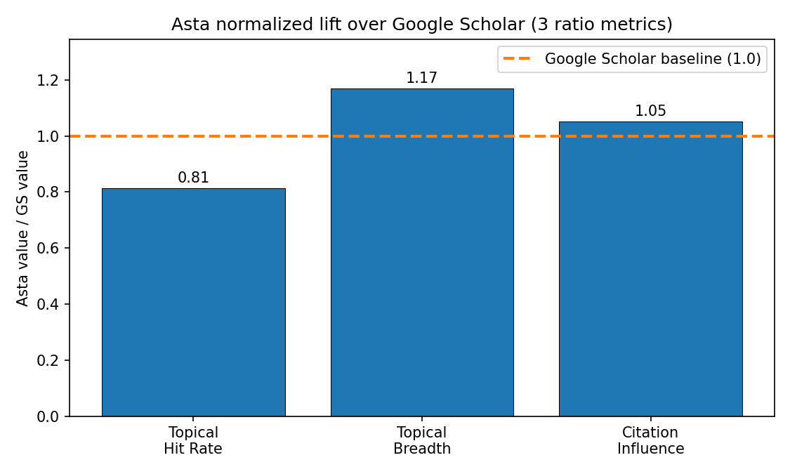
Figure 1. Asta normalized lift over Google Scholar on the three ratio metrics (Topical Hit Rate, Topical Breadth, Citation Influence). Google Scholar baseline at 1.0 is shown as the dashed horizontal line.
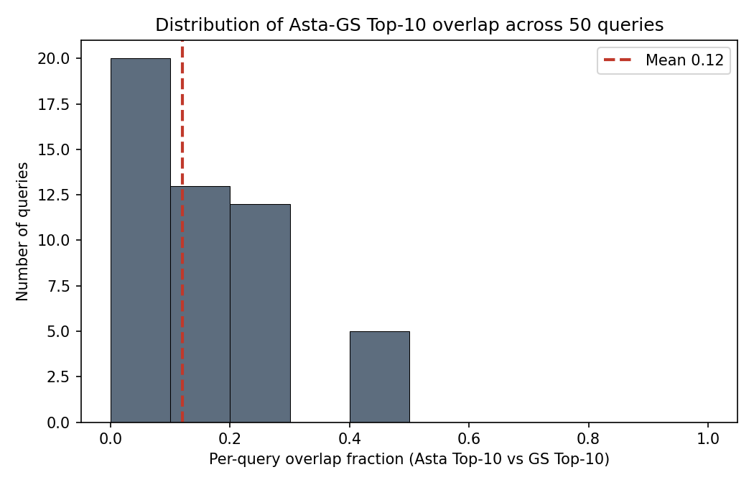
Figure 2. Distribution of per-query Top-10 overlap (Asta intersect Google Scholar by title fuzzy match). Mean overlap 0.12; 20 of 50 queries return entirely disjoint result sets.
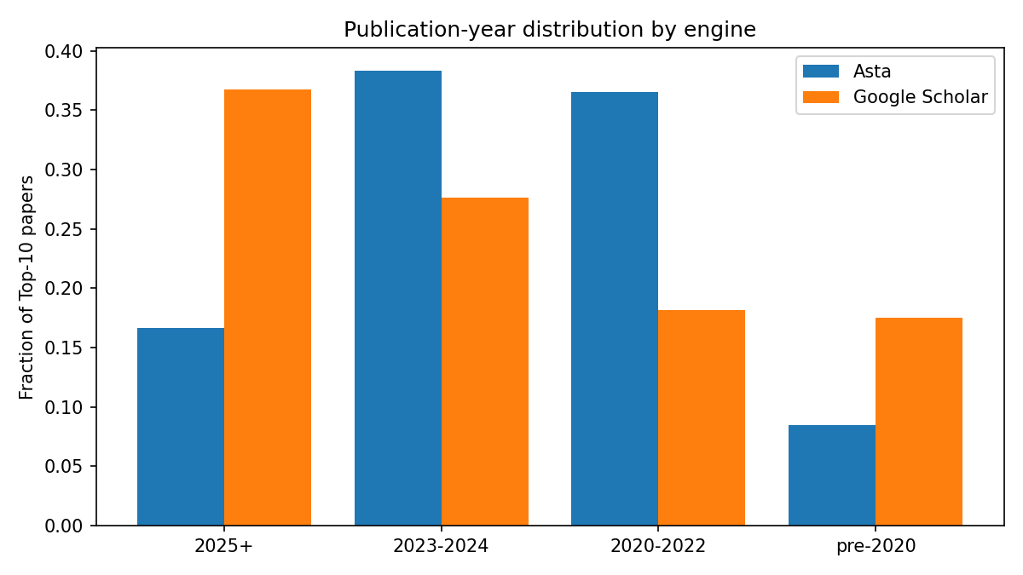
Figure 3. Publication-year band distribution. Mean years are essentially tied, but Google Scholar is bimodal (2025+ at 37% and pre-2020 at 17%) while Asta concentrates in the 2023 to 2024 band (38%).

1.4 Findings and Interpretation
The most striking finding is the very low Top-10 overlap (Figure 2). Across the 50 queries the two engines share an average of 1.2 papers in the Top-10, and in 40% of queries they share none. Asta and Google Scholar do not deliver the same bibliography in a different order; they deliver substantially different bibliographies. This is structurally expected, since Asta indexes the Semantic Scholar corpus while Google Scholar crawls a broader web of journal sites, preprint servers, and theses. The consequence is that the rest of the comparison is not between near-identical result sets but between two distinct retrieval policies operating over partially disjoint indices.
Google Scholar leads on Topical Hit Rate (0.80 against Asta's 0.65). The lead is the expected behavior of a lexical matcher confronted with keyword queries: a paper whose title contains DeFi, blockchain, and game theory is trivially returned for the query DeFi game theory blockchain. Asta's pipeline rephrases the query, expands citation neighborhoods over SPECTER-style embeddings [1], and runs LLM relevance judgment [2], producing results that are topically related but do not always carry the literal keyword string. Where 'on-topic' is operationalized as 'in the intended sub-cluster', the lexical engine wins. This advantage is partly an artifact of the keyword dictionary, which is derived from the same paper pool that defines ground truth and therefore rewards lexical matchers (see Section 1.5, limitation 1).
Asta leads on Topical Breadth (1.52 versus 1.30 unique sub-areas per Top-10, Figure 1) by approximately 17%, consistent with its semantic expansion across citation-graph neighborhoods. A paired t-test on the 50 per-query values places this difference at p = 0.055, marginal significance just outside the conventional 0.05 threshold. Citation Influence shows a small Asta advantage (mean log 3.08 against 2.93, approximately 21 versus 18 citations) that is not statistically significant on the 50-query sample (paired t-test p = 0.27); the engines are essentially tied on this axis, with the observed lift compatible with sampling noise and database asymmetry (Google Scholar's broader crawl typically reports higher numbers for the same paper, which would push GS upward and Asta downward in any apparent comparison). By contrast, the Topical Hit Rate gap reported above is highly significant (paired t-test p < 0.001), so the lexical-matching advantage of Google Scholar is robust to sampling variation while the Asta-leaning metrics are not.
Currency tells the most informative compound story (Figure 3). The mean publication year is essentially tied (Asta 2022.25, Google Scholar 2022.07), yet the underlying band distributions diverge sharply. Google Scholar pushes 37% of its Top-10 into the 2025+ band and 17% into pre-2020, producing a bimodal distribution of cutting-edge and foundational work. Asta concentrates 38% into the 2023 to 2024 band and only 17% into 2025+, consistent with a SPECTER-family embedding substrate [1] whose corpus refresh lag bounds the share of post-substrate-training papers. Reporting the mean year alone hides this structural difference; the band distribution is the more informative view.
Asta exposes one capability Google Scholar does not: per-paper evidence snippets with attributed section sources. Across 1,726 Asta snippets surfaced for Top-10 papers, only 9% are drawn from the paper's abstract; 19% come from Introduction sections, 8% from Conclusion, and the remaining 64% from named subsections specific to individual papers. Asta is therefore not paraphrasing abstracts; it is performing a deeper retrieval that reaches into the body of each paper to surface the passage most directly relevant to the query, a property a researcher needs in order to trust a surfaced evidence passage without opening the PDF.
The two Asta-only diagnostics together temper the picture. Self-Confidence Calibration sits at 0.66: of the 416 papers Asta labels Perfectly Relevant in its Top-10 set, only 276 fall in the cluster the query is asking about. Summary Concept Coverage sits at 0.49: roughly half of the noun-level concepts in Asta's per-paper relevanceSummary appear in the paper's abstract verbatim. Both numbers indicate non-trivial noise in Asta's LLM-generated layer (the relevance labels and the summary text), but the interpretation of each is constrained by the limitations listed in Section 1.5.
Taken together, the seven metrics describe Google Scholar as the stronger tool for lexically anchored known-item retrieval and recency monitoring, and Asta as the stronger tool for multi-disciplinary exploration and evidence-grounded reading. The two are best treated as complementary rather than substitutable. For the initial direction-setting stage of FinTech research, where the user does not yet know which sub-areas exist or which papers to read first, Asta's breadth and evidence depth are the more useful properties, with the caveat that its LLM-generated labels and summaries should be verified against the surfaced snippets rather than accepted at face value.

1.5 Limitations and Caveats
The seven metrics admit four substantive limitations that bound their interpretation.
First, the Topical Hit Rate (Metric 2) and Topical Breadth (Metric 3) depend on the eight-cluster keyword dictionary used to classify paper titles. The dictionary contains approximately 400 lowercase substrings drawn from the curated paper domain pool and augmented with FinTech-specific vocabulary. The classifier assigns 26% of Asta Top-10 titles to the 'other' bucket against only 13% for Google Scholar, indicating that Asta surfaces roughly twice as many papers whose titles fall outside the controlled vocabulary even when the paper is topically relevant (for example, 'Flash Boys 2.0: Frontrunning, Transaction Reordering, and Consensus Instability in Decentralized Exchanges' is squarely DeFi/MEV (Maximal Extractable Value) but matches no cluster keyword under the current spelling). This systematically depresses Asta's measured Hit Rate; the true on-topic rate is bounded above by the reported 0.65.
Second, the Citation Influence comparison (Metric 5) draws citation counts from two different databases. Asta exposes Semantic Scholar's conservative academic-citation count; Google Scholar reports its own broader crawl that includes more grey literature. The five-percent Asta lead therefore reflects a combination of retrieval quality and database policy, not retrieval quality alone. The qualitative direction is informative; the magnitude is approximate.
Third, the Self-Confidence Calibration rate of 0.66 (Metric 7a) is a lower bound on Asta's true judgment accuracy. The calibration check classifies each paper by title only, while the Asta LLM that issued the Perfectly Relevant label saw the paper's full abstract, extracted snippets, and per-criterion judgment metadata. Papers that are perfectly relevant on grounds the title does not signal, for example a general algorithmic-fairness paper that applies directly to the lending domain, are counted as misses by the title-only classifier. The 0.34 gap therefore conflates true overclaim with legitimate semantic relevance not visible in the title.
Fourth, the Summary Concept Coverage of 0.49 (Metric 7b) is not a hallucination rate. It is the fraction of concept nouns in Asta's relevanceSummary that also appear in the paper's abstract. The remaining 51% comprises three indistinguishable components: paraphrase of abstract concepts in different wording, concepts drawn from non-abstract portions of the paper that Asta legitimately read via the snippet pipeline, and any genuine inserted content. The current metric cannot disambiguate these three. A future iteration comparing the summary against the union of abstract and all surfaced snippets would isolate the genuine-insertion component.
The strict definitions of hallucination (sampling numerical claims from Asta's Generate Report mode and verifying against cited papers) and synthesis quality (a 1 to 10 rubric on report sectioning and cross-paper comparison) require Generate Report output not collected in this experiment. Both are noted as future work.

2. How Does Asta Find Papers Work Under the Hood?

2.1 System Overview
Asta (https://asta.allen.ai/chat) is an AI-powered scientific research assistant built by the Allen Institute for AI (Ai2). Its Find Papers mode draws on the Semantic Scholar corpus of over 100 million paper abstracts and over 10 million full-text papers. Architecturally, Asta instantiates Retrieval-Augmented Generation (RAG) [3], in which a language model first retrieves relevant documents from an external corpus and generates a response grounded in that evidence rather than relying solely on parametric knowledge. Asta extends the basic RAG paradigm through a multi-stage manually coded pipeline documented in the AstaBench paper [2] (Appendix F.3).
Because Asta's live deployment is not fully open-source, this analysis draws on three sources: the AstaBench paper [2]; the public asta-paper-finder GitHub repository; and Allen AI's official blog posts. Empirical corroboration of the resulting pipeline description against the 50-query FinTech suite is provided in Section 2.4. For the FinTech application context within which Asta is evaluated in Q1, Cook et al. [4] survey recent agentic-RAG designs and identify domain-specific retrieval and cross-encoder re-ranking challenges that frame the FinTech-side comparison points used here.

2.2 Pipeline Architecture and Component Analysis
Asta Paper Finder is a pipeline of manually coded components with LLM calls at key decision points [2]. This design was preferred over granting the LLM full execution autonomy because it reduces LLM call count, enables parallelization, and improves reliability. The top-level flow is: Query Analyser to Execution Planner to Sub-Workflow (retrieval, expansion, relevance judgment) to Final Ranker. The Execution Planner internally distinguishes three query types: navigational (specific known-paper lookup, routed to direct title-based search), metadata (structured-criteria filtering, routed to Semantic Scholar API filter parameters), and semantic (content-description retrieval, routed to the multi-component sub-workflow detailed below). The remainder of this section traces the semantic sub-workflow within Find Papers mode (Components 1 through 5); the navigational and metadata routes share the Query Analyser (Component 1) and Final Ranker (Component 4) but skip the semantic-specific retrieval and relevance-judgment stages. Component 6 describes the separate Generate Report mode.
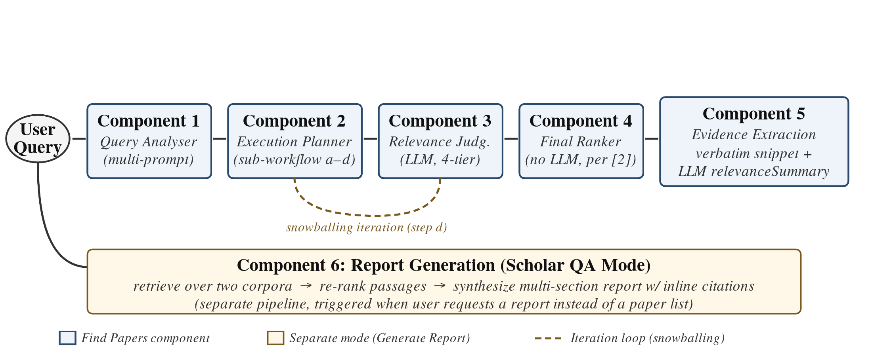
Figure 4. Asta Paper Finder workflow. Components 1 to 5 (blue) form the Find Papers semantic pipeline; the dashed orange loop indicates iterative citation snowballing within Component 2 step (d). Component 6 (orange) is a separate Generate Report mode triggered by the same user query.
Component 1: Query Analyser
The Query Analyser runs several short LLM prompts, each extracting a different property subset from the raw query [2]. Extracted properties include: query type (navigational vs. semantic), semantic criteria string, multiple sub-criteria with importance scores, metadata constraints (year, author, venue), and modifiers such as "recent", "classic", or "highly cited". The closest academic technique is HyDE (Hypothetical Document Embeddings) [5], in which an LLM generates a hypothetical answer document whose dense vector embedding is used to retrieve real documents by nearest-neighbour search. HyDE outperforms the unsupervised retriever Contriever and approaches fine-tuned retrieval performance across web search, QA, and fact verification. Asta diverges from HyDE in that it decomposes the query into typed structured fields rather than generating a single unstructured document, enabling explicit handling of metadata constraints that HyDE's vector-only approach cannot express.
Component 2: Execution Planner and Semantic Sub-Workflow
The Execution Planner routes the structured query to a type-specific sub-workflow [2]. For semantic queries, the pipeline (a) rephrases the semantic criteria into k variants and submits all k+1 queries in parallel to Semantic Scholar's vector search API, (b) aggregates returned snippets per paper across all queries, (c) adds papers cited within retrieved snippets as additional candidates (cited-paper expansion), and (d) performs forward and backward citation snowballing on top-ranked candidates after Relevance Judgment, then formulates additional queries from the most relevant papers whose embeddings are furthest from the original query, repeating iteratively until a quality threshold or call budget is reached [2]. The underlying document-level retrieval model is SPECTER [1] (extended as SPECTER2 in current Semantic Scholar deployments), a Transformer pretrained via triplet-loss on citation pairs (paper A cites paper B as positive, random paper C as negative), producing document-level embeddings that encode genuine academic relatedness. SPECTER outperforms SciBERT on the SCIDOCS benchmark across citation prediction, classification, and recommendation without task-specific fine-tuning. Asta's layering of multi-query parallelism, cited-paper expansion, and iterative snowballing on top of SPECTER's embedding substrate has, to our knowledge, no single-paper precedent we identified in the dense retrieval literature, although citation snowballing as a research methodology is itself a long-established systematic-review technique.
Component 3: Relevance Judgment
Each candidate paper is judged independently by an LLM against the sub-criteria from Component 1, producing a four-tier categorical label: perfectly relevant, highly relevant, somewhat relevant, or not-relevant [2]. This adapts the LLM-as-a-Judge paradigm of Zheng et al. [6], who demonstrate that strong LLMs achieve over 80% agreement with human expert raters on quality assessment tasks. Zheng et al. identify four failure modes: position bias, verbosity bias, self-enhancement bias, and limited reasoning ability. Asta's per-sub-criterion decomposition of the relevance prompt is an Asta-specific addition that allows the system to express partial relevance; it is absent from the original LLM-as-a-Judge framework.
Component 4: Final Ranker
Per [2], the re-ranking step uses a formula that combines the semantic relevance score from Component 3 with metadata criteria such as publication date and citation count, with query modifiers (e.g., 'recent', 'classic', 'central') shifting the weights between semantic and metadata terms. [2] does not describe an LLM call at this stage, in contrast to its explicit treatment of LLM use at upstream stages (query analysis, semantic reformulation, relevance judgment). The closest academic techniques are RankGPT [7] and Rank-K [8]. Sun et al. demonstrate that instructed LLMs can produce listwise ranked permutations of candidate sets, outperforming supervised models on TREC, BEIR, and Mr. TyDi without dedicated ranking training. Yang et al. extend this with test-time reasoning, achieving a 23% improvement over the prior best listwise reranker RankZephyr on a BM25 first stage (19% on SPLADE-v3). Asta's formula-based ranker diverges from both: based on [2], it appears to rely on a deterministic combination of signals rather than LLM listwise ranking, trading potential implicit-signal learning for speed and consistency.
Component 5: Evidence Extraction
Each ranked result is presented with two complementary outputs: a verbatim retrieved snippet as an attributed evidence passage, and a short LLM-generated relevanceSummary describing why the paper matches the query. The verbatim snippet is retrieval-driven (maximizing faithfulness), while the summary is generation-driven (whose grounding to the underlying paper is quantified by Summary Concept Coverage = 0.49 in Section 1.4). The ALCE benchmark [9] formalizes a different design point in which the generation step itself emits inline citations as part of free-form text, evaluated by citation recall and citation precision. Asta keeps the two layers separated rather than fusing them into a single citation-annotated generated text.
Component 6: Report Generation (Scholar QA Mode)
In Generate a Report mode, Asta routes to the Scholar QA component: retrieve over two corpora, re-rank passages, then synthesize a multi-section report with inline citations [2]. The analogous framework is Self-RAG [10], which trains a single LLM to emit four reflection tokens during inference: Retrieve (should retrieval occur here?), ISREL (is the retrieved passage relevant?), ISSUP (is the generated claim supported by the passage?), and ISUSE (is the response useful overall?). Self-RAG integrates retrieval and generation decisions within one model; Asta's Scholar QA uses separate modular components, trading tight retrieval-generation coupling for independent replaceability of each component.

2.3 Summary: Asta vs. Academic References
Table 2 consolidates the component-level analysis. For each component it lists the closest academic reference and the key architectural difference, directly addressing the Q2 question of how Asta's solutions differ from those studied in the literature.
Table 2.
Asta Paper Finder components, closest academic references, and key architectural differences.
# | Component | Closest Academic Reference | Key Architectural Difference
0 | Overall Paradigm (RAG) | [3] Lewis et al.: single-pass RAG | Asta extends base RAG with iterative citation expansion and structured query decomposition. Base RAG retrieves once.
1 | Query Analyser | [5] Gao et al. (HyDE): one hypothetical document | Asta decomposes into typed fields and generates multiple rephrasings. HyDE generates a single unstructured vector; Asta handles metadata constraints explicitly.
2 | Execution Planner / Semantic Sub-Workflow | [1] Cohan et al.: SPECTER citation-graph embeddings | SPECTER provides the embedding substrate. Asta adds multi-query parallelism, cited-paper expansion, and iterative snowballing. No single paper proposes this full combination.
3 | Relevance Judgment | [6] Zheng et al.: LLM-as-a-Judge (80%+ agreement; four failure modes) | Asta applies LLM judgment to document relevance against structured sub-criteria. Per-criterion decomposition is Asta-specific and absent from the original framework.
4 | Final Ranker | [7] Sun et al.: RankGPT listwise LLM ranking / [8] Yang et al.: Rank-K +23%/+19% | Asta uses a formula combining relevance tier, date, citation count, and query modifiers, with no LLM call described at this stage [2]. RankGPT and Rank-K learn implicit ranking signals via LLM reasoning.
5 | Evidence Extraction | [9] Gao et al.: ALCE retrieve-then-generate with inline citations | Asta surfaces a verbatim retrieved snippet alongside a short LLM-generated relevanceSummary, keeping retrieval (snippet) and generation (summary) as separate layers. ALCE-style systems instead fuse the two into a single citation-annotated generated text.
6 | Report Generation (Scholar QA) | [10] Asai et al.: Self-RAG with four reflection tokens (Retrieve, ISREL, ISSUP, ISUSE) | Asta uses modular separate components (retrieve, re-rank, synthesize). Self-RAG integrates retrieval decisions into the LLM generation via reflection tokens; tighter coupling, harder to modularise.

2.4 Empirical Validation via Section 1 Evidence
Empirical validation of the architectural differences summarized in Table 2 is provided by the 50-query FinTech suite analyzed in Section 1. The 0.12 mean Top-10 overlap and the 40% of queries that share no result confirm that Asta and Google Scholar implement structurally different retrieval strategies, consistent with Table 2 entries for Components 1 (Query Analyser with multi-rephrasing) and 2 (multi-query parallelism and citation-graph expansion over SPECTER). The 1.17x lift on Topical Breadth (1.52 versus 1.30 unique sub-areas per Top-10, paired t-test p = 0.055) is consistent with the behavioral signature of semantic expansion across citation-graph neighborhoods (Component 2 of Table 2). The bimodal Currency profile of Google Scholar (37% from 2025+, 17% pre-2020) against Asta's mid-band concentration (38% from 2023 to 2024) is consistent with two architectural factors: the Semantic Scholar embedding substrate (Component 2 of Table 2), whose corpus refresh lag bounds the share of 2025+ papers, and the deterministic Final Ranker (Component 4 of Table 2), which weights relevance tier and citation count alongside publication date. The Asta-only Evidence Depth distribution, in which only 9% of surfaced snippets are drawn from abstracts, is consistent with the snippet display described in Component 5 of Table 2 (verbatim retrieval-driven attribution, separate from the LLM-generated summary layer). The 50-query bulk evidence therefore corroborates the component-level differences inferred from documentation and code review.
3. Cluster-Aware Visualization of Asta Paper Finder Results

3.1 Selected Task from Asta Workflow
From the Asta workflow components analysed in Section 2 (Figure 4, Table 2), the selected task is Asta Find Papers’ user-facing report and result presentation stage, where Asta delivers its retrieved, ranked, and relevance-judged paper set to the user. In Asta’s current workflow this output is presented mainly as a ranked list. Following the brief’s allowance to propose changes, the implementation described here does not modify Asta’s internal retrieval, ranking, or relevance-judgment pipeline; it adds a separate consumer-side layer on top of Asta’s existing output.

3.2 Task Definition
In the current Find Papers interface, Asta presents the analyzed paper set primarily as a ranked list, similar to a traditional academic search results page, while also adding Asta-specific information such as relevance judgments, tier badges, and per-paper rationale.
Input (from upstream): 50 to 100 papers with basic metadata (title, abstract, snippets, authors, citation count) plus Asta-specific LLM-generated annotations (a relevance judgement with a numeric score and per-criterion natural-language summaries).
Output (to user): an embedded paper-list widget in the chat thread, paginated in rank order. Each row shows title, authors, year, citation count, a tier badge (“perfectly/highly/somewhat relevant”), and the LLM-generated rationale on a click-to-expand handle.

3.3 Why This Task Is Important
Report Generation is Asta’s only touchpoint with the user. Section 1 showed that Asta’s strengths over Google Scholar (per-paper relevance rationale, tier judgements, currency-balanced ranking) are precisely the artefacts produced here. What the user ultimately receives and acts on is the final report, so this stage determines whether Asta’s upstream advantage reaches the user in a usable form.

3.4 Why This Task Is Challenging
Designing this stage well across queries is hard for reasons inherent to the problem.
Result sets vary in size from a handful of papers to over a hundred, and a UI that suits one extreme often fails the other. User intent varies too: the same 70-paper result might serve a quick fact-check, a deep read of one paper, or a full survey, none of which a single linear ranking satisfies equally. The 50 to 100 range is itself an uncomfortable middle ground, too many to read individually but too few to summarise without loss. Ranking is a one-dimensional projection, so sub-topical structure (method, era, application domain) collapses onto a single axis. Per-paper LLM rationale helps individual reading but adds load when shown in bulk, so when and at what granularity to expose it is itself a design problem.

3.5 State of the Art
The dominant approach for delivering analyzed search results in academic search is the paginated ranked list: Google Scholar, Semantic Scholar, Web of Science, You.com Pro Search, and Asta itself all use this format. State-of-the-art work differs primarily in the ranking component, not the presentation: BM25, learning-to-rank, citation-aware re-ranking, and most recently LLM-as-judge approaches (which Asta exemplifies) have advanced ranking quality while keeping the list-based output unchanged.
This format suits a uniform metadata view (title, year, snippet, citation count) but does not naturally surface deeper analyzed content when the upstream pipeline produces it. Asta is in this position: its LLM-generated per-paper relevance summaries and per-criterion judgements are richer than the metadata fields a list row is built around, but those signals end up behind click-to-expand handles in the same linear order. The present work uses Asta’s richer signals as direct input to a cluster-aware view rather than as supplementary metadata.

3.6 Implementation Plan and Our Q3
The prototype is a Chrome MV3 extension on asta.allen.ai/chat. It does not modify Asta; it captures Asta’s paper payload and runs an in-browser clustering pipeline on top, rendered as a radial mind map in a popup window.
Capture. After each search Asta’s web client fetches mabool-demo.allen.ai/api/2/rounds/{rid}/result/widget, which returns the judged paper set with full metadata plus Asta’s LLM-generated relevance judgement (numeric score and per-criterion summaries). The extension reads the round ID from Asta’s ui_state telemetry and re-fetches this endpoint in the page context, giving the clustering pipeline the same payload Asta’s own UI consumes.
Clustering. The pipeline uses classical TF-IDF over noun and adjective concepts (POS-filtered, suffix-lemmatised, normalised by a small academic-domain thesaurus). Three signal-strengthening steps address the homogeneous-result-set problem from Section 3.4:
1. Title concepts are weighted twice, so the denser topical signal in titles outweighs the noisier abstract.
2. Concepts derived from the query string are removed from every paper. For a “sorting algorithms” query, this drops “sort” and “algorithm” from every paper so they cannot dominate the clustering.
3. Concepts appearing in over 70 percent of the result set are dropped automatically, catching near-universal terms the query did not mention.
Clusters come from k-means on L2-normalised TF-IDF vectors with a deterministic k-means++ initialisation. Labels come from c-TF-IDF with a minimum-presence floor: a candidate must appear in at least 25 percent of cluster members, preventing outlier vocabulary from being elevated as the cluster label. Classical TF-IDF and k-means are used rather than embedding-based methods (BERTopic, Top2Vec) because Asta’s per-criterion summary text is itself LLM-generated and topically dense, substituting for SBERT-style embeddings while keeping the pipeline entirely in the browser.
Future work. The most impactful next step is LLM-based cluster naming. Other directions: bigram and noun-phrase concept extraction, explicit weighting of criteria summaries in clustering input, recursive sub-clustering for very large clusters, and a citation-graph overlay from Semantic Scholar’s open API.
References
[1] Cohan, Arman, Sergey Feldman, Iz Beltagy, Doug Downey, and Daniel S. Weld. "SPECTER: Document-level Representation Learning using Citation-informed Transformers." In Proceedings of the 58th Annual Meeting of the Association for Computational Linguistics (ACL 2020), 2270–2282. https://arxiv.org/abs/2004.07180.
[2] Bragg, Jonathan, Mike D'Arcy, Nishant Balepur, Dan Bareket, Bhavana Dalvi, Sergey Feldman, et al. "AstaBench: Rigorous Benchmarking of AI Agents with a Scientific Research Suite." ICLR 2026 (Oral). arXiv:2510.21652. https://arxiv.org/abs/2510.21652. Named-component and parallel-prompt details additionally draw on: Allen Institute for AI, "Introducing Ai2 Paper Finder," March 26, 2025, https://allenai.org/blog/paper-finder.
[3] Lewis, Patrick, Ethan Perez, Aleksandra Piktus, Fabio Petroni, Vladimir Karpukhin, Naman Goyal, Heinrich Küttler, Mike Lewis, Wen-tau Yih, Tim Rocktäschel, Sebastian Riedel, and Douwe Kiela. "Retrieval-Augmented Generation for Knowledge-Intensive NLP Tasks." Advances in Neural Information Processing Systems 33 (NeurIPS 2020): 9459–9474. https://arxiv.org/abs/2005.11401.
[4] Cook, Thomas, Richard Osuagwu, Liman Tsatiashvili, Vrynsia Vrynsia, Koustav Ghosal, Maraim Masoud, and Riccardo Mattivi. "Retrieval Augmented Generation (RAG) for Fintech: Agentic Design and Evaluation." arXiv:2510.25518 (2025). https://arxiv.org/abs/2510.25518.
[5] Gao, Luyu, Xueguang Ma, Jimmy Lin, and Jamie Callan. "Precise Zero-Shot Dense Retrieval without Relevance Labels." In Proceedings of the 61st Annual Meeting of the Association for Computational Linguistics (ACL 2023), 1762–1777. https://arxiv.org/abs/2212.10496.
[6] Zheng, Lianmin, Wei-Lin Chiang, Ying Sheng, Siyuan Zhuang, Zhanghao Wu, Yonghao Zhuang, Zi Lin, Zhuohan Li, Dacheng Li, Eric P. Xing, Hao Zhang, Joseph E. Gonzalez, and Ion Stoica. "Judging LLM-as-a-Judge with MT-Bench and Chatbot Arena." Advances in Neural Information Processing Systems 36 (NeurIPS 2023, Datasets and Benchmarks Track). https://arxiv.org/abs/2306.05685.
[7] Sun, Weiwei, Lingyong Yan, Xinyu Ma, Shuaiqiang Wang, Pengjie Ren, Zhumin Chen, Dawei Yin, and Zhaochun Ren. "Is ChatGPT Good at Search? Investigating Large Language Models as Re-Ranking Agents." In Proceedings of the 2023 Conference on Empirical Methods in Natural Language Processing (EMNLP 2023, Outstanding Paper), 14918–14937. https://arxiv.org/abs/2304.09542.
[8] Yang, Eugene, Andrew Yates, Kathryn Ricci, Orion Weller, Vivek Chari, Benjamin Van Durme, and Dawn Lawrie. "Rank-K: Test-Time Reasoning for Listwise Reranking." arXiv:2505.14432 (2025). https://arxiv.org/abs/2505.14432.
[9] Gao, Tianyu, Howard Yen, Jiatong Yu, and Danqi Chen. "Enabling Large Language Models to Generate Text with Citations." In Proceedings of the 2023 Conference on Empirical Methods in Natural Language Processing (EMNLP 2023), 6465–6488. https://arxiv.org/abs/2305.14627.
[10] Asai, Akari, Zeqiu Wu, Yizhong Wang, Avirup Sil, and Hannaneh Hajishirzi. "Self-RAG: Learning to Retrieve, Generate, and Critique through Self-Reflection." International Conference on Learning Representations (ICLR 2024, Oral). https://arxiv.org/abs/2310.11511.

