//c program to find the largest number //

#include<stdio.h>

int main()

{

int a,b,c;

printf("Enter the number:\n");

scanf("%d%d%d",&a,&b,&c);

if((a>b)&&(a>c))

{

printf("A is largest number");

}

else if((b>a)&&(b>c))

{

printf("B is largest number");

}

else

{

printf("C is largest number");

}

return 0;

}

Output:

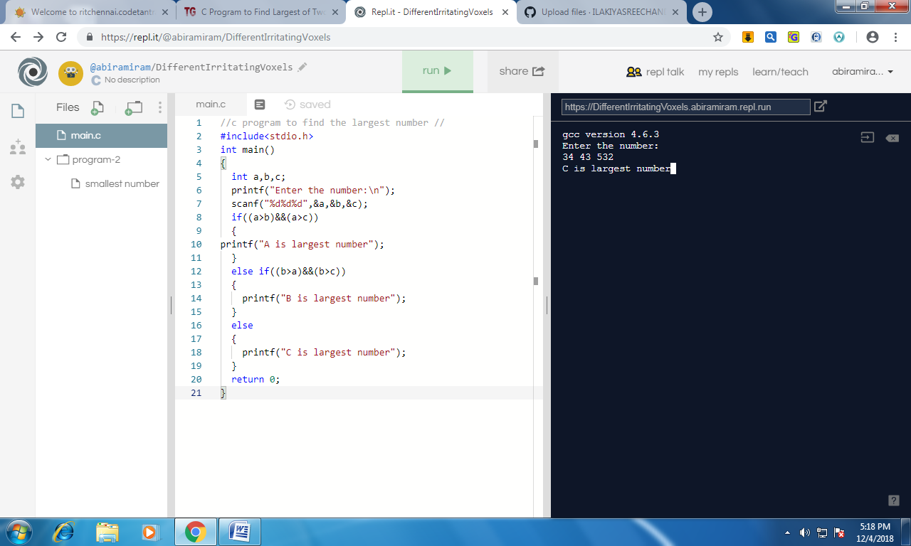

//c program to find smallest number using nested if//

#include<stdio.h>

void main()

{

int a,b,c;

printf("enter the number:\n");

scanf("%d%d%d",&a,&b,&c);

if((a<b)&&(a<c))

{

printf("A is the smallest number");

}

else{

if(c<b)

{

printf("C is smallest number");

}

else{

printf("B is smallest number");

}

}

}

Output:

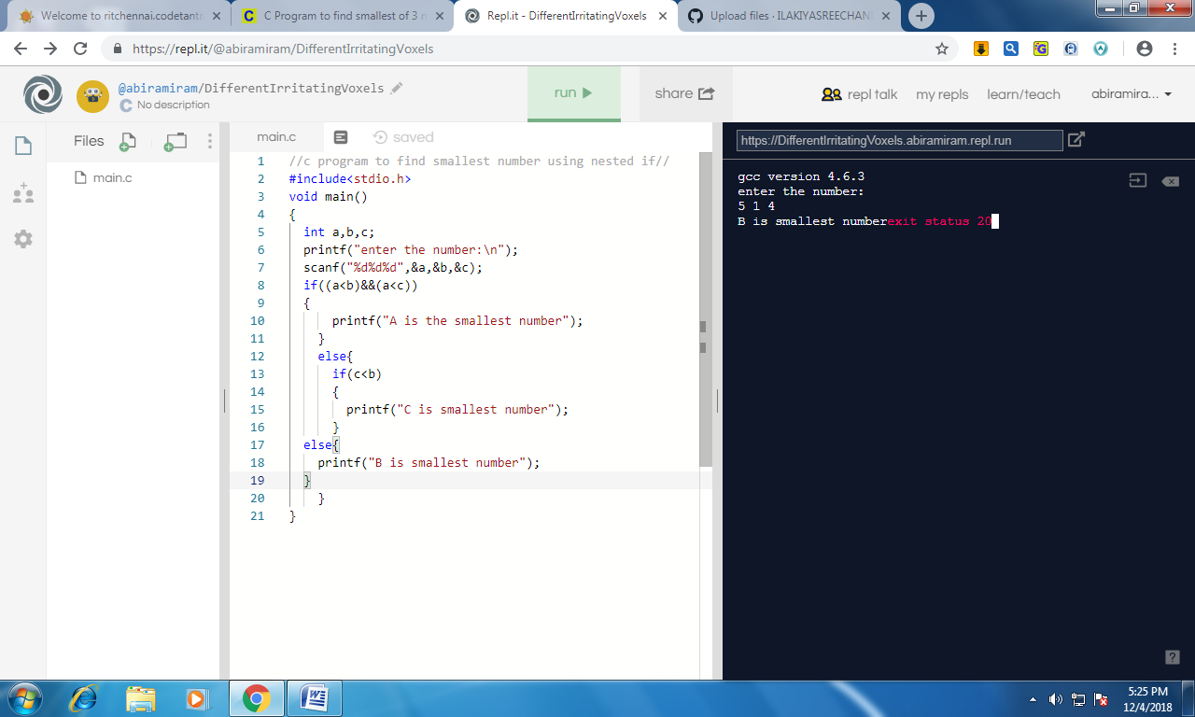

// C program to accept an integer & find the sum of its digits//

#include <stdio.h>

void main()

{

int n, temp, digit, sum = 0;

printf("Enter the number \n");

scanf("%d", &n);

temp = n;

while (n > 0)

{

digit = n % 10;

sum = sum + digit;

n = n/10;

}

printf("Given number = %d\n", temp);

printf("Sum of the digits %d = %d\n", temp, sum);

}

Output:

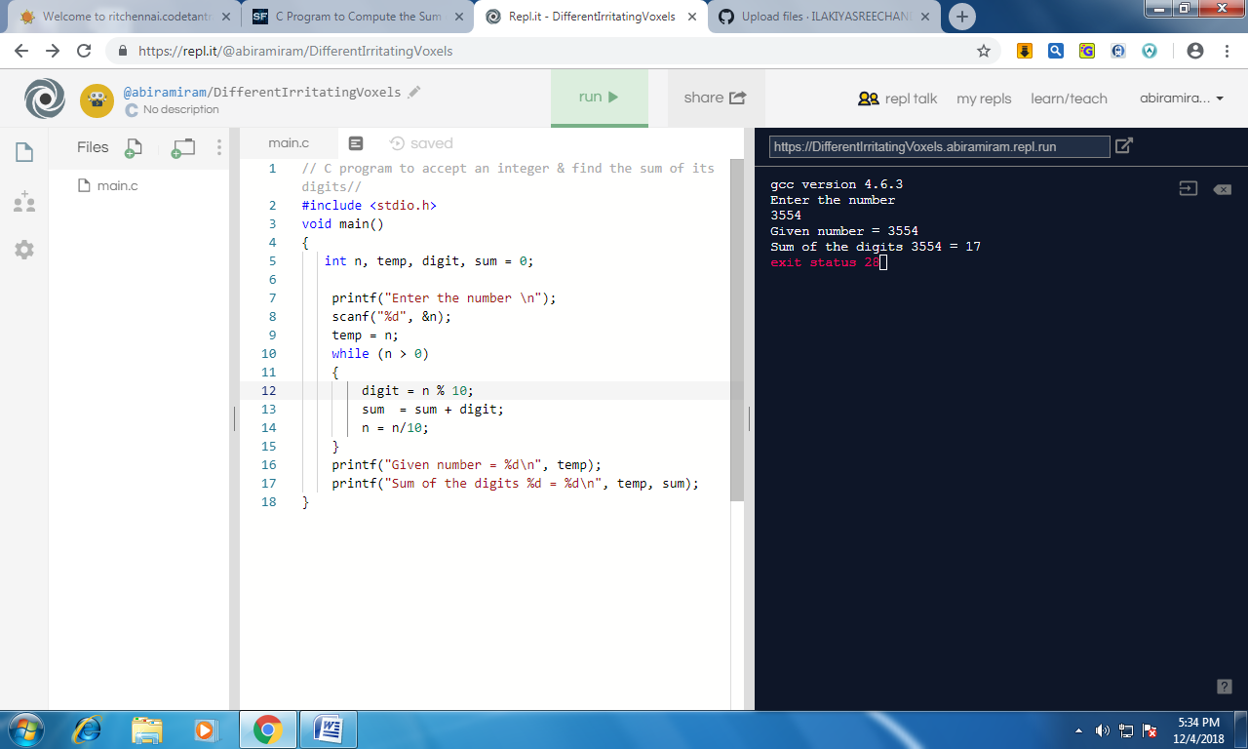

// C program to find LCM of two numbers

#include <stdio.h>

int gcd(int a, int b){

if (a == 0 || b == 0)

return 0;

if (a == b)

return a;

if (a > b)

return gcd(a-b, b);

return gcd(a, b-a);

}

int lcm(int a, int b)

{

return (a\*b)/gcd(a, b);

}

int main()

{

int a , b ;

printf("enter two numbers:\n");

scanf("%d%d",&a,&b);

printf("LCM of %d and %d is %d ", a, b, lcm(a, b));

return 0;

}

Output:

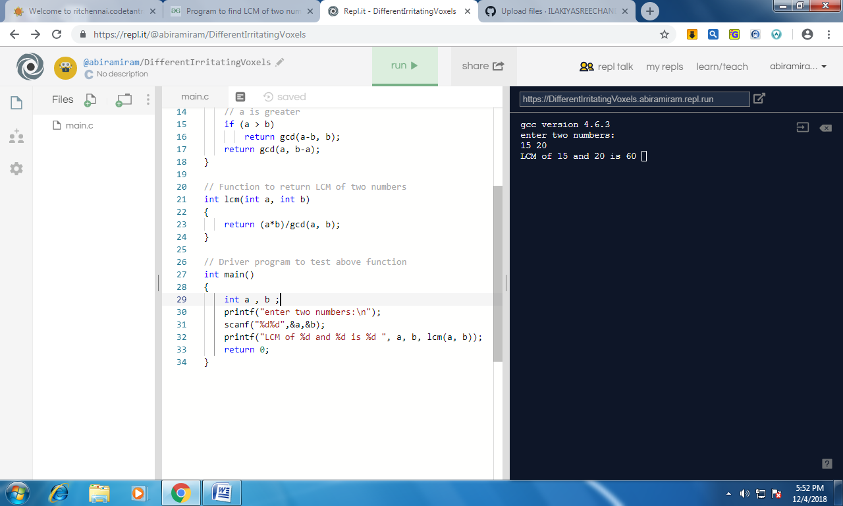

// C program to check whether the number is prime or not//

#include <stdio.h>

int main()

{

int n, i, flag = 0;

printf("Enter a number:\n ");

scanf("%d", &n);

for(i = 2; i <= n/2; ++i)

{

if(n%i == 0)

{

flag = 1;

break;

}

}

if (n == 1)

{

printf("1 is neither a prime nor a composite number.");

}

else

{

if (flag == 0)

printf("%d is a prime number.", n);

else

printf("%d is not a prime number.", n);

}

return 0;

}

Output:

