//c program to print even and odd numbers in array//

#include<stdio.h>

void main(){

int a[5],i;

printf("\n Enter the number:");

for(i=0;i<5;i++)

{

scanf("%d",&a[i]);

}

printf("even numbers are:");

for(i=0;i<5;i++)

{

if(a[i]%2==0){

printf("%d\t",a[i]); }

}

printf("\n");

printf("odd numbers are:");

for(i=0;i<5;i++){

if(a[i]%2!=0){

printf("%d\t",a[i]);}

}

}

Output:

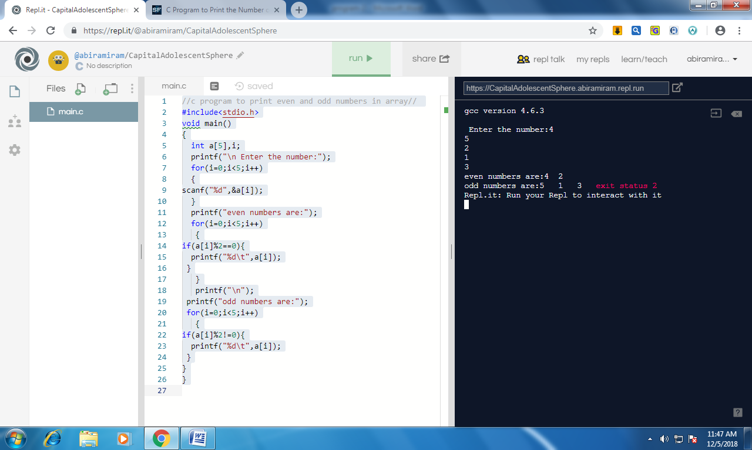

//c program to print fibonnaci series in array//

#include<stdio.h>

void main(){

int a[10];

a[0]=0;

a[1]=1;

for(int i=2;i<10;i++)

{

a[i]=a[i-1]+a[i-2];

}

printf(" the fibonacci series is:\n");

for(int i=0;i<10;i++){

printf("%d\n",a[i]);

}

}

Output:

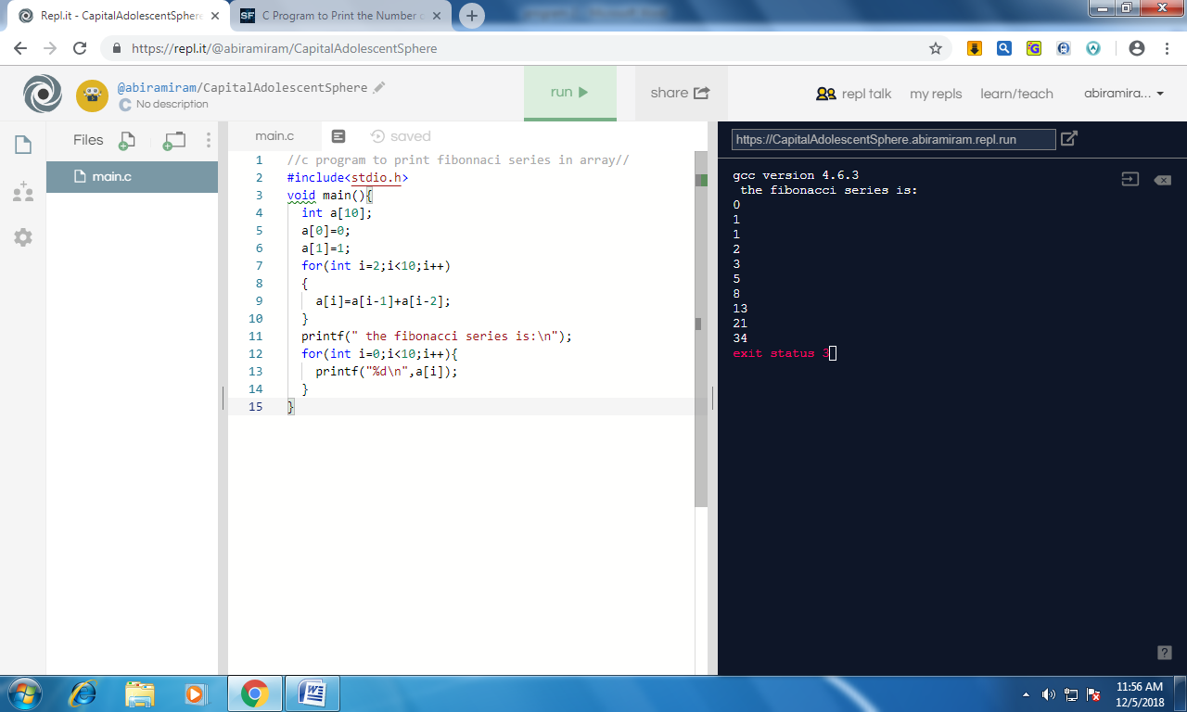

//c program to compare two array and print the same number//

#include<stdio.h>

void main(){

int a[5],b[5],i,j;

printf("enter the array1 elements:");

for(i=0;i<5;i++){

scanf("%d",&a[i]);

}

printf("enter the array2 elements:");

for(j=0;j<5;j++){

scanf("%d",&b[j]);

}

printf("the similar elements are:");

for(i=0;i<5;i++)

{

for(j=0;j<5;j++)

{

if(a[i]==b[j])

{

printf("%d\t",a[i],b[i]);

}}

}

}

Output:

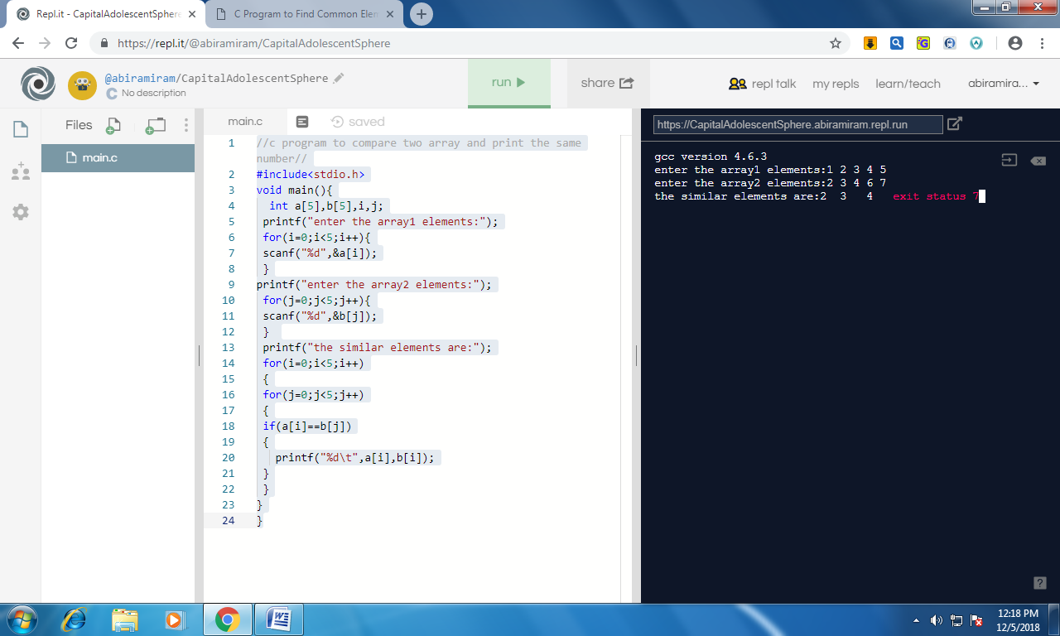

//c program to swap two numbers in array//

#include<stdio.h>

void main(){

int a[5],b[5],i;

printf("enter the array1 elements:");

for(i=0;i<5;i++){

scanf("%d",&a[i]);}

printf("enter the array2 elements:");

for(i=0;i<5;i++){

scanf("%d",&b[i]);}

printf("after swapping is a:");

for(i=0;i<5;i++){

a[i]=a[i]+b[i];

b[i]=a[i]-b[i];

a[i]=a[i]-b[i];

}

for(i=0;i<5;i++){

printf("%d\t",a[i]);}

printf("after swapping b is");

for(i=0;i<5;i++){

printf("%d\t",b[i]);

}}

Output:

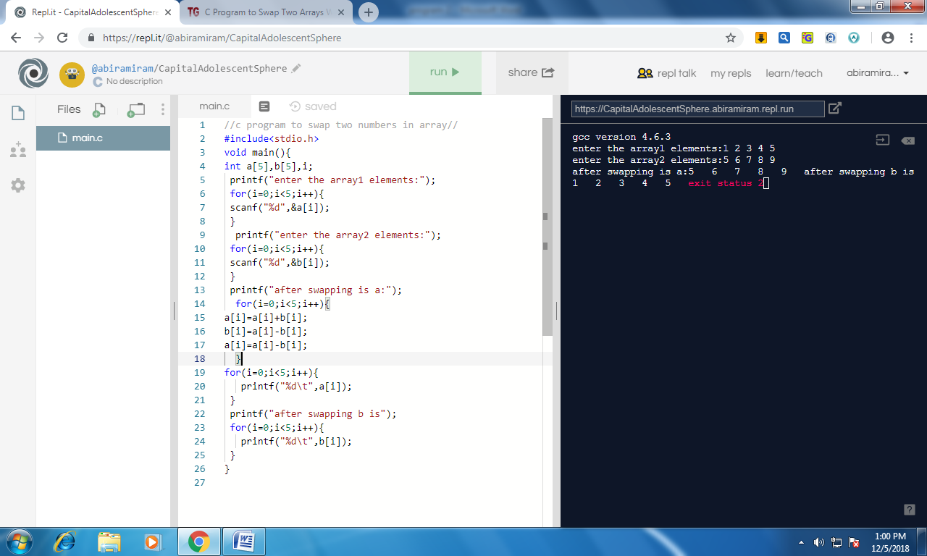

//c program to reverse a number in array//

#include<stdio.h>

void main()

{

int a[5],i;

printf("enter the value for array:\n");

for(i=0;i<5;i++)

{

scanf("%d",&a[i]);

}

printf("the elements are:");

for(i=4;i>=0;i--)

{

printf("%d\t",a[i]);

}

}

Output:

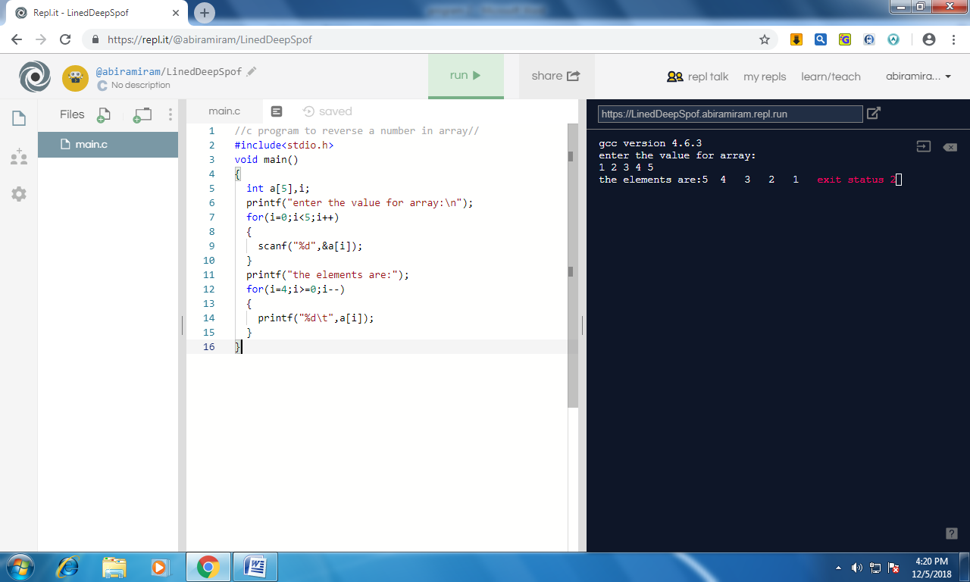

//c program to implement matrix addition using array//

#include<stdio.h>

void main()

{

int a[2][2],b[2][2],c[2][2],i,j;

printf("enter the value for array a:\n");

for(i=0;i<2;i++){

for(j=0;j<2;j++){

scanf("%d",&a[i][j]);

}

}

printf("enter the value for array b:\n");

for(i=0;i<2;i++){

for(j=0;j<2;j++) {

scanf("%d",&b[i][j]);}}

printf("matrix addition is:");

for(i=0;i<2;i++){

for(j=0;j<2;j++){

c[i][j]=a[i][j]+b[i][j];

printf("%d\t",c[i][j]);}}

}

Output:

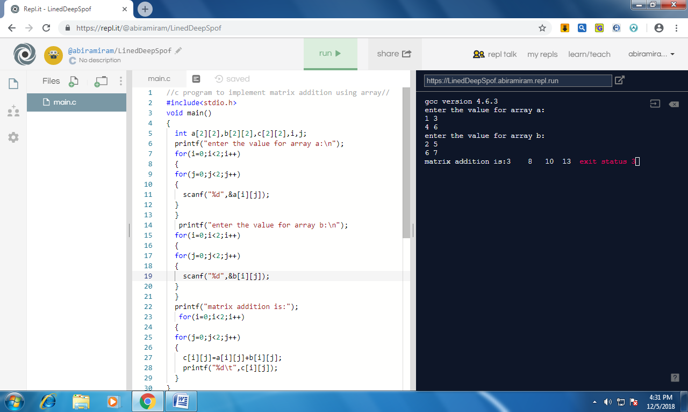

//c program to implement matrix multiplication using array//

#include<stdio.h>

void main()

{

int r1,r2,c1,c2,i,j,k;

int a[10][10],b[10][10],c[10][10],sum=0;

printf("Number of rows in A matrix : ");

scanf("%d", &r1);

printf("Number of columns in A matrix : ");

scanf("%d", &c1);

printf("Elements of A matrix : \n");

for (i = 0; i < r1; i++){

for (j = 0; j < c1; j++){

scanf("%d", &a[i][j]);

}

}

printf("Number of rows in B matrix : ");

scanf("%d", &r2);

printf("Number of columns in B matrix : ");

scanf("%d", &c2);

if (c1 != r2)

printf("Matrices with entered orders cannot be multiplied.\n");

else

{

printf("Elements of B matrix : \n");

for (i = 0; i < r2; i++)

for (j = 0; j < c2; j++)

scanf("%d", &b[i][j]);

for (i = 0; i < r1; i++) {

for (j = 0; j < c2; j++) {

for (k = 0; k < r2; k++) {

sum = sum + a[i][k]\*b[k][j];

}

c[i][j] = sum;

sum = 0;

}

}

printf("After Multiplication, the result is : \n");

for (i = 0; i < r1; i++) {

for (j = 0; j < c2; j++){

printf("%d\t", c[i][j]);

printf("\n");

}

}

}

}

Output:

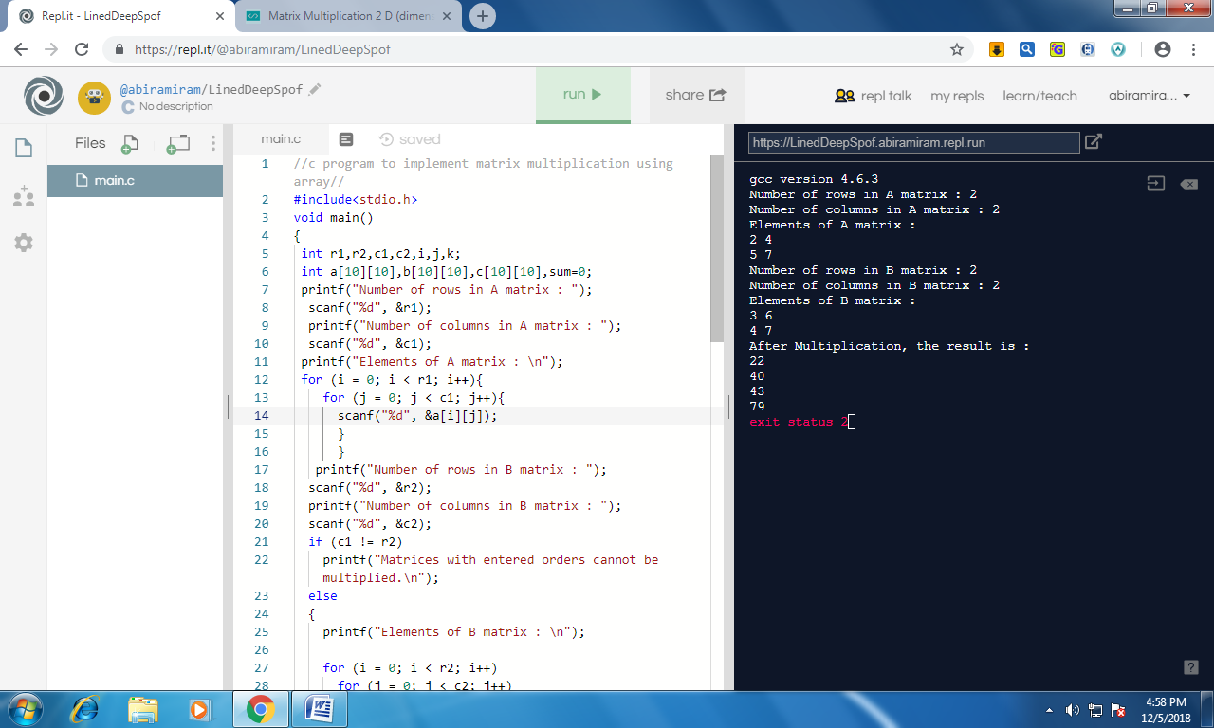

//c program to search an element in array//

#include<stdio.h>

void main() {

int a[30], x, n, i;

printf("\nEnter no of elements :");

scanf("%d", &n);

printf("\nEnter the values :");

for (i = 0; i < n; i++) {

scanf("%d", &a[i]);

}

printf("\nEnter the elements to be searched :");

scanf("%d", &x);

i = 0;

while (i < n && x != a[i]) {

i++;}

if (i < n) {

printf("Number found at the location = %d", i + 1);

} else {

printf("Number not found");

}

}

Output:

