//c program to print the character array//

#include <stdio.h>

void main()

{

char s1[50];

printf("enter the string:");

scanf("%s",s1);

printf("the given string is:%s",s1);

}

Output:

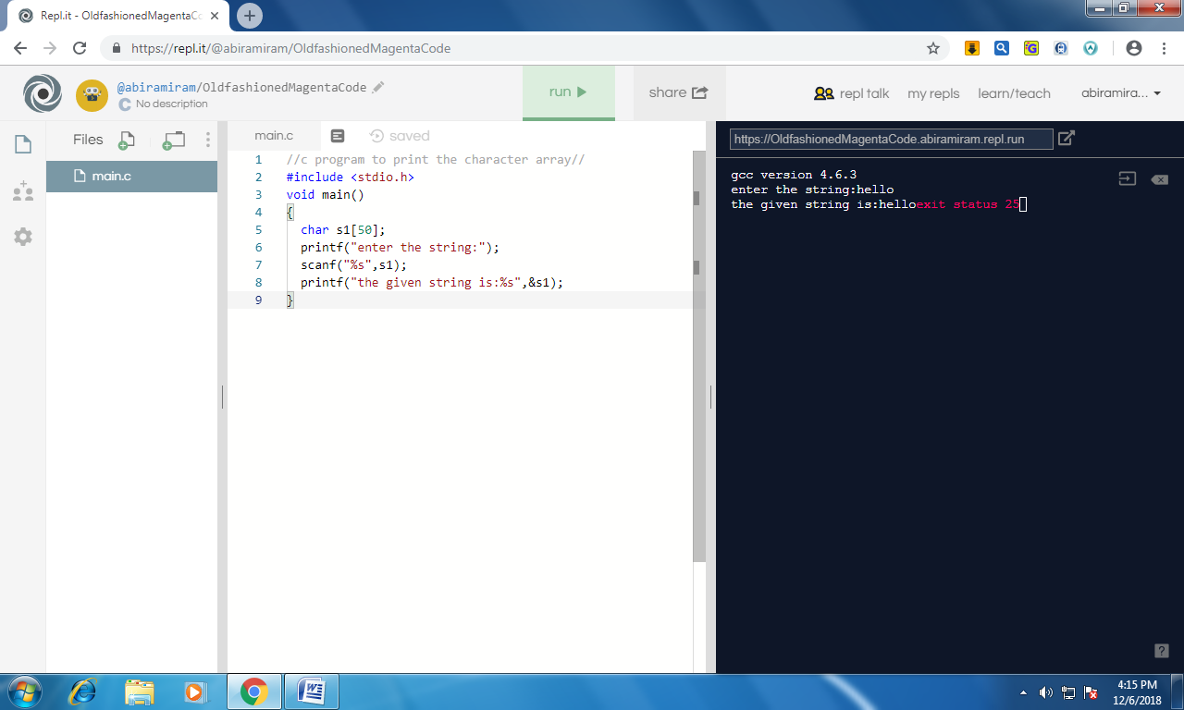

//following c program to print different types types of character array manipulation//

1)#include <stdio.h>

void main()

{

char s1[50];

printf("enter the string:");

scanf("%[a-z ]",s1);

printf("the given string is:%s",s1);

}

Output:

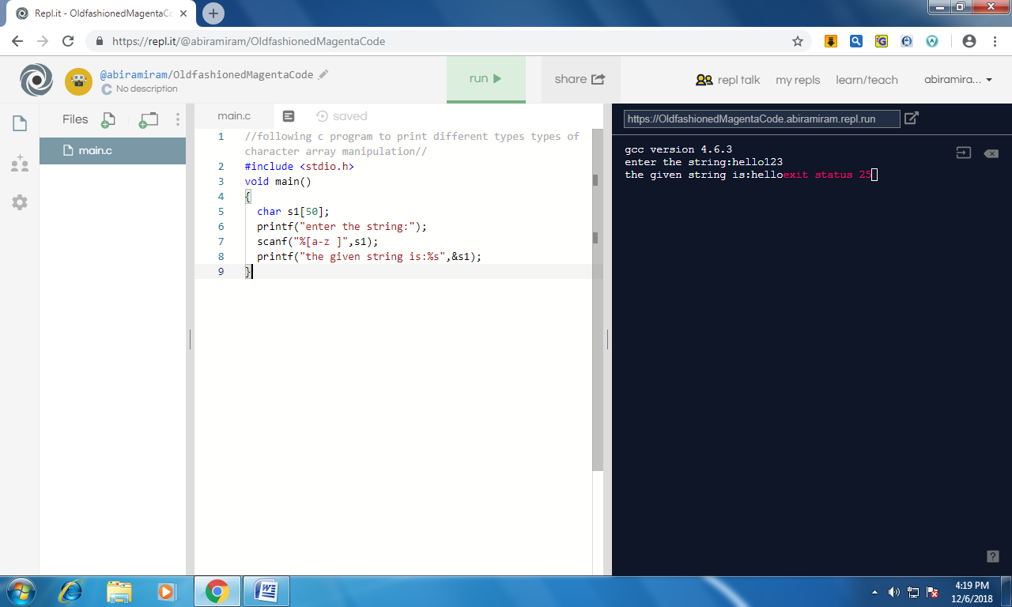

2)#include <stdio.h>

void main()

{

char s1[50];

printf("enter the string:");

scanf("%[0-9]",s1);

printf("the given string is:%s",s1);

}

Output:

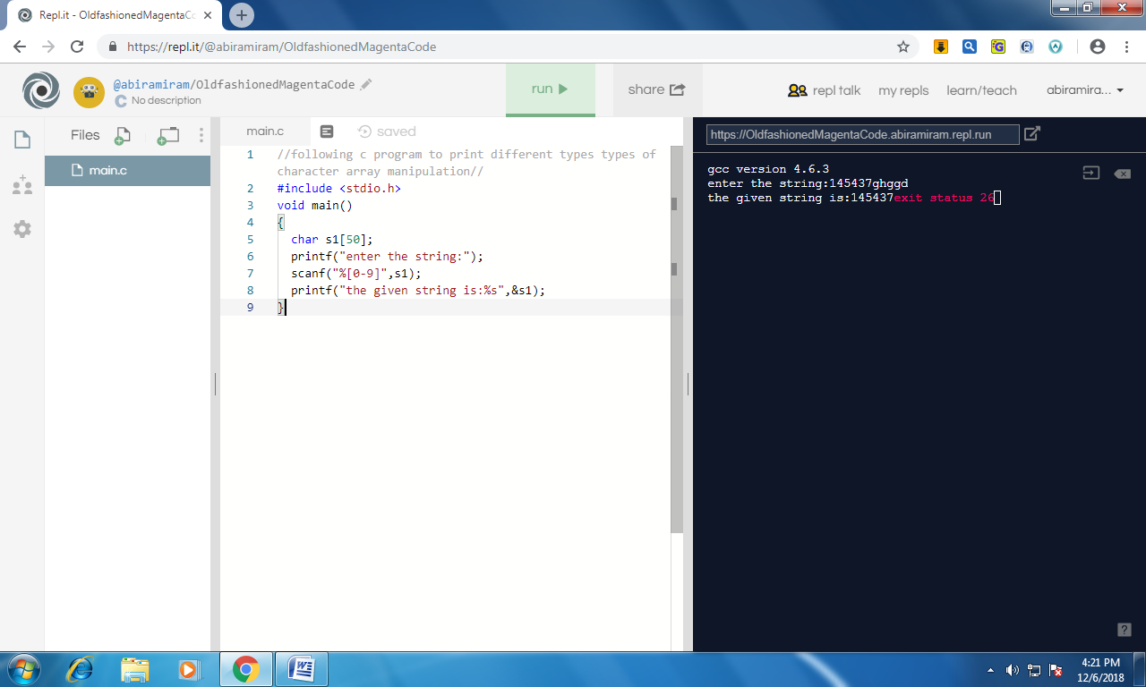

3) #include <stdio.h>

void main()

{

char s1[50];

printf("enter the string:");

scanf("%[^~]",s1);

printf("the given string is:%s",s1);

}

Output:

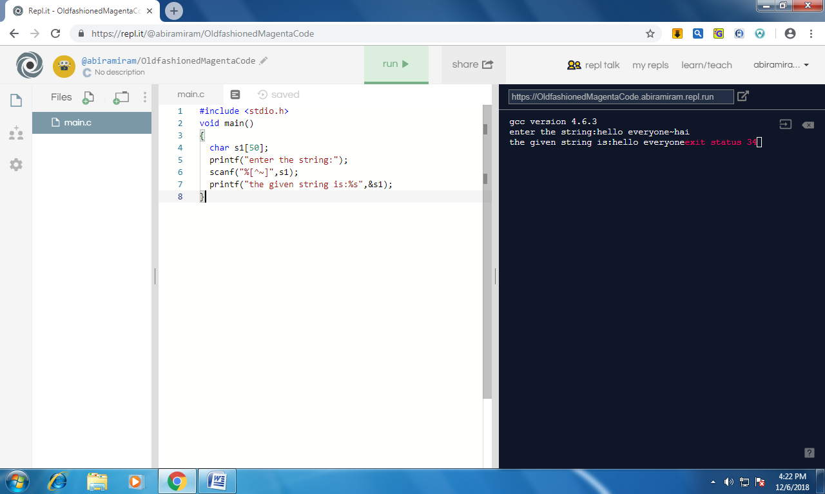

4) #include <stdio.h>

void main()

{

char s1[50];

printf("enter the string:");

scanf("%s",s1);

printf("the given string is:%.2s\n",s1);

printf("the given string is:%20s\n",s1);

printf("the given string is:%-20s\n",s1);

printf("the given string is:%.4s\n",s1);

printf("the given string is:%20.4s\n",s1);

printf("the given string is:%-20.4s\n",s1);

}

Output:

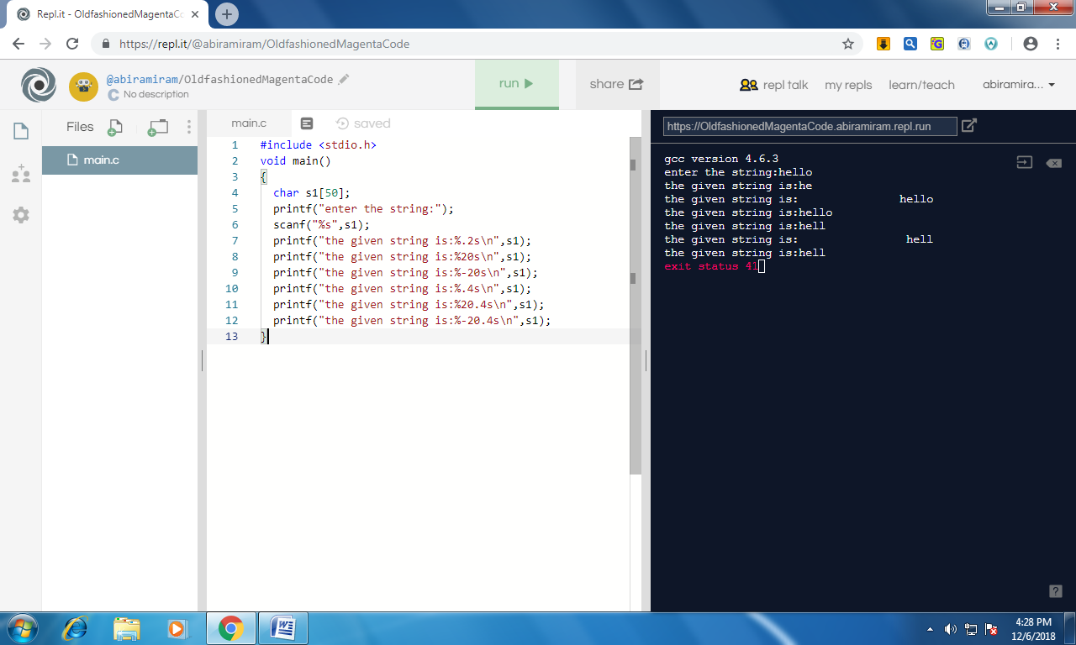

//c program to perform following string manipulations//

//length of a string//

#include<stdio.h>

#include<string.h>

void main()

{

char s1[20];

int n;

printf("enter the sting:");

scanf("%s",s1);

n=strlen(s1);

printf("the length is %d",n);

}

Output:

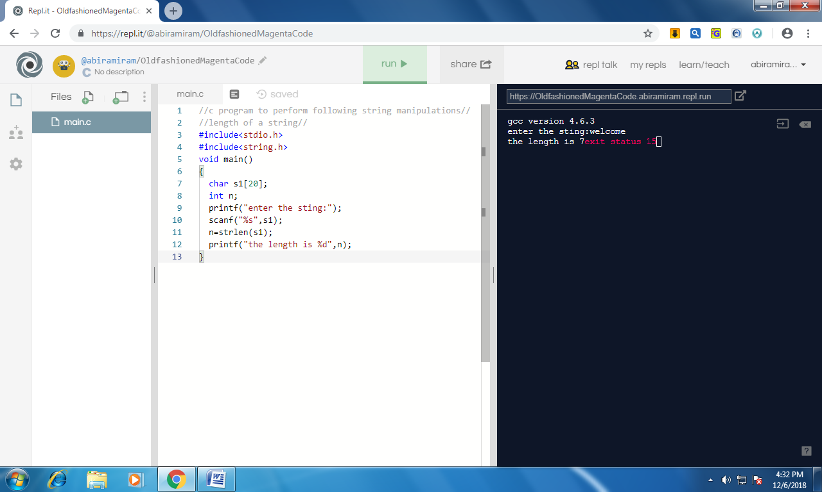

//copy of a string//

#include<stdio.h>

#include<string.h>

void main()

{

char s1[20],s2[20];

printf("enter the sting:");

scanf("%s",s1);

strcpy(s2,s1);

printf("the copied string is %s",s2);

}

Output:

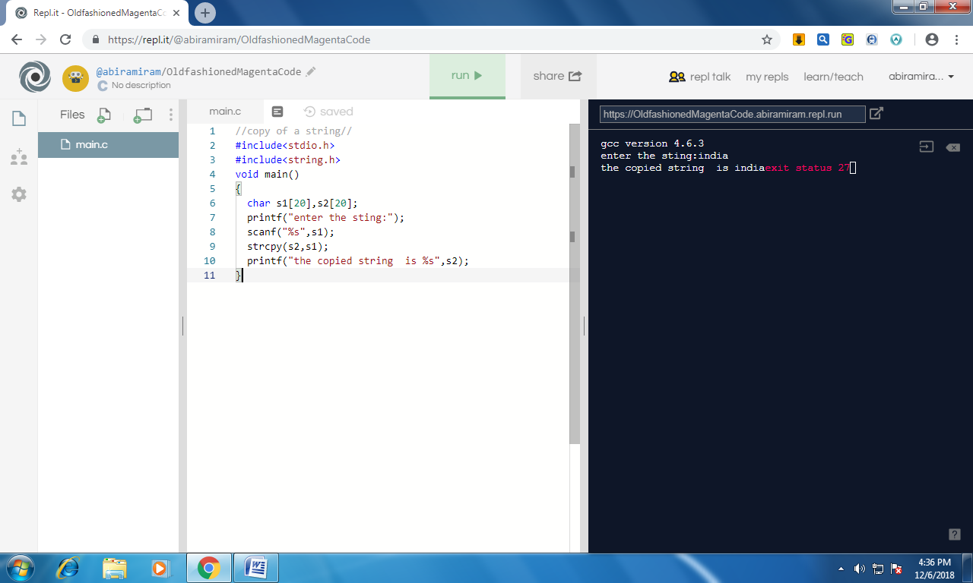

//comparision of a string//

#include<stdio.h>

#include<string.h>

void main()

{

char s1[20],s2[20];

printf("enter the sting:");

scanf("%s",s1);

printf("enter the sting:");

scanf("%s",s2);

if(strcmp(s1,s2)<0)

{

printf("%s comes before %s",s2,s1);

}

else if(strcmp(s1,s2)>0)

{

printf("%s comes before %s",s1,s2);

}

else

{

printf("two strings are equal");

}

}

Output

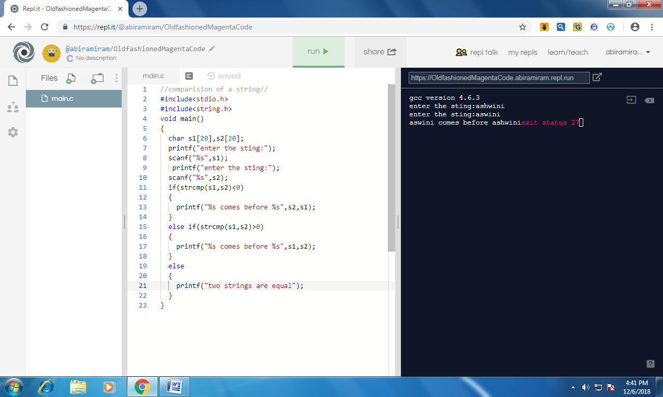

//concatination of a string//

#include<stdio.h>

#include<string.h>

void main()

{

char s1[20],s2[20];

printf("enter the sting:");

scanf("%s",s1);

printf("enter the sting:");

scanf("%s",s2);

strcat(s1,s2);

printf("the concatinated string is:%s",s1,s2);

}

Output:

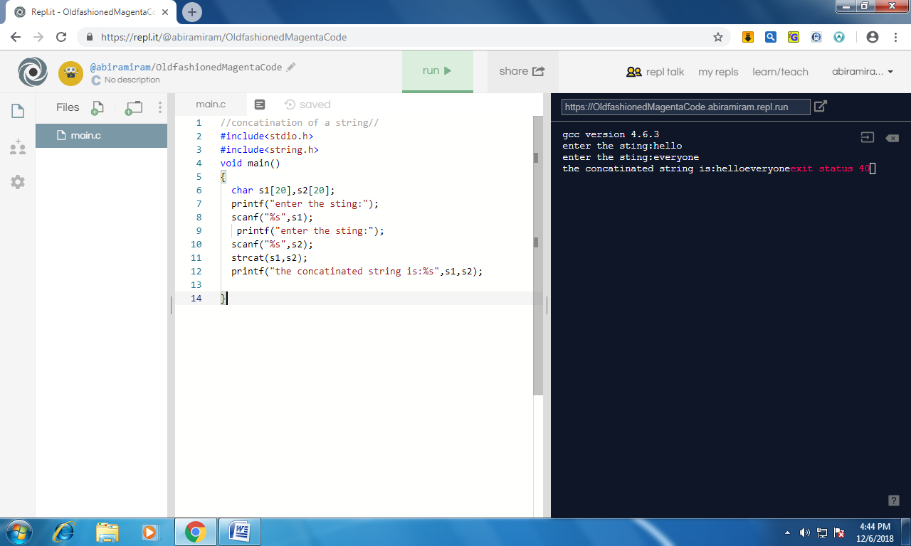

//reverse of a string//

#include<stdio.h>

#include<string.h>

void main()

{

char s1[20],s2[20];

int i=0,j=0;

printf("enter the sting:");

scanf("%s",s1);

while(s1[i]!='\0')

i++;

i=i-1;

while(i>=0)

{

s2[j]=s1[i];

i--;

j++;

}

s2[j]='\0';

printf("reverse of %s is %s",s1,s2);

}

Output:

