/* C Program to Merge and sort Two Arrays */

#include<stdio.h>

#include<stdlib.h>

void main()

{

 int m,n,mergsize,i,j,k,a[100],b[100],merged[50];

 printf("\n Please Enter the First Array Size : ");

 scanf("%d", &m);

 printf("\nPlease Enter the First Array Elements : ");

 for(i = 0; i < m; i++)

  {

  scanf("%d", &a[i]);

  }

  printf("\n Please Enter the Second Array Size : ");

 scanf("%d", &n);

 printf("\nPlease Enter the Second Array Elements : ");

 for(i = 0; i < n; i++)

  {

  scanf("%d", &b[i]);

  }

  mergsize = m + n;

  i = 0;

  j = 0;

 for(k = 0; k < mergsize; k++)

  {

    if(i >= m || j >= n)

    {

      break;

     }

     if(a[i] < b[j])

     {

       merged[k] = a[i];

       i++;

    }

    else

    {

      merged[k] = b[j];

      j++;

    }

  }

  while(i < m)

  {

    merged[k] = a[i];

    k++;

    i++;

  }

  while(j < n)

  {

    merged[k] = b[j];

    k++;

    j++;

  }

 printf("\n a[%d] Array Elements After Merging \n", mergsize);

 for(i = 0; i < mergsize; i++)

  {

  printf(" %d \t ",merged[i]);

  }

}

**Output:**

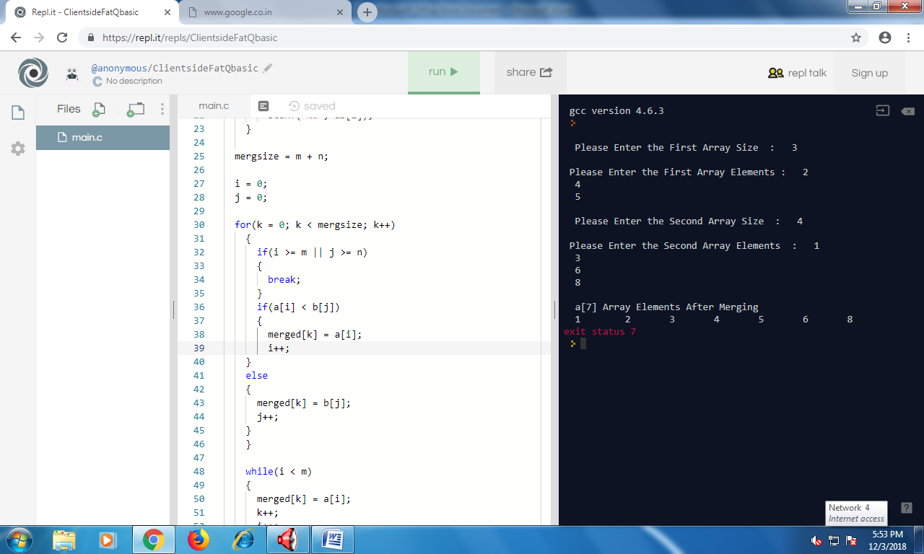

//c program to find area of circle//

#include<stdio.h>

#include<math.h>

#include<stdlib.h>

void main()

{

int r;

float area,pi=3.14;

printf("enter the radius of the circle:\n");

scanf("%d",&r);

area=pi*r*r;

printf("the area of circle is:%f\n",area);

}

Output:

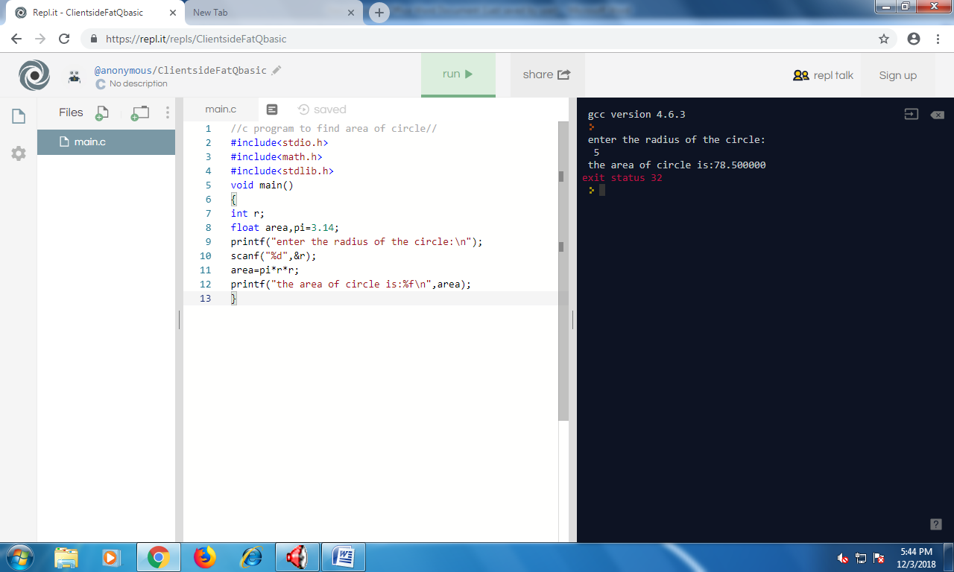

//c program to display day,month and year//

#include<stdio.h>

void main()

{

int a,day,month,year;

printf("enter the number:");

scanf("%d",&a);

day=a-(month*30);

printf("the day is: %d",day);

month=a/30;

printf("the month is: %d",month);

year=a/365;

a=a-(year*365);

printf("the year is: %d",year);

}

OUTPUT:

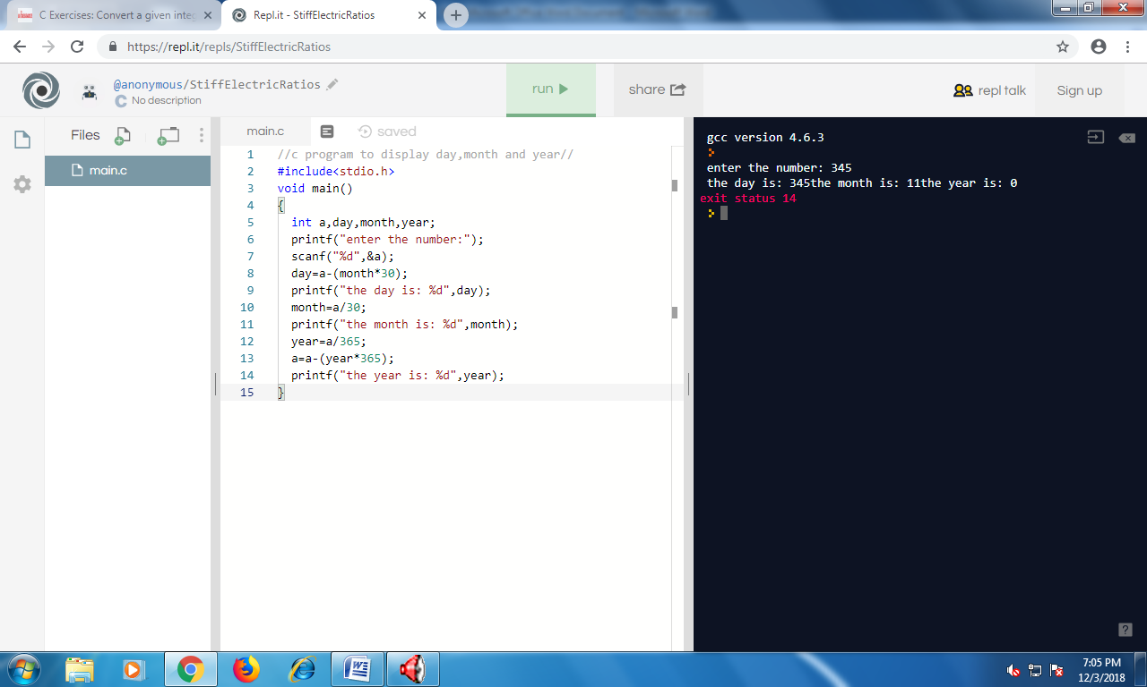

//c program to find area of circle using new pi value//

#include<stdio.h>

#include<math.h>

#include<stdlib.h>

void main()

{

int r;

float area,pi=3.14;

printf("enter the radius of the circle:\n");

scanf("%d",&r);

area=pi*r*r;

printf("the area of circle is:%f\n",area);

}

OUTPUT:

