**Step 1:**

Use Postman to test the API end points.

Hit the below URL after you the start the Spring boot application.

[**http://localhost:8080/customer/multi/statements/record.rabo**](http://localhost:8080/customer/multi/statements/record.rabo)

**Step 2:**

Use Post method

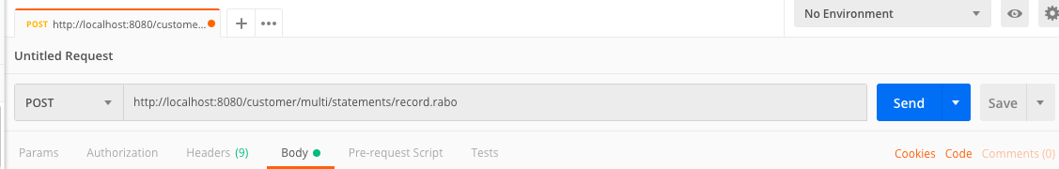

**Step 3:**

Click body tab and select “form-data”

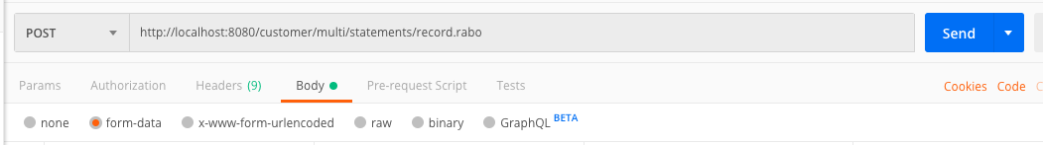

**Step 4:**

Type **files** in key text box column.

Note:

Make sure you are still in body tab when you do this.

Parameter **files** is case sensate as shown in below figure.

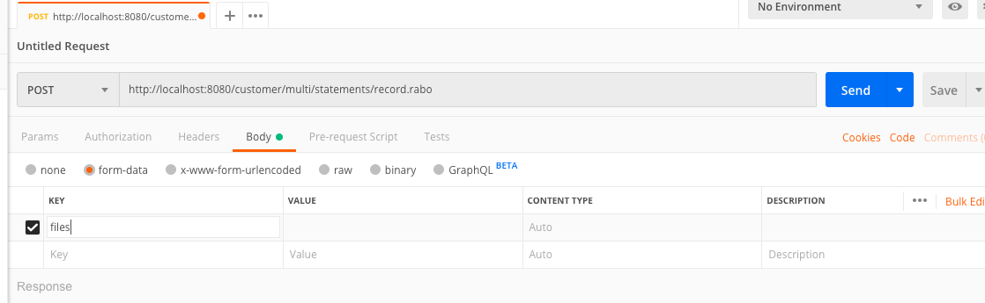

**Step 5:**

Note:

Make sure you are still in body tab when you do this.

Select **File** type in drop down list box.

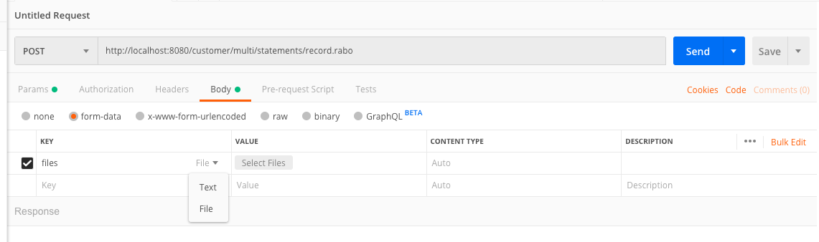

**Step 6:**

Now you will see select files option in values column where you can browse for input files from your PC.

Note:

You can select multiples files of CSV and XML at same time.

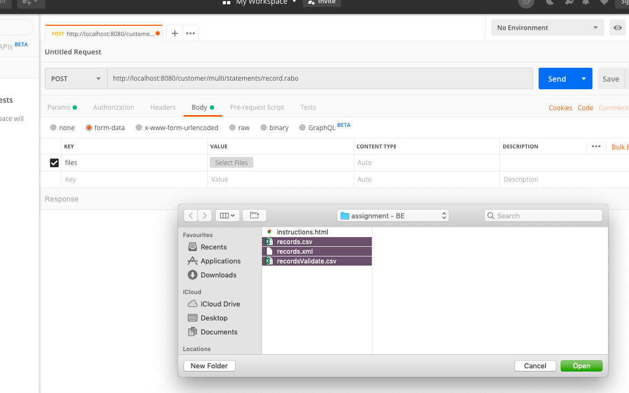

**Step 6:**

Once selected you will see numbers of files Counts as shown in below figure.

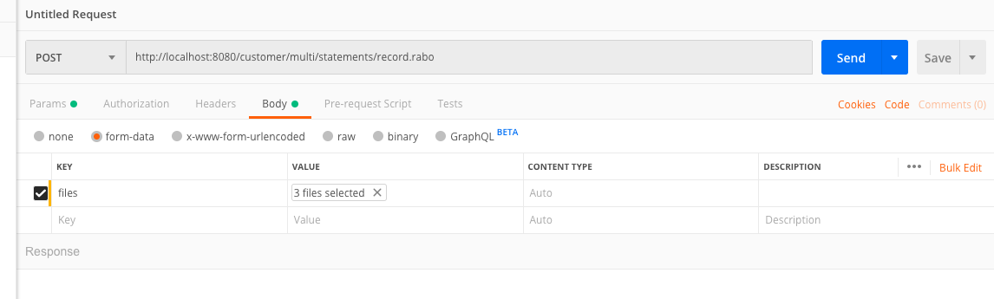

**Step 6:**

Click the send button to hit the API. You will see the response as show below.

