
MODULE CODE & NAME: SWDSA401 DATA STRUCTURE AND ALGORITHM USING JAVASCRIPT
DATE: …../03/2025
EXAM PERIOD: 3Hours



NYARUGENGE DISTRICT COMPREHENSIVE ASSESSMENT, 2024-2025
MARKING GUIDE
SECTOR: ICT & MULTIMEDIA
SUB-SECTOR/TRADE: SOFTWARE DEVELOPMENT
RQF LEVEL: 4
DURATION: 3 HOURS
TRAINEE’ NAMES: …………………………………………………………………

100
DURATION: 3 Hours

INSTRUCTIONS TO CANDIDATES:
This Exam paper is composed of Three (3) Sections (A, B, C). Follow the instructions given below, and answer the indicated questions for a total of 100 marks.
Section A: Attempt all seventeen(17)Compulsory questions.55 Marks
Section B:Among 5 questions, attempt any three (3).30 Marks
Section C: Among (2) questions, attempt any one (1). 15 Marks
Allowed materials:
- Ruler
- Blue or black pen
- Pencil , calculator

Section A: Answer All Questions (55 Marks)
- a) A linked list is a collection of(2 Marks)
- Nodes
- Arrays
- Stacks
- Queues
b) Which of the options listed bellow are the types
of Linked list? (2 marks)
- Singly linked lists
- Doubly linked lists
- Circular linked list
- All
Answer:
a) Nodes(2 marks)
iv) All(2 marks)
Reference: (L.O.2. Apply data structure, I.C.2.2. Linear Data Structures are properly applied based on their operational complexity, page 8, curriculum version 2023, Remembering)

- Answer the following questions using True or False
- The decimal equivalent of the hexadecimal number A3 is 163. True
- The hexadecimal number system uses base 15 and includes the digits 0-9 and the letters A-F, where A represents 10 and F represents 15. False
- Each octal digit can be directly converted to a 3-digit binary equivalent. True
- The binary equivalent of the octal number 10 is 1000 True
- The octal number 4 is represented as 101 in binary. False
Reference: (L.O.1. Apply Algorithm Fundamentals, I.C.1.1 Number systems are correctly converted according to the base conversion methods, page 4, curriculum version 2023, Remembering)
- Fill in the blanks: The _______ operation removes the top element from the stack.(3 marks)
Answer: pop (3 marks)
Reference: (L.O.2. Apply Data Structure, I.C.2.2 Linear Data Structures are properly applied based on their operational complexity, page 8, curriculum version 2023, Remembering)
- Arrange the JavaScript arithmetic operators in the order of precedence (highest to lowest): *, +, -, / (3 marks
Answer:
*, /, +, - (3 marks)
Reference: (L.O.1. Apply Algorithm Fundamentals, I.C.1.4 Operators are appropriately used based on datatype, page 5, curriculum version 2023, Applying)
- a) Which of the following is a non-linear data structure?(1 mark)
- Array
- Linked List
- Tree
- Queue

- What's the difference between Linear and Non-Linear Data Structure (Choose 2 options)? (4 marks)
- In a linear data structure, elements are arranged in a sequential manner
- In a non-linear data structure, elements are arranged in a sequential manner
- In a non-linear data structure, elements are not arranged sequentially and can have hierarchical relationships.
- In a linear data structure, elements are not arranged sequentially and can have hierarchical relationships.
Answer:
c) Tree (1 mark)
a) and c) (4 marks)
Reference: (L.O.2. Apply Data Structure, I.C.2.1 Data structure concepts are clearly identified based on intended use, page 7, curriculum version 2023, Understanding)
- True/False: To convert a decimal number to binary, you repeatedly multiply the decimal number by 2.(2 marks)
Answer: False (repeatedly divide)(2 marks)
Reference: (L.O.1. Apply Algorithm Fundamentals, I.C.1.1 Number systems are correctly converted according to the base conversion methods, page 4, curriculum version 2023, Understanding)

Answer
Operation | Output
!((myvar1+20)>myvar2) | False
(myvar2%3==myvar1/2+1) | False
myvar1-20/10<=0 ||myvar2/10<5 | True
Myvar1++%2==1 | True
Myvar1+myvar2/6>25 | True
Reference: (L.O.1. Apply Algorithm Fundamentals, I.C.1.4 Operators are appropriately used based on datatype, page 5, curriculum version 2023, Applying)
- Which of the following is the correct pseudocode structure for finding the largest number in an array?(5 marks)
  - findLargest(array) { largest = 0; for each number in array { if number < largest { largest = number; } } return largest; }
  - findLargest(array) {largest = array[0]; for each number in array { if number > largest { largest = number; } } return largest; }
  - findLargest(array) { largest = array[0]; for each number in array { if number < largest { largest = number; } } return number; }
  - findLargest(array) { largest = 0; for each number in array { if number > largest { largest = number; } } return number; }
Answer: b) (5 marks)
Reference: (L.O.1. Apply Algorithm Fundamentals, I.C.1.5 Algorithm is properly written based on problem to be solved, page 5, curriculum version 2023, Applying)
- Write an algorithm/Pseudocode that ask a user two (2) values and display a largest among them 2marks
START
DECLARE A,B as Integer
WRITE(“Put any two numbers”)
READ A, B
IF A>B THEN
WRITE(A, “Is greater that”, B)
ELSE
WRITE (B,”Is greater than”, A)

END
Reference: (L.O.1. Apply Algorithm Fundamentals, I.C.1.3 Data types are effectively used according to their intended use, page 5, curriculum version 2023, Applying)
- An operator is a special symbol or keyword in programming languages that performs operations on one or more operands (variables, values, etc.) to produce a result.

Match the Operator with Its Application

 | Operator | Application
C | 1. Logical AND Operator (&&) | A. Used to find the remainder of a division operation.
D | 2. Ternary Operator (? :) | B. Used to evaluate whether at least one of the conditions is true.
A | 3. Modulus Operator (%) | C. Used to evaluate whether both conditions are true.
B | 4. Logical OR Operator (||) | D. A shorthand for if-else statements, used for conditional expressions.
Reference: (L.O.1. Appy algorithm fundamentals, I.C.1.3 Operators, page 5, curriculum version 2023, Understanding)
- What is the time complexity of the bubble sort algorithm in the worst-case scenario?(3 marks)
- O(n)
- O(log n)
- O(n²)
- O(n log n)
Answer: c) O(n²) (3 marks)
Reference: (L.O.2. Apply Data Structure, I.C.2.3 Non-Linear Data Structures are properly applied based on their operational complexity, page 7, curriculum version 2023, Applying)

- True/False: Time complexity measures the amount of memory used by an algorithm.(2 marks)
Answer: False (measures time taken)(2 marks)
Reference: (L.O.2. Apply Data Structure, I.C.2.1 Data structure concepts are clearly identified based on intended use, page 7, curriculum version 2023, Understanding)
- Arrange the steps for performing a binary search in the correct order:(5 marks)
- If the target element is less than the middle element, search the left subarray.
- Find the middle element of the array.
- Sort the array.
- If the target element is equal to the middle element, return the index.
- If the target element is greater than the middle element, search the right subarray.
Answer: c, b, d, a, e (5 marks)
Reference: (L.O.3. Implement Algorithm using JavaScript, I.C.3.2 JavaScript source code is successfully run in accordance with expected result, page 9, curriculum version 2023, Applying)
- An operator is a special symbol or keyword in programming languages that performs operations on one or more operands (variables, values, etc.) to produce a result. (Ap, outcome 1)

- If you have the variables greeting = "Hello" and name = "Alice", what will be the result of the expression greeting + ", " + name + "!"?

Answer: Hello, Alice!
- Consider the boolean variables isLoggedIn = false and hasAccount = true. What will the result be of the expression isLoggedIn || hasAccount?
Answer: The result will be true. The logical OR operator (||) returns true if at least one of the operands is true.

- If x = 10 and y = "10", what will be the result of the expressions x == y and x === y?
Answer: The expression x == y will be true (loose equality), and x === y will be false (strict equality) because x is a number and y is a string.
- Write a ternary operator expression that checks if a variable age is greater than or equal to 18. If true, it should return "Adult"; otherwise, it should return "Minor". What would the expression look like in code?
Answer: The expression would be: let result = age >= 18 ? "Adult" : "Minor";. This evaluates the condition and assigns the corresponding string to result.
Reference: (L.O.1. Apply Algorithm Fundamentals, I.C.1.5 Algorithm is properly written based on problem to be solved, page 6, curriculum version 2023, Applying)
- A Binary Search Tree is a binary tree data structure in which each node has at most two children, referred to as the left child and the right child. Answer the questions related to the following Binary Search Tree
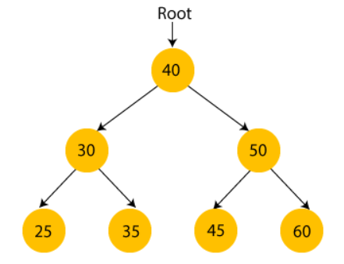

      - Provide the steps to traverse above tree in (in-order, Pre-order and Post-Order traversals) with the output
      - What is a best case of time complexity to search an element in BST

Answer
a)
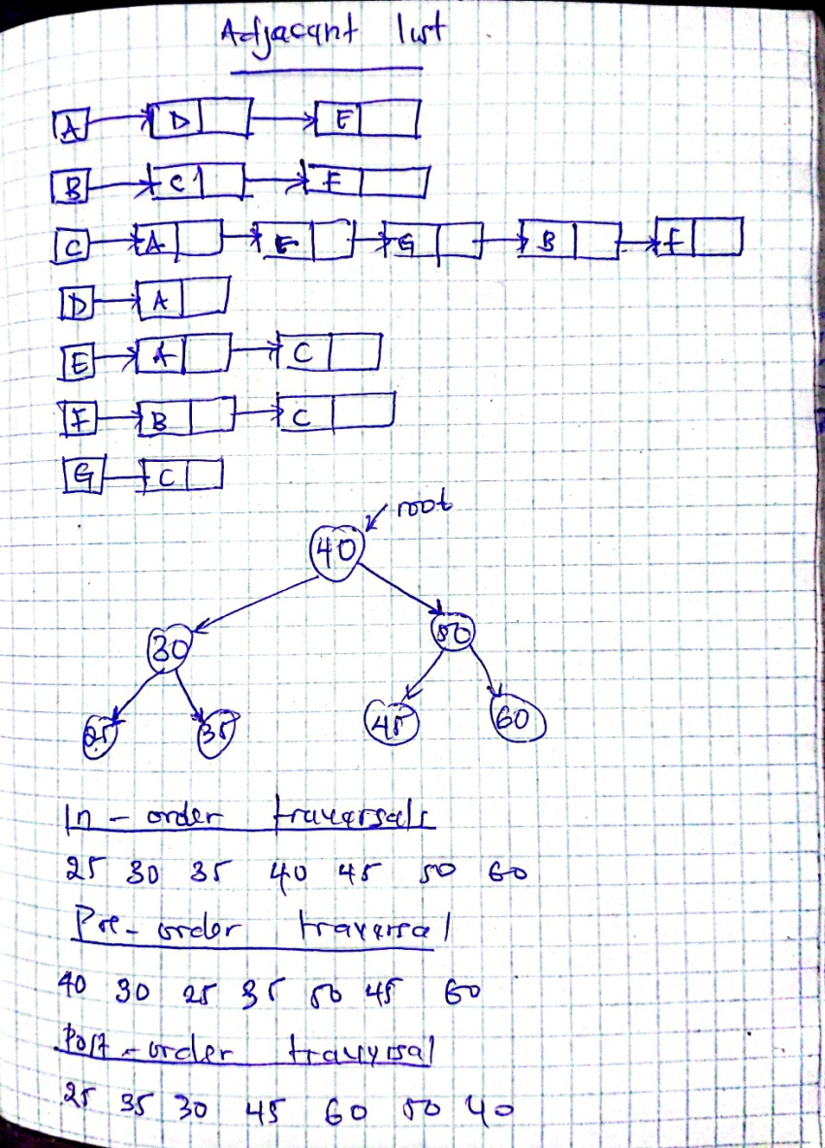

b) O(1)
References: (L.0.2. Apply data structure, I.C.2.2. Non- Linear Data Structures are properly applied based on their operational complexity, page 6, curriculum version 2023, APPLYIMG)

- a) What are the two (2) main functions used in queue? (2marks)
b) What is PUSH and POP in stack? (2 marks)

- Write a JavaScript arrow function that uses arithmetic operators to calculate the area of a rectangle, given its length and width. Provide the code. (3 marks)
Answer:
function calculateRectangleArea (length, width) {
return length * width;
}
Reference: (L.O.1. Apply Algorithm Fundamentals, I.C.1.4 Operators are appropriately used based on datatype, page 5, curriculum version 2023, Applying)

Section B: ATTEMPT ONLY THREE (3) QUESTIONS (10 Marks)
- a) Briefly explain how a Queue data structure works, including the enqueue and dequeue operations. (5 marks)
b) List five real world application where Queue can be used as efficiently (5 marks)
Answer:
(a) Explanation of Queue Data Structure (5 Marks)
A Queue is a linear data structure that follows the First In, First Out (FIFO) principle, meaning the element added first is removed first.
Operations in Queue:
- Enqueue (Insertion): Adds an element to the rear (end) of the queue.
- Dequeue (Deletion): Removes an element from the front (beginning) of the queue.
- Peek: Retrieves the front element without removing it.
- isEmpty: Checks if the queue is empty.
- isFull: Checks if the queue is full (in case of a fixed-size queue).

(b) Real-World Applications of Queues (5 Marks)

- Job Scheduling in Operating Systems – Queues are used to manage CPU tasks, ensuring fair execution.
- Customer Service Systems – Call centers or bank counters use queues to serve customers in order.
- Print Queue in Computers – When multiple documents are sent to a printer, they are processed in order.
- Networking (Packet Scheduling) – Data packets in networking are queued before being processed.
- Traffic Management Systems – Vehicles at toll booths or traffic signals follow a queue system.

Reference: (L.O.2. Apply Data Structure, I.C.2.2 Linear Data Structures are properly applied based on their operational complexity, page 8, curriculum version 2023, Applying)
- In what scenarios is Binary Search more efficient than Linear Search? Explain why.
Answer:
When is Binary Search More Efficient than Linear Search?
Binary Search is more efficient than Linear Search when:
- The Data is Sorted – Binary Search works only on sorted data, making it much faster than Linear Search.
- Large Datasets – Binary Search has O(log n) complexity, making it significantly faster than Linear Search (O(n)) for large datasets.
- Frequent Searches – If searching happens often, Binary Search saves time compared to checking each element sequentially.
- Random Access is Available – Works best with arrays that allow direct access, unlike linked lists.
- Memory Efficiency – Does not require extra space, making it more efficient for sorted arrays.
Why is it Faster?
- Divides the dataset in half at each step.
- Reduces comparisons significantly (logarithmic time complexity).
- Best for large, sorted data with frequent searches.

Reference: (L.O.2. Apply Data Structure, I.C.2.1 Data structure concepts are clearly identified based on intended use, page 7, curriculum version 2023, Analyzing)
- Hashing is a process that transforms input data of any size into a fixed-size string of characters, which is typically a sequence of numbers and letters.(Ap, Outcome2)
Given the following keys:
K=3, 2 , 9, 6, 11, 13, 7, 12 and
N(k)=2k+3
M=10 (m means a size of a hash table)

Use division method and open addressing (chaining to prevent a collision) to store these values in a hash table

Answer:
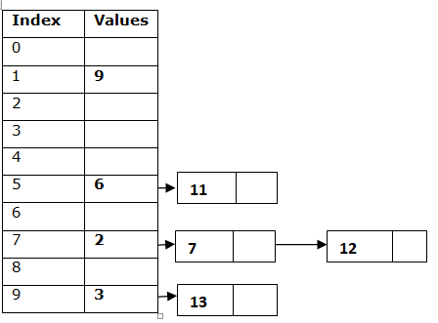

Reference: (L.O.2. Apply data str Fundamentals, I.C.1.5 Algorithm is properly written based on problem to be solved, page 5, curriculum version 2023, Analyzing)
    - Analyze the following codes and fill in the dotted spaces (An, outcome 2)
binarySearch(arr, targetVal):
left = 0
right = …………………………….

while left <= right:
mid = …………………………………..

if arr[mid] == targetVal:
return ………………………….

if arr[mid] < targetVal:
left = ………………………….
else:
right = …………………………

return -1

myArray = [1, 3, 5, 7, 9, 11, 13, 15, 17, 19]
myTarget = 15

result = binarySearch(myArray, myTarget)

if result != -1:
print("Value",myTarget,"found at index", result)
else:
print("Target not found in array.")

answer
binarySearch(arr, targetVal):
left = 0
right = len(arr) - 1

while left <= right:
mid = (left + right) // 2

if arr[mid] == targetVal:
return mid

if arr[mid] < targetVal:
left = mid + 1
else:
right = mid - 1

return -1

myArray = [1, 3, 5, 7, 9, 11, 13, 15, 17, 19]
myTarget = 15

result = binarySearch(myArray, myTarget)

if result != -1:
print("Value",myTarget,"found at index", result)
else:
print("Target not found in array.")
Reference: (L.O.2. Apply Data Structure, I.C.2.2 Linear Data Structures are properly applied based on their operational complexity, page 7, curriculum version 2023, creating)
- Describe Boolean logic gates and expressions.

Reference: (L.O.1. Apply Algorithm Fundamentals, I.C.1.2 Logic gates and expressions are well described based on Boolean algebra, page 4, curriculum version 2023, Understanding)
Section C: Essay Questions (15 Marks)
- The arrays PollData[1:10] and CardData[1:10] store data

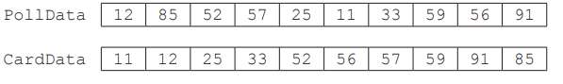
An insertion sort sorts these data.
- State why it will take less time to complete an insertion sort on CardData than on PollData.

CardData is partially sorted/ordered // more items in order/sorted

- The following pseudocode algorithm performs an insertion sort on the CardData array.

Complete the following pseudocode algorithm.
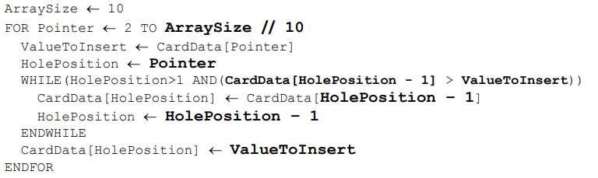
- (i) A binary search algorithm is used to find a specific value in an array.
Explain why an array needs to be sorted before a binary search algorithm can be used.

  - It doesn’t check every value
  - The midpoint is the middle element, not the middle numerical value
  - When the higher/lower elements are discarded they will not be the higher/lower elements
  - It might discard the value you are looking for

(ii) The current contents of CardData are shown.
Explain how a binary search will find the value 25 in CardData.

Answer:
- Find mid-point and comparison // 25 is smaller than/compared to 52/56
  - Discard/ignore greater // change upper bound to 33/52/midpoint - 1 //e.g. right hand side // only use array elements 1 - 4/5
  - Find and compare to mid-point of new list e.g. 12/25
  - Value is the midpoint // Continue until value found

Reference: (L.O.2. Apply Data structure, I.C.2.2 Linear data structure, page 9, curriculum version 2023, Creating)
- Write a program in JavaScript that display a factorial of a number.
Answer:
// Function to calculate factorial
function factorial(n) {
if (n < 0) {
return "Factorial is not defined for negative numbers.";
}
let result = 1;
for (let i = 1; i <= n; i++) {
result *= i;
}
return result;
}

// Example: Display factorial of a number
let num = 5; // Change this number to test different values
console.log (`Factorial of ${num} is: ${factorial(num)}`);
References: (L.0.3. Implement Algorithm using JavaScript I.C.3.1. JavaScript Source code is properly written based on Algorithm, page 8, curriculum version 2023, Creating)

