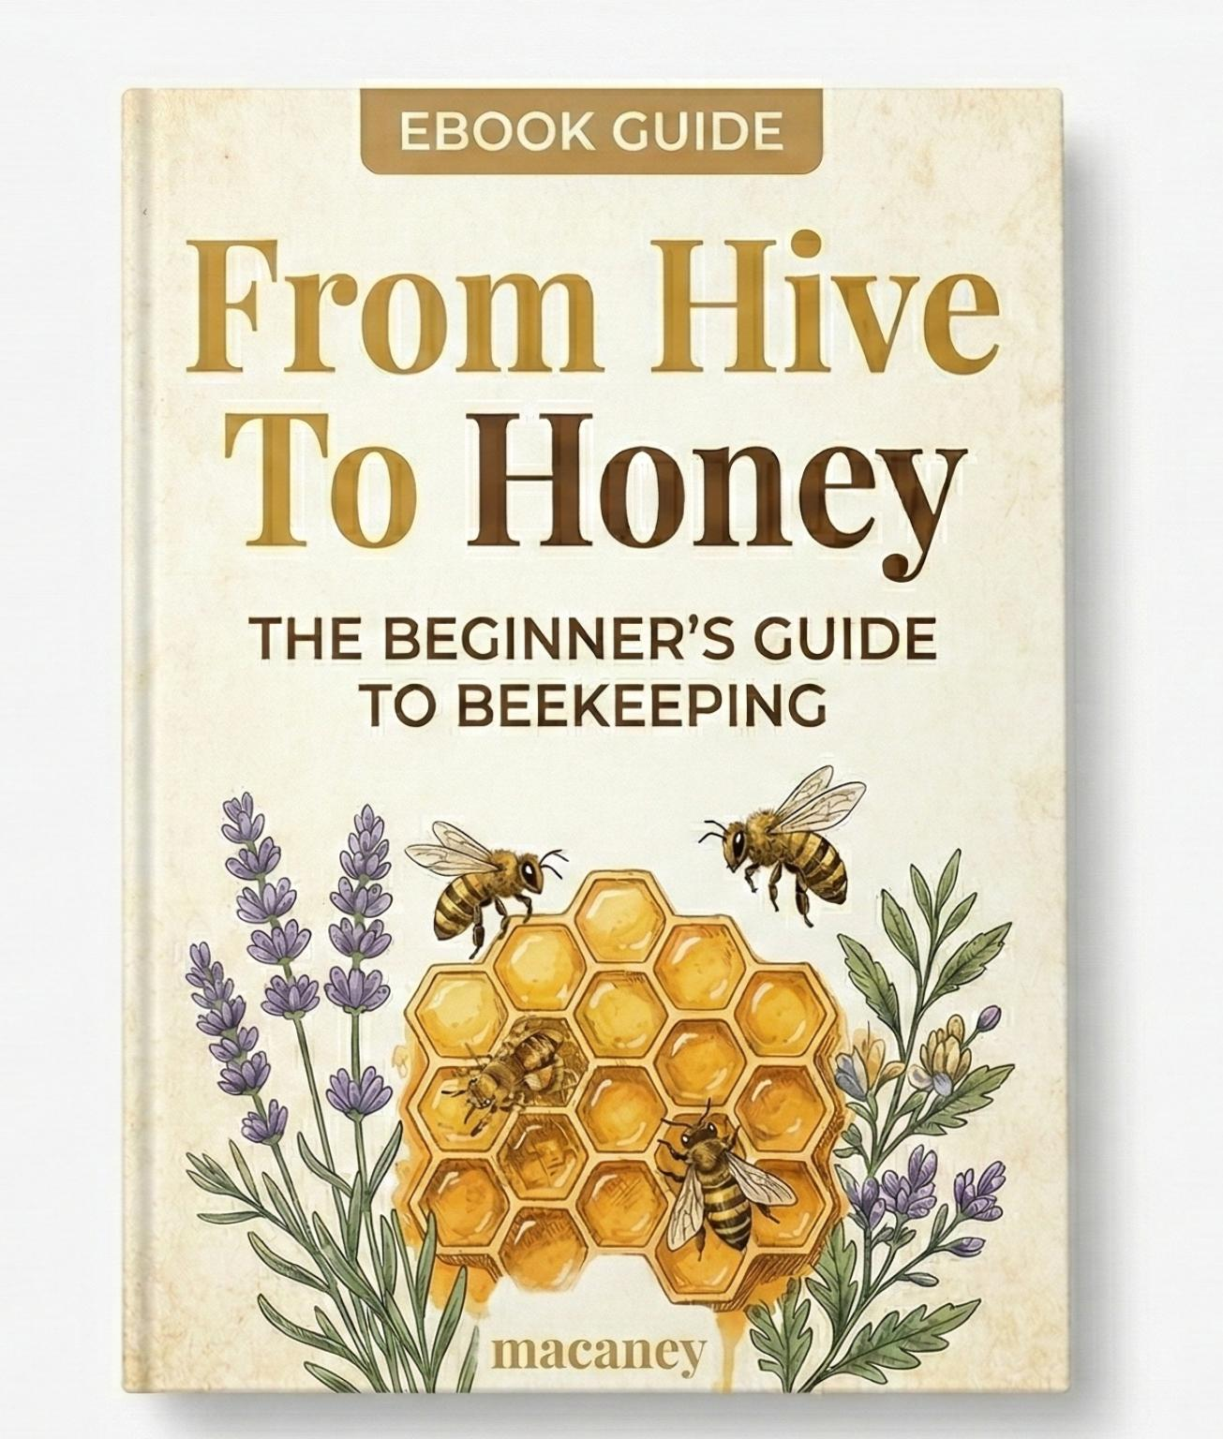

AUTHOR: CHIAMAKA PRECIOUS ORJI

From Hive To Honey
The Beginner’s Guide To Beekeeping
Table of Contents
- Welcome to Beekeeping
Why Beekeeping Is More Than Honey
The Opportunity Most People Are Missing

- Understanding the Honey Bee
The Colony Structure
How Bees Produce Honey
What Makes Bees Stay or Leave

- Choosing the Right Hive System
Traditional Hive vs KTB vs Langstroth
Which One Should You Start With?

- Setting Up Your First Apiary
Location Selection
Nectar Sources & Water
Basic Equipment Checklist

- Getting Your First Colony
Baiting vs Buying Colonies
Signs of a Healthy Colony

- Avoiding Beginner Mistakes
Why Bees Abscond
Poor Hive Management
Harvesting Too Early

- Harvesting and Handling Honey
When to Harvest
Basic Processing & Storage

- The Business Side of Beekeeping
Selling Honey Profitably
Common Marketing Mistakes

- Your Next Step
Why Most Beginners Fail Alone
How Proper Guidance Changes Everything
Invitation to the Mentorship Program

Chapter One
Welcome to Beekeeping
My Beginning
When I first started beekeeping, I did not start as an expert.
I started curious.
I had questions. I had doubts. I had excitement. But I had real guidance From my mentor with over 25years of experience in Beekeeping, I learnt from the best and avoided most beginners mistakes.
Like most beginners I never knew they was anything like beekeepers until my 3rd year at the University, I Over heard my Lecturer who later became my beekeeping mentor talking about it, and I decided to join them for the training, I paid immediately because I was curious.
The truth! Immediately I went to visit the bees, something sparked up in me, it was pure love and excitement, from then on I dedicated all my time to studying bees.
I then went on to write a book with my mentor titled “THE SECRET LIVES OF BEES”.
From then on I had a mission and that is to Organize the Fragmented beekeeping industry in Nigeria and move to support it to become the #1 honey Export producers in the world.
And that was how macaney Sustainable solutions came into existence.

I would not lie the journey is difficult, but nothing good comes easy..
But I did not quit.
I observed. I learned. I failed forward. I corrected errors. I studied bee behavior instead of fighting it.
That was when everything changed.
I stopped “trying to keep bees” and started understanding how bees think, move, respond, and survive. My results improved. My confidence grew. And beekeeping became more than just honey. It became a system.

If you are reading this now, you are at the beginning of that same journey.

Let’s start properly.

Beekeeping Terms You Must Understand
Before you step fully into practical beekeeping, you must understand the language. Beekeeping has its own vocabulary. If you misunderstand the terms, you will misunderstand instructions.
Below are essential terms used throughout this book.
- Hive
A man-made structure where bees live. It is the box or container that houses the colony. It can be traditional, KTB, or Langstroth.

- Colony
The entire bee community living inside a hive. It includes the queen, worker bees, drones, brood, and stored food.

- Queen
The reproductive female bee responsible for laying eggs and maintaining colony population.

- Worker Bees
Female bees that perform all major tasks in the hive, including foraging, cleaning, feeding larvae, and guarding.

- Drones
Male bees whose primary role is to mate with a queen.

- Brood
Developing bees inside cells. This includes eggs, larvae, and pupae.

- Nectar
Sweet liquid collected from flowers. Bees convert nectar into honey.

- Pollen
Powdery substance from flowers that bees collect as a protein source for feeding brood.

- Nectar Flow
A period when flowers produce abundant nectar, allowing bees to store surplus honey.

- Dearth Period
A time when nectar is scarce. Colonies may struggle if food reserves are low.

- Absconding
When an entire colony abandons the hive due to stress or unsuitable conditions.

- Swarm
A group of bees that leaves an existing colony to form a new one, usually led by a queen.

- Apiary
A location where multiple hives are kept.

- Inspection
Opening and examining the hive to check colony health, brood pattern, food stores, and pest presence.

- Capped Honey
Honey that has been sealed with wax by bees, indicating it is fully ripened and ready for harvest.

- Moisture Content
The amount of water in honey. High moisture can cause fermentation.

- Fermentation
Spoilage of honey caused by excess moisture, leading to sour taste and reduced quality.

- Frame
A removable structure inside a Langstroth hive that holds comb.

- Top Bar
A horizontal wooden bar used in a Kenya Top Bar hive where bees build natural comb.

- Comb
The hexagonal wax structure built by bees to store honey and raise brood.

- Feeder
A device used to supply sugar syrup to bees during scarcity.

- Hive Tool
A metal tool used to pry open hive parts and separate frames during inspection.

- Smoker
A device that produces cool smoke to calm bees during hive inspection.

Understanding these terms allows you to follow instructions accurately, communicate with other beekeepers confidently, and avoid costly mistakes caused by misunderstanding.
Clarity in language leads to clarity in action.

Why Beekeeping Is More Than Honey
Most beginners enter beekeeping for one reason: honey.
But honey is only the surface.
Beekeeping is:
Pollination power that increases crop yield
Wax production
Propolis and other value-added products
A scalable agricultural business
A long-term wealth asset if structured correctly
A single strong colony can visit thousands of flowers in a day. That activity supports agriculture in ways most people never think about.
When you understand this, you stop seeing bees as insects in a box.
You start seeing them as an agricultural engine.

The Opportunity Most People Are Missing
Here is the truth.
Beekeeping looks simple from outside. That is why many people jump in unprepared.
They set up hives without studying location.
They ignore nectar flow patterns.
They harvest too early.
They lose colonies and assume beekeeping “doesn’t work.”
The opportunity is not just in owning hives.

The opportunity is in doing it correctly.
In many regions, demand for pure honey is higher than supply. Fake honey dominates markets. Consumers are desperate for authenticity. Restaurants, supermarkets, and health-conscious buyers are searching for reliable suppliers.

This gap is where smart beekeepers win.
But winning requires knowledge, structure, and guidance.
This book will give you the foundation.
The deeper mastery comes when you move beyond information into implementation.
And that is what we will build step by step.

Chapter Two
Understanding the Honey Bee
There are over 20,000 bee species in the world, but less than 5% of them produce honey in quantities humans can harvest. Most bees are solitary. They do not live in large colonies, they do not store surplus honey, and they are not suitable for hive management. The species we focus on in beekeeping, especially here in Nigeria, is Apis mellifera, commonly known as the Western honey bee. This is the species that forms large, organized colonies, produces surplus honey, builds wax comb, and can be managed in hives like the KTB or Langstroth. In Nigeria, the subspecies commonly found is well adapted to tropical conditions. They are resilient, defensive, hardworking, and capable of strong honey production when properly managed. Understanding Apis mellifera is essential because everything in this book revolves around managing this particular species effectively and profitably.
If you misunderstand bees, you will struggle with them.
If you understand bees, you will work with them.
Beekeeping is not about controlling insects. It is about managing a superorganism. A colony behaves like one living body made up of thousands of smaller parts.
Let’s break it down properly.

The Colony Structure
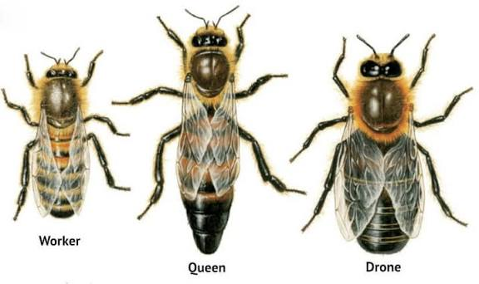

A honey bee colony has three types of bees:
- The Queen
She is the reproductive engine of the colony.
Her primary role is laying eggs. A strong queen can lay up to 1,500 to 2,000 eggs per day during peak season.
No queen. No future colony.

- Worker Bees
These are all female. They do almost everything:
Cleaning
Feeding larvae
Guarding the entrance
Foraging for nectar and pollen
Producing wax
Regulating hive temperature
When you think of “bees working,” you are thinking of workers.

- Drones
Male bees. Their primary purpose is to mate with a virgin queen.
They do not forage. They do not produce honey.
During scarcity, workers often push them out to conserve resources.
When you inspect a hive, what you are really checking is balance.
Is the queen laying properly?
Are there enough workers?
Is the colony population increasing or declining?

Classification of Worker Bees.
Worker bees are not randomly assigned duties.
Their roles change as they age. This system is called age polyethism which simply means division of labor based on age. From the moment a worker bee emerges from her cell, her job will keep changing as her body develops.
Here is how it works:
Day 1 to 3 – Cleaner Bees
Immediately after emerging from the cell, the young worker begins cleaning. She cleans the very cell she was born in and prepares it for the queen to lay eggs again. Clean cells are critical for healthy brood development.

Day 3 to 10 – Nurse Bees
As her glands develop, she begins feeding larvae. She produces brood food and royal jelly from special glands in her head. At this stage, she cares for developing baby bees and attends to the queen.

Day 10 to 16 – House Bees
Her duties expand inside the hive. She receives nectar from foragers, helps process it into honey, builds wax comb, fans her wings to regulate temperature, and guards the entrance if necessary.

Day 16 to 21 – Guard Bees
Now stronger and more alert, she may take up guarding duties at the hive entrance. She checks incoming bees and defends the colony from intruders.

Day 21 until death – Forager Bees
This is the final and most dangerous stage. She leaves the hive to collect nectar, pollen, water, and propolis. Foraging is risky, and most worker bees die in this phase due to exhaustion or predators.
A worker bee’s lifespan during active season is typically 5 to 6 weeks. In that short time, she moves through multiple careers, each essential for colony survival.
Understanding this progression helps you interpret colony strength. A hive full of young bees behaves differently from one dominated by older foragers. When you inspect a hive, you are not just seeing “bees.” You are observing a structured workforce organized by biology and time.

How Bees Produce Honey
Honey is not just “collected.”
It is processed.
- Worker bees collect nectar from flowers.
- The nectar is stored temporarily in a special honey stomach.
- Enzymes begin breaking down complex sugars into simpler sugars
- Back at the hive, nectar is passed between bees, reducing moisture content.
- Bees deposit it into cells and fan their wings to evaporate excess water.
- When moisture drops to a safe level, they cap the cell with wax.
That capped honey is what you harvest.
If you harvest before capping, moisture content will be high.
High moisture means fermentation.
Fermentation means spoiled honey.
Understanding this alone saves many beginners from costly mistakes.

What Makes Bees Stay or Leave
Many beginners blame “bad luck” when bees abscond.
It is rarely luck.
Bees leave when:
The hive environment is too hot
There is trapped humidity and mold
There is constant disturbance
Food sources are insufficient
Pests or predators stress the colony
The hive location is poorly chosen
Bees are highly sensitive to their environment.
If conditions feel unsafe or unproductive, they relocate.
Your role as a beekeeper is simple:
Create a space where bees want to stay.
Not by forcing them.
By understanding what they need.
Once you master bee behavior, management becomes easier.
And once management becomes easier, productivity increases.
This is the difference between guessing and knowing.

Chapter Three
Choosing the Right Hive System
This is where many beginners get confused.
They argue about hive types before they understand bee behavior.
Your hive is a tool.
The bees are the system.
Choose the tool that fits your environment, budget, and management style.
Let’s break it down clearly.

Traditional Hive
The traditional hive is common in many rural communities.
It is usually made from hollowed logs, clay pots, or locally constructed materials. It is affordable and easy to build.
Advantages:
Low cost
Easy to construct with local materials
Suitable for remote areas
Limitations:
Difficult to inspect
Hard to manage colony health
Destructive harvesting in many cases
Low honey yield compared to modern systems
Traditional hives can catch bees.
But they do not give you full control as a serious beekeeper.

Kenya Top Bar Hive (KTB)
The KTB is designed for easier management without complex frames.
It uses top bars instead of full frames. Bees build natural comb attached to each bar.
Advantages:
Easy to inspect
Lower cost than Langstroth
Encourages natural comb building
Suitable for small to medium scale operations
Limitations:
Comb can break if handled poorly
Slightly lower productivity than Langstroth when scaling
Requires careful handling during inspections.
For beginners who want balance between cost and control, KTB is often a strong starting point.

Langstroth Hive
This is the most widely used modern hive system.
It uses removable frames inside stacked boxes, allowing expansion as the colony grows.
Advantages:
High honey yield potential
Easy expansion
Efficient for commercial scaling
Non-destructive harvesting
Limitations:
Higher startup cost
Requires proper training
More equipment needed
If your goal is serious production and long term scaling, Langstroth offers flexibility and efficiency.

Which One Should You Start With?
Ask yourself:
What is my budget?
Am I starting small or planning to scale fast?
Do I have access to proper training?
What hive type works best in my region?
There is no emotional answer here.
There is only strategic choice.
Many beginners copy what others are using without understanding why.
The right hive system does not guarantee success.
Proper management does.
And management is where guidance matters most.
Choosing the correct hive is step one.
Knowing how to run it profitably is step two.

Chapter Four
Setting Up Your First Apiary
You can buy the best hive in the market.
If you place it in the wrong location, you will struggle.
Apiary setup is not decoration.
It is strategy.
Bees respond to environment more than equipment. If the environment works, the hive works.

Location Selection
Your apiary should be:
Quiet and away from constant human disturbance
Protected from strong winds
Not directly exposed to harsh afternoon sun
Safe from flooding during heavy rains
Partial shade is ideal. Under trees is good, but not in a damp, moldy area.
Also consider security.
Beekeeping equipment is an investment. Protect it.
Good location reduces stress on the colony.
Less stress means stronger production.

Nectar Sources and Water
Bees do not produce honey from thin air.
They need consistent nectar flow within flying distance. Ideally within 2 to 3 kilometers.
Before setting up hives, ask:
What crops are around?
Are there flowering trees?
When is peak nectar flow season?
Is there dearth period and how long?
Without nectar, bees survive.
With nectar, bees produce.
Water is also essential. Bees use water to regulate hive temperature and dilute honey for feeding larvae.
If there is no natural water source nearby, provide one. A simple shallow container with stones for landing can work.
No nectar, no surplus honey.
No water, stressed colony.

Basic Equipment Checklist
At minimum, you need:
Hive boxes or top bar hive
Hive stand
Protective clothing
Hive tool
Smoker
Bee brush
Do not overspend on equipment you do not understand.
Start with essentials.

JOIN MY WHATSAPP GROUP WHERE I EXPLAIN THIS IN MORE DETAIL FOR FREE! CLICK ME
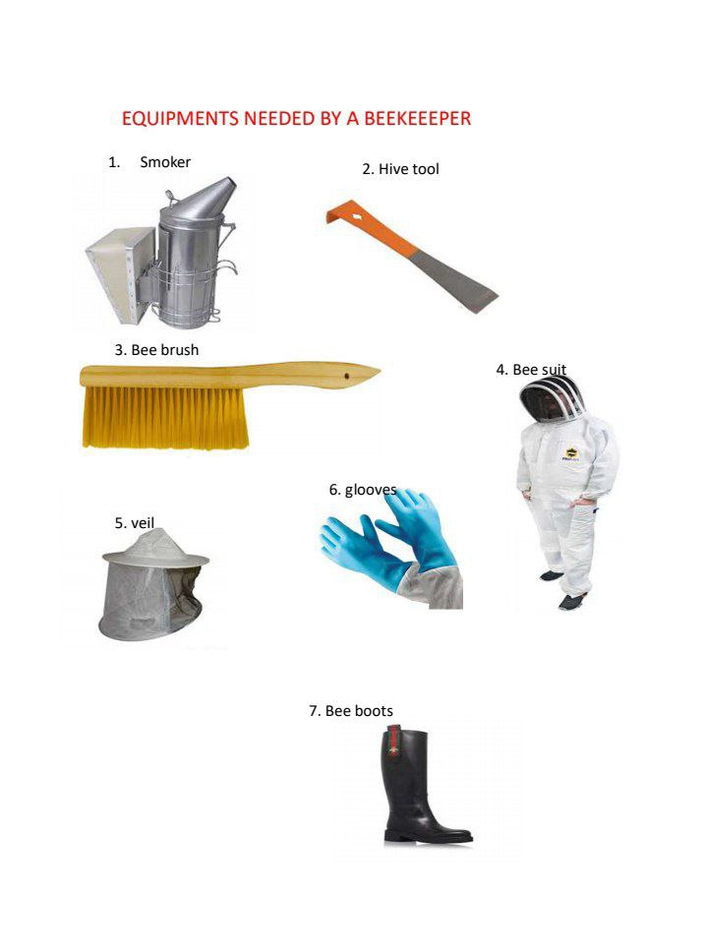

Master management first.
Equipment does not create profit.
Management creates profit.
A well-positioned apiary reduces absconding, improves colony strength, and increases harvest potential.
Many beginners rush this stage.
Experienced beekeepers plan it carefully.
The difference shows during harvest season.

Chapter Five
Getting Your First Colony
Your hive is ready.
Now comes the moment many beginners rush.
Getting bees.
This stage determines whether your journey starts smoothly or becomes a cycle of frustration.

Baiting vs Buying Colonies
There are two main ways to populate your hive.
- Baiting (Attracting a Swarm)
You set up your hive and wait for a natural swarm to occupy it.
Advantages:
Lower cost
Natural colony
Strong genetics adapted to your environment
Disadvantages:
Unpredictable timing
No guarantee of quick occupation
Requires proper preparation.
If your hive is poorly positioned or unattractive to bees, it may stay empty for months.
Baiting is strategic patience.

- Buying a Colony
You purchase an already established colony from another beekeeper.

Advantages:
Faster start
Immediate colony presence
Reduced waiting time
Disadvantages:
Higher cost
Risk of weak or poorly managed colony
Possible pest or disease transfer
If you do not know how to inspect colony strength, you can easily overpay for a weak setup.
Buying is fast, but speed without knowledge is expensive.

Signs of a Healthy Colony
Whether you baited or bought, you must assess strength.
Look for:
Active entrance activity
Bees carrying pollen
Calm behavior during inspection
Presence of eggs and brood
Capped brood pattern that looks compact, not scattered
Adequate food stores
A strong colony grows.
A weak colony survives.
Your goal is growth.
Many beginners celebrate too early once bees enter the hive.
Occupation is not success.
Stability is.
The first few weeks are critical.
Avoid excessive disturbance.
Observe more than you interfere.
If you understand colony strength from the beginning, you prevent losses before they happen.
And prevention is always cheaper than correction.

Chapter Six
Avoiding Beginner Mistakes
Beekeeping rarely fails because bees are stubborn.
It fails because beginners repeat avoidable errors.
The painful part is this: most of these mistakes look small in the beginning. The consequences show later.
Let’s confront them directly.

Why Bees Abscond
Absconding is not random.
When an entire colony leaves, they are responding to pressure.
Common triggers include:
Excessive disturbance from frequent inspections
Trapped humidity and mold inside the hive
Poor location with weak nectar flow
Ants, termites, or predators stressing the colony
Overheating due to direct sun exposure
Poor hive construction with internal discomfort
Many beginners assume adding extra holes equals ventilation.
It does not.
Ventilation is about airflow balance and moisture control, not random openings.
If humidity builds up and mold forms, bees will not tolerate it. They relocate.
Your job is to create a stable, comfortable environment. Not a box that looks good outside but fails inside.

Poor Hive Management
Management mistakes include:
Opening the hive too often
Crushing bees during inspection
Ignoring signs of weak queen performance
Allowing pests to multiply
Failing to monitor food stores during dearth
Each inspection must have purpose.
Do not open a hive just to satisfy curiosity. Bees value stability. Every unnecessary disturbance reduces productivity.
Good management is calm, intentional, and observant.

Harvesting Too Early
This is one of the most common profit-killers.
New beekeepers see honey and rush to harvest.
If the honey is not fully capped, moisture content will be high. That leads to fermentation and spoilage.
Also, harvesting too much leaves the colony weak, especially before a dearth period.
A smart beekeeper thinks beyond today’s harvest.
Take surplus. Leave strength.

Most beginner mistakes come from impatience.
Beekeeping rewards discipline.
The colony moves according to seasons, nectar flow, and internal biology. If you move faster than that rhythm, you create problems.
Mastery begins when you stop reacting emotionally and start managing strategically.

Chapter Seven
Harvesting and Handling Honey
Harvesting honey is where the sweet reward of beekeeping meets the first real test of your skill. Do it right, and you have pure, market-ready honey. Do it wrong, and you risk loss, fermentation, or weakened colonies.
This chapter teaches you the basics so your first harvest is a success.
When to Harvest
Timing is everything. Harvest too early, and honey is watery. Wait too long, and the colony may consume most of it.
Signs that honey is ready:
Most of the honey cells are capped with wax
Frames feel heavier than before
Bees are actively storing nectar but not building new comb rapidly
Remember: bees always keep enough honey for themselves. Never harvest everything.

Basic Processing & Storage
Once harvested, honey must be handled carefully:
- Remove bees gently – Use a bee brush or smoker. Avoid crushing bees.
- Extract honey – For KTB, crush and strain; for Langstroth, use a centrifugal extractor if available.
- Filter impurities – Remove wax particles, dead bees, or debris.
- Store properly – Use clean, airtight containers. Avoid moisture contamination.

Tips for beginners:
Do not heat honey excessively. It kills enzymes and reduces quality.
Keep honey away from direct sunlight.
Label containers with date and source for traceability.

Protecting Colony Strength
Your harvest should never compromise the hive:
Leave enough honey for the colony to survive until the next nectar flow.
Avoid overharvesting during dearth periods.
Always inspect the hive after harvest to ensure the queen and brood are safe.
Honey is your reward, but the colony is your ongoing investment. Protect the system, and it will continue producing for years.

Harvesting is more than a task.
It’s a balance between profit and colony sustainability.
Master this, and you’ve crossed from beginner curiosity into strategic beekeeping.

Chapter Eight
The Business Side of Beekeeping
Beekeeping is sweet—but only when you turn honey into profit.
Many beginners focus on hives, bees, and harvesting, but forget the most important step: selling effectively.
If you produce honey and nobody buys it, your efforts are wasted. Let’s change that.

Selling Honey Profitably
Think beyond the backyard jar. Real profit comes from:
Local markets & grocery stores – Start small, sell consistently.
Health-conscious buyers – People pay more for pure, unprocessed honey.
Value-added products – Beeswax, propolis, and royal jelly can double your revenue.

Tips for beginners:
Brand your honey—even with a simple label. People trust packaging.
Be consistent with quality. One bad batch can harm your reputation.
Build relationships with buyers. Repeat customers are gold.

Common Marketing Mistakes
Selling to anyone who will buy, without understanding market demand
Ignoring digital platforms like WhatsApp, Instagram, or local Facebook groups
Not educating buyers about your honey’s quality
Overpricing or underpricing because of emotion rather than strategy
Profit comes from strategy, consistency, and trust, not just volume.
Turning Knowledge into a Scalable Business
Beekeeping is more than a hobby when approached correctly:
Track your harvests and costs
Plan hive expansion around market demand
Understand seasonal peaks for nectar flow and sales
Keep learning to improve efficiency and product quality
Many beginners fail because they treat beekeeping like a hobby.
The ones who succeed see bees as a business system, where every action affects both productivity and profit.

By now, you’ve learned the basics: bees, hives, location, management, and harvesting.
But here’s the truth: knowledge alone won’t make you a profitable beekeeper.
The next step is mastering execution—and that is where guided mentorship becomes the fastest shortcut to success.

Chapter Nine
Your Next Step
First, thank you.
Thank you for reaching the end of this ebook. The fact that you read through every chapter shows one thing clearly: you are serious about beekeeping. Most beginners stop halfway. You didn’t. That alone sets you apart.

Why Most Beginners Fail Alone
Being serious is only the first step. Knowledge alone does not guarantee success.
Many beginners fail because:
They mismanage hives without understanding bee behavior
They harvest too early or too late
They struggle to find buyers or price honey correctly
They try to scale without guidance, losing colonies or money
Even with the best intentions, working alone can cost years of progress.

How Proper Guidance Changes Everything
Mentorship bridges the gap between theory and real results. With guidance, you will:
Inspect hives efficiently without stressing your bees
Harvest optimally for maximum yield and colony strength
Expand strategically without unnecessary loss
Market and sell honey profitably from day one
Get direct support whenever challenges arise.
What usually takes beginners years to figure out can be learned in months with proper mentorship.

Invitation to the Mentorship Program
If you are serious—and finishing this ebook proves that—my mentorship program is designed for you.
Here’s what you’ll gain:
Step-by-step hive management strategies
Colony setup and optimization for your environment
Harvesting and processing methods that protect quality
Marketing and sales techniques to maximize income
Direct guidance and support throughout your journey
The difference between hobbyist beekeeping and profitable beekeeping is having experience-guided action.

Conclusion
Beekeeping is more than honey—it’s a system.
You can struggle and learn slowly on your own, or you can take guided action and grow quickly.
Since you made it this far, the choice is clear. You are serious. You want results.
The next step is simple: take action, start strong, and protect your bees, your harvest, and your future.

Text MENTOR now to Whatsapp +2349014671808 To secure your SPOT and join the journey toward becoming a successful beekeeper.

