 YUI Library: ImageCropper Control 2011-3-21 v2.9
 |  | YAHOO.widget.ImageCropper: Methods  getActiveHandleEl() Get the HTML reference for the currently active resize handle.  getCropCoords() Get the coordinates needed to crop the image  getCropperById() Get an ImageCropper object by the HTML id of the image associated with the ImageCropper object.  getEl() Get the HTML reference for the image element.  getMaskEl() Get the HTML reference for the mask element.  getResizeEl() Get the HTML reference for the resize element.  getResizeMaskEl() Get the HTML reference for the resizable object's mask element.  getResizeObject() Get the Resize Utility object.  getWrapEl() Get the HTML reference for the wrap element.  destroy() Destroys the ImageCropper object and all of its elements & listeners.
  Simple Use Case: YAHOO.widget.ImageCropper
  Markup:
  <img src="yui.jpg" id="crop1">
  Script:
  crop = new YAHOO.widget.ImageCropper('crop1');
  Using the above code will get you a rich control that looks something like this:
  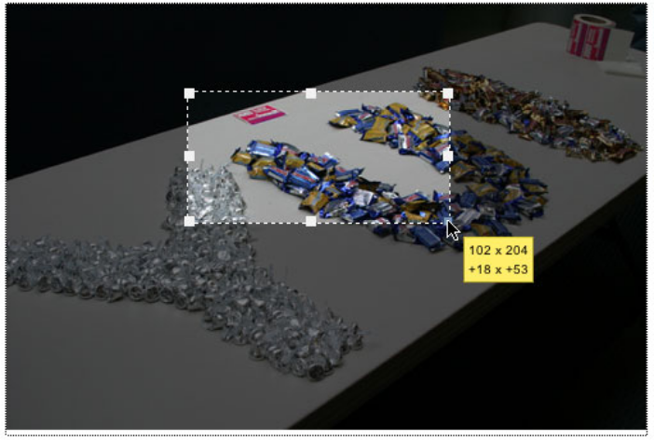
  Constructor: YAHOO.widget.ImageCropper
  YAHOO.widget.ImageCropper(str | el ref container[, obj config])
  Arguments:
  (1) Element: The element to make croppable.
  (2) Configuration object: When instantiating the ImageCropper Control, you can pass all configurations in as an object argument or configure the instance after instantiation. See Configuration Options section for common configuration object members.
  Dependencies
  ImageCropper requires the Yahoo Global Object, Dom, Event, Element, DragDrop, and Resize.
  ImageCropper Events
  See online docs for complete list of Resize events.
  Event | Fires...
  dragEvent | Fires when the DragDrop dragEvent is fired.
  startResizeEvent | Fires when a resize action is started.
  resizeEvent | Fires on event element resize
  moveEvent | Fires on every element move. Inside these methods: _handleKeyPress, _handleDragEvent, _handleResizeEvent
  All ImageCropper events are Custom Events (see Element docs); subscribe to these events using their subscribe method: crop.on(‘resize',fnMyHandler);.
  Key ImageCropper Configuration Options
  See online docs for complete list of ImageCropper configuration options.
  Option | Default | Description
  initHeight | 1/4 of the image height | Set the initlal height of the crop area.
  initWidth | 1/4 of image width | Set the initla width of the crop area.
  initialXY | [10,10] | Array of the XY position that we need to set the crop element to when we build it.
  keyTick | 1 | The pixel tick for the arrow keys.
  ratio | false | Constrain the resize to a ratio of the current size.
  status | True | Show the Resize Utility status.
  Most of ImageCropper’s options can be set in the constructor's second argument (eg,
  {ratio: true}) or at runtime via set (eg, crop.set("ratio", true);).
  Getting the crop area
  //set up a new cropper
  var cropImg = new YAHOO.widget.ImageCropper('img1');
  //get the crop area
  var cropArea = cropImg.getCropCoords();
  // cropArea now looks like this:
  {
  top: 70,
  left: 122,
  height: 86,
  width: 172,
  image: 'yui.jpg'
  }

