 YUI Library: Carousel 2011-3-21 v2.9
 |  | YAHOO.widget.Carousel  containerId (str)  cfg (Config)  the carousel’s configuration object  YAHOO.widget.Carousel Methods  Manipulation:  addItem(String, index)  addItems(array)  replaceItem(String, index)  replaceItems(array)  clearItems()  removeItem(int)  registerPagination(String)  updatePagination()  Navigation:  scrollBackward()  scrollForward()  scrollTo(int)  Rendering:  render([String])  renders current state to page  show()  hide()  Selection:  set(“selectedItem”, int)  Other:  resets carousel to original state  carousel.set  (propName, propValue)  carousel. get  (propName)
  Simple Use Case: YAHOO.widget.Carousel
  Styles:
  .yui-carousel-element li { width: Ypx; height: Zpx; }
  Markup:
  <div id="container"><ul><li>item</li></ul></div>
  Script:
  var carousel = new YAHOO.widget.Carousel("container");
  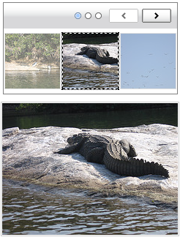
  carousel.render();
  Creates a simple Carousel of items inside the list container (UL).
  Carousel ships with a skin (left) that provides visual elements for the navigation controls. Apply the CSS class yui-skin-sam to the body element or other parent element of your Carousel’s container in order to make use of the default skin.
  Constructor: YAHOO.widget.Carousel
  YAHOO.widget.Carousel([str container,] [,obj config]);
  Arguments:
  (1) container: HTML ID or HTMLElement of existing markup to use when building Carousel. This should be a UL or an OL element.
  (2) Configuration Object: JS object defining configuration properties for the Carousel instance. See Configuration section and online docs for a list of these options.
  Carousel Options
  Configure options using the constructor configuration object or set(), as described in “Solutions”
  Carousel objects include several configurable options, including:
  animation  autoPlayInterval | isCircular  isVertical | numVisible  revealAmount
  Dependencies
  Carousel requires YAHOO, Dom, Event and Element.
  Interesting Moments in Carousel
  See online docs for complete list of Carousel events.
  Event | Fires... | Passes back:
  afterScroll | After the viewport in the Carousel has scrolled. | The indices of the first and last items in the viewport.
  itemAdded | After an item has been added to the Carousel. | The content of the inserted item and the position where it is inserted.
  pageChangeEvent | When the Carousel navigates to a new page. | Page number of the current page.
  navigationStateChange | When the state of the navigation buttons change (enabled/disabled). | The state of the navigation buttons (true if enabled, false otherwise)
  loadItems | When the Carousel needs more items to be loaded for displaying them. | The first and last visible items in the Carousel and the number of items to be loaded.
  All Carousel events are Custom Events (see Event Utility docs); subscribe to these events using their subscribe method: carousel.loadItems.subscribe(fnMyHandler);. Event-specific arguments, if present, will be passed in an array as the second argument to the event handler. Some events also have a before event to which you can subscribe.
  Solutions
  Basic markup for a Carousel:
  <div id="container">
  <ul>
  <li><img alt="" src="..."></li>
  </ul>
  </div>
  Render a Carousel that scrolls automatically every two seconds and animating while scrolling:
  carousel = new YAHOO.widget.Carousel("container", {
  autoPlayInterval: 2000, animation: { speed: 0.5 }
  });
  carousel.render();
  carousel.startAutoPlay();
  There are two ways to configure options on your Carousel:
  // 1. In the constructor, via an object literal:
  carousel = new YAHOO.widget.Carousel("container", {
  isCircular: true
  });
  // 2. Via "set":
  carousel.set("isCircular", true);
YUI Library: Carousel 2011-3-21 v2.9
  Multi-row Carousel
  Styles:
  .yui-carousel-element li { width: Ypx; height: Zpx; }
  Markup:
  <div id="container"><ul><li>item</li></ul></div>
  Script:
  var carousel = new YAHOO.widget.Carousel("container", {
  numVisible: [ 3, 4 ]
  });
  carousel.render();
  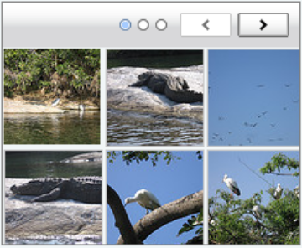
  Creates a simple multi-row Carousel of items inside the list container (UL) to display items in an album view layout.
  Accomplished by setting Carousel’s numVisible property to an array containing the number of columns and rows of items to display.
  Items can be applied any width or height via CSS and can contain more markup than just image tags.
  Other single-row Carousel events, methods, and options are still available in multi-row including (but not limited to): loadItems, animation, autoPlayInterval, isCircular, and isVertical.
  Pagination Template
  Render a Carousel that displays pagination data:
  var carousel = new YAHOO.widget.Carousel("container”);
  carousel.registerPagination("<strong>Image</strong> {firstVisible} - {lastVisible} <strong>of</strong> {numItems}");
  carousel.render();
  After Carousel instantiation, we use the public registerPagination method to register a text or HTML template embedded with Carousel {tokens}.
  
  The public updatePagination method automatically substitutes each token with its respective data on render and every time Carousel’s state changes.
  Any combination of the following tokens can be embedded in your template:
  numVisible, numPages, numItems, selectedItem, currentPage, firstVisible, and/or lastVisible.

