 YUI Library: Color Picker Control 2011-3-21 v2.9
 |  | YAHOO.widget.ColorPicker:  Methods  getElement(id | key element) returns the requested element; see API docs for keyset…pass in YUI_PICKER to return the host element for the instance  setValue(arr RGB[, b silent]) sets the currently selected color  YAHOO.widget.  ColorPicker: Form Fields  When a form wrapping a Color Picker instance is submitted, the following form fields are included:
  Simple Use Case: YAHOO.widget.ColorPicker
  Markup:
  <div id="picker"></div>
  Script:
  var oPicker = new
  YAHOO.widget.ColorPicker("picker", {
  showhsvcontrols: true,
  showhexcontrols: true
  );
  Creates a Color Picker instance from script; the Color Picker's DOM structure is created in the element whose ID is "picker".
  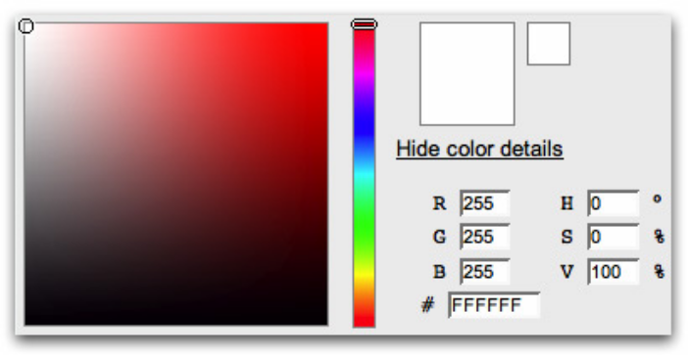
  Constructor: YAHOO.widget.ColorPicker
  YAHOO.widget.ColorPicker(str ID|HTMLElement element[, obj config]);
  Arguments:
  (1) Element: HTML ID or HTMLElement where the Color Picker Control will be inserted.
  (2) Configuration Object: JS object defining configuration properties for the Color Picker instance. See Configuration Options section for full list.
  Setting the Color Picker's Value
  You can set the Color Picker's current value by script any time after instantiation using setValue:
  oPicker.setValue([255, 255, 255], false);
  The second argument is a boolean; if true, it suppresses the rgbChange event that would otherwise be fired when the value is changed.
  Interesting Moment in Color Picker
  This is the full list of Custom Events exposed in the Color Picker API.
  Event: | Event Fields:
  rgbChange | newValue (arr) and oldValue (arr), in both cases an array of RGB values; type (s), "rgbChange".
  All Color Picker events are Custom Events (see Event Utility docs); subscribe to these events using “addListener” or "on": (e.g. oPicker.on('rgbChange', fn); ).
  Key Color Picker Configuration Options
  See online docs for complete list of Color Picker configuration options.
  Option (type) | Default | Description
  showcontrols (b) | true | Hide/show the entire set of controls.
  showhexcontrols (b) | true | Hide/show the hex controls.
  showhexsummary (b) | true | Hide/show the hexadecimal summary information.
  showhsvcontrols (b) | false | Hide/show the HSV controls.
  showrgbcontrols (b) | true | Hide/show the RGB controls.
  showwebsafe (b) | true | Hide/show the websafe swatch.
  images (o) | Default images served by Y! servers | Object Members:  PICKER_THUMB: Image representing the draggable thumb for the color region slider.  HUE_THUMB: Image representing the draggable thumb for the HSV slider.
  Color Picker options can be set in the constructor's second argument (eg,
  {showwebsafe: false}) or at runtime via set (eg, oPicker.set("showwebsafe", false);).
  Solutions
  Listen for the rgbChange event and make use of the event's fields:
  var oPicker = new
  YAHOO.widget.ColorPicker("container");
  //a listener for logging RGB color changes;
  //this will only be visible if logger is enabled:
  var onRgbChange = function(o) {
  /*o is an object
  { newValue: (array of R, G, B values),
  prevValue: (array of R, G, B values),
  type: "rgbChange"
  }
  */
  YAHOO.log("The new color value is " + o.newValue, "info", "example");
  }
  //subscribe to the rgbChange event;
  oPicker.on("rgbChange", onRgbChange);
  yui-picker-r | RGB red
  yui-picker-g | RGB green
  yui-picker-b | RGB bluee
  yui-picker-h | HSV hue
  yui-picker-s | HSV saturation
  yui-picker-v | HSV value/ brightness
  yui-picker-hex | Hex triplet for current color
  Dependencies
  Color Picker requires Yahoo, Dom, Event, Element, Drag & Drop, and Slider. For the richest interaction, the optional Animation Utility is highly recommended.

