MVC
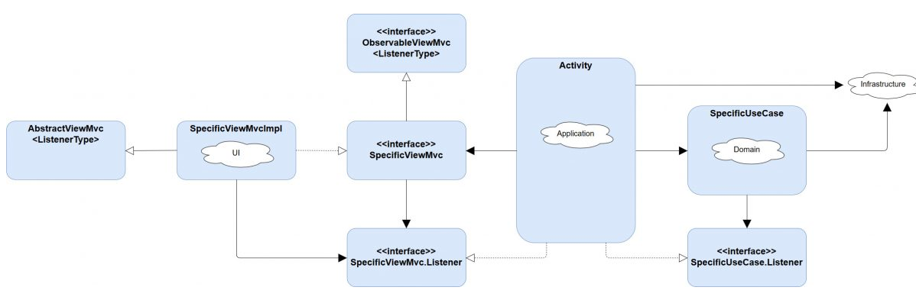
ACTIVITY IS CONTROLLER
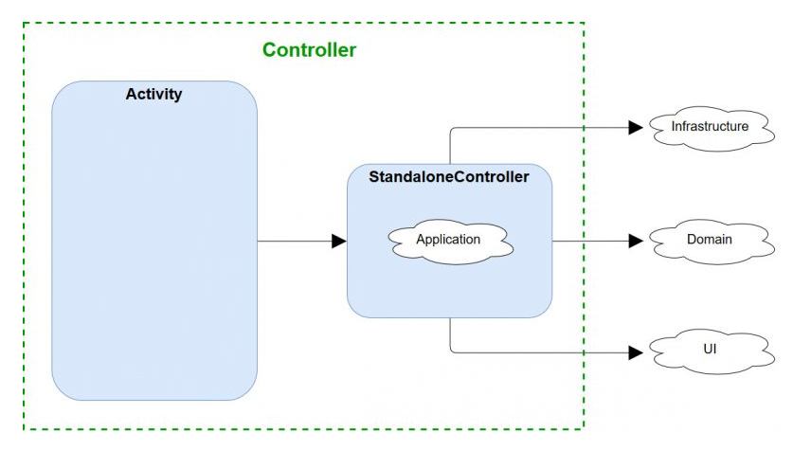

MVVM
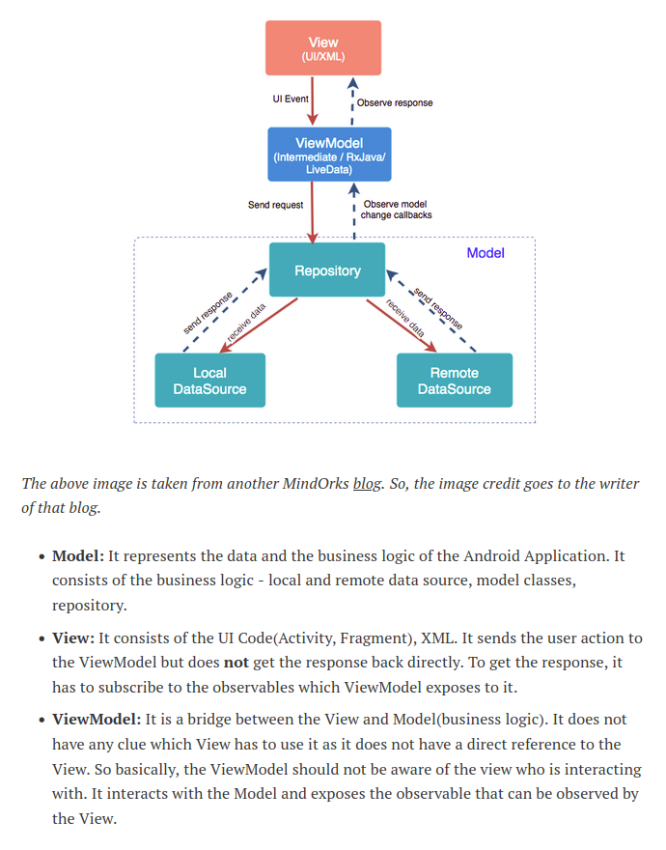

COLLECTIONS

Associate﻿
1) associateWith() creates a Map in which the elements of the original collection are keys, and values are produced from them by the given transformation function.
2) associateBy(). It takes a function that returns a key based on an element's value. If two elements' keys are equal, only the last one remains in the map.
3) associate() should be used when the performance isn't critical or it's more preferable than other options.
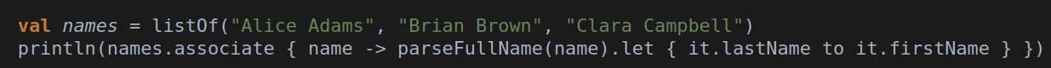
groupBy()
1) groupBy() with a second lambda argument – a value transformation function. In the result map of groupBy() with two lambdas, the keys produced by keySelector function are mapped to the results of the value transformation function instead of the original elements.
partition()
2) partition() – filters a collection by a predicate and keeps the elements that don't match it in a separate list.

CoordinatorLayout

Is a view group that lets you stack views on top of each other.

RxJava

Defer
1) This operator does not create the Observable until the Observer subscribes. The only downside to defer() is that it creates a new Observable each time you get a new Observer. create() can use the same function for each subscriber, so it’s more efficient.

Onsubscribe — применяем только единожды, сработает только первый
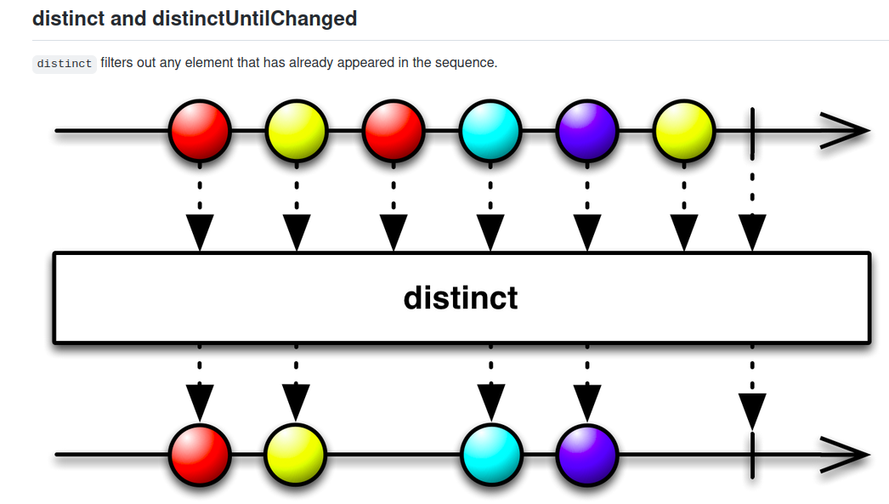

Question 1
Which of the following is true about the floating action button (FAB)?
▢ The FAB is usually associated with a primary action the user can take on the screen.
▢ The FAB must be positioned in the bottom-right corner, 16 dp from the edge of the screen.
▢ The FAB uses a special click handler so that you don't have to write your own view model code.
▢ The FAB is a mandatory element for apps that implement Material Design principles.

Question 2
Which ViewGroup allows you to stack views on top of each other?
▢ CoordinatorLayout
▢ StackedViewsLayout
▢ ConstraintLayout
▢ You cannot stack views

Question 3
Which of the following are reasons for using Material Design components? Select all that apply.
▢ They are designed to be beautiful, functional, and work together.
▢ They help you create an app that uses consistent styling.
▢ They help you make your app accessible for vision impaired users.
▢ Android Studio will give you a warning if you are using a poor color scheme.

Question 4
What is a theme overlay for? Select all that are true.
▢ Allows you to apply attributes from a different theme to a view and all its children.
▢ With a theme overlay, all the styles of that theme are applied automatically.
▢ You create a theme overlay by defining styles in XML.
▢ When you apply a theme to a view, you can use that theme's attributes for the view and all its children.

Question 5
Which of the following are reasons for defining and using dimensions? Select all that apply.
▢ Makes it easier to apply the same measurements across the app.
▢ Allows you to give meaningful semantic names to measurements.
▢ Makes it easier to change measurements across your app.
▢ Dimensions are required for using Material Design.

Question 1
Which component in the Android Architecture Components is responsible for keeping the offline cache up-to-date and getting data from the network?
▢ ViewModel
▢ LiveData
▢ Repository
▢ Activities

Question 2
What is the best way to save structured data on the device file system for offline caching?
▢ Room
▢ Files
▢ Shared preferences
▢ Retrofit caching

Question 3
The Transformations.map converts one LiveData into another _______.
▢ ViewModel
▢ LiveData
▢ Repository
▢ DAO object

Question 4
When implementing offline caching, which one of the following strategies is a good example of the concept of separation of concerns?
▢ Create separate classes to represent the network, domain, and database objects.
▢ Create a single class to represent the network, domain, and database objects.
▢ Create a single class to represent the network and domain objects, and another class to represent the database object.
▢ Create a single class to represent the network object and another class to represent the database and domain objects.

Question 1
What are the concrete implementations of the WorkRequest class?
▢ OneTimeWorkPeriodicRequest
▢ OneTimeWorkRequest and PeriodicWorkRequest
▢ OneTimeWorkRequest and RecurringWorkRequest
▢ OneTimeOffWorkRequest and RecurringWorkRequest

Question 2
Which of the following classes does the WorkManager use to schedule the background task on API 23 and higher?
▢ Only JobScheduler
▢ BroadcastReceiver and AlarmManager
▢ AlarmManager and JobScheduler
▢ Scheduler and BroadcastReceiver

Question 3
Which API do you use to add constraints to a WorkRequest?
▢ setConstraints()
▢ addConstraints()
▢ setConstraint()
▢ addConstraintsToWorkRequest()

