The original article contained errors in thermal-data extraction and growth-stage alignment during data processing. In some plots, excessive bare-soil pixels affected thermal-data extraction, thereby amplifying the apparent contribution of thermal information. In addition, irrigation treatments and cultivar differences may affect crop phenological development, while the previous procedure used to align vegetation indices across growth stages did not fully follow a standardized phenology-based workflow and may therefore have introduced errors. These issues affected the numerical results, tables, figures, and related text. The affected parts are corrected below.

1. In the Abstract
The sentences “In our results, the fusion of dual-sensor data showed high yield prediction accuracy [coefficient of determination (R²) = 0.527–0.667] compared to using a single multispectral sensor (R² = 0.130–0.461). Results showed that the grain filling stage was the optimal stage to predict GY with R² = 0.667, root mean square error (RMSE) = 0.881 t ha⁻¹, relative root-mean-square error (RRMSE) = 15.2%, and mean absolute error (MAE) = 0.721 t ha⁻¹.” should read: “The addition of NRCT improved single-stage yield prediction from jointing to grain filling. Mean R² increased from 0.159 to 0.427 at jointing, from 0.368 to 0.493 at booting, from 0.409 to 0.525 at heading, from 0.444 to 0.518 at flowering, and from 0.479 to 0.518 at grain filling. At maturity, the VI-only and VI+NRCT models showed similar performance.”

The sentences “The EWF model outperformed at all the individual growth stages with R² varying from 0.677 to 0.729. The best prediction result (R² = 0.729, RMSE = 0.831 t ha⁻¹, RRMSE = 14.3%, and MAE = 0.684 t ha⁻¹) was achieved through combining the predicted values of all growth stages.” should read: “For multistage prediction, EWF performed similarly to or better than the individual growth-stage models in most evaluated combinations. The best EWF performance was obtained by combining heading, flowering, and maturity, with a mean R² of 0.558 and an RMSE of 0.970 t ha⁻¹, exceeding the best individual growth-stage result.”

The sentence “This study suggests that the fusion of UAV-based multispectral and thermal IR data within an ENR-EWF framework can provide a precise and robust prediction of wheat yield.” should read: “These results indicate that integrating UAV-based thermal information with multispectral vegetation indices improves wheat yield prediction from jointing through grain filling, although the magnitude of improvement varies among growth stages. EWF can further improve prediction by integrating information from selected growth-stage combinations.”

- In the Results，Subsection Results of Gray Relational Analysis and Feature Selection
In the first paragraph, the sentence “A total of 22 indices were ranked using the GRA method.” should read: “Before GRA, each vegetation index and NRCT were individually fitted to grain yield using simple linear regression. The resulting fitted-yield series were then used to calculate the grey relational degrees. This procedure allowed both positive and negative relationships with grain yield to be evaluated on a consistent basis, which was particularly relevant for NRCT because it was often negatively associated with grain yield.”

In the first paragraph, the sentences “The GRD of the normalized relative canopy temperature (NRCT) ranked first for the jointing, booting, and flowering stages and relatively high for the heading (rank = 10) and grain filling (Rank = 9) stages. However, the NRCT ranked last at maturity.” should read: “NRCT ranked first at jointing, booting, and heading, second at flowering, third at grain filling, and fifth at maturity.”

In the first paragraph, the sentences “For example, plant pigment ratio (PPR) and difference vegetation index (DVI) had a high ranking at both jointing and booting but ranked low at flowering and grain filling. ” should read: “For example, plant pigment ratio (PPR) had a high ranking at both jointing and booting but ranked low at flowering and grain filling. ”

In the second paragraph, the sentences “Among the six developmental stages, the grain filling stage yielded the lowest error, and it tended to be stable when the number of features was 19. The highest error was observed in jointing, and the model showed a stable tendency after inputting 16 features. The appropriate numbers of input features for the booting, heading, flowering, and maturity stages were found to be 18, 18, 22, and 22, respectively.” should read: “For each growth stage, the feature subset with the lowest training error was selected. To enable a consistent comparison between the VI-only and VI+NRCT models, NRCT was retained in all VI+NRCT candidate subsets, while vegetation indices were added sequentially according to their GRD rankings. The final numbers of selected input features, including NRCT, were 11, 6, 2, 21, 2, and 20 for jointing, booting, heading, flowering, grain filling, and maturity, respectively.”

- In the Results, Subsection Performance of Elastic Net Regression Model for Individual Growth Stage
In the first paragraph, the sentences “The mean prediction values for the grain filling stage was R² = 0.461, followed by flowering (R² = 0.432), heading (R² = 0.422), maturity (R² = 0.417), booting (R² = 0.290), and jointing (R² = 0.130). ” should read: “The mean prediction values using multispectral vegetation indices were R² = 0.479 at grain filling, followed by maturity (R² = 0.478), flowering (R² = 0.444), heading (R² = 0.409), booting (R² = 0.368), and jointing (R² = 0.159).”

In the first paragraph, the sentences “The results show that the dual-sensor data fusion method achieves higher prediction accuracy at all measured stages compared to using single multispectral sensor-based features. As with using only multispectral features, the ENR showed the highest prediction results with a low error at the grain filling (R² = 0.667) stage. The mean prediction results at jointing, booting, heading, flowering, and maturity were R² = 0.544, R² = 0.571, R² = 0.602, R² = 0.640, and R² = 0.527, respectively.” should read: “Adding NRCT improved ENR performance from jointing to grain filling. Mean R² values for VI-only and VI+NRCT models were 0.159 and 0.427 at jointing, 0.368 and 0.493 at booting, 0.409 and 0.525 at heading, 0.444 and 0.518 at flowering, and 0.479 and 0.518 at grain filling, respectively. At maturity, the two models produced the same mean R² of 0.478.”

In the second paragraph, the sentences “High correlations ranging from R² = 0.59 to R² = 0.89 between adjacent growth stages were observed across the growth stages. Moreover, the greater the interval between the growth stages, the lower the R²-value. For example, the R² between the jointing stage and the booting, heading, flowering, grain filling, and maturity stages were 0.78, 0.66, 0.64, 0.52, and 0.41, respectively. In comparison, the correlations between the predicted yield in the maturity and other growth stages were lower, with quite weak regression values ranging from R² = 0.41 to R² = 0.59.” should read: “The corrected regression analysis showed that the R²-values between predicted grain yield values from adjacent growth stages ranged from 0.60 to 0.95. The correlations generally decreased as the interval between growth stages increased, although this trend was not strictly monotonic for all stage pairs. For example, the R²-values between the jointing stage and the booting, heading, flowering, grain filling, and maturity stages were 0.89, 0.79, 0.68, 0.68, and 0.60, respectively. The correlations between the predicted grain yield at maturity and those at the other growth stages were moderate, ranging from R² = 0.60 to R² = 0.68.”

- In the Results, Performance of Entropy Weight Fusion Method
In the first paragraph, the sentences “The results indicated that combining the features of multiple stages increases the accuracy of yield prediction than individual stages (Figure 8). The C4 yielded the highest R² -value of 0.725, followed by C3 (R² = 0.717) and C2 (R² = 0.691). The remaining combinations achieved similar prediction accuracy (R² = 0.669–0.681). However, the obvious fluctuations of accuracy parameters (R², RMSE, RRMSE, and MAE) with wide ranges were observed.” should read: “Across the eight evaluated growth-stage combinations, ENR with concatenated multistage features achieved mean R² values of 0.514 (C1), 0.501 (C2), 0.503 (C3), 0.570 (C4), 0.504 (C5), 0.507 (C6), 0.552 (C7), and 0.572 (C8), respectively. It should be noted that only three growth-stage combinations achieved higher prediction accuracy than their corresponding individual growth-stage models.”

In the second paragraph, the sentences “Among the eight combinations, the optimal test results of the EWF model were observed in C4, with a mean R² of 0.729. An increase of 0.062 compared with the highest mean R² -value was observed in the grain filling stage (R² = 0.667). Moreover, the RMSE, RRMSE, and MAE values were reduced to 0.831 t ha⁻¹, 14.3%, and 0.684 t ha⁻¹, respectively. A low prediction was observed in C1 (R² = 0.681). Compared to C5 (R² = 0.692), C6 (R² = 0.678), C7 (R² = 0.677), and C8 (R² = 0.688), C2 (R² = 0.721) and C3 (R² = 0.719) had a more accurate predictions.” should read: “Among the eight growth-stage combinations, the optimal test results of the EWF model were observed in C8, with a mean R² of 0.558. This value was higher than the highest mean R²-value observed at the individual growth stages, which was obtained at the heading stage (R² = 0.525). Moreover, the RMSE, RRMSE, and MAE values of C8 were 0.970 t ha⁻¹, 17.0%, and 0.774 t ha−1, respectively. A relatively low prediction accuracy was observed in C1 (R² = 0.503). Compared with C2 (R² = 0.521), C3 (R² = 0.530), C4 (R² = 0.546), C5 (R² = 0.527) and C6 (R² = 0.536), C7 (R² = 0.554) had a more accurate prediction.Among them, six EWF combinations achieved higher prediction accuracy than the individual growth-stage models, which was considerably more than that achieved by directly inputting multitemporal features into the model. ”

In the second paragraph, the sentences “A paired t-test was utilized to assess whether the EWF models performed statistically high in terms of the R²-values compared with the other models (Figure 10). The results showed significantly high R²-values for the EWF model in all the growth stage combinations.” should read: “Paired t-tests were used to compare the R² values of the EWF models with those of the corresponding individual growth-stage models (Figure 10). EWF achieved significantly higher R² values than most individual growth-stage models.”

- In the Discussion
In the fifth paragraph, the sentences “Among the combinations of EMF, the prediction accuracy of C2 was comparable to a combination with the highest prediction accuracy of C4. The data required for C2 can be obtained at the flowering stage, which is appropriate for application in practical management.” should read: “Among the EWF combinations, C6 achieved the highest prediction accuracy before maturity. Because all data required for C6 can be collected by the grain-filling stage, this combination provides a practical timing option for data acquisition and in-season yield prediction.”

- In the Conclusion
The sentence “This study suggests that the fusion of UAV-based multispectral and thermal IR data within an ENR-EWF framework can provide a precise and robust prediction of wheat yield.” should read: “Integrating UAV-based thermal information with multispectral vegetation indices improved wheat yield prediction from jointing to grain filling. EWF effectively integrated information across growth stages and achieved higher prediction accuracy than the best single-stage model.”

- Table errors
Because of errors in the original data extraction, the elastic net regression hyperparameters reported in Table 3 and the index rankings derived from grey relational analysis in Table 5 were inaccurate. Consequently, Tables 3 and 5 were revised.

- Figure Errors
Because of errors in the original data extraction, Figures 4–10 did not accurately reflect the results. Following data re-extraction, the models were retrained and predictions were regenerate. Consequently, Figures 4–10 were revised.

The authors apologize for these errors and state that, although some numerical and stage-specific results have changed, the central scientific conclusions remain supported. The original article has been updated. All data, code, and outputs associated with this corrigendum have been uploaded to GitHub and are available at: https://github.com/ILIKEWIND123/UAV-yield-workflow.

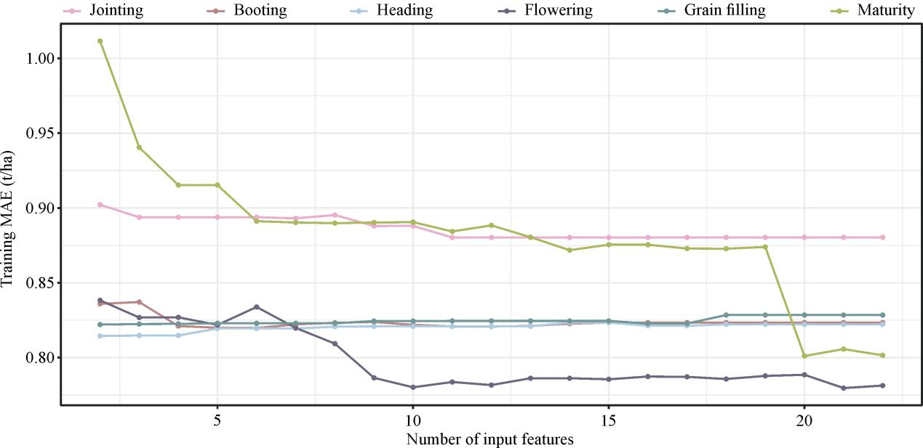
FIGURE 4 Model training error as a function of the number of features. The order of input of features depends on the gray relational degree (GRD). MAE, mean absolute error.

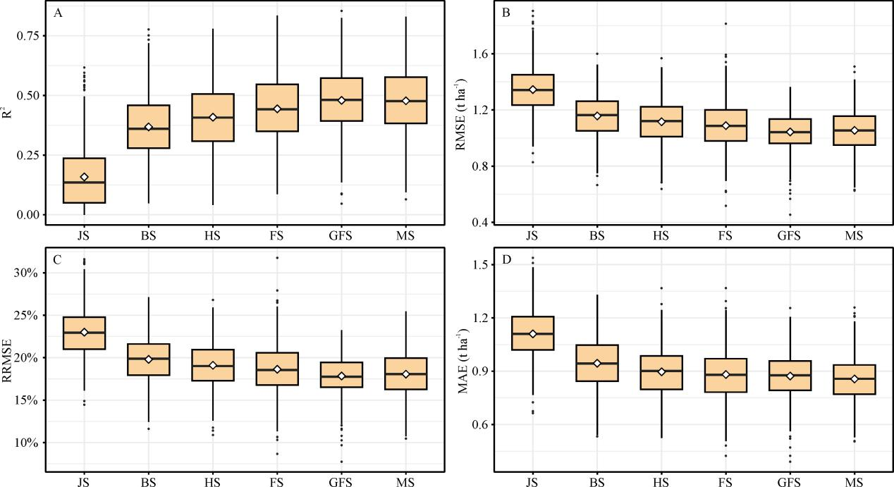
FIGURE 5 Statistical distributions of (A) coefficient of determination (R2), (B) root mean square error (RMSE), (C) relative root-mean-square error (RRMSE), and (D) mean absolute error (MAE) of the elastic net regression (ENR) algorithm for GY prediction using multispectral features in test phases. JS, jointing stage; BS, booting stage; HS, heading stage; FS, flowering stage; GFS, grain filling stage; MS, maturity stage.
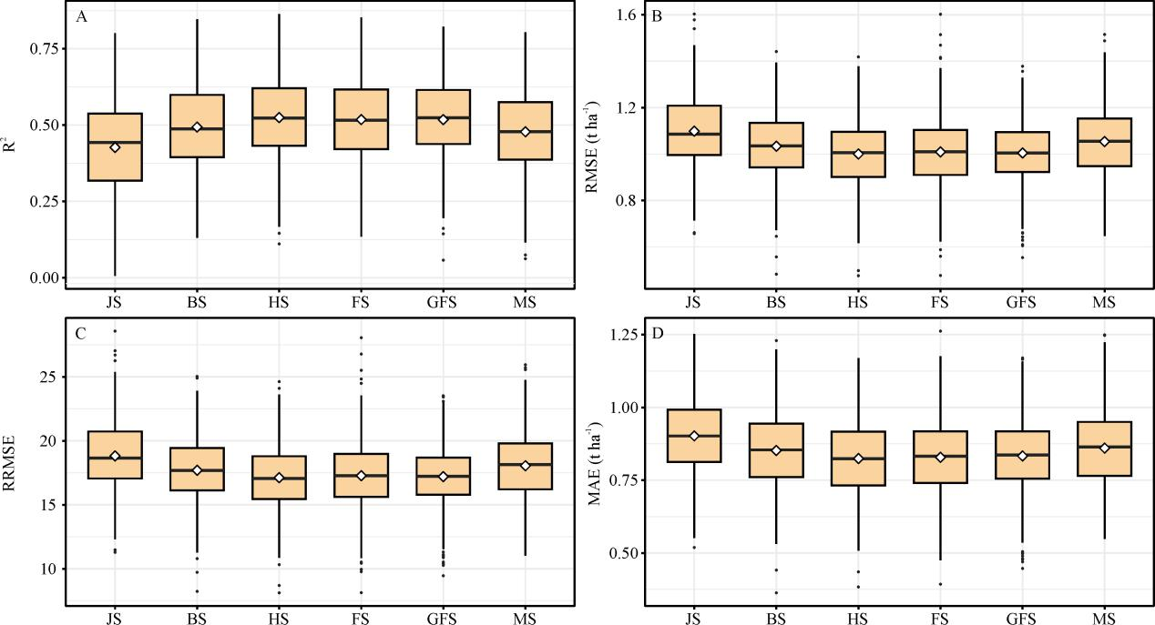
FIGURE 6 Statistical distributions of (A) R² , (B) RMSE, (C) RRMSE, and (D) MAE of the ENR for GY prediction using both multispectral and thermal features in test phases. JS, jointing stage; BS, booting stage; HS, heading stage; FS, flowering stage; GFS, grain filling stage; MS, maturity stage.

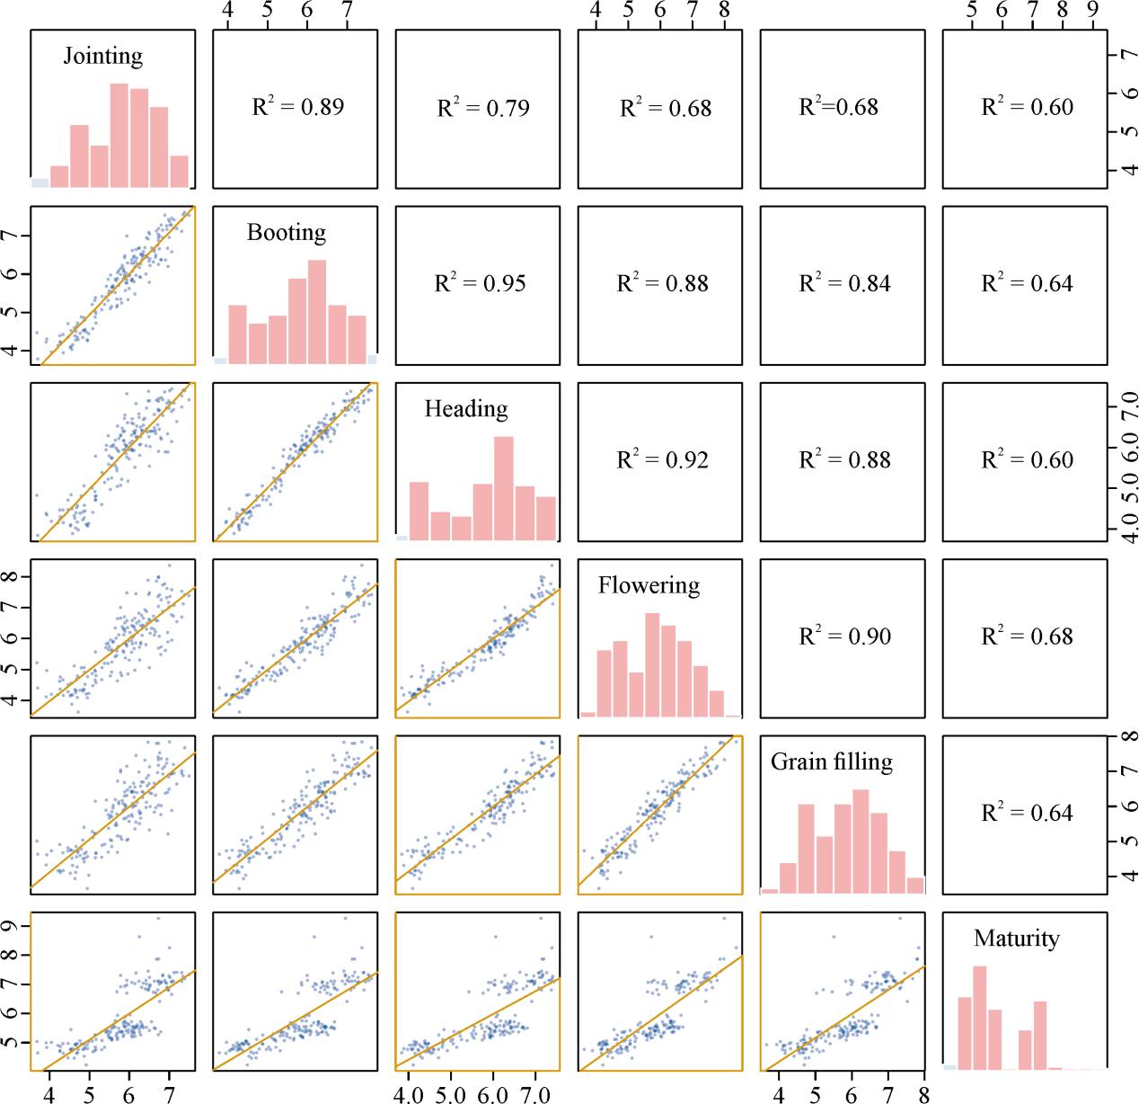
FIGURE 7 Regression plots, density curve, and R² -values between predicted GY in six developmental stages.

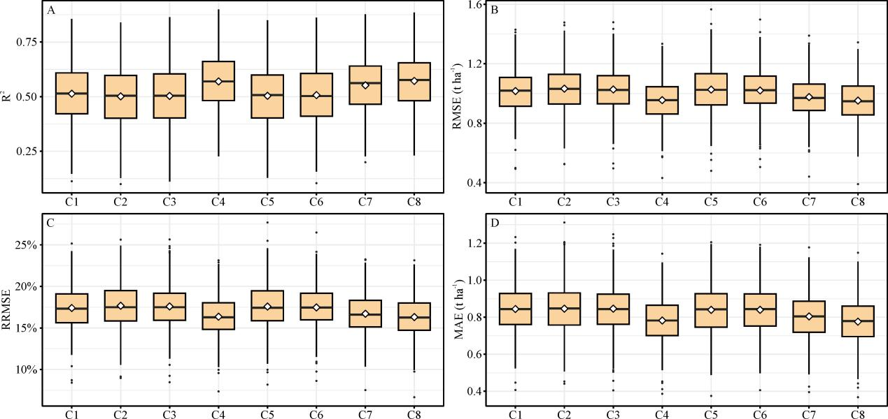
FIGURE 8 Statistical distributions of (A) R², (B) RMSE, (C) RRMSE, and (D) MAE of the ENR model that uses both multispectral and thermal features from different stages as inputs.
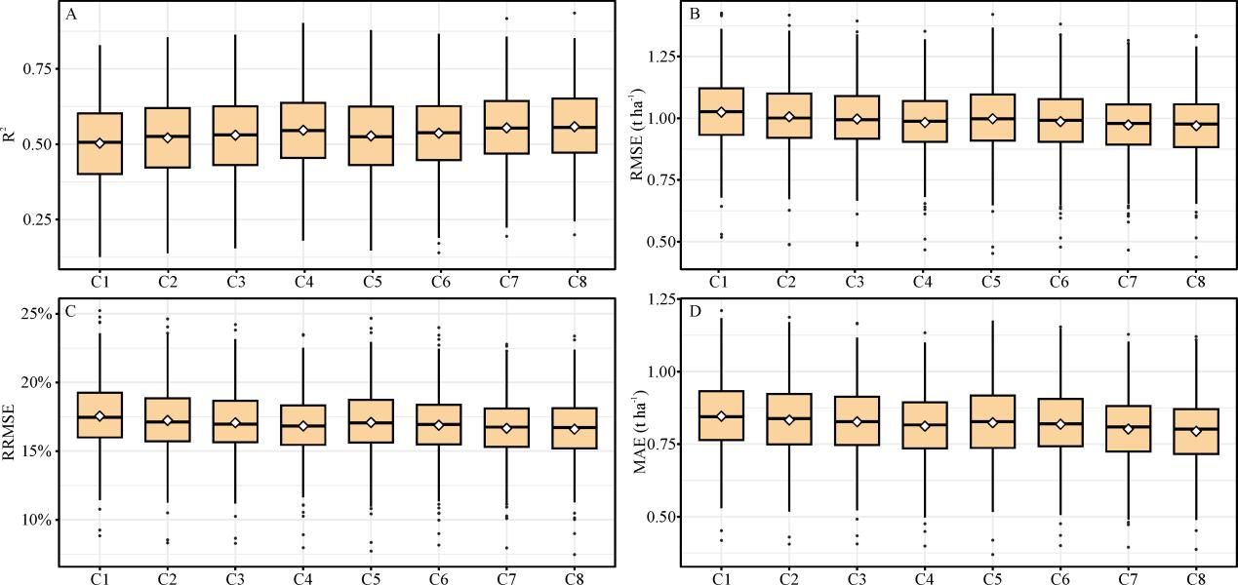
FIGURE 9 Statistical distributions of (A) R² , (B) RMSE, (C) RRMSE, and (D) MAE of the entropy weight fusion (EWF) method for GY prediction in the test phases.

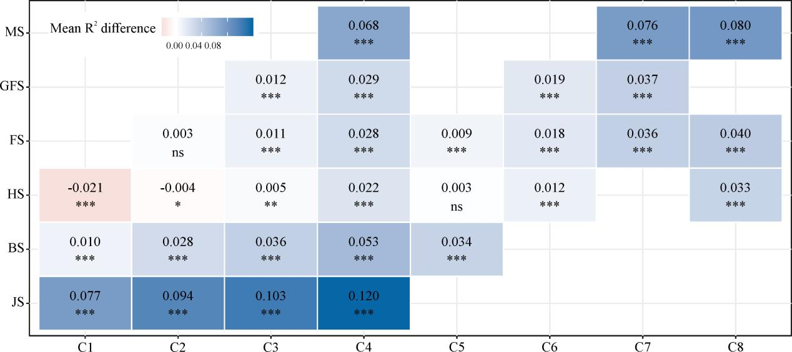
FIGURE 10 Results from paired t-test between model R² obtained from the EWF method and the individual stages. ns, not significant, p ≥ 0.05; *, p < 0.05; **, p < 0.01; ***, p < 0.001. JS, jointing stage; BS, booting stage; HS, heading stage; FS, flowering stage; GFS, grain filling stage; MS, maturity stage.

TABLE 3 Candidate hyperparameters for elastic net regression.
Parameter | Ranges
alpha | Fixed at 0.5 for all ENR models in the reanalysis.
lambda | Selected as lambda.min from the data-adaptive cv.glmnet path within the training data of each outer-CV fold

TABLE 5 Ranking of indices using the gray relational analysis (GRA) for six growth stages.
Rank | Jointing | Booting | Heading | Flowering | Grain filling | Maturity
1 | NRCT | NRCT | NRCT | RVI | TCARI | PPR
2 | PSRI | PPR | TCARI | NRCT | MSR | TCARI
3 | RDVI | RDVI | OSAVI | MSR | NRCT | DVI
4 | DVI | DVI | SAVI | TCARI | NDVIRE | MCARI1
5 | EVI | SAVI | RVI | TVI | CIRE | NRCT
6 | TVI | TVI | RDVI | DVI | MTCI | CIRE
7 | SAVI | EVI | NRI | CIRE | RVI | EVI
8 | PPR | MCARI1 | PPR | EVI | DVI | RVI
9 | OSAVI | PSRI | MSR | NRI | MCARI1 | SAVI
10 | MCARI1 | TCARI | MTVI2 | RDVI | TVI | RDVI
11 | MTVI2 | NLI | EVI | SAVI | GNDVI | MSR
12 | TCARI | OSAVI | DVI | MTCI | EVI | GNDVI
13 | NLI | SIPI | MCARI1 | NDVIRE | MTVI2 | MTVI2
14 | NRI | NRI | GNDVI | MTVI2 | SAVI | NDVIRE
15 | MTCI | MTCI | TVI | GNDVI | RDVI | MTCI
16 | CIRE | NDVI | NDVI | PPR | PPR | OSAVI
17 | SIPI | MSR | SIPI | OSAVI | OSAVI | PSRI
18 | NDVIRE | CIRE | NLI | NDVI | NRI | NLI
19 | GNDVI | MTVI2 | PSRI | NLI | NLI | NDVI
20 | RVI | RVI | NDVIRE | MCARI1 | NDVI | TVI
21 | MSR | NDVIRE | CIRE | PSRI | SIPI | SIPI
22 | NDVI | GNDVI | MTCI | SIPI | PSRI | NRI

