## APPENDIX 1

**FILE MANAGER**

**END TERM REPORT**

by

ILLA DEEPAK GOUD, VASA NARESH, VELDHI RAJA

Section: K19PG

Roll Numbers: 18,54,05



**Department of Intelligent Systems,**

**School of Computer Science Engineering,**

**Lovely Professional University, Jalandhar**

November, 2020

## APPENDIX 2

**Student Declaration**

This is to declare that this report has been written by deepak,naresh,raja. No part of the report is copied from other sources. All information included from other sources have been duly acknowledged. We aver that if any part of the report is found to be copied, I/we are shall take full responsibility for it.

Signature:

Name:

Roll Number:

Place:

Date:

**APPENDIX 3**

**TABLE OF CONTENTS**

**TITLE PAGENO.**

|  |  |
| --- | --- |
| **1. Introduction of project assigned ................** | **5** |
| **2 Description of Project ... .....................................................** | **6** |
| **3.work among students …………………… … 7** |
| **4. file manager image ……………………………………8** |
| **5.learning outcome…………………………………………9**  **6.result. ……………………………………………………9.2** |
|  |

APPENDIX 4

BONAFIDE CERTIFICATE

Certified that this project report “FILE MANAGER” is the bonafide work of “Deepak , Naresh ,raja ” who carried out the project work under my supervision.

### <<Signature of the Supervisor>>(Due to Covid 19, signature is exempted )

<<Name of supervisor>>

<<Academic Designation>>

<<ID of Supervisor>>

<<Department of Supervisor>>

INTRODUCTION

This Project is about the Graphic User Interface which the interface of file manager shows

where you can add file and open a file and copy a file from one folder to another folder ,and

we can delete the file which is in the file manager and we can rename a file and move file

from one folder to another folder .This is a module where we use to create a graphical user

interface of file manager , showing required output and some back ground design. We are

using six module in the given project ,they are Tkinter,shuttle,os,easygui,file dialog,imageio.

DESCRIPTION

File manager is mainly used for arranging the files on our computer and locate the files on our system.

The file manager which we are going to prepare is very useful to everyone who uses a computer. And our

file manager does important things that we need daily when we use the computer. Such as creating a file

on the file manager that is the main when we want to gather some files in one folder and we can open a

folder by opening this folder we can see the only files which we wanted to see and we can copy a file

from one folder to another folder by doing this our work gets easy and we can delete a file/folder we do

not require on our computer. when we are using file manager we mainly get work so easily.

WORK AMONG STUDENTS

First of all, when have received the project of file manager in the course int213. we had divided the work

between us and seen that everyone gets the equal opportunity to learn well about the given project and

the main motive was to gain the knowledge by doing this project. by receiving this project i.e., file

manager for windows, we were so excited while doing this project and we divided the coding into two

parts and first part is done by Deepak and second part is done by Naresh. after completing the coding, we

have successfully made the project of file manager using python and we both got an equal opportunity to l

earn all about the project and full report is made by Deepak and report is totally studied by Naresh.

FILE MANAGER IMAGE

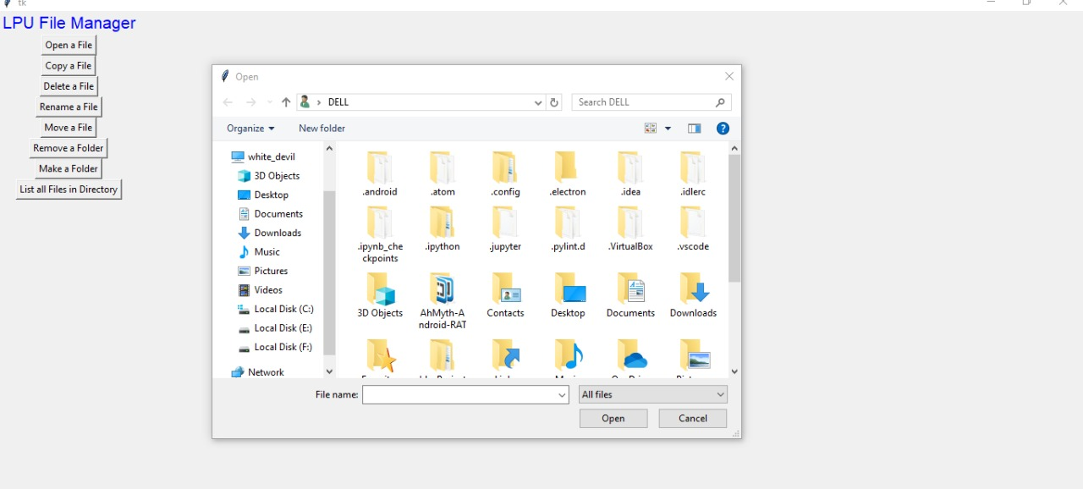

LEARNING OUTCOME

By Taking up this project we have learnt how to create a file manager using python and to design windows with colours and pictures and placing them on suitable places by using tkinter  and how to give commands .by doing this project I have learnt that how a file manager works on windows by writing python code and managing all the files which we are having on the desktop and by this project I have made myself a project which works for me and my desktop .In this project we will be knowing all about file manager and its uses and we will gain a brief idea about how to create files and open the files , copy a file from one folder to another folder ,and deleting the folder and renaming the folder .

RESULT

As a result we got our output which is file manager and in the file manager we will get to

know all about opening a folder and creating a folder and copying a file from one folder to

another folder which is very useful and deleting the files which we does not need on our

desktop and we can move a file from one folder to another folder .we can rename the

file/folder as we wish .and we can remove the file where we have moved the file.