Light exposure behaviors predict emotion, cognition and sleep quality

Mushfiqul Anwar Siraji1, Vineetha Kalavally2, & Shamsul Haque1

1 Monash University, Department of Psychology, Jeffrey Cheah School of Medicine and Health Sciences, Malaysia

2 Monash University, Department of Electrical and Computer Systems Engineering, Malaysia, Selangor, Malaysia

Author note

Department of Psychology, Jeffrey Cheah School of Medicine and Health Sciences, Monash University Malaysia.

The authors made the following contributions. Mushfiqul Anwar Siraji: Conceptualization, Writing - Original Draft Preparation, Writing - Review & Editing; Vineetha Kalavally: Conceptualization, Writing - Review & Editing; Shamsul Haque: Conceptualization, Writing - Review & Editing.

Correspondence concerning this article should be addressed to Shamsul Haque, Monash University Malaysia,Jalan Lagoon Selatan, 47500 Bandar Sunway,Selangor Darul Ehsan, Malaysia.. E-mail: [shamsul@monash.edu](mailto:shamsul@monash.edu)

Abstract

The light effect on emotion, cognition and sleep is well established, but a little research has investigated if different light exposure-related behaviors, such as time spent outdoor, use of electric light during daytime, and use of smart gadgets before sleeping, influence those variables. Three-hundred-and-one Malaysian adults (MeanAge±SD=28±9) completed the Light Exposure Behavior Assessment (LEBA) tool that measured five types of light exposure behaviors. They also completed the Morningness-Eveningness Questionnaire, Positive and Negative Affect Schedule, Pittsburgh Sleep Quality Index, and single items assessing trouble in memory and concentration. A partial least square structural equation model, showing satisfactory predictive power (61.36%), revealed that increased use of wearable blue filters indoors and outdoors decreased the morning affect (Direct effect, DE=-0.16) and sleep quality (Total effect, TE=0.11). Increased time spending outdoors predicted positive affect (DE=0.32) and early chronotype (DE: RI=0.14, PT=0.15, RT=0.15). Increased use of smart gadgets before sleep predicted late chronotype (DE: RT=-0.26; RI=-0.23; PT=-0.24; MA=-0.13), increased negative affect, reduced sleep quality (DE=0.13) and increased trouble in memory and concentration (TE=0.20 & 0.23, respectively). Increased use of electric light in the morning and daytime predicted positive affect (DE=0.16) and sleep quality (DE=-0.16). Collectively, these results provide valuable insights into developing a healthy light diet to promote health and wellness.

*Keywords:* light exposure; light-related behaviors; non-visual effects of light; light diet; PLS-SEM

*Word count:* X

Light exposure behaviors predict emotion, cognition and sleep quality

We posed the following questions: What are the influences of LEBA categories on (a) chronotype, (b) mood, (c) sleep quality, and (d) memory and concentration? To answer these questions, we proposed a theoretical framework (Figure 1) based on the literature reviewed. We used the partial least squares structural equation modeling (PLS-SEM), which is best suited to formulate such a predictive model [54, 55]. Predicting relationships using PLS-SEM is a two-step process where first, a measurement model is used to assess the reliability and validity of the latent variables used in the model. Second, a structural model is used to investigate the precited relationships of the latent structures. In the structural model, (i) the direct effects (DE): influences unmediated by any other constructs in the model, (ii) indirect effects (IE): influences mediated by at least one intervening construct in the model and (iii) total effects (TE): sums of direct and indirect effects of a given construct can be estimated [56]. We predicted that five types of LEBA behavior categories would directly influence chronotype (H1), mood (H2), and sleep quality (H3). We also predicted that sleep quality would be influenced by mood (H4) and chronotype (H5). Memory and concentration would be influenced by sleep quality (H6), mood (H7), and chronotype (H8). LEBA categories would directly influence memory and concentration (H9). Lastly, we predicted that LEBA categories would exhibit a significant total effect on sleep quality (H10), memory and concentration (H11).

# Methods

## Participants

We conducted a large-scale online survey to gather data for this study. The inclusion criteria for respondents to be included in this study were as follows: (1) Malaysian resident >18 years of age and able to read and write English (2) no physiological and psychological disorder (self reported) . 366 adults completed the survey. However, we excluded 45 participants, due to incomplete data (87.4 completion rate). We further excluded 19.0 participants based on our inclusion criteria. Thus, we used we data form 301 participants for further processing. A priori power analysis was done to determine adequate sample sizes with GPower 3.0 (Faul, Erdfelder, Lang, & Buchner, 2007). To achieve a effect size of .15 (Cohen, 1988) and 80% statistical power and =0.05, for a multiple liner multiple regression with 13 predictors will need a total sample of 131 individuals. Also, the maximum number of items per factor in our model was six.To detect minimum vale of 0.10 for a factor with six items with 80% statistical power and =0.05 at least 130 participants are required (Joseph F. Hair Jr, Hult, Ringle, & Sarstedt, 2021). Our sample size exceeded these recommendations. Out of 301 participants 72.43% (218) were female ranging in age from 18 to 59 (26.85±8.07) and 27.57% (83) were male with an age range between 18 to 74 years (30.35±12.14). 78.66% of the participants were unmarried. Majority of the participants were students (71.42%). 56.29% participants had at least a Bachelor Degree.

## Material

### Light exposure behaviour assessment..

Light exposure related behaviours was measured using the short form of Light Exposure Behaviour Assessment (LEBA)(Siraji et al., 2022). The short form contains five factors with 19 items. LEBA measures the propensity of different light exposure related behaviours in the last one month retrospectively using a five-point Likert type response scale (1 = never; 2 = rarely; 3 = sometimes; 4 = often; 5 = always). The first factor of LEBA (F1) investigate the propensity of wearing blue light filter glasses indoors and outdoors. The second factor (F2) measures how much time spend under sunlight. The third factor measures (F3) our habit of using smart devices in bed. The fourth factor(F4) looks into our habit of controlling light exposure before bedtime. The last factor (F5) captures our habit of using different electric light sources throughout the day. All 19 items of LEBA and and the participants’ responses to them are shown in 1.

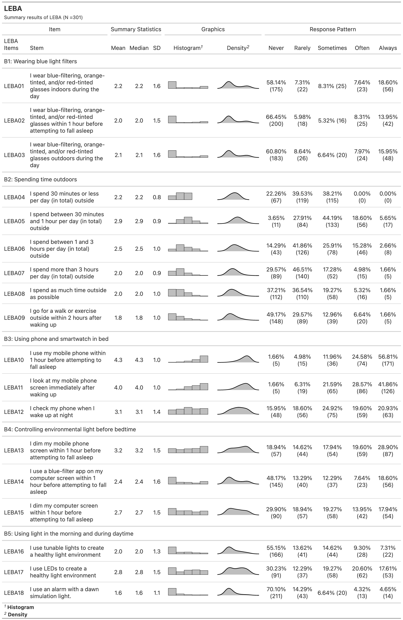

*Figure* *1.*  Response districution of LEBA

### Positive and Negative Affect Schdule.

The positive and negative affect schedule (PANAS) (Watson, Clark, & Tellegen, 1988) was used to measure positive and negative affect. PANAS is comprised two 10-item mood scales measuring positive affect (PA) and negative affect (NA). The internal consistency reliability of the original scale was satisfactory (PA:0.88; NA:0.87) (Watson et al., 1988). In this study participants rate their positive and negative affect based on the last one month retrospectively using a five-point Likert type response scale (1 = very slightly/not at all; 2 = a little; 3 = moderately; 4 = quite a bit; 5 = extremely).

### Trouble in Memory and Concentration.

To assess trouble in memory and concentration we used two items with four-point Likert type response options. These two items asked the participants about the propensity of their memory and concentration difficulty in the last one month (0=Absent; 1=Slight; 2=Moderate; 3=Severe)

### Pittsburgh Sleep Quality Index.

We used the Pittsburgh Sleep Quality Index (PSQI) (Buysse, Reynolds C. F., Monk, Berman, & Kupfer, 1989) to measure the sleep quality of the participants. PSQI measures seven domains of sleep to differentiate “poor” from “good” sleep. Participants responded to the PSQI using a Likert type responses option ranging from zero the three, whereby 3 reflects the negative extreme on the Likert Scale. A sum of scores equal to or greater than five indicates poor sleep quality. Though Buysse et al. (1989) reported an one factor structure of the scale, there are evidence that the factor structure of PSQI varies from one factor to three factors (Manzar et al., 2018). Dunleavy et al. (2019) in their study recommended to use a two-factor model: perceived sleep quality (PSQ) and sleep efficiency (SE) while measuring the sleep quality among Singapore citizen. In this study we followed their recommended structure.

### Morningness-Eveningness Questionnaire.

Chronotype was measured using Morningness-Eveningness questionnaire (MEQ) (Horne & Ostberg, 1976). MEQ is consist of 19 questions and the scores range from 16 to 86. A higher score indicates more morning propensity. Caci, Deschaux, Adan, and Natale (2009) reported a four factor structure of MEQ: peak time (PT), morning affect (MA), retiring (RT) and rising (RI) in s student sample.

## Data Collection

The project received ethics clearance from Monash University Human Research Ethics Committee (Project ID: 14786). A quantitative cross-sectional fully anonymous online survey was conducted. Participants were invited via email and social media (i.e., LinkedIn, Twitter, Facebook) with the attachment of an Explanatory Statement. It was mentioned in the explanatory statement that their participation was voluntary and that they could withdraw from participation anytime without being penalized. If the participants expressed happiness with the Explanatory Statement, a survey link was sent to them. At the beginning of the survey, their consent was recorded digitally. The survey took around 15 to 20 minutes for which they were not compensated. We collected the survey data between April 2022 and September 2022.

## Analytic Strategy

Our aim was to predict chronotype, sleep quality and trouble in memory and concentration from the light exposure related behaviour. The partial least squares structural equation modelling (PLS-SEM) is best suited to formuate such predictive model (Joe F. Hair Jr, Matthews, Matthews, & Sarstedt, 2017). We used partial least squares structural equation modelling in R ((R Core Team, 2021); version 4.1.2) using “SeminR”(Ray, Danks, & Calero Valdez, 2022) package. Additionally, PLS-SEM is able to facilitate solution of models regardless of model complexity.

### Measurement Model Assessment.

First, we assessed the quality of measurement model. We excluded items with factor loading bellow .40 to increase the robustness of the measurement model (Joseph F. Hair Jr et al., 2021). Second, we estimated the internal consistency reliability estimates of each costruct. We reported both the lower bound estimate of reliability- Cronbach’s coefficient and upper bound estimate of reliability-construct reliability (CR). Both Cronbach’s and CR coefficient values range between 0 to 1, where higher values represent better reliability. As a general guideline Cronbach’s above .70 is considered satisfactory(MacCallum, Roznowski, Mar, & Reith, 1994; MacKenzie, Podsakoff, & Jarvis, 2005). and value above .50 is considered acceptable (Hinton, McMurray, & Brownlow, 2014). CR coefficient value .60 and above indicates satisfactory reliability(Joseph F. Hair Jr et al., 2021).

Third, We assessed the convergent and discriminant validity of the measurement model. We used the average variance extracted (AVE) value of each construct to assess convergent validity. To indicate satisfactory convergent validity the AVE value should be 0.50 and above (Fornell & Larcker, 1981). However, AVE value lower than 0.5 with a composite reliability coefficient higher than 0.6 also indicate acceptable convergent validity (Fornell & Larcker, 1981). We assessed the discriminant validity of the measurement model by comparing the square root of each construct’s AVE with its correlation with other constructs (Fornell & Larcker, 1981). The square root of the AVE values of each construct should be higher than its correlation with other constructs. We have also reported the heterotrait-monotrait ratio (HTMT) of correlations of the construct to assess discriminant validity. For conceptually similar construct the HTMT value should be lower than .90 and for constructs which are conceptually distinct the HTMT value should be lower than .80 (Henseler, Ringle, & Sarstedt, 2015).

### Structural Model Assessment.

First, we assessed collinearity of the constructs in our structural model by calculating variance inflation factor (VIF) values. VIF>5 indicates probable collinearity issues (Henseler et al., 2015). Next, we estimated the the path coefficients of the structural model using a bootstrapping approach with 10000 sub samples and reported the significant total effects (p<0.05) observed in our model.Lastly we reported the adjusted as a measure of explanatory power of our model and values for the constructs as a predictive relevance index of our model. For assessing the explanatory power we followed the guidelines of Falk and Miller (1992) : values 0.10 indicates adequate explanatory power and categorize the values following and Cohen (2013) guidelines : 0.02 (weak), 0.13 (moderate), and 0.26 (substantial). >0 indicates good predictive relevance. We further assessed the fitted model’s predictive power by K-fold cross-validation using the function from “SeminR” package(Ray et al., 2022). provides the root-mean-square error (RMSE) and respective linear-regression model(LM) benchmarks for all indicators. We assessed the model’s predictive power by following the guideline of Sarstedt, Ringle, and Hair (2021): (i) high predictive power- All indicators in the fitted PLS-SEM model have lower RMSE values compared to the linear regression (LM) benchmarks(ii) medium predictive power- the majority($≥$50%) of the indicators have lower RMSE values than LM (iii)low predictive power- less than 50% of the indicator have lower RMSE vale than LM the model has low predictive power, (iv) no predictive power- no indicator has lower RMSE value than LM model (Sarstedt et al., 2021). Figure 2 depicts the analyses steps we followed.

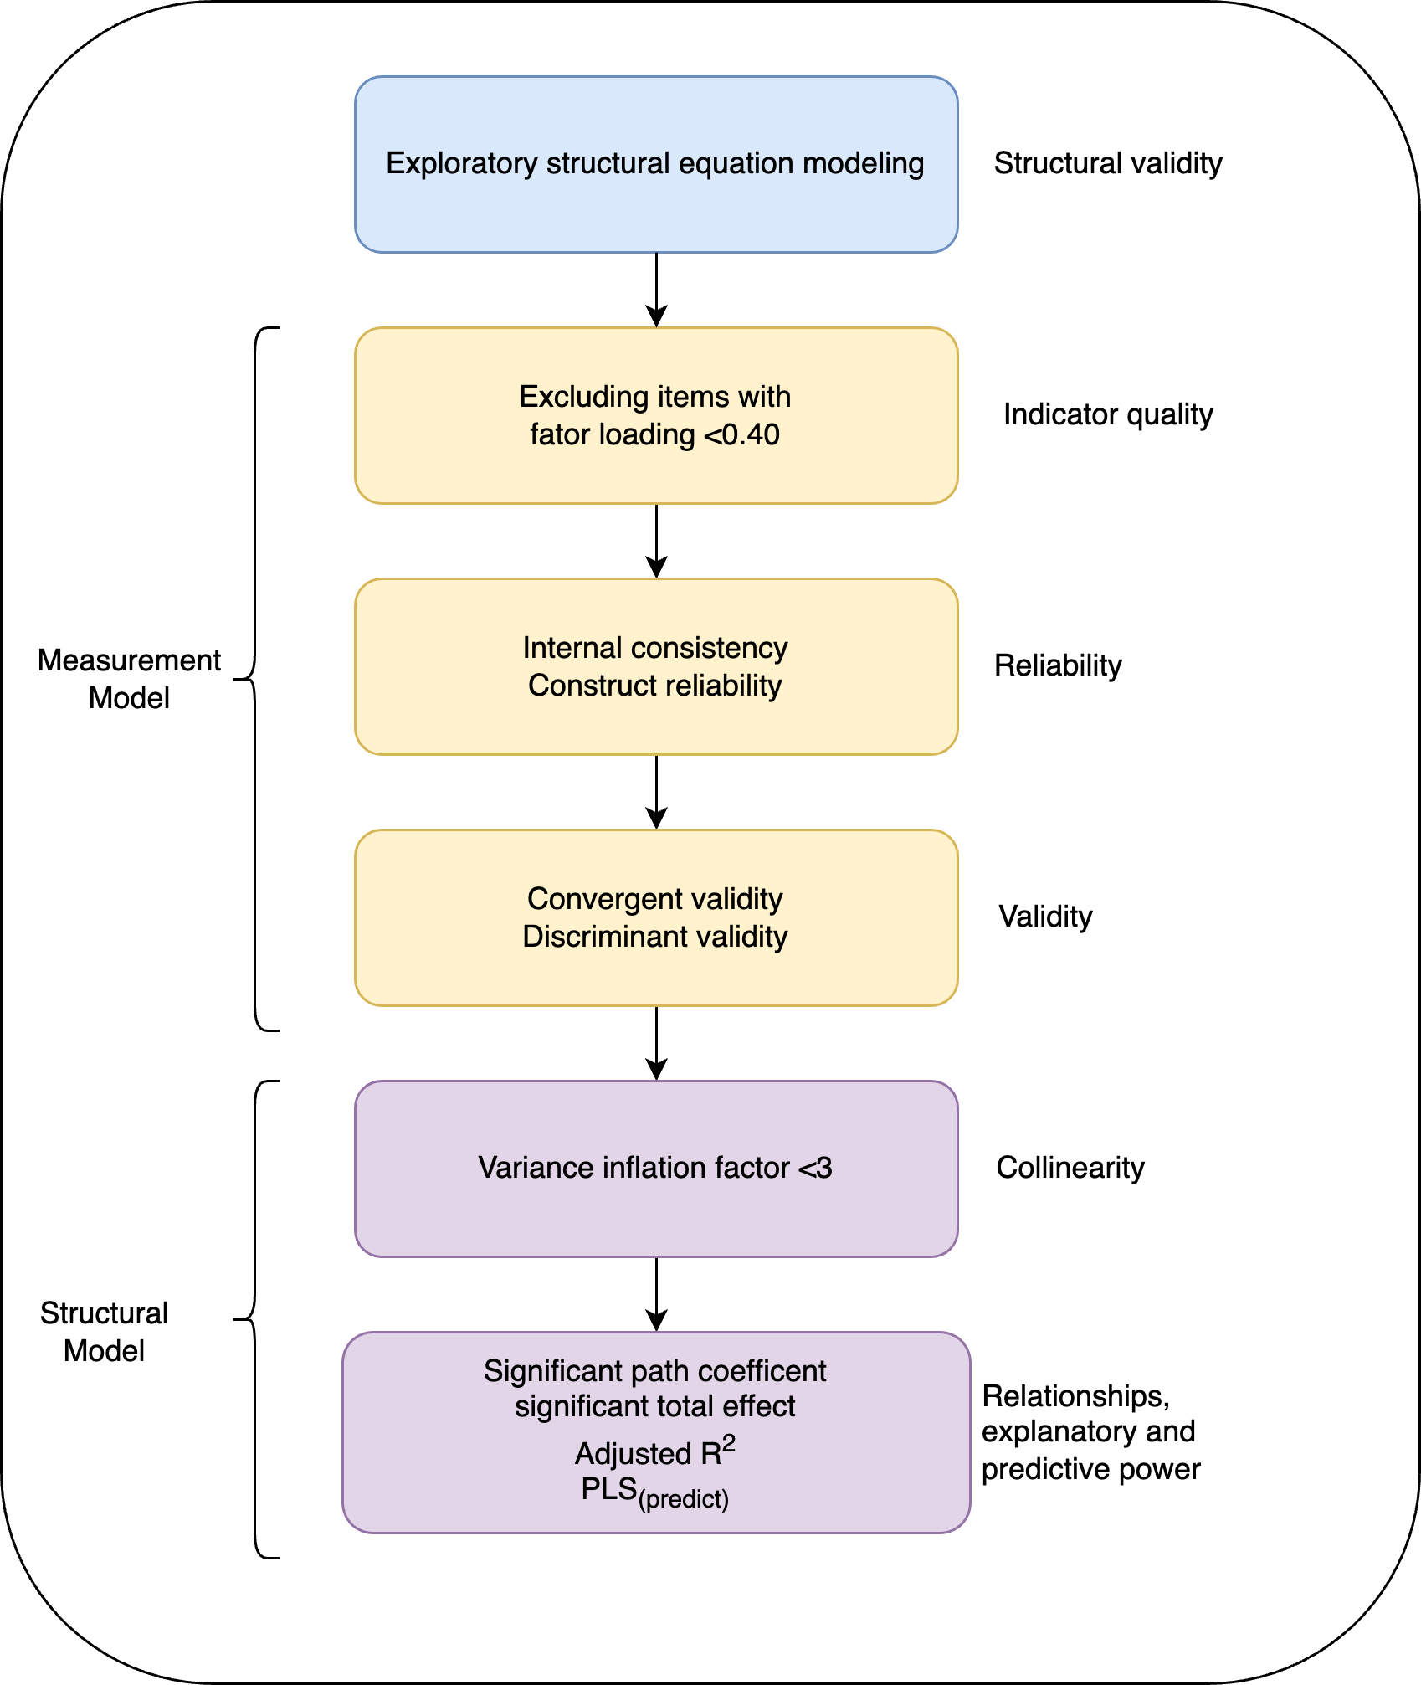

*Figure* *2.*  Analyses Steps

# Results

Table 1:

*Results of Measurement assessment(Supplimental table)*

| Constructs | Factor Loading | Cronbach’s alpha | CR | AVE |
| --- | --- | --- | --- | --- |
| OLS_Concentration_rec | 1.00 | 1.00 | 1.00 | 1.00 |
| PSQ1 | 0.72 | 0.60 | 0.73 | 0.36 |
| PSQ2 | 0.44 | NA | NA | NA |
| PSQ3 | 0.51 | NA | NA | NA |
| PSQ4 | 0.43 | NA | NA | NA |
| PSQ5 | 0.81 | NA | NA | NA |
| Sleep_efficieny1 | 0.86 | 0.48 | 0.79 | 0.66 |
| Sleep_efficieny2 | 0.75 | NA | NA | NA |
| LEBA_F1_item1 | 0.95 | 0.94 | 0.96 | 0.66 |
| LEBA_F1_item2 | 0.95 | NA | NA | NA |
| LEBA_F1_item3 | 0.94 | NA | NA | NA |
| LEBA_F2_item1 | 0.31 | 0.69 | 0.78 | 0.39 |
| LEBA_F2_item2 | 0.47 | NA | NA | NA |
| LEBA_F2_item3 | 0.72 | NA | NA | NA |
| LEBA_F2_item4 | 0.63 | NA | NA | NA |
| LEBA_F2_item5 | 0.68 | NA | NA | NA |
| LEBA_F2_item6 | 0.78 | NA | NA | NA |
| LEBA_F3_item1 | 0.85 | 0.71 | 0.84 | 0.64 |
| LEBA_F3_item2 | 0.86 | NA | NA | NA |
| LEBA_F3_item3 | 0.68 | NA | NA | NA |
| LEBA_F4_item1 | 0.75 | 0.67 | 0.82 | 0.60 |
| LEBA_F4_item2 | 0.69 | NA | NA | NA |
| LEBA_F4_item3 | 0.88 | NA | NA | NA |
| LEBA_F5_item1 | 0.76 | 0.51 | 0.74 | 0.50 |
| LEBA_F5_item2 | 0.54 | NA | NA | NA |
| LEBA_F5_item3 | 0.79 | NA | NA | NA |
| MEQ_F1_item1 | 0.53 | 0.71 | 0.79 | 0.39 |
| MEQ_F1_item2 | 0.75 | NA | NA | NA |
| MEQ_F1_item3 | 0.58 | NA | NA | NA |
| MEQ_F1_item4 | 0.50 | NA | NA | NA |
| MEQ_F1_item5 | 0.79 | NA | NA | NA |
| MEQ_F1_item6 | 0.55 | NA | NA | NA |
| MEQ_F2_item1 | 0.85 | 0.53 | 0.70 | 0.48 |
| MEQ_F2_item2 | 0.79 | NA | NA | NA |
| MEQ_F2_item3 | 0.73 | NA | NA | NA |
| MEQ_F2_item4 | -0.15 | NA | NA | NA |
| MEQ_F3_item1 | 0.75 | 0.42 | 0.61 | 0.29 |
| MEQ_F3_item2 | 0.58 | NA | NA | NA |
| MEQ_F3_item3 | 0.78 | NA | NA | NA |
| MEQ_F3_item4 | 0.38 | NA | NA | NA |
| MEQ_F3_item5 | 0.54 | NA | NA | NA |
| MEQ_F3_item6 | -0.26 | NA | NA | NA |
| MEQ_F3_item7 | 0.06 | NA | NA | NA |
| MEQ_F4_item1 | 0.85 | 0.51 | 0.80 | 0.67 |
| MEQ_F4_item2 | 0.78 | NA | NA | NA |
| PA1 | 0.74 | 0.92 | 0.93 | 0.57 |
| PA2 | 0.72 | NA | NA | NA |
| PA3 | 0.84 | NA | NA | NA |
| PA4 | 0.81 | NA | NA | NA |
| PA5 | 0.71 | NA | NA | NA |
| PA6 | 0.63 | NA | NA | NA |
| PA7 | 0.80 | NA | NA | NA |
| PA8 | 0.77 | NA | NA | NA |
| PA9 | 0.72 | NA | NA | NA |
| PA10 | 0.82 | NA | NA | NA |
| OLS_Memory_rec | 1.00 | 1.00 | 1.00 | 1.00 |
| NegA1 | 0.67 | 0.86 | 0.89 | 0.45 |
| NegA2 | 0.72 | NA | NA | NA |
| NegA3 | 0.64 | NA | NA | NA |
| NegA4 | 0.74 | NA | NA | NA |
| NegA5 | 0.46 | NA | NA | NA |
| NegA6 | 0.68 | NA | NA | NA |
| NegA7 | 0.65 | NA | NA | NA |
| NegA8 | 0.73 | NA | NA | NA |
| NegA9 | 0.58 | NA | NA | NA |
| NegA10 | 0.78 | NA | NA | NA |

Table 2:

*Results of Measurement assessment*

| Constructs | Factor Loading | Cronbach’s alpha | CR | AVE |
| --- | --- | --- | --- | --- |
| OLS_Concentration_rec | 1.00 | 1.00 | 1.00 | 1.00 |
| PSQ1 | 0.72 | 0.60 | 0.73 | 0.36 |
| PSQ2 | 0.44 | NA | NA | NA |
| PSQ3 | 0.51 | NA | NA | NA |
| PSQ4 | 0.42 | NA | NA | NA |
| PSQ5 | 0.81 | NA | NA | NA |
| Sleep_efficieny1 | 0.86 | 0.48 | 0.79 | 0.66 |
| Sleep_efficieny2 | 0.75 | NA | NA | NA |
| LEBA_F1_item1 | 0.95 | 0.94 | 0.96 | 0.66 |
| LEBA_F1_item2 | 0.95 | NA | NA | NA |
| LEBA_F1_item3 | 0.94 | NA | NA | NA |
| LEBA_F2_item1 | 0.46 | 0.71 | 0.80 | 0.45 |
| LEBA_F2_item2 | 0.73 | NA | NA | NA |
| LEBA_F2_item3 | 0.62 | NA | NA | NA |
| LEBA_F2_item4 | 0.69 | NA | NA | NA |
| LEBA_F2_item5 | 0.79 | NA | NA | NA |
| LEBA_F3_item1 | 0.85 | 0.71 | 0.84 | 0.64 |
| LEBA_F3_item2 | 0.86 | NA | NA | NA |
| LEBA_F3_item3 | 0.68 | NA | NA | NA |
| LEBA_F4_item1 | 0.73 | 0.67 | 0.82 | 0.60 |
| LEBA_F4_item2 | 0.69 | NA | NA | NA |
| LEBA_F4_item3 | 0.89 | NA | NA | NA |
| LEBA_F5_item1 | 0.76 | 0.51 | 0.74 | 0.50 |
| LEBA_F5_item2 | 0.55 | NA | NA | NA |
| LEBA_F5_item3 | 0.78 | NA | NA | NA |
| MEQ_F1_item1 | 0.53 | 0.71 | 0.79 | 0.39 |
| MEQ_F1_item2 | 0.75 | NA | NA | NA |
| MEQ_F1_item3 | 0.58 | NA | NA | NA |
| MEQ_F1_item4 | 0.50 | NA | NA | NA |
| MEQ_F1_item5 | 0.79 | NA | NA | NA |
| MEQ_F1_item6 | 0.55 | NA | NA | NA |
| MEQ_F2_item1 | 0.87 | 0.72 | 0.84 | 0.64 |
| MEQ_F2_item2 | 0.80 | NA | NA | NA |
| MEQ_F2_item3 | 0.73 | NA | NA | NA |
| MEQ_F3_item1 | 0.76 | 0.60 | 0.77 | 0.46 |
| MEQ_F3_item2 | 0.61 | NA | NA | NA |
| MEQ_F3_item3 | 0.78 | NA | NA | NA |
| MEQ_F3_item4 | 0.53 | NA | NA | NA |
| MEQ_F4_item1 | 0.85 | 0.51 | 0.80 | 0.67 |
| MEQ_F4_item2 | 0.78 | NA | NA | NA |
| PA1 | 0.74 | 0.92 | 0.93 | 0.57 |
| PA2 | 0.72 | NA | NA | NA |
| PA3 | 0.84 | NA | NA | NA |
| PA4 | 0.81 | NA | NA | NA |
| PA5 | 0.71 | NA | NA | NA |
| PA6 | 0.63 | NA | NA | NA |
| PA7 | 0.80 | NA | NA | NA |
| PA8 | 0.77 | NA | NA | NA |
| PA9 | 0.72 | NA | NA | NA |
| PA10 | 0.82 | NA | NA | NA |
| OLS_Memory_rec | 1.00 | 1.00 | 1.00 | 1.00 |
| NegA1 | 0.67 | 0.86 | 0.89 | 0.45 |
| NegA2 | 0.72 | NA | NA | NA |
| NegA3 | 0.64 | NA | NA | NA |
| NegA4 | 0.74 | NA | NA | NA |
| NegA5 | 0.46 | NA | NA | NA |
| NegA6 | 0.68 | NA | NA | NA |
| NegA7 | 0.65 | NA | NA | NA |
| NegA8 | 0.73 | NA | NA | NA |
| NegA9 | 0.58 | NA | NA | NA |
| NegA10 | 0.78 | NA | NA | NA |

*Note.* All factors loadings are significant(p<0.05)

Table 3:

*Discriminant validity assessment using the Fornell-Larker Criterion*

| rowname | L1 | L2 | L3 | L4 | L5 | PA | NegA | PSQ | SE | PT | MA | RT | RI | Memory | Concentration |
| --- | --- | --- | --- | --- | --- | --- | --- | --- | --- | --- | --- | --- | --- | --- | --- |
| L1 | 0.95 | NA | NA | NA | NA | NA | NA | NA | NA | NA | NA | NA | NA | NA | NA |
| L2 | 0.05 | 0.67 | NA | NA | NA | NA | NA | NA | NA | NA | NA | NA | NA | NA | NA |
| L3 | -0.10 | -0.21 | 0.80 | NA | NA | NA | NA | NA | NA | NA | NA | NA | NA | NA | NA |
| L4 | 0.17 | 0.12 | 0.02 | 0.77 | NA | NA | NA | NA | NA | NA | NA | NA | NA | NA | NA |
| L5 | 0.11 | 0.22 | -0.17 | 0.29 | 0.71 | NA | NA | NA | NA | NA | NA | NA | NA | NA | NA |
| PA | -0.06 | 0.35 | -0.12 | 0.02 | 0.21 | 0.76 | NA | NA | NA | NA | NA | NA | NA | NA | NA |
| NegA | 0.09 | 0.02 | 0.14 | 0.05 | 0.13 | -0.19 | 0.67 | NA | NA | NA | NA | NA | NA | NA | NA |
| PSQ | 0.08 | -0.06 | 0.23 | 0.02 | -0.18 | -0.33 | 0.37 | 0.60 | NA | NA | NA | NA | NA | NA | NA |
| SE | 0.02 | 0.01 | -0.06 | -0.03 | 0.02 | 0.22 | -0.08 | -0.04 | 0.81 | NA | NA | NA | NA | NA | NA |
| PT | -0.07 | 0.22 | -0.28 | 0.01 | 0.17 | 0.33 | -0.17 | -0.26 | 0.10 | 0.63 | NA | NA | NA | NA | NA |
| MA | -0.12 | 0.12 | -0.15 | 0.06 | 0.16 | 0.31 | -0.20 | -0.35 | 0.18 | 0.41 | 0.80 | NA | NA | NA | NA |
| RT | -0.01 | 0.21 | -0.31 | -0.09 | 0.16 | 0.27 | -0.08 | -0.18 | 0.10 | 0.63 | 0.37 | 0.68 | NA | NA | NA |
| RI | 0.05 | 0.20 | -0.28 | -0.01 | 0.15 | 0.18 | -0.05 | -0.11 | 0.11 | 0.35 | 0.20 | 0.34 | 0.82 | NA | NA |
| Memory | 0.01 | -0.09 | 0.20 | 0.11 | 0.08 | -0.16 | 0.47 | 0.32 | -0.10 | -0.22 | -0.28 | -0.22 | -0.10 | 1.00 | NA |
| Concentration | 0.01 | -0.05 | 0.23 | 0.06 | -0.04 | -0.26 | 0.46 | 0.43 | -0.15 | -0.26 | -0.31 | -0.16 | -0.17 | 0.52 | 1.00 |

Table 4:

*Discriminant validity assessment using the HTMT*

| rowname | L1 | L2 | L3 | L4 | L5 | PA | NegA | PSQ | SE | PT | MA | RT | RI | Memory | Concentration |
| --- | --- | --- | --- | --- | --- | --- | --- | --- | --- | --- | --- | --- | --- | --- | --- |
| L1 | NA | NA | NA | NA | NA | NA | NA | NA | NA | NA | NA | NA | NA | NA | NA |
| L2 | 0.09 | NA | NA | NA | NA | NA | NA | NA | NA | NA | NA | NA | NA | NA | NA |
| L3 | 0.13 | 0.26 | NA | NA | NA | NA | NA | NA | NA | NA | NA | NA | NA | NA | NA |
| L4 | 0.21 | 0.23 | 0.09 | NA | NA | NA | NA | NA | NA | NA | NA | NA | NA | NA | NA |
| L5 | 0.19 | 0.40 | 0.28 | 0.52 | NA | NA | NA | NA | NA | NA | NA | NA | NA | NA | NA |
| PA | 0.07 | 0.41 | 0.15 | 0.09 | 0.31 | NA | NA | NA | NA | NA | NA | NA | NA | NA | NA |
| NegA | 0.11 | 0.16 | 0.21 | 0.11 | 0.29 | 0.25 | NA | NA | NA | NA | NA | NA | NA | NA | NA |
| PSQ | 0.12 | 0.28 | 0.38 | 0.14 | 0.34 | 0.35 | 0.49 | NA | NA | NA | NA | NA | NA | NA | NA |
| SE | 0.09 | 0.06 | 0.17 | 0.17 | 0.13 | 0.32 | 0.13 | 0.23 | NA | NA | NA | NA | NA | NA | NA |
| PT | 0.09 | 0.25 | 0.34 | 0.15 | 0.29 | 0.41 | 0.26 | 0.34 | 0.21 | NA | NA | NA | NA | NA | NA |
| MA | 0.15 | 0.15 | 0.20 | 0.08 | 0.27 | 0.36 | 0.25 | 0.43 | 0.31 | 0.52 | NA | NA | NA | NA | NA |
| RT | 0.14 | 0.27 | 0.46 | 0.14 | 0.30 | 0.36 | 0.17 | 0.34 | 0.25 | 0.94 | 0.54 | NA | NA | NA | NA |
| RI | 0.08 | 0.26 | 0.44 | 0.14 | 0.28 | 0.27 | 0.15 | 0.34 | 0.22 | 0.52 | 0.33 | 0.57 | NA | NA | NA |
| Memory | 0.04 | 0.12 | 0.24 | 0.13 | 0.10 | 0.16 | 0.49 | 0.35 | 0.16 | 0.26 | 0.32 | 0.26 | 0.14 | NA | NA |
| Concentration | 0.03 | 0.10 | 0.28 | 0.06 | 0.14 | 0.27 | 0.49 | 0.45 | 0.21 | 0.29 | 0.35 | 0.20 | 0.23 | 0.52 | NA |

Table 5:

*Structural model assessment*

| rowname | Original Est. | Bootstrap Mean | Bootstrap SD | T Stat. | 2.5% CI | 97.5% CI |
| --- | --- | --- | --- | --- | --- | --- |
| L1  ->  MA | -0.16 | -0.16 | 0.06 | -2.44 | -0.28 | -0.03 |
| L2  ->  PA | 0.32 | 0.32 | 0.05 | 6.21 | 0.22 | 0.42 |
| L2  ->  PT | 0.15 | 0.15 | 0.07 | 2.27 | 0.02 | 0.28 |
| L2  ->  RT | 0.15 | 0.15 | 0.06 | 2.29 | 0.02 | 0.27 |
| L2  ->  RI | 0.14 | 0.14 | 0.06 | 2.33 | 0.02 | 0.25 |
| L3  ->  NegA | 0.17 | 0.17 | 0.06 | 2.84 | 0.05 | 0.29 |
| L3  ->  PSQ | 0.13 | 0.13 | 0.06 | 2.24 | 0.01 | 0.24 |
| L3  ->  PT | -0.24 | -0.24 | 0.05 | -4.39 | -0.35 | -0.14 |
| L3  ->  MA | -0.13 | -0.13 | 0.06 | -2.24 | -0.24 | -0.01 |
| L3  ->  RT | -0.26 | -0.27 | 0.05 | -4.83 | -0.37 | -0.16 |
| L3  ->  RI | -0.23 | -0.23 | 0.06 | -3.79 | -0.35 | -0.11 |
| L5  ->  PA | 0.16 | 0.16 | 0.06 | 2.45 | 0.03 | 0.28 |
| L5  ->  PSQ | -0.16 | -0.16 | 0.06 | -2.59 | -0.27 | -0.03 |
| PA  ->  PSQ | -0.18 | -0.18 | 0.06 | -3.02 | -0.30 | -0.06 |
| PA  ->  SE | 0.22 | 0.21 | 0.07 | 3.08 | 0.07 | 0.35 |
| NegA  ->  PSQ | 0.28 | 0.29 | 0.06 | 4.83 | 0.17 | 0.40 |
| NegA  ->  Memory | 0.38 | 0.38 | 0.06 | 6.63 | 0.26 | 0.49 |
| NegA  ->  Concentration | 0.33 | 0.32 | 0.06 | 5.87 | 0.21 | 0.43 |
| PSQ  ->  Memory | 0.17 | 0.18 | 0.06 | 3.11 | 0.07 | 0.29 |
| PSQ  ->  Concentration | 0.26 | 0.26 | 0.06 | 4.60 | 0.15 | 0.37 |
| MA  ->  PSQ | -0.20 | -0.20 | 0.06 | -3.31 | -0.31 | -0.08 |

*Note.* Only significant paths are reported

Table 6:

*SAtab2-All paths*

|  | Original Est. | Bootstrap Mean | Bootstrap SD | T Stat. | 2.5% CI | 97.5% CI |
| --- | --- | --- | --- | --- | --- | --- |
| L1  ->  PA | -0.09 | -0.09 | 0.06 | -1.54 | -0.20 | 0.02 |
| L1  ->  NegA | 0.09 | 0.09 | 0.07 | 1.30 | -0.05 | 0.22 |
| L1  ->  PSQ | 0.04 | 0.04 | 0.05 | 0.68 | -0.07 | 0.14 |
| L1  ->  SE | 0.06 | 0.06 | 0.06 | 0.99 | -0.05 | 0.18 |
| L1  ->  PT | -0.11 | -0.11 | 0.06 | -1.94 | -0.22 | 0.00 |
| L1  ->  MA | -0.16 | -0.16 | 0.06 | -2.44 | -0.28 | -0.03 |
| L1  ->  RT | -0.04 | -0.04 | 0.06 | -0.57 | -0.17 | 0.08 |
| L1  ->  RI | 0.02 | 0.02 | 0.05 | 0.44 | -0.09 | 0.13 |
| L1  ->  Memory | -0.04 | -0.04 | 0.06 | -0.72 | -0.15 | 0.07 |
| L1  ->  Concentration | -0.04 | -0.04 | 0.05 | -0.74 | -0.13 | 0.06 |
| L2  ->  PA | 0.32 | 0.32 | 0.05 | 6.21 | 0.22 | 0.42 |
| L2  ->  NegA | 0.03 | 0.02 | 0.07 | 0.35 | -0.12 | 0.16 |
| L2  ->  PSQ | 0.07 | 0.07 | 0.07 | 1.11 | -0.05 | 0.20 |
| L2  ->  SE | -0.09 | -0.09 | 0.07 | -1.27 | -0.23 | 0.05 |
| L2  ->  PT | 0.15 | 0.15 | 0.07 | 2.27 | 0.02 | 0.28 |
| L2  ->  MA | 0.07 | 0.07 | 0.06 | 1.14 | -0.05 | 0.18 |
| L2  ->  RT | 0.15 | 0.15 | 0.06 | 2.29 | 0.02 | 0.27 |
| L2  ->  RI | 0.14 | 0.14 | 0.06 | 2.33 | 0.02 | 0.25 |
| L2  ->  Memory | -0.10 | -0.10 | 0.05 | -1.79 | -0.20 | 0.01 |
| L2  ->  Concentration | 0.01 | 0.01 | 0.06 | 0.18 | -0.11 | 0.14 |
| L3  ->  PA | -0.03 | -0.03 | 0.06 | -0.50 | -0.15 | 0.09 |
| L3  ->  NegA | 0.17 | 0.17 | 0.06 | 2.84 | 0.05 | 0.29 |
| L3  ->  PSQ | 0.13 | 0.13 | 0.06 | 2.24 | 0.01 | 0.24 |
| L3  ->  SE | -0.02 | -0.02 | 0.07 | -0.32 | -0.15 | 0.11 |
| L3  ->  PT | -0.24 | -0.24 | 0.05 | -4.39 | -0.35 | -0.14 |
| L3  ->  MA | -0.13 | -0.13 | 0.06 | -2.24 | -0.24 | -0.01 |
| L3  ->  RT | -0.26 | -0.27 | 0.05 | -4.83 | -0.37 | -0.16 |
| L3  ->  RI | -0.23 | -0.23 | 0.06 | -3.79 | -0.35 | -0.11 |
| L3  ->  Memory | 0.09 | 0.09 | 0.06 | 1.59 | -0.02 | 0.20 |
| L3  ->  Concentration | 0.11 | 0.11 | 0.06 | 1.95 | 0.00 | 0.22 |
| L4  ->  PA | -0.05 | -0.05 | 0.07 | -0.68 | -0.19 | 0.09 |
| L4  ->  NegA | -0.01 | 0.00 | 0.06 | -0.19 | -0.13 | 0.12 |
| L4  ->  PSQ | 0.05 | 0.05 | 0.07 | 0.74 | -0.08 | 0.17 |
| L4  ->  SE | -0.03 | -0.04 | 0.09 | -0.31 | -0.20 | 0.13 |
| L4  ->  PT | -0.01 | -0.01 | 0.08 | -0.18 | -0.16 | 0.14 |
| L4  ->  MA | 0.04 | 0.03 | 0.08 | 0.51 | -0.12 | 0.18 |
| L4  ->  RT | -0.13 | -0.12 | 0.08 | -1.60 | -0.25 | 0.06 |
| L4  ->  RI | -0.06 | -0.06 | 0.08 | -0.69 | -0.21 | 0.10 |
| L4  ->  Memory | 0.07 | 0.07 | 0.07 | 1.05 | -0.08 | 0.20 |
| L4  ->  Concentration | 0.04 | 0.03 | 0.06 | 0.72 | -0.09 | 0.14 |
| L5  ->  PA | 0.16 | 0.16 | 0.06 | 2.45 | 0.03 | 0.28 |
| L5  ->  NegA | 0.15 | 0.13 | 0.10 | 1.43 | -0.09 | 0.32 |
| L5  ->  PSQ | -0.16 | -0.16 | 0.06 | -2.59 | -0.27 | -0.03 |
| L5  ->  SE | -0.03 | -0.03 | 0.07 | -0.49 | -0.16 | 0.11 |
| L5  ->  PT | 0.11 | 0.12 | 0.07 | 1.67 | -0.01 | 0.25 |
| L5  ->  MA | 0.13 | 0.14 | 0.07 | 1.92 | 0.00 | 0.27 |
| L5  ->  RT | 0.12 | 0.12 | 0.07 | 1.73 | -0.02 | 0.26 |
| L5  ->  RI | 0.09 | 0.10 | 0.07 | 1.34 | -0.04 | 0.24 |
| L5  ->  Memory | 0.08 | 0.08 | 0.06 | 1.31 | -0.05 | 0.20 |
| L5  ->  Concentration | -0.01 | -0.01 | 0.06 | -0.16 | -0.13 | 0.11 |
| PA  ->  PSQ | -0.18 | -0.18 | 0.06 | -3.02 | -0.30 | -0.06 |
| PA  ->  SE | 0.22 | 0.21 | 0.07 | 3.08 | 0.07 | 0.35 |
| PA  ->  Memory | 0.01 | 0.01 | 0.06 | 0.12 | -0.12 | 0.13 |
| PA  ->  Concentration | -0.09 | -0.09 | 0.06 | -1.33 | -0.21 | 0.04 |
| NegA  ->  PSQ | 0.28 | 0.29 | 0.06 | 4.83 | 0.17 | 0.40 |
| NegA  ->  SE | -0.01 | -0.01 | 0.06 | -0.11 | -0.13 | 0.11 |
| NegA  ->  Memory | 0.38 | 0.38 | 0.06 | 6.63 | 0.26 | 0.49 |
| NegA  ->  Concentration | 0.33 | 0.32 | 0.06 | 5.87 | 0.21 | 0.43 |
| PSQ  ->  Memory | 0.17 | 0.18 | 0.06 | 3.11 | 0.07 | 0.29 |
| PSQ  ->  Concentration | 0.26 | 0.26 | 0.06 | 4.60 | 0.15 | 0.37 |
| SE  ->  Memory | -0.06 | -0.06 | 0.05 | -1.23 | -0.16 | 0.03 |
| SE  ->  Concentration | -0.09 | -0.09 | 0.05 | -1.71 | -0.19 | 0.01 |
| PT  ->  PSQ | -0.06 | -0.06 | 0.08 | -0.69 | -0.22 | 0.11 |
| PT  ->  SE | -0.02 | -0.02 | 0.08 | -0.28 | -0.18 | 0.15 |
| MA  ->  PSQ | -0.20 | -0.20 | 0.06 | -3.31 | -0.31 | -0.08 |
| MA  ->  SE | 0.14 | 0.14 | 0.07 | 1.92 | -0.01 | 0.27 |
| RT  ->  PSQ | 0.04 | 0.04 | 0.07 | 0.59 | -0.10 | 0.19 |
| RT  ->  SE | 0.00 | 0.00 | 0.08 | -0.03 | -0.17 | 0.16 |
| RI  ->  PSQ | 0.02 | 0.03 | 0.05 | 0.45 | -0.08 | 0.14 |
| RI  ->  SE | 0.06 | 0.06 | 0.07 | 0.84 | -0.08 | 0.21 |

Table 7:

*Significant Total effects*

| rowname | Original Est. | Bootstrap Mean | Bootstrap SD | T Stat. | 2.5% CI | 97.5% CI |
| --- | --- | --- | --- | --- | --- | --- |
| L1  ->  PSQ | 0.11 | 0.12 | 0.05 | 2.06 | 0.01 | 0.22 |
| L1  ->  MA | -0.16 | -0.16 | 0.06 | -2.44 | -0.28 | -0.03 |
| L2  ->  PA | 0.32 | 0.32 | 0.05 | 6.21 | 0.22 | 0.42 |
| L2  ->  PT | 0.15 | 0.15 | 0.07 | 2.27 | 0.02 | 0.28 |
| L2  ->  RT | 0.15 | 0.15 | 0.06 | 2.29 | 0.02 | 0.27 |
| L2  ->  RI | 0.14 | 0.14 | 0.06 | 2.33 | 0.02 | 0.25 |
| L3  ->  NegA | 0.17 | 0.17 | 0.06 | 2.84 | 0.05 | 0.29 |
| L3  ->  PSQ | 0.21 | 0.21 | 0.06 | 3.53 | 0.09 | 0.32 |
| L3  ->  PT | -0.24 | -0.24 | 0.05 | -4.39 | -0.35 | -0.14 |
| L3  ->  MA | -0.13 | -0.13 | 0.06 | -2.24 | -0.24 | -0.01 |
| L3  ->  RT | -0.26 | -0.27 | 0.05 | -4.83 | -0.37 | -0.16 |
| L3  ->  RI | -0.23 | -0.23 | 0.06 | -3.79 | -0.35 | -0.11 |
| L3  ->  Memory | 0.20 | 0.19 | 0.06 | 3.12 | 0.06 | 0.31 |
| L3  ->  Concentration | 0.23 | 0.23 | 0.06 | 3.89 | 0.11 | 0.34 |
| L5  ->  PA | 0.16 | 0.16 | 0.06 | 2.45 | 0.03 | 0.28 |
| L5  ->  PSQ | -0.17 | -0.17 | 0.07 | -2.38 | -0.30 | -0.02 |
| PA  ->  PSQ | -0.18 | -0.18 | 0.06 | -3.02 | -0.30 | -0.06 |
| PA  ->  SE | 0.22 | 0.21 | 0.07 | 3.08 | 0.07 | 0.35 |
| PA  ->  Concentration | -0.15 | -0.15 | 0.06 | -2.56 | -0.27 | -0.04 |
| NegA  ->  PSQ | 0.28 | 0.29 | 0.06 | 4.83 | 0.17 | 0.40 |
| NegA  ->  Memory | 0.43 | 0.43 | 0.05 | 8.26 | 0.33 | 0.53 |
| NegA  ->  Concentration | 0.40 | 0.40 | 0.05 | 7.86 | 0.30 | 0.50 |
| PSQ  ->  Memory | 0.17 | 0.18 | 0.06 | 3.11 | 0.07 | 0.29 |
| PSQ  ->  Concentration | 0.26 | 0.26 | 0.06 | 4.60 | 0.15 | 0.37 |
| MA  ->  PSQ | -0.20 | -0.20 | 0.06 | -3.31 | -0.31 | -0.08 |
| MA  ->  Memory | -0.04 | -0.04 | 0.02 | -2.37 | -0.08 | -0.01 |
| MA  ->  Concentration | -0.06 | -0.06 | 0.02 | -2.98 | -0.11 | -0.03 |

*Note.* Only significant effects are reported

## Measurement Model

We excluded one items from LEBA (item04) and four items from MEQ(items 06, 10,16,12) due to weak factor loadings (<0.40) (SA1). All renaming factor loadings were significant. The results of the measurement model assessment are shown in Table 2. Sleep Efficiency construct exhibited poor reliability in terms of coefficient Cronbach’s alpha coefficient (=.0.48) but had a satisfactory construct reliability (CR=0.79). All other constructs exhibited acceptable to satisfactory internal consistency in terms of Cronbach’s coefficient [0.51-0.94] and construct reliability[0.72-0.96]. In terms of convergent validity, AVE for all constructs were higher than .50 except LEBA factor 2, negative affect, PSQ, PT and RI. However all constructs construct validity were higher than .60 and AVEs were less than their respective construct reliability indicating sufficient reliability and convergent validity. To establish the discriminant validity we summarized the square root of each constructs’ AVE and compared them with the its correlation with other construct in table 3. All constructs’ square root of AVE values were greater than their inter construct correlation indicating satisfactory discriminant validity. Table 4 summarises the HTMT values and also indicated satisfactory discriminant validity (HTMT<.80).

## Structural Model

VIF for all constructs were bellow 3 indicating no possible collinearity problem. ?? reports the significant (T-value >1.906, p<0.05) path coefficients and total effects observed in our model.

### Total effects of light exposure related behavior.

We observed a positive significant total effect of LEBA F1 on perceived sleep quality (PSQ) (= 0.11) and negative effect on MA (= -0.16). There are significant positive total effect of LEBA F2 on PA (= 0.32), PT (= 0.15), RT (= 0.15), RI (= 0.14). LEBA F3 had significant positive total effect on negative affect (= 0.17), PSQ (= 0.21). LEBA F3 also exhibited significant positive effect on trouble in memory (= 0.20) and concentration (= 0.23). LEBA F3 also exhibited negative total effect all four chronotype factors (PT, MA, RI, RI). LEBA F5 showed significant total effect on PA (= 0.16) and PSQ (= -0.17). Our model did not yield any significant total effect of LEBA factor 4 on sleep quality, chronotype, mood and trouble in memory and concentration.

### Total effects of mood, chronotype and sleep quality.

Our model indicated a significant negative total effect of positive affect on trouble in concentration (= -0.18). Negative affect had a significant positive total effect on PSQ (= 0.28), trouble in memory (= 0.43) and concentration (= 0.40). Both PSQ and MA also showed significant positive total effects on trouble in memory (PSQ:= 0.17; MA: = -0.04)) and concentration (PSQ:= 0.26; MA:= -0.06). Figure 3 depicts significant path coefficents.

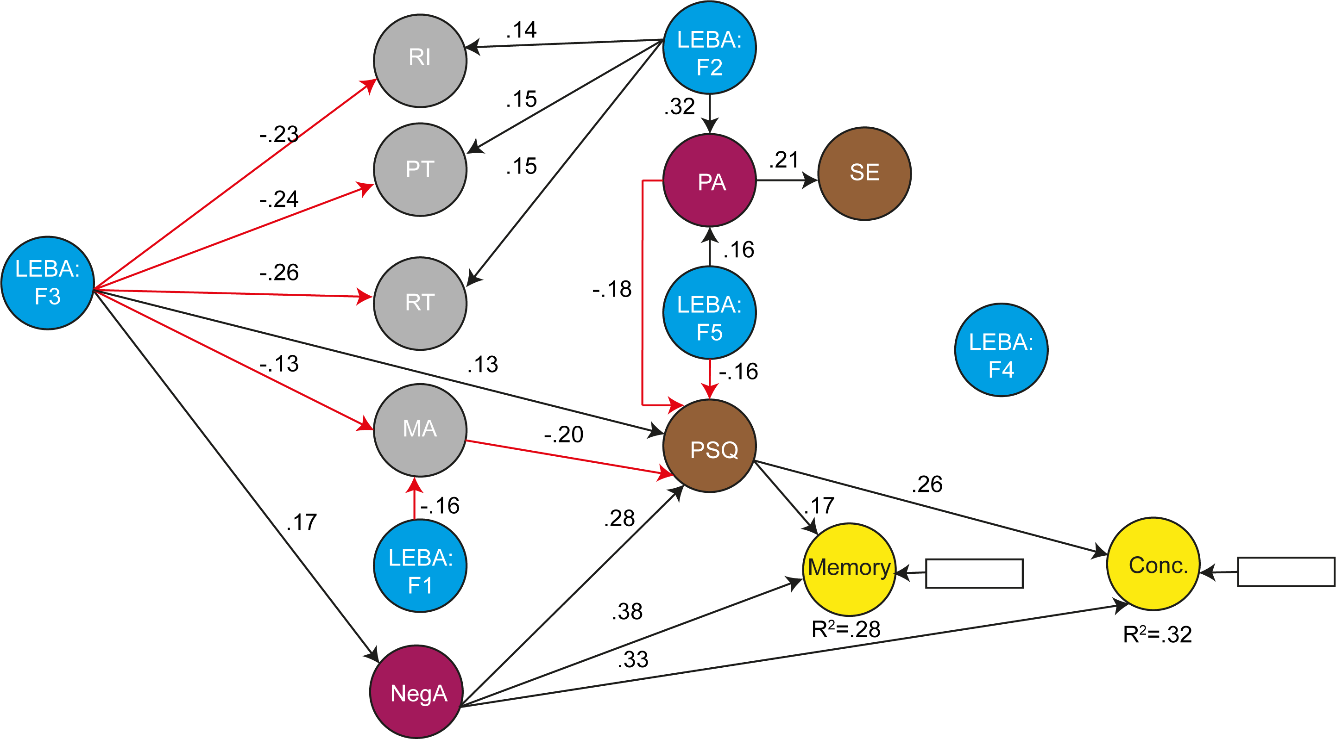

*Figure* *3.*  Analyses Steps

### Explanatory and predictive Power of the fitted model.

Our fitted model exhibited substantial explanatory power for PSQ (26.79%) and trouble in concentration (30.35% ). Moderate explanatory power was observed for PA (13.85%) and Memory (25.51%). For the two factors of chronotype we observed weak but adequate explanatory power for PT (10.96%) and RT (12.45%). MA, RI, SE and negative affect did not had adequate explanatory power. The values of the respective constructs indicated good predictive relevance (>0) for all constructs except positive and negative affect (<0) and RI (close to 0). function indicated our model had medium predictive power with 61.36% of the indicators having RMSE value lower than the LM benchmark.

# Discussion

# References

Buysse, D. J., Reynolds C. F., 3rd, Monk, T. H., Berman, S. R., & Kupfer, D. J. (1989). The Pittsburgh Sleep Quality Index: A new instrument for psychiatric practice and research [Journal article]. *Psychiatry Research*, *28*(2), 193–213. <https://doi.org/10.1016/0165-1781(89)90047-4>

Caci, H., Deschaux, O., Adan, A., & Natale, V. (2009). Comparing three morningness scales: Age and gender effects, structure and cut-off criteria. *Sleep Medicine*, *10*(2), 240–245.

Cohen, J. (1988). Statistical power analysis for the behavioral sciences [internet]. *Statistical Power Analysis for the Behavioral Sciences*, 567.

Cohen, J. (2013). *Statistical power analysis for the behavioral sciences*. Routledge.

Dunleavy, G., Bajpai, R., Comiran Tonon, A., Chua, A. P., Cheung, K. L., Soh, C.-K., … Car, J. (2019). Examining the factor structure of the pittsburgh sleep quality index in a multi-ethnic working population in singapore. *International Journal of Environmental Research and Public Health*, *16*(23), 4590.

Falk, R. F., & Miller, N. B. (1992). *A primer for soft modeling.* University of Akron Press.

Faul, F., Erdfelder, E., Lang, A.-G., & Buchner, A. (2007). G* power 3: A flexible statistical power analysis program for the social, behavioral, and biomedical sciences. *Behavior Research Methods*, *39*(2), 175–191.

Fornell, C., & Larcker, D. F. (1981). Evaluating structural equation models with unobservable variables and measurement error. *Journal of Marketing Research*, *18*(1), 39–50.

Hair Jr, Joseph F., Hult, G. T. M., Ringle, C. M., & Sarstedt, M. (2021). *A primer on partial least squares structural equation modeling (PLS-SEM)*. SAGE Publications.

Hair Jr, Joe F., Matthews, L. M., Matthews, R. L., & Sarstedt, M. (2017). PLS-SEM or CB-SEM: Updated guidelines on which method to use. *International Journal of Multivariate Data Analysis*, *1*(2), 107–123.

Henseler, J., Ringle, C. M., & Sarstedt, M. (2015). A new criterion for assessing discriminant validity in variance-based structural equation modeling. *Journal of the Academy of Marketing Science*, *43*(1), 115–135.

Hinton, P., McMurray, I., & Brownlow, C. (2014). *SPSS explained*. Routledge.

Horne, J. A., & Ostberg, O. (1976). A self-assessment questionnaire to determine morningness-eveningness in human circadian rhythms [Journal article]. *International Journal of Chronobiology*, *4*(2), 97–110.

MacCallum, R. C., Roznowski, M., Mar, C. M., & Reith, J. V. (1994). Alternative strategies for cross-validation of covariance structure models. *Multivariate Behavioral Research*, *29*(1), 1–32.

MacKenzie, S. B., Podsakoff, P. M., & Jarvis, C. B. (2005). The problem of measurement model misspecification in behavioral and organizational research and some recommended solutions. *Journal of Applied Psychology*, *90*(4), 710.

Manzar, M. D., BaHammam, A. S., Hameed, U. A., Spence, D. W., Pandi-Perumal, S. R., Moscovitch, A., & Streiner, D. L. (2018). Dimensionality of the pittsburgh sleep quality index: A systematic review. *Health and Quality of Life Outcomes*, *16*(1), 1–22.

R Core Team. (2021). *R: A language and environment for statistical computing*. Vienna, Austria: R Foundation for Statistical Computing. Retrieved from <https://www.R-project.org/>

Ray, S., Danks, N. P., & Calero Valdez, A. (2022). *Seminr: Building and estimating structural equation models*. Retrieved from <https://CRAN.R-project.org/package=seminr>

Sarstedt, M., Ringle, C. M., & Hair, J. F. (2021). Partial least squares structural equation modeling. In *Handbook of market research* (pp. 587–632). Springer.

Siraji, M. A., Lazar, R., Duijnhoven, J., Schlangen, L., Haque, S., Kalavally, V., … Spitschan, M. (2022). *LIGHT EXPOSURE BEHAVIOUR ASSESSMENT (LEBA): A NOVEL SELF-REPORTED INSTRUMENT TO MEASURE LIGHT EXPOSURE-RELATED BEHAVIOUR*. 33rd Annual Meeting of the Society for Light Treatment; Biological Rhythms (SLTBR), Manchester, UK.

Watson, D., Clark, L. A., & Tellegen, A. (1988). Development and validation of brief measures of positive and negative affect: The PANAS scales. *Journal of Personality and Social Psychology*, *54*(6), 1063.