The title

Mushfiqul Anwar Siraji1, Yi Jiau Saw2, Vineetha Kalavally2, & Shamsul Haque1

1 Monash University, Department of Psychology, Jeffrey Cheah School of Medicine and Health Sciences, Malaysia

2 Monash University, Department of Electrical and Computer Systems Engineering, Malaysia, Selangor, Malaysia

Author note

Add complete departmental affiliations for each author here. Each new line herein must be indented, like this line.

Enter author note here.

The authors made the following contributions. Mushfiqul Anwar Siraji: Conceptualization, Data curation, Investigation, Project administration, Methodology, Formal Analysis, Visualization, Writing - Original Draft Preparation, Writing - Review & Editing; Yi Jiau Saw: Conceptualization, Investigation, Data curation, Writing - Review & Editing; Vineetha Kalavally: Conceptualization, Project administration, Methodology, Writing – original draft, Writing – review & editing; Shamsul Haque: Conceptualization, Project administration, Methodology, Writing – original draft, Writing – review & editing.

Correspondence concerning this article should be addressed to Shamsul Haque, Postal address. E-mail: email

Abstract

One or two sentences providing a **basic introduction** to the field, comprehensible to a scientist in any discipline.

Two to three sentences of **more detailed background**, comprehensible to scientists in related disciplines.

One sentence clearly stating the **general problem** being addressed by this particular study.

One sentence summarizing the main result (with the words “**here we show**” or their equivalent).

Two or three sentences explaining what the **main result** reveals in direct comparison to what was thought to be the case previously, or how the main result adds to previous knowledge.

One or two sentences to put the results into a more **general context**.

Two or three sentences to provide a **broader perspective**, readily comprehensible to a scientist in any discipline.

*Keywords:* keywords

*Word count:* X

The title

# Methods

We report how we determined our sample size, all data exclusions (if any), all manipulations, and all measures in the study.

## Participants

Twenty four healthy university students age ranging between 20-29( mean age ± SD:23.96±2.42)- 16 females, (Mean age ± SD = 23.88±2.64 ) and 8 males (Mean age ± SD = 24.00±2.39 ) were studies in the Intelligent Lighting Lab at Monash University Malaysia. The study obtained ethics clearance from the Monash University Human Research Ethics Committee (Project ID: 14786) and participants provided written informed consent prior to study. All participants reported to be free from medial and psychological conditions and had no color blindness (tested by Ishihara Blindness Test (Clark, 1924)). Majority of them were poor sleeper (15 (62%)) and had intermediate chronotype (17 (71%)).

Table 1:

**

|  | label | stat_0 | stat_1 | stat_2 | stat_3 |
| --- | --- | --- | --- | --- | --- |
|  | **Variable** | **Overall**, N = 24 | **MELR 0.5_low**, N = 7 | **MELR 0.7_neutral**, N = 7 | **MELR 1.0_high**, N = 10 |
| 1 | Age | 23.96 (2.42) | 25.00 (2.52) | 23.29 (2.87) | 23.70 (2.00) |
| 2 | Gender | NA | NA | NA | NA |
| 3 | Female | 8 (33%) | 1 (14%) | 4 (57%) | 3 (30%) |
| 4 | Male | 16 (67%) | 6 (86%) | 3 (43%) | 7 (70%) |
| 5 | Marital Status | NA | NA | NA | NA |
| 6 | Single | 24 (100%) | 7 (100%) | 7 (100%) | 10 (100%) |
| 7 | Education | NA | NA | NA | NA |
| 8 | Bachelor’s Degree | 22 (92%) | 7 (100%) | 5 (71%) | 10 (100%) |
| 9 | Master’s Degree | 2 (8.3%) | 0 (0%) | 2 (29%) | 0 (0%) |
| 10 | Sleep Quality | NA | NA | NA | NA |
| 11 | Good | 9 (38%) | 3 (43%) | 3 (43%) | 3 (30%) |
| 12 | Poor | 15 (62%) | 4 (57%) | 4 (57%) | 7 (70%) |
| 13 | Chronotype | NA | NA | NA | NA |
| 14 | Definite Evening | 1 (4.2%) | 0 (0%) | 0 (0%) | 1 (10%) |
| 15 | Intermediate | 17 (71%) | 6 (86%) | 5 (71%) | 6 (60%) |
| 16 | Moderate Evening | 5 (21%) | 1 (14%) | 2 (29%) | 2 (20%) |
| 17 | Moderate Morning | 1 (4.2%) | 0 (0%) | 0 (0%) | 1 (10%) |
| .1 | Mean (SD); n (%) | Mean (SD); n (%) | Mean (SD); n (%) | Mean (SD); n (%) | Mean (SD); n (%) |

## Light Exposure Conditions

The experimental site was at Intelligent Light Lab, Monash University Malaysia (length x width x height; xx m by xx m by xx m). The lab was furnished with one ractangular working desk with three chairs. The walls of the lab was covered with grey cartains and all glass windows were covered by blackout blinds. The room temperature was set to 25 $​^{0}$ C. The three light conditions were generated using 12 Phillips tuneable LED ceiling mounted luminaries. We have measured the light sources at the horizontal plane at desk level (80 cm) and the vertical plane at eye level of the participants seated at the desk (122 cm). Figure XX depicts the spectral composition of the three light conditions. Table XX presents alpha-opic melanopic equivalent daylight illuminances (Melanopic EDI) and melanopic daylight efficacy ratio (MDER) values both at desk and eyelevel for the three light conditions: (a) high MDER light settings (HM):0.85 MDER, 210.93 MEDI, 6381 K; (b) neutral MDER light settings (NM):0.6 MDER, 156.09 MEDI, 3875 K; and (c) low MDER light settings (LM): 0.43 MDER, 90.57 MEDI, 2648 K. For all light conditions At the beginning of each sessions the light exposure level was maintained at approximately 250 photopic lx at the horizontal plane (79.23 μW/cm $​^{2}$) and approximately 139 lx (42.79 μW/cm $​^{2}$) at the vertical plane for thirty minutes. After this adaptation period, the photopic lx of three light settings were kept ~250 lx at desk level (Mean=238.12; SD=±13.11). In vertical plane at eye level the mean photopic lx was 238.12 (SD=±13.11). The α-opic values and MDER values are obtained using Loux software (Spitschan et al., 2022) and CIE S 026:2018 toolbox (Schlangen, 2020) following the CIE S 026 guidelines (CIE, 2018b).

## Study Protocol

Participants were asked not to ingest any caffeine and drink alcohol on the experiment day. Each session started with a practice block to familiarize the participants with the cognitive tests. Each participant spent approximately two hours in our lab in a time cue free environment (all doors and windows covered with blinds, no watches, internet, mobile, TV, newspaper and radio). Participants were randomly assigned to one the light conditions and were allowed thirty minutes to attune to the light condition. During this thirty minutes they answered a series of a questionnaire regarding their demographic information sleep quality, chronotype and completed Ishihara Blindness Test (Clark, 1924). Throughout the two hour protocol participants remained seated at their desks. Exercising and napping were not allowed. Participants took part in a series of cognitive tests in the following order: aPVT, N-back test, digit span, and Tower of London test . Subjective measures of sleepiness were recorded both at the beginning and the end of the protocol.

## Data analysis

We used R (R Core Team, 2022) for all our analyses using packages including psych (Revelle, 2022), tabledown, and WRS2 (Mair & Wilcox, 2020). Classical ANOVA methods assumes normality and homoscedascity and any violation to these assumptions raise serious practical concerns. Hence we used 10% trimmed mean based robust oneway or factorial anova which were less prone to these these assumption violations and outliers (Mair & Wilcox, 2020). “t1way” and “bwtrim” functions from the package “WRS2”(Mair & Wilcox, 2020) were used to conduct the robust oneway and factorial ANOVA respectively. We reported $ξ$ as the explanatory measure of the effect size where 0.10, 0.30, 0.50 correspond to small, medium and large effect size. The confidence interval of the effect size was estimated using 1000 bootstrap samples (Wilcox & Tian, 2011). In case of a significant F statistics we conducted robust pairwise post-hoc tests to compare the three light conditions using “lincon” function with Bonferroni correction from WRS2.

# Results

## Alerting effects

We observed a significant differences in subjective sleepiness across the three light settings [F(2,11.7)=4.85, p=0.03, $ξ$ = 0.69 (CI: 0.42-1.04)]. Post-hoc tests revealed that there was a trend of reporting decreased subjective sleepiness (beginning of the protocol vs end of the protocol) in High condition compared to Low ( $\hat{ψ}$ =–1.71; p=0.09) and Neutral ( $\hat{ψ}$ = –1.86; p=0.07) light conditions. No significant difference between Low and neutral light condition was observed (p=1.0).

In aPVT, we did not observe any significant effect of light conditions on general reaction time [F(2,10.1)=1.29, p=0.32, $ξ$ = 0.54 (CI: 0.21-1.03)], attention lapses [F(2,10.99)=0.49, p=0.63, $ξ$ = 0.34 (CI: 0.07-0.73)], and 10% fastest reaction time [F(2,12.21)=0.09, p=0.91, $ξ$ = 0.29 (CI: 0.06-0.66) ]

## $effsize  
## [1] 0  
##   
## $alpha  
## [1] 0.05  
##   
## $CI  
## [1] 0.0000000 0.7302957

(ref:alert) Panel A-D depicts the one-way ANOVA results comparing the light conditions’ effect on : (A) subjective sleepiness, (B) general reaction time, and (C) attention lapses and (D) 10% fastest reaction time. Each bar represents the mean ± standard error of measurements.

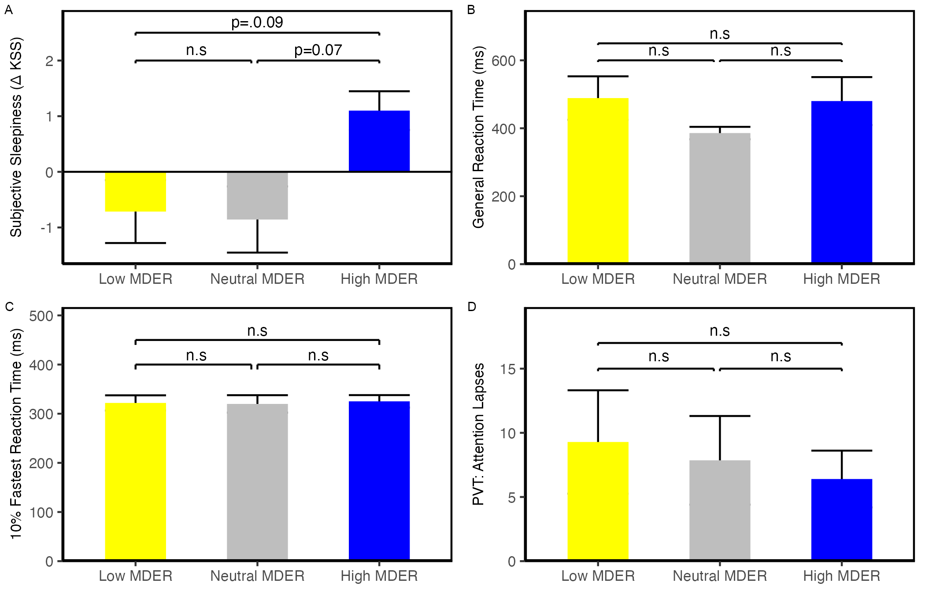

*Figure* *1.*  (ref:alert)

## Working Memory and Executive Functioning

We observed a significant differences in forward digit span task across the three light settings [F(2,12.14)=4.99, p=0.03, $ξ$ = 0.59 (CI: 0.34-0.82)]. Post-hoc tests revealed that participants performaed significantly better in Neutral condition compared to Low light condition ($\hat{ψ}$ =-1.57, p<0.04). No other pair-wise comparison in Forward digit span was significant. We did not observe any significant differences in backward [F(2,12.11)=0.33, p=0.72, $ξ$ = 0.37 (CI: 0.07-0.88)] and sequential digit span task performance [F(2,12.05)=0.54, p=0.60, $ξ$ = 0.41 (CI: 0.1-0.74)].

In the ToL task we observed a significant effect of light condition on execution time [F(2,11.47)=4.38, p=0.04, $ξ$ = 0.59 (CI: 0.31-0.85)]. Participants under Low light condition had signifiacntly lower efficiency than participants under neutral light condition ($\hat{ψ}$ =-10.89, p<0.04). We did not observe any significant influence of light on efficiency [F(2,12.56)=0.11, p=0.90, $ξ$ = 0.31 (CI: 0.06-0.68)] and planning time [F(2,10.57)=1.20, p=0.34, $ξ$ = 0.48 (CI: 0.16-1.04)] in the ToL task.

In N-back task we observed a significant main effect of task difficulty where participants had significantly faster reaction time [F(1,11.76)=45.71, p<0.001, $ξ$ = 0.88 (CI: 0.78-0.98)] and higher accuracy [F(1,6.72)=44.43, p<0.001, $ξ$ = 0.94 (CI: 0.75-0.99)] in the easy blocks (one back) compared to difficult blocks (two-blocks). However, we did not observe any significant effect of light condition on reaction time [F(2,9.26)=2.90, p=0.10, $ξ$ = 0.41 (CI: 0-0.79)], accuracy [F(2,6.11)=1.24, p=0.35, $ξ$ = 0.14 (CI: 0-0.68)],hit ratio [F(2,7.05)=2.82, p=0.13, $ξ$ = 0.13 (CI: 0-0.60)], false alarm [F(2,5.7)=1.28, p=0.35, $ξ$ = 0.24 (CI: 0-0.81)], sensitivity [F(2,2.91)=1.22, p=0.41, $ξ$ = 0.08 (CI: 0-0.61)], bias [F(2,2.67)=3.68, p=0.17, $ξ$ = 0.14 (CI: 0-0.68)].

Further, we observed no significant interaction effect of light condition and task complexity on N back reaction time [F(2,9.25)=1.46, p=0.28, $ξ$ = 0.41 (CI: CI: 0-0.79)] and accuracy [F(2,6.11)=0.32, p=0.74, $ξ$ = 0.14 (CI: 0-0.68)], hit ratio [F(2,7.05)=2.24, p=0.18, $ξ$ = 0.03 (CI: 0-0.56)], false alarm [F(2,5.7)=1.28, p=0.59, $ξ$ = 0.24 (CI: 0-0.78)],sensitivity [F(2,2.91)=0.03, p=0.97, $ξ$ = 0.08 (CI: 0-0.55)], bias [F(2,2.67)=1.41, p=0.38, $ξ$ = 0.71 (CI: 0.18-0.91)].

(ref:ef) light conditions’ effect on : (A) forward digit span, (B) backward digit span, (C) sequential digit span (D) Tol: execution time (E) Tol: efficacy (F) Tol: planning time (G) reaction time in N-back (H) accuracy in N back. Each bar represents the mean ± standard error of measurements.

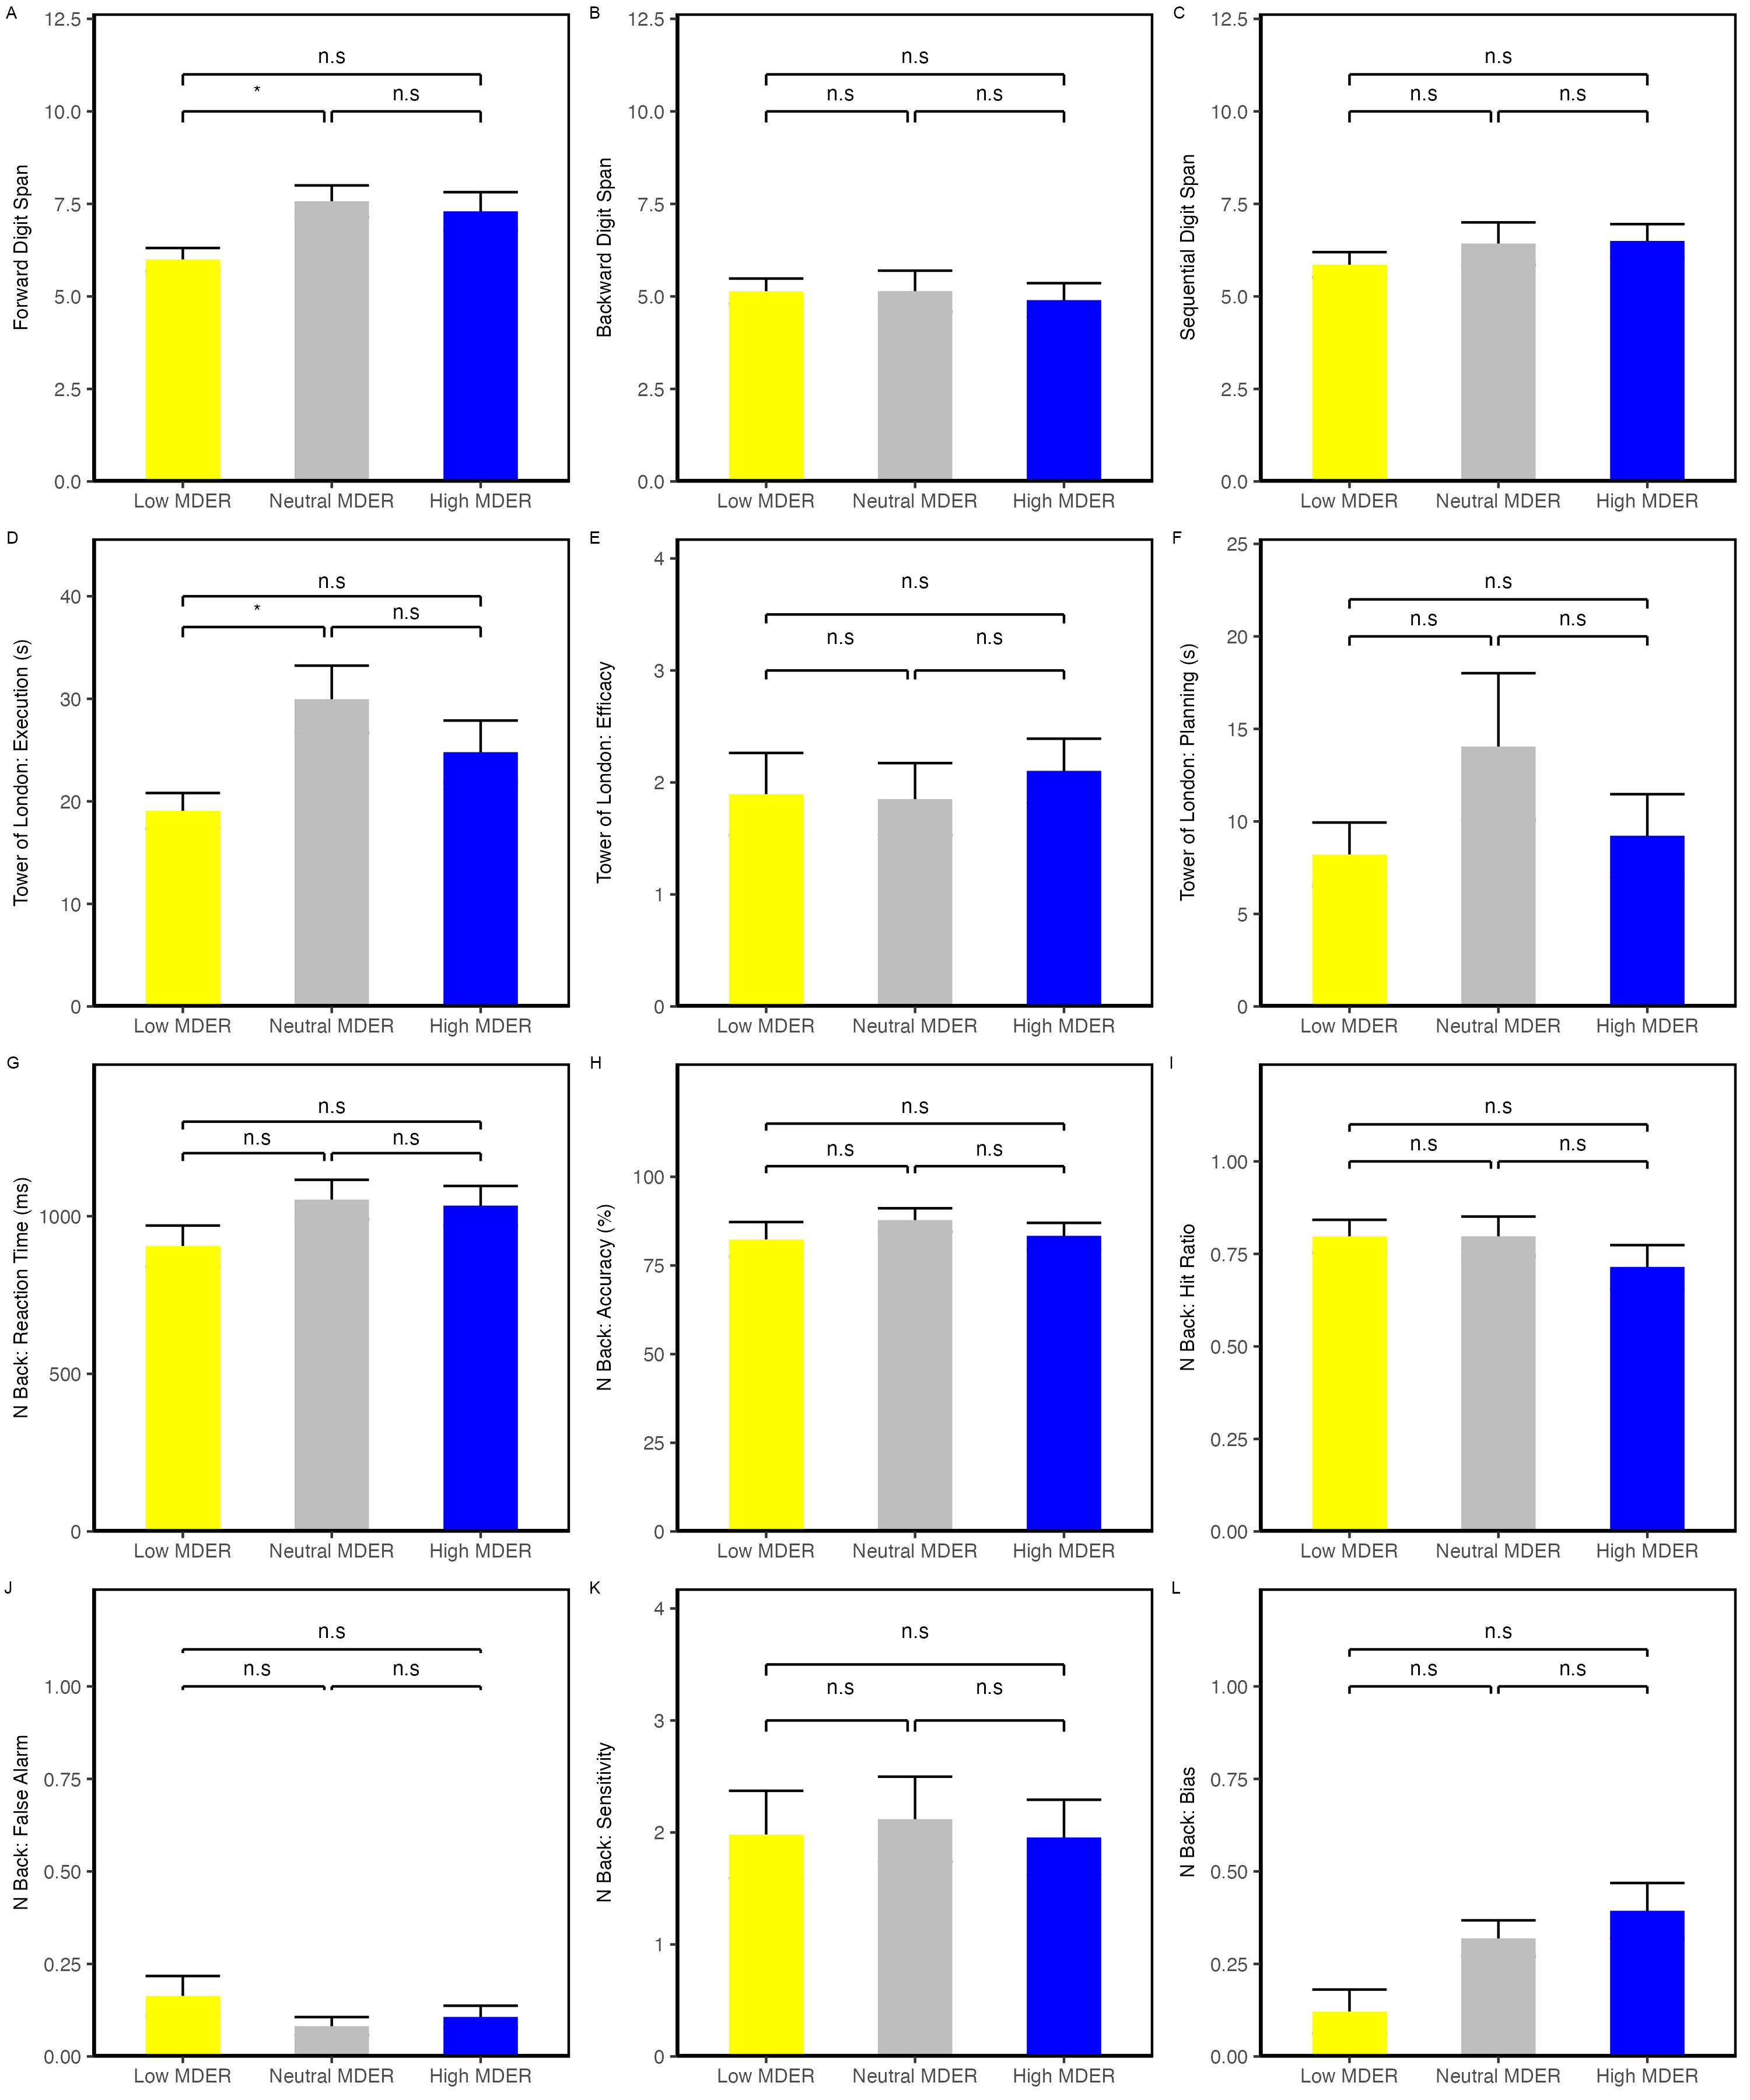

*Figure* *2.*  (ref:ef)

# Discussion

# References

Clark, J. (1924). The ishihara test for color blindness. *American Journal of Physiological Optics*.

Mair, P., & Wilcox, R. (2020). Robust Statistical Methods in R Using the WRS2 Package. *Behavior Research Methods*, *52*, 464–488.

R Core Team. (2022). *R: A language and environment for statistical computing*. Vienna, Austria: R Foundation for Statistical Computing. Retrieved from <https://www.R-project.org/>

Revelle, W. (2022). *Psych: Procedures for psychological, psychometric, and personality research*. Evanston, Illinois: Northwestern University. Retrieved from <https://CRAN.R-project.org/package=psych>

Wilcox, R. R., & Tian, T. S. (2011). Measuring effect size: A robust heteroscedastic approach for two or more groups. *Journal of Applied Statistics*, *38*(7), 1359–1368.