《Java面向对象程序设计SSD3》

实验报告

项目名称 实验4《面向对象——继承》
专业班级 软工2507班
学 号 8209250708
姓 名 雷楠

实验成绩：

批阅教师：邝砾

2026年 5 月 17 日

中南大学计算机学院实验报告
课程名称 Java面向对象程序设计SSD3
实验项目名称 实验4《面向对象——继承》
学生姓名 雷楠 专业班级 软工2507班 学号 8209250708
实验成绩 日期
已设置目录可快速跳转

一、实验目的
- 理解面向对象编程，尤其是继承的思想，学习通过继承，在父类的基础上创建子类。
- 使用关键字 super 调用父类的构造方法和方法。
- 在子类中覆盖（Override）父类的方法。

二、实验内容
本次实验完成了三个面向对象的编程任务：
1.智能家居设备系统：实现了 SmartDevice 基类和 SmartLight 子类。
2.图书馆资源管理系统：实现了 LibraryItem 基类，以及 Book 和 Magazine 子类。
3.员工薪资管理系统：实现了 Employee 基类，FullTimeEmployee 和 PartTimeEmployee 子类，以及管理类 PayrollSystem。

三、实验结果与分析
题目1 运行结果：
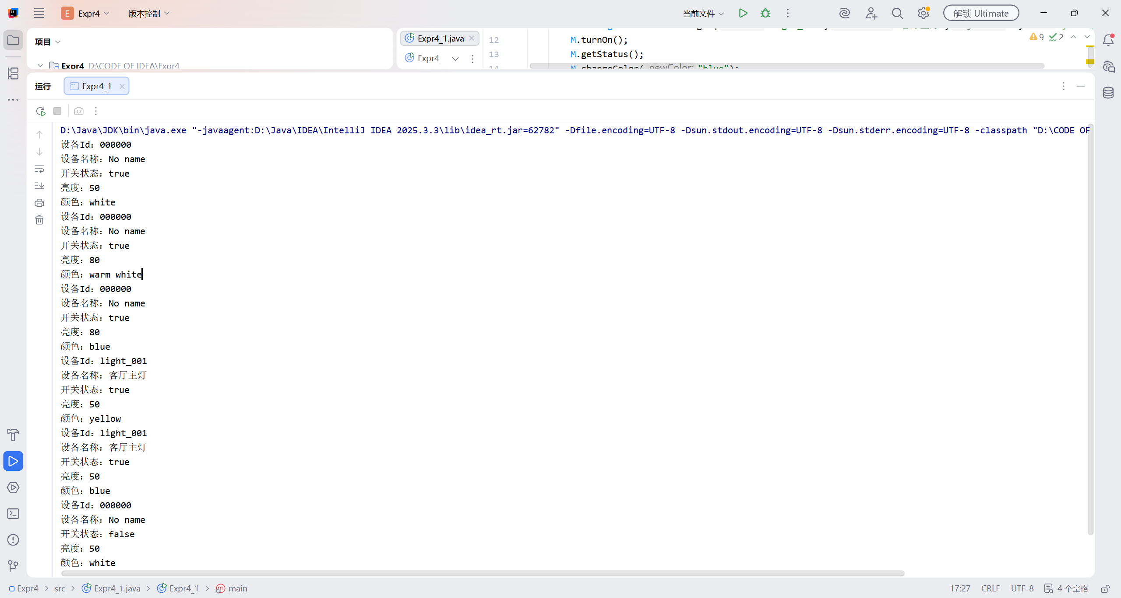
无参构造与默认值：
SmartLight Test1 使用无参构造函数创建。输出显示，继承自父类的 deviceId 和 deviceName 成功初始化为 "000000" 和 "No name"。
子类特有属性 brightness 和 color 在构造函数中被正确初始化为 50 和 "white"。
方法重写与多态：
调用 getStatus() 时，输出包含了父类的设备信息和子类的亮度、颜色信息，证明 SmartLight 成功重写了父类方法并扩展了功能。
turnOn() 方法被重写，不仅改变了开关状态，还强制将亮度恢复为默认值 50（尽管测试中先设置了80，但在后续 turnOn 后亮度重置为50，体现了业务逻辑的正确性）。
继承链测试：
SmartDevice Test2 = new SmartLight(); 演示了向上转型。虽然引用类型是父类，但实际调用的是子类重写的 getStatus()，输出了完整的子类信息，验证了多态的运行时绑定机制。
题目2 运行结果：
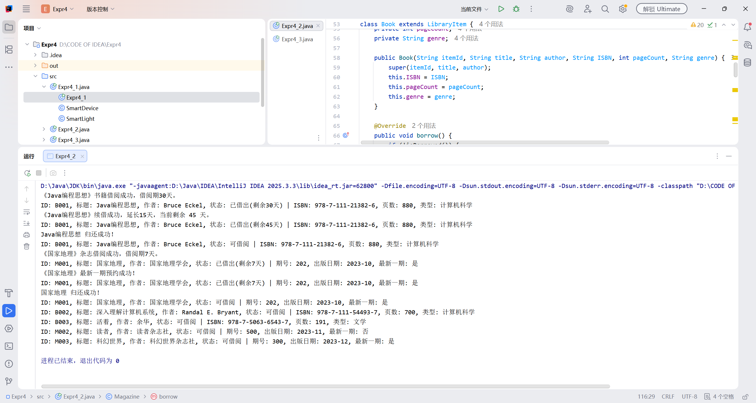
多态性验证（核心分析点）：
程序定义了一个 LibraryItem 类型的数组 items，但实际存储的是 Book 和 Magazine 对象。
在 for 循环中，调用 item.getInfo() 时，程序能自动识别对象的实际类型，分别输出书籍的 ISBN 信息和杂志的期号信息。这证明了运行时多态的有效性，是面向对象设计中“一个接口，多种实现”的典型体现。
方法重写差异：
Book 的 borrow 方法设置了 30 天借阅期，并提供了 renew（续借）功能。
Magazine 的 borrow 方法设置了 7 天借阅期，并提供了 reserve（预约）功能。
测试输出中，两者的借阅提示语不同（“书籍借阅成功” vs “杂志借阅成功”），且状态栏显示的剩余天数逻辑正确。
逻辑控制：
测试中对已借出的资源尝试再次借阅时，系统能正确提示“已被借出”，防止了非法操作。
题目3 运行结果：
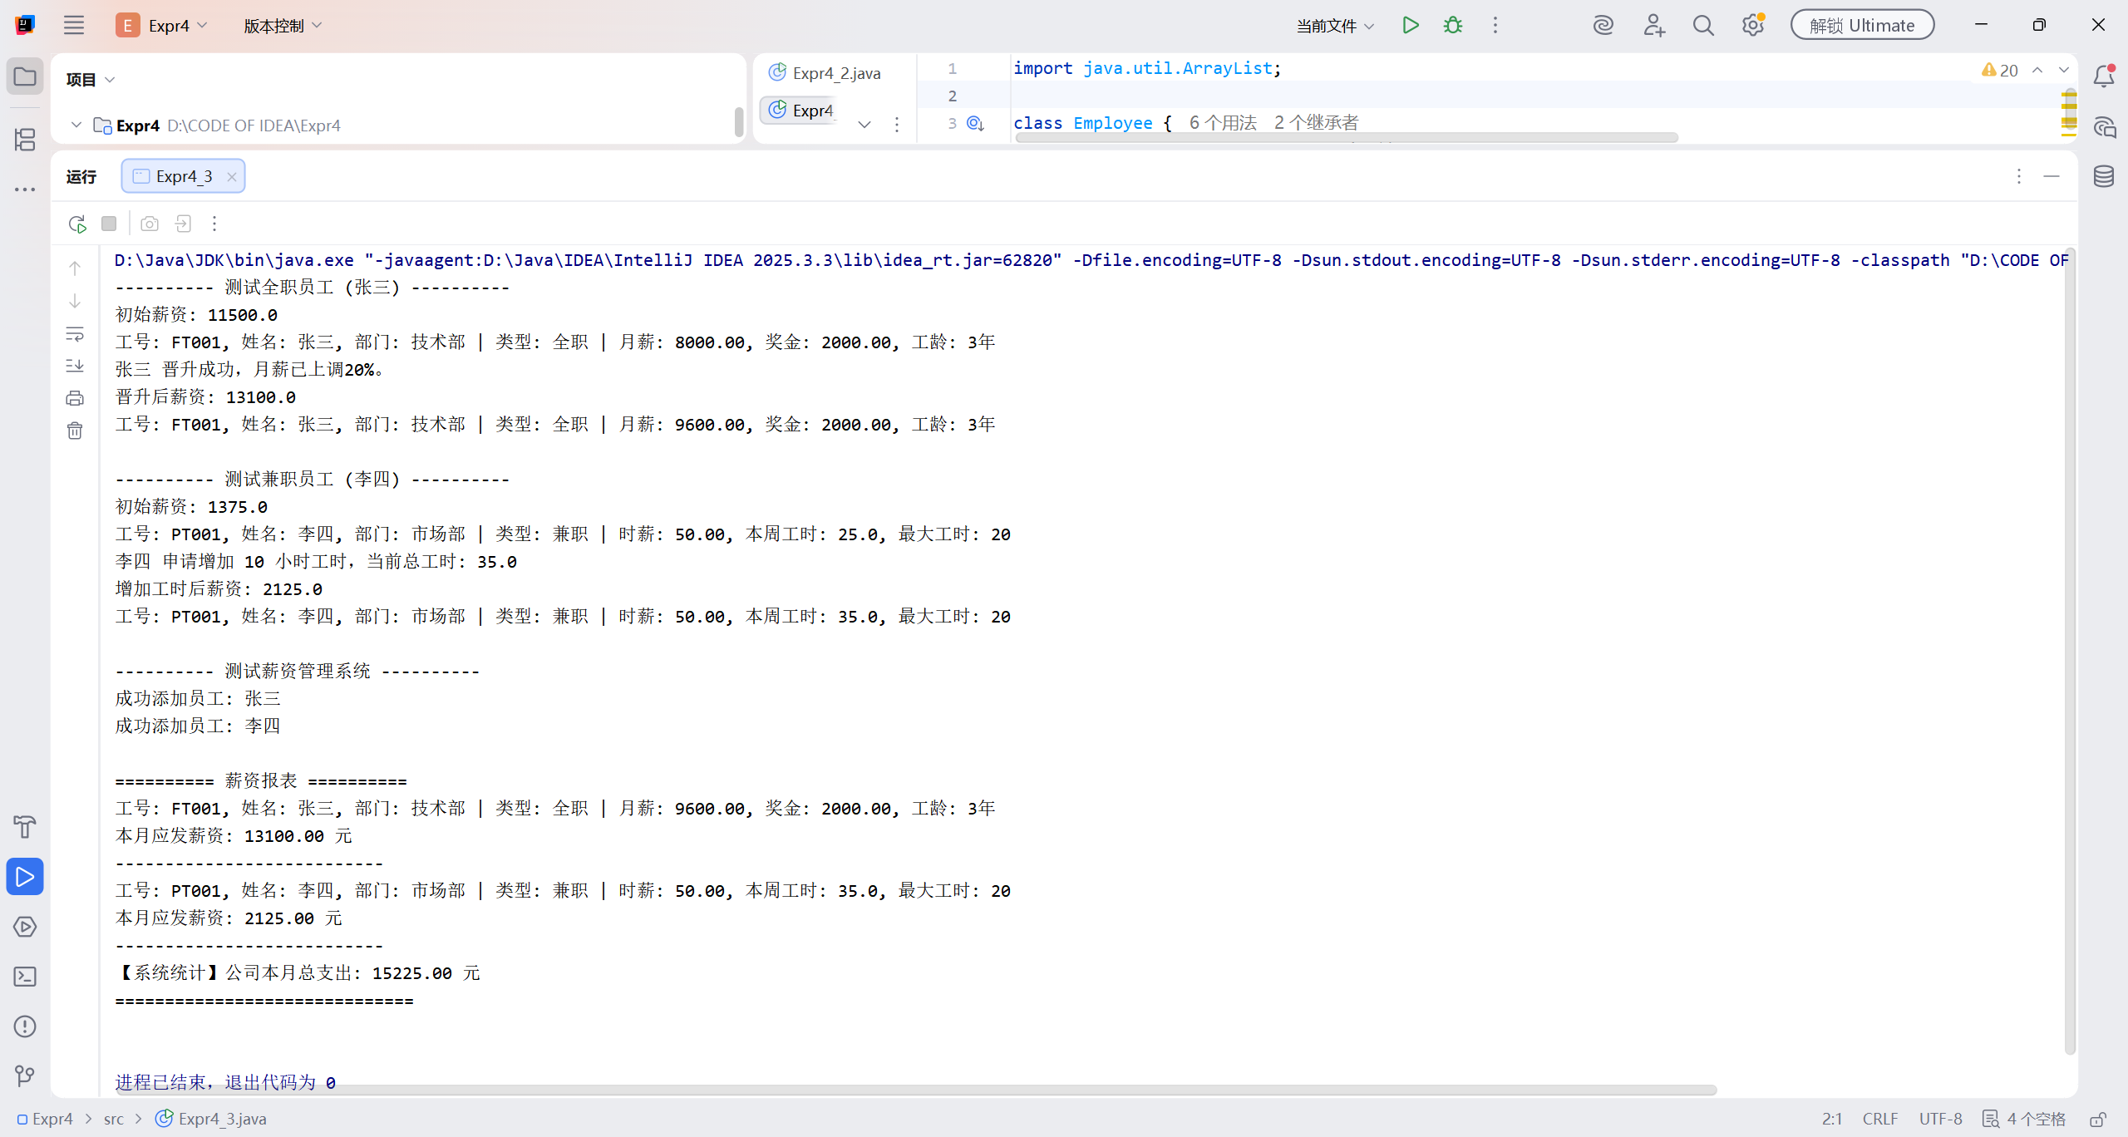
继承与构造：
FullTimeEmployee 和 PartTimeEmployee 在构造函数中均使用 super(...) 正确初始化了父类 Employee 的通用属性（工号、姓名、部门）。
多态计算薪资：
PayrollSystem 类中的 generatePayrollReport 方法接收 Employee 数组。
调用 emp.calculateSalary() 时，系统根据对象实际类型自动调用全职员工的“月薪+奖金+工龄津贴”算法或兼职员工的“时薪×工时（含加班费）”算法。
数据验证：
全职员工张三：初始月薪 8000 + 奖金 2000 + 工龄 3年×500 = 11500（与输出一致）。晋升后月薪上调 20%（9600），总薪资变为 13100。
兼职员工李四：初始 25小时（超时5小时）= (20×50) + (5×50×1.5) = 1375。增加10小时后共35小时 = (20×50) + (15×50×1.5) = 2125。计算逻辑完全符合任务书要求。
集合管理：
PayrollSystem 成功使用 ArrayList 存储了不同类型的员工，并实现了添加、移除和统计总薪资的功能，证明了面向对象设计在数据管理上的灵活性。

四、心得体会

1. UML 类设计图
题目1：智能家居设备系统
+-------------------------+
| SmartDevice |
+-------------------------+
| - deviceId: String |
| - deviceName: String |
| - isOn: boolean |
+-------------------------+
| + SmartDevice() |
| + SmartDevice(id,n) |
| + turnOn(): void |
| + turnOff(): void |
| + getStatus(): void |
| + get/set Methods |
+-------------------------+
^
| (继承)
|
+-------------------------+
| SmartLight |
+-------------------------+
| - brightness: int |
| - color: String |
+-------------------------+
| + SmartLight() |
| + SmartLight(id,n,b,c) |
| + turnOn(): void |
| + setBrightness(l):void |
| + changeColor(c):void |
| + getStatus(): void |
+-------------------------+
题目2：图书馆资源管理系统
+-------------------------+
| LibraryItem |
+-------------------------+
| - itemId: String |
| - title: String |
| - author: String |
| - isBorrowed: boolean |
| - dayReturn: int |
+-------------------------+
| + LibraryItem(id,t,a) |
| + borrow(): void |
| + returnItem(): void |
| + getInfo(): String |
+-------------------------+
^
| (继承)
+-------+-------+
| |
+-----------+ +-----------+
| Book | | Magazine |
+-----------+ +-----------+
| - ISBN | | - issueNum|
| - pageCount| | - pubDate |
| - genre | | - isCurrent|
+-----------+ +-----------+
| + Book(...) | | + Magazine..|
| + borrow() | | + borrow() |
| + renew() | | + reserve() |
| + getInfo()| | + getInfo() |
+-----------+ +-----------+
题目3：员工薪资管理系统
+-------------------------+
| Employee |
+-------------------------+
| - employeeId: String |
| - name: String |
| - department: String |
+-------------------------+
| + Employee(id,n,d) |
| + calculateSalary(): double |
| + getEmployeeInfo(): String |
+-------------------------+
^
| (继承)
+-------+-------+
| |
+-----------+ +-----------+
|FullTimeEmp| |PartTimeEmp|
+-----------+ +-----------+
| - monthly | | - hourly |
| - bonus | | - hoursW |
| - years | | - maxHours|
+-----------+ +-----------+
| + calc() | | + calc() |
| + promote()| | + requestH()|
| + getEmpI()| | + getEmpI()|
+-----------+ +-----------+

+-------------------------+
| PayrollSystem |
+-------------------------+
| - employees: ArrayList<Employee> |
+-------------------------+
| + addEmployee(e): void |
| + removeEmployee(id):void|
| + calcTotal(): double |
| + generateReport():void |
+-------------------------+

2.实验感受
通过本次实验，我深入理解了Java继承机制的核心概念。通过编写 SmartDevice 和 SmartLight 等类，我掌握了如何利用 extends 关键字复用父类代码，并通过 super 关键字正确初始化父类属性。同时，在实现多态（如 LibraryItem 数组存储不同子类对象）的过程中，我体会到了面向对象编程的灵活性和扩展性。
遇到的困难及解决办法：
- 构造方法链的调用：在 SmartLight 的构造方法中，最初忘记调用 super(deviceId, deviceName)，导致父类的属性没有被正确初始化。解决办法是检查构造函数，确保第一行使用 super 调用父类构造器。
- 逻辑运算符优先级：在题目3的 PartTimeEmployee 计算薪资时，因括号位置错误导致计算结果偏差，通过调试逐步排查修正。

五、附源程序

文件名：Expr4_1.java
public class Expr4_1 {
public static void main(String[] args){
SmartLight Test1=new SmartLight();
Test1.turnOn();
Test1.getStatus();
Test1.setBrightness(80);
Test1.changeColor("warm white");
Test1.getStatus();
Test1.changeColor("blue");
Test1.getStatus();
SmartLight M=new SmartLight("light_001","客厅主灯",70,"yellow");
M.turnOn();
M.getStatus();
M.changeColor("blue");
M.getStatus();
SmartDevice Test2=new SmartLight();
Test2.getStatus();
}
}
class SmartDevice{
private String deviceId;
private String deviceName;
private boolean isOn;
public SmartDevice(){
deviceId="000000";
deviceName="No name";
isOn=false;
}
public SmartDevice(String deviceId,String deviceName){
this.deviceId=deviceId;
this.deviceName=deviceName;
isOn=false;
}
public void turnOn(){
isOn=true;
}
public void turnOff(){
isOn=false;
}
public String getDeviceId(){
return deviceId;
}
public String getDeviceName(){
return deviceName;
}
public boolean getisOn(){
return isOn;
}
public void setDeviceId(String deviceId){
this.deviceId=deviceId;
}
public void setDeviceName(String deviceName){
this.deviceName=deviceName;
}
public void setisOn(boolean isOn){
this.isOn=isOn;
}
public void getStatus(){
System.out.println("设备Id："+deviceId);
System.out.println("设备名称："+deviceName);
System.out.println("开关状态："+isOn);
}
}
class SmartLight extends SmartDevice{
private int brightness;
private String color;
public SmartLight(){
super();
brightness=50;
color="white";
}
public SmartLight(String deviceId,String deviceName
,int brightness,String color){
super(deviceId,deviceName);
this.brightness=brightness;
this.color=color;
}
@Override
public void turnOn(){
super.turnOn();
brightness=50;
}
@Override
public void getStatus(){
super.getStatus();
System.out.println("亮度："+brightness);
System.out.println("颜色："+color);
}
public void setBrightness(int level){
brightness=level;
}
public void changeColor(String newColor){
color=newColor;
}
}

文件名：Expr4_2.java
class LibraryItem {
private String itemId;
private String title;
private String author;
private boolean isBorrowed;
private int dayReturn;
public LibraryItem(String itemId, String title, String author) {
this.itemId = itemId;
this.title = title;
this.author = author;
this.isBorrowed = false;
this.dayReturn = 0;
}
public void borrow() {
if (!isBorrowed) {
isBorrowed = true;
System.out.println(title + " 借阅成功！");
} else {
System.out.println(title + " 已被借出，无法借阅。");
}
}
public void returnItem() {
if (isBorrowed) {
isBorrowed = false;
dayReturn = 0;
System.out.println(title + " 归还成功！");
} else {
System.out.println(title + " 未被借出，无需归还。");
}
}
public String getInfo() {
return "ID: " + itemId + ", 标题: " + title + ", 作者: " + author +
", 状态: " + (isBorrowed ? "已借出(剩余" + dayReturn + "天)" : "可借阅");
}
// 访问器和修改器
public String getItemId() { return itemId; }
public void setItemId(String itemId) { this.itemId = itemId; }
public String getTitle() { return title; }
public void setTitle(String title) { this.title = title; }
public String getAuthor() { return author; }
public void setAuthor(String author) { this.author = author; }
public boolean isBorrowed() { return isBorrowed; }
public void setBorrowed(boolean borrowed) { isBorrowed = borrowed; }
public int getDayReturn() { return dayReturn; }
public void setDayReturn(int dayReturn) { this.dayReturn = dayReturn; }
}
class Book extends LibraryItem {
private String ISBN;
private int pageCount;
private String genre;
public Book(String itemId, String title, String author, String ISBN, int pageCount, String genre) {
super(itemId, title, author);
this.ISBN = ISBN;
this.pageCount = pageCount;
this.genre = genre;
}
@Override
public void borrow() {
if (!isBorrowed()) {
setBorrowed(true);
setDayReturn(30);
System.out.println("《" + getTitle() + "》书籍借阅成功，借阅期30天。");
} else {
System.out.println("《" + getTitle() + "》已被借出。");
}
}
public void renew() {
if (isBorrowed()) {
int newDays = getDayReturn() + 15;
setDayReturn(newDays);
System.out.println("《" + getTitle() + "》续借成功，延长15天，当前剩余 " + newDays + " 天。");
} else {
System.out.println("《" + getTitle() + "》未被借出，无法续借。");
}
}
@Override
public String getInfo() {
return super.getInfo() + " | ISBN: " + ISBN + ", 页数: " + pageCount + ", 类型: " + genre;
}
// 访问器和修改器
public String getISBN() { return ISBN; }
public void setISBN(String ISBN) { this.ISBN = ISBN; }
public int getPageCount() { return pageCount; }
public void setPageCount(int pageCount) { this.pageCount = pageCount; }
public String getGenre() { return genre; }
public void setGenre(String genre) { this.genre = genre; }
}
class Magazine extends LibraryItem {
private int issueNumber;
private String publicationDate;
private boolean isCurrentIssue;
public Magazine(String itemId, String title, String author, int issueNumber, String publicationDate, boolean isCurrentIssue) {
super(itemId, title, author);
this.issueNumber = issueNumber;
this.publicationDate = publicationDate;
this.isCurrentIssue = isCurrentIssue;
}
@Override
public void borrow() {
if (!isBorrowed()) {
setBorrowed(true);
setDayReturn(7);
System.out.println("《" + getTitle() + "》杂志借阅成功，借阅期7天。");
} else {
System.out.println("《" + getTitle() + "》已被借出。");
}
}
public void reserve() {
if (isCurrentIssue) {
System.out.println("《" + getTitle() + "》最新一期预约成功！");
} else {
System.out.println("《" + getTitle() + "》不是最新一期，无法预约。");
}
}
@Override
public String getInfo() {
return super.getInfo() + " | 期号: " + issueNumber + ", 出版日期: " + publicationDate +
", 最新一期: " + (isCurrentIssue ? "是" : "否");
}
// 访问器和修改器
public int getIssueNumber() { return issueNumber; }
public void setIssueNumber(int issueNumber) { this.issueNumber = issueNumber; }
public String getPublicationDate() { return publicationDate; }
public void setPublicationDate(String publicationDate) { this.publicationDate = publicationDate; }
public boolean isCurrentIssue() { return isCurrentIssue; }
public void setCurrentIssue(boolean currentIssue) { isCurrentIssue = currentIssue; }
}
public class Expr4_2 {
public static void main(String[] args) {
Book book = new Book("B001", "Java编程思想", "Bruce Eckel", "978-7-111-21382-6", 880, "计算机科学");
book.borrow();
System.out.println(book.getInfo());
book.renew();
System.out.println(book.getInfo());
book.returnItem();
System.out.println(book.getInfo());
Magazine magazine = new Magazine("M001", "国家地理", "国家地理学会", 202, "2023-10", true);
magazine.borrow();
System.out.println(magazine.getInfo());
magazine.reserve();
System.out.println(magazine.getInfo());
magazine.returnItem();
System.out.println(magazine.getInfo());
LibraryItem[] items = {
new Book("B002", "深入理解计算机系统", "Randal E. Bryant", "978-7-111-54493-7", 700, "计算机科学"),
new Book("B003", "活着", "余华", "978-7-5063-6543-7", 191, "文学"),
new Magazine("M002", "读者", "读者杂志社", 500, "2023-11", false),
new Magazine("M003", "科幻世界", "科幻世界杂志社", 300, "2023-12", true)
};
for (LibraryItem item : items) {
System.out.println(item.getInfo());
}
}
}

文件名：Expr4_3.java
import java.util.ArrayList;
class Employee {
private String employeeId;
private String name;
private String department;
public Employee(String employeeId, String name, String department) {
this.employeeId = employeeId;
this.name = name;
this.department = department;
}
public double calculateSalary() {
return 0.0;
}
public String getEmployeeInfo() {
return "工号: " + employeeId + ", 姓名: " + name + ", 部门: " + department;
}
public String getEmployeeId() { return employeeId; }
public void setEmployeeId(String employeeId) { this.employeeId = employeeId; }
public String getName() { return name; }
public void setName(String name) { this.name = name; }
public String getDepartment() { return department; }
public void setDepartment(String department) { this.department = department; }
}
class FullTimeEmployee extends Employee {
private double monthlySalary;
private double bonus;
private int yearsOfService;
public FullTimeEmployee(String employeeId, String name, String department, double monthlySalary, int yearsOfService, double bonus) {
super(employeeId, name, department);
this.monthlySalary = monthlySalary;
this.bonus = bonus;
this.yearsOfService = yearsOfService;
}
@Override
public double calculateSalary() {
return monthlySalary + bonus + (yearsOfService * 500);
}
public void promote() {
this.monthlySalary *= 1.2;
System.out.println(getName() + " 晋升成功，月薪已上调20%。");
}
@Override
public String getEmployeeInfo() {
return super.getEmployeeInfo() + String.format(" | 类型: 全职 | 月薪: %.2f, 奖金: %.2f, 工龄: %d年", monthlySalary, bonus, yearsOfService);
}
public double getMonthlySalary() { return monthlySalary; }
public void setMonthlySalary(double monthlySalary) { this.monthlySalary = monthlySalary; }
public double getBonus() { return bonus; }
public void setBonus(double bonus) { this.bonus = bonus; }
public int getYearsOfService() { return yearsOfService; }
public void setYearsOfService(int yearsOfService) { this.yearsOfService = yearsOfService; }
}
class PartTimeEmployee extends Employee {
private double hourlyRate;
private double hoursWorked;
private int maxHoursPerWeek;
public PartTimeEmployee(String employeeId, String name, String department, double hourlyRate, double hoursWorked, int maxHoursPerWeek) {
super(employeeId, name, department);
this.hourlyRate = hourlyRate;
this.hoursWorked = hoursWorked;
this.maxHoursPerWeek = maxHoursPerWeek;
}
@Override
public double calculateSalary() {
if (hoursWorked <= maxHoursPerWeek) {
return hourlyRate * hoursWorked;
} else {
double normalPay = hourlyRate * maxHoursPerWeek;
double overtimePay = (hoursWorked - maxHoursPerWeek) * hourlyRate * 1.5;
return normalPay + overtimePay;
}
}
public void requestMoreHours(int additionalHours) {
this.hoursWorked += additionalHours;
System.out.println(getName() + " 申请增加 " + additionalHours + " 小时工时，当前总工时: " + this.hoursWorked);
}
@Override
public String getEmployeeInfo() {
return super.getEmployeeInfo() + String.format(" | 类型: 兼职 | 时薪: %.2f, 本周工时: %.1f, 最大工时: %d", hourlyRate, hoursWorked, maxHoursPerWeek);
}
public double getHourlyRate() { return hourlyRate; }
public void setHourlyRate(double hourlyRate) { this.hourlyRate = hourlyRate; }
public double getHoursWorked() { return hoursWorked; }
public void setHoursWorked(double hoursWorked) { this.hoursWorked = hoursWorked; }
public int getMaxHoursPerWeek() { return maxHoursPerWeek; }
public void setMaxHoursPerWeek(int maxHoursPerWeek) { this.maxHoursPerWeek = maxHoursPerWeek; }
}
class PayrollSystem {
private ArrayList<Employee> employees;
public PayrollSystem() {
this.employees = new ArrayList<>();
}
public void addEmployee(Employee emp) {
employees.add(emp);
System.out.println("成功添加员工: " + emp.getName());
}
public void removeEmployee(String employeeId) {
employees.removeIf(emp -> emp.getEmployeeId().equals(employeeId));
System.out.println("成功移除工号为 " + employeeId + " 的员工。");
}
public double calculateTotalPayroll() {
double total = 0;
for (Employee emp : employees) {
total += emp.calculateSalary();
}
return total;
}
public void generatePayrollReport() {
System.out.println("\n========== 薪资报表 ==========");
for (Employee emp : employees) {
System.out.println(emp.getEmployeeInfo());
System.out.printf("本月应发薪资: %.2f 元\n", emp.calculateSalary());
System.out.println("---------------------------");
}
System.out.printf("【系统统计】公司本月总支出: %.2f 元\n", calculateTotalPayroll());
System.out.println("==============================\n");
}
}
public class Expr4_3 {
public static void main(String[] args) {
System.out.println("---------- 测试全职员工 (张三) ----------");
FullTimeEmployee ftEmp = new FullTimeEmployee("FT001", "张三", "技术部", 8000, 3, 2000);
System.out.println("初始薪资: " + ftEmp.calculateSalary()); // 8000+2000+1500 = 11500
System.out.println(ftEmp.getEmployeeInfo());
ftEmp.promote(); // 月薪变为 8000 * 1.2 = 9600
System.out.println("晋升后薪资: " + ftEmp.calculateSalary()); // 9600+2000+1500 = 13100
System.out.println(ftEmp.getEmployeeInfo());
System.out.println("\n---------- 测试兼职员工 (李四) ----------");
PartTimeEmployee ptEmp = new PartTimeEmployee("PT001", "李四", "市场部", 50, 25, 20);
System.out.println("初始薪资: " + ptEmp.calculateSalary()); // 20*50 + 5*50*1.5 = 1000 + 375 = 1375
System.out.println(ptEmp.getEmployeeInfo());
ptEmp.requestMoreHours(10); // 工时变为 35
System.out.println("增加工时后薪资: " + ptEmp.calculateSalary()); // 20*50 + 15*50*1.5 = 1000 + 1125 = 2125
System.out.println(ptEmp.getEmployeeInfo());
System.out.println("\n---------- 测试薪资管理系统 ----------");
PayrollSystem payrollSystem = new PayrollSystem();
payrollSystem.addEmployee(ftEmp);
payrollSystem.addEmployee(ptEmp);
payrollSystem.generatePayrollReport();
}
}

