**#1 CREATION DATABASE**

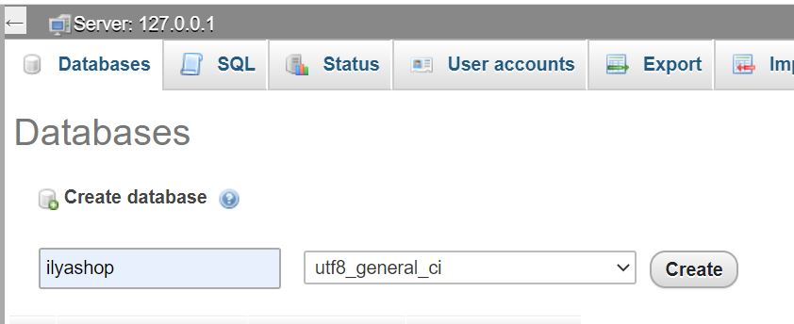

At first, I create my database i named ilyashop

**#2 CREATE DATABASE USER**

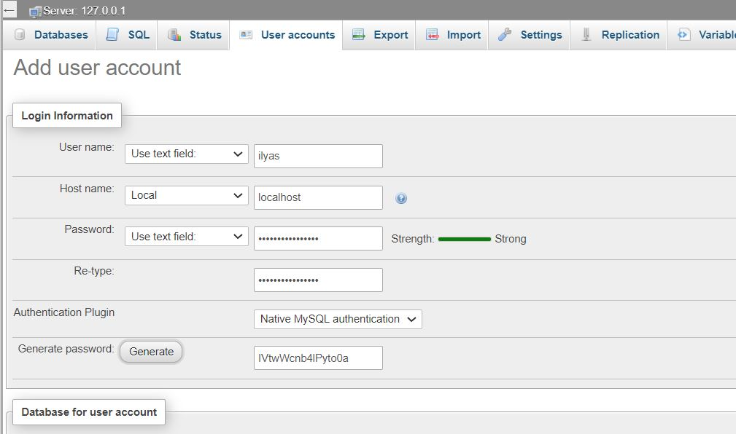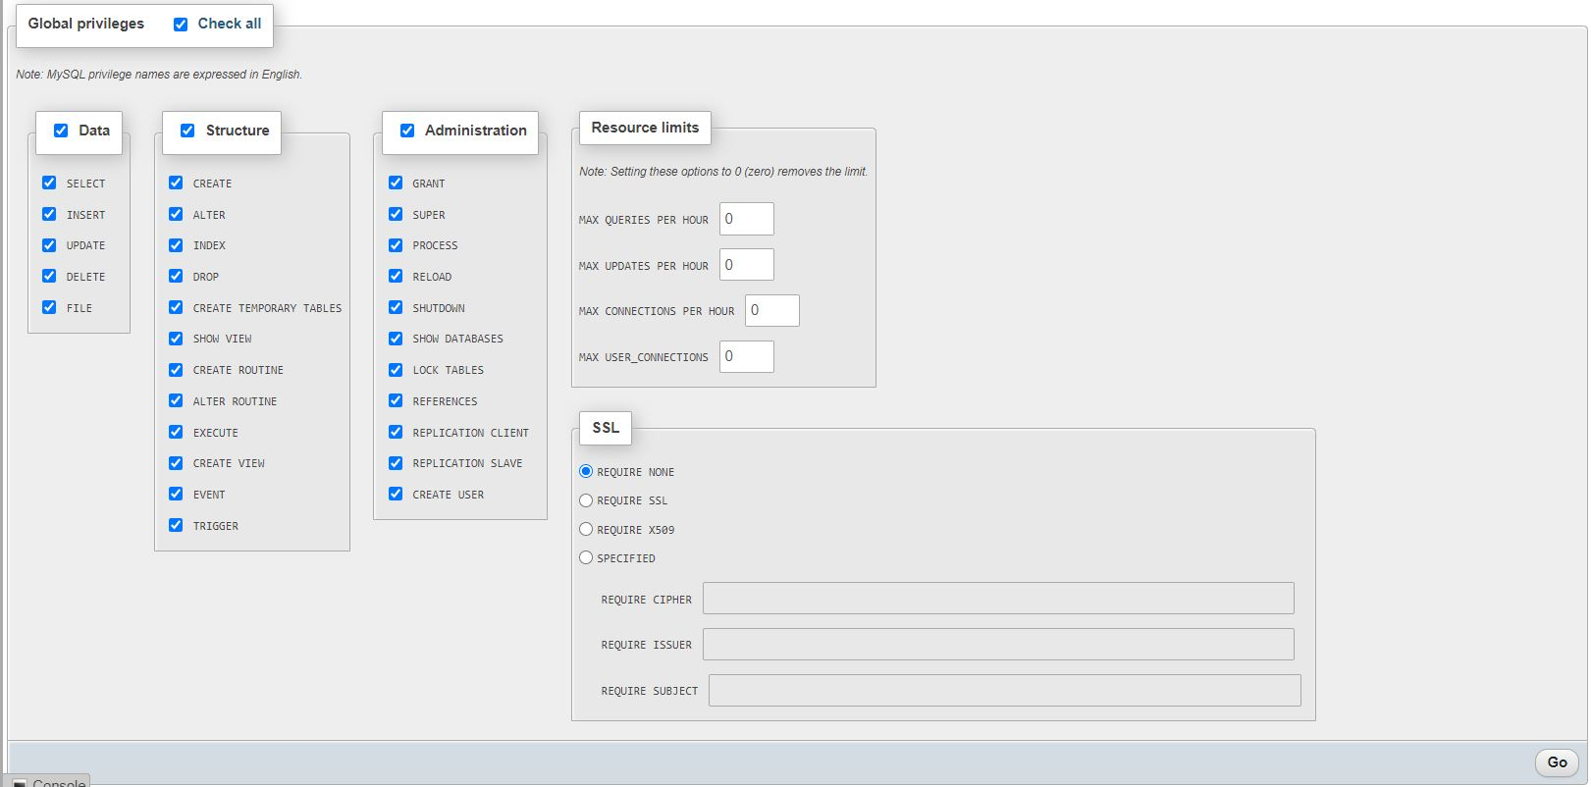

After i went to privileges section and add new user account

And check all permetions of for get all privileges

**#3 install WordPress**

Go to [www.wordpress.org/download](http://www.wordpress.org/download) for download wordpress like winrar



After Extract it

And copy directory wordpress into : htdocs in xampp

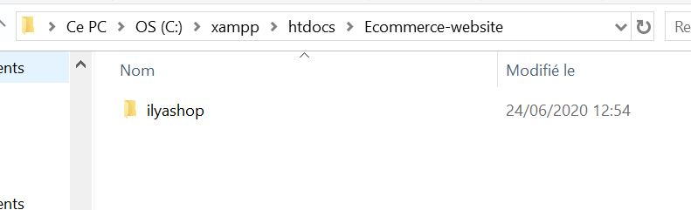

I rename it to ilyashop

After i open this foler in chrome for config wordp

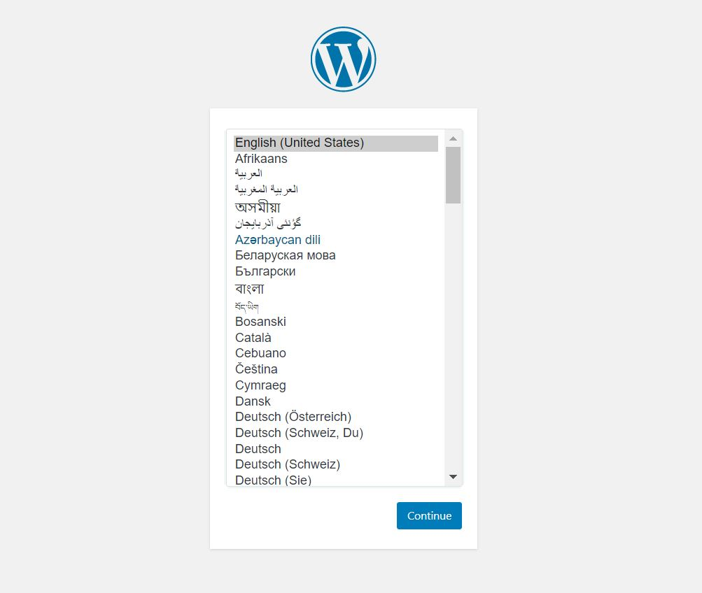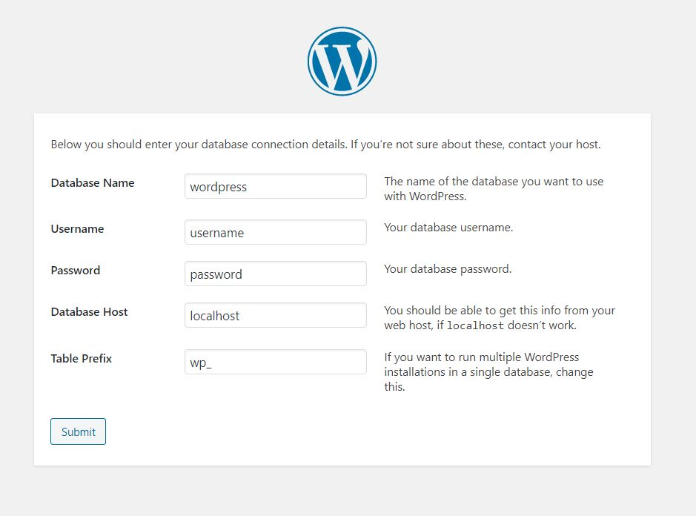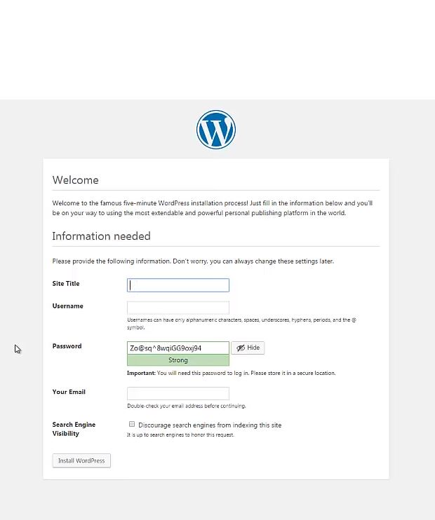

Here i write user in installation wordpress

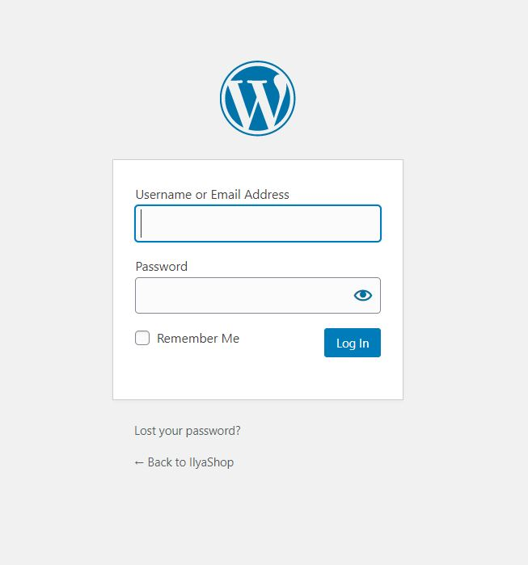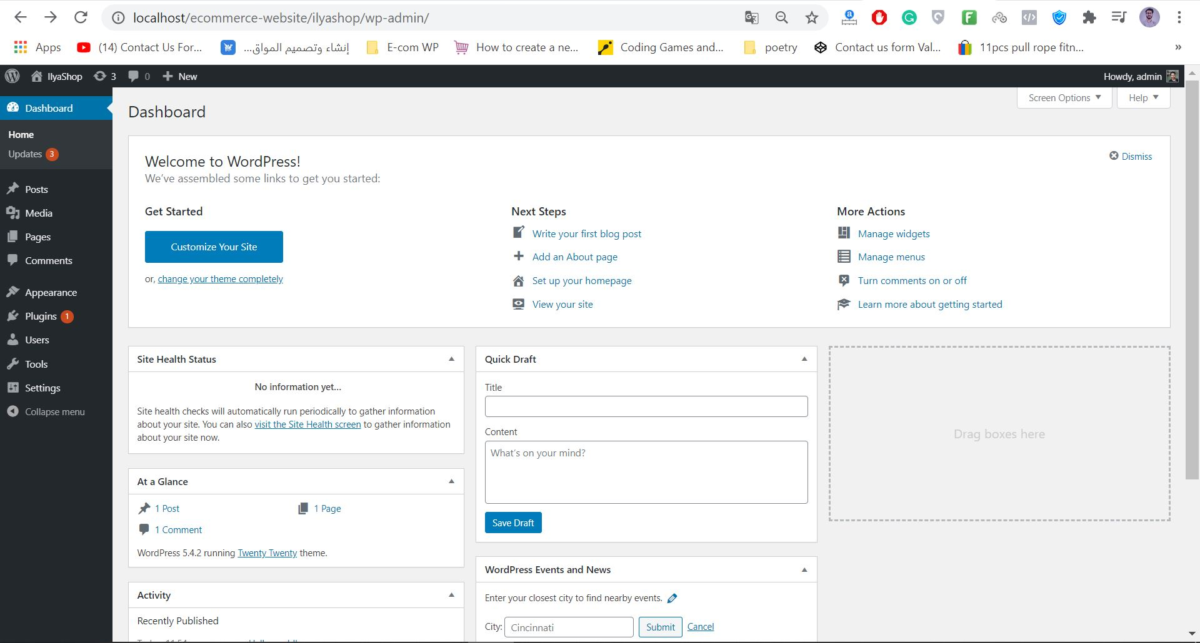

**#4 install Template**

After, i went to looking for template for my site

And download it like .rar

I went to ‘Appearance’ and in ‘Themes‘ after i click-on Upload Theme and i choose my template .rar

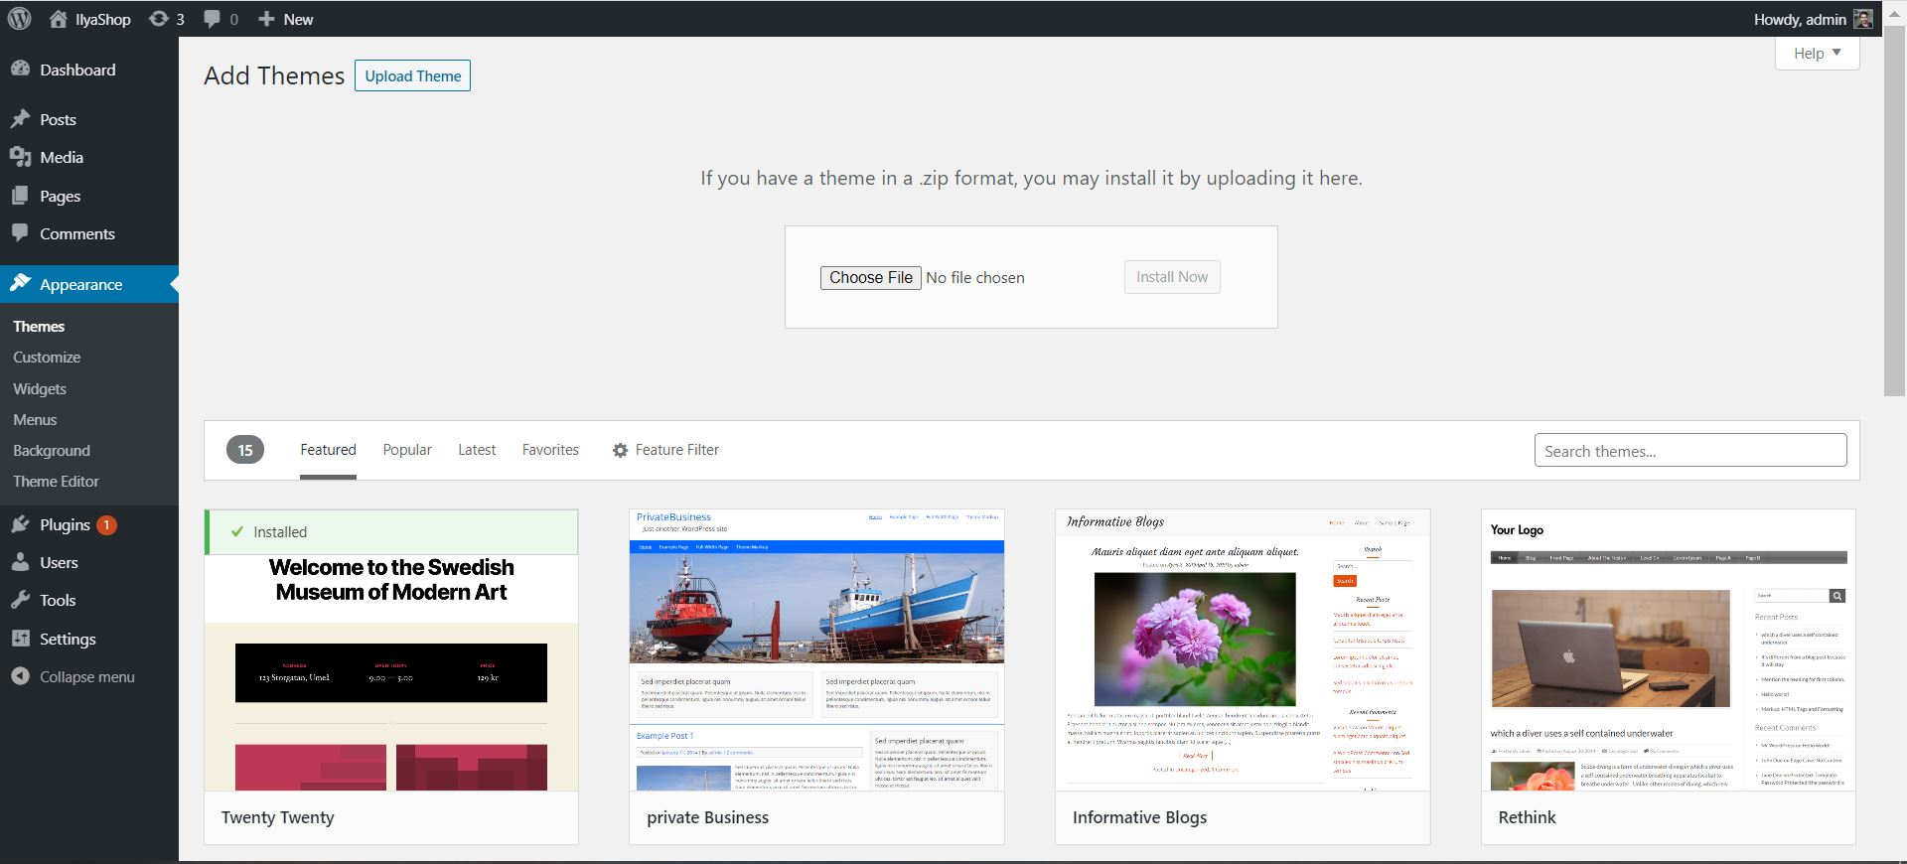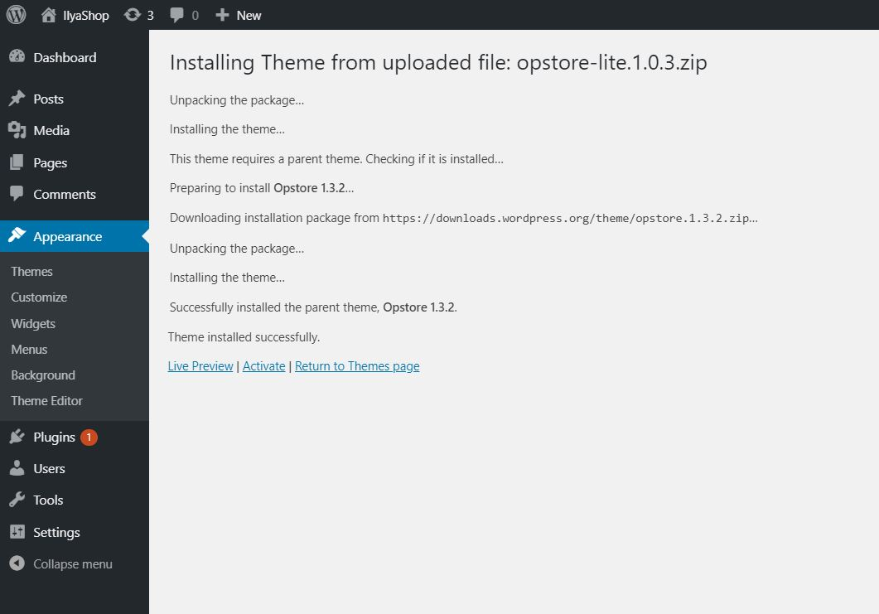

I activate it when finished to install

That look like my template at begain :

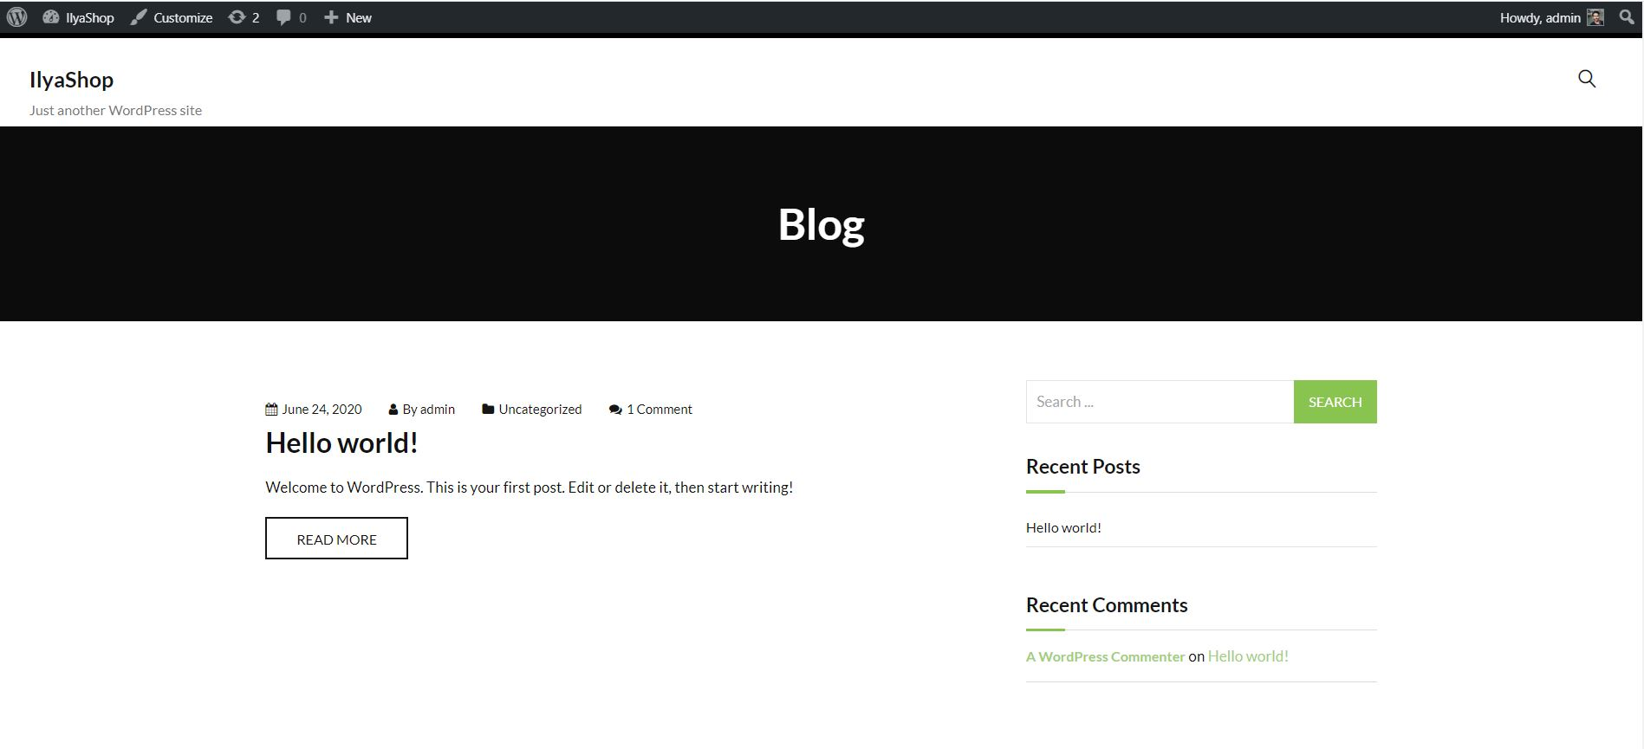

**#5 install plugin Woocommerce**

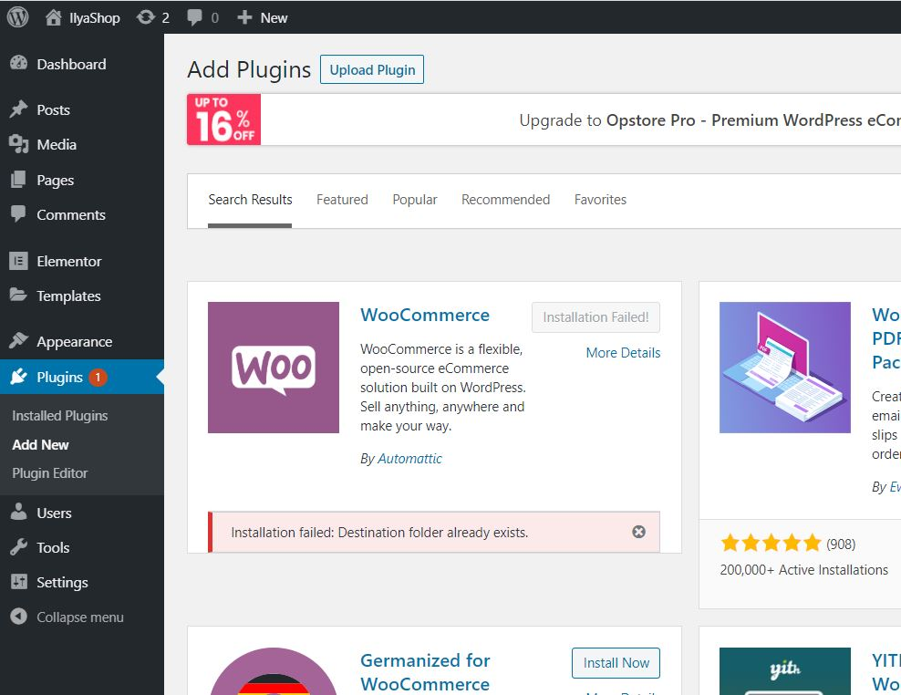

As you can see, When I was installing the plugin I had a problem, installation faied

So I can’t install this plugin in this method

I used other method to installation

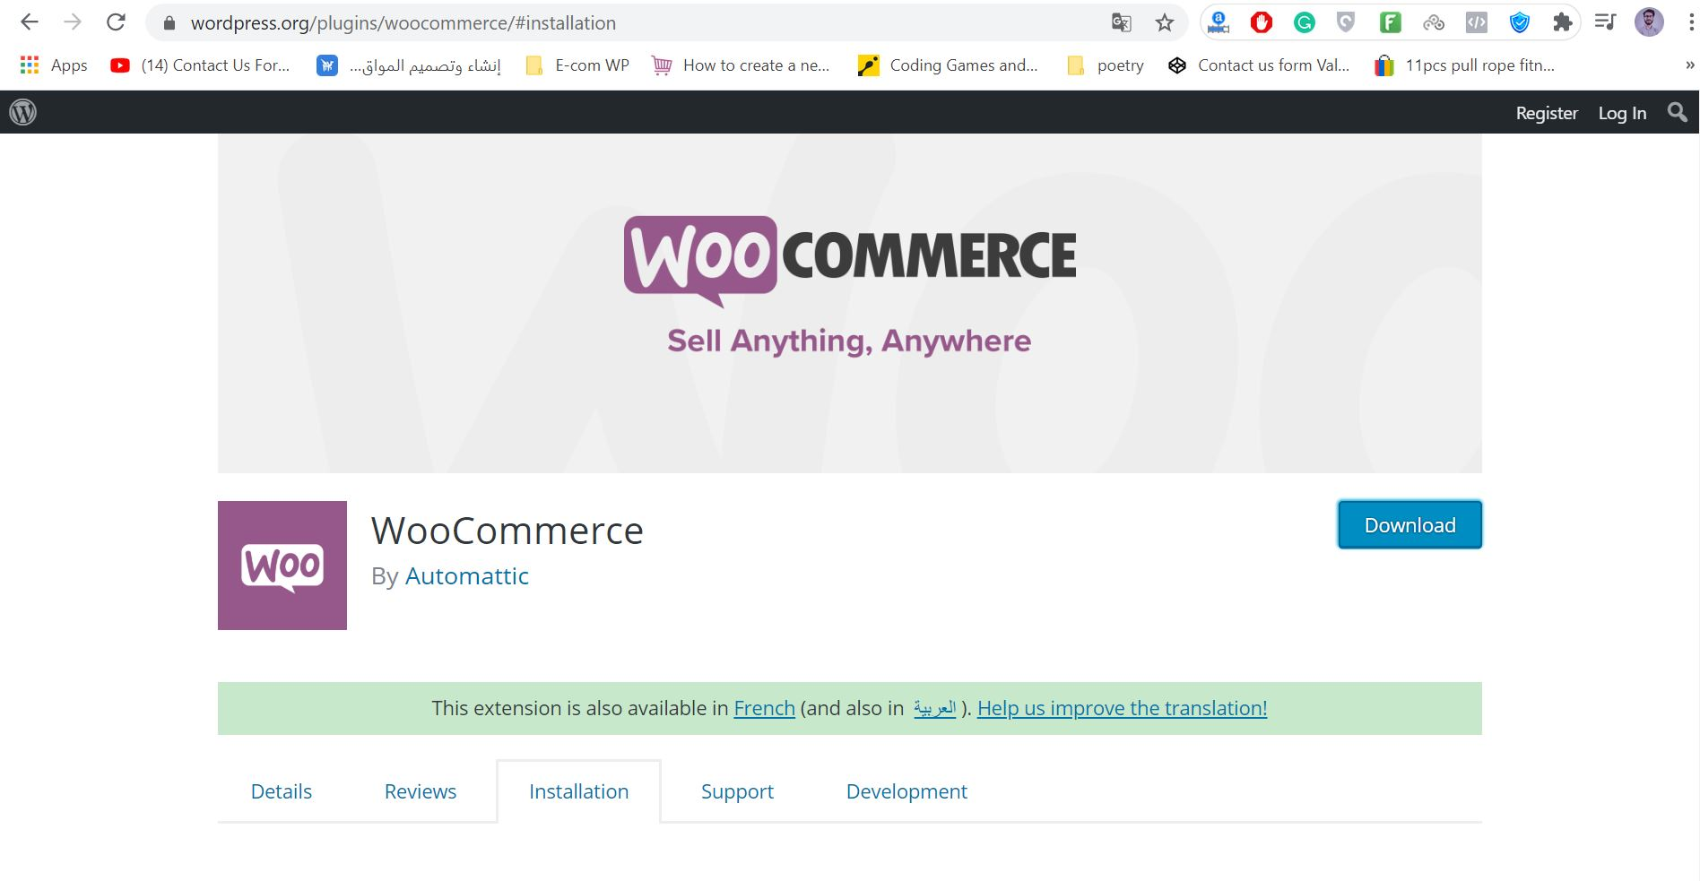

I went to wordpress.org and i went to offecial plugin Woo and i install it like .rar

After, I went to: wp-content/plugins

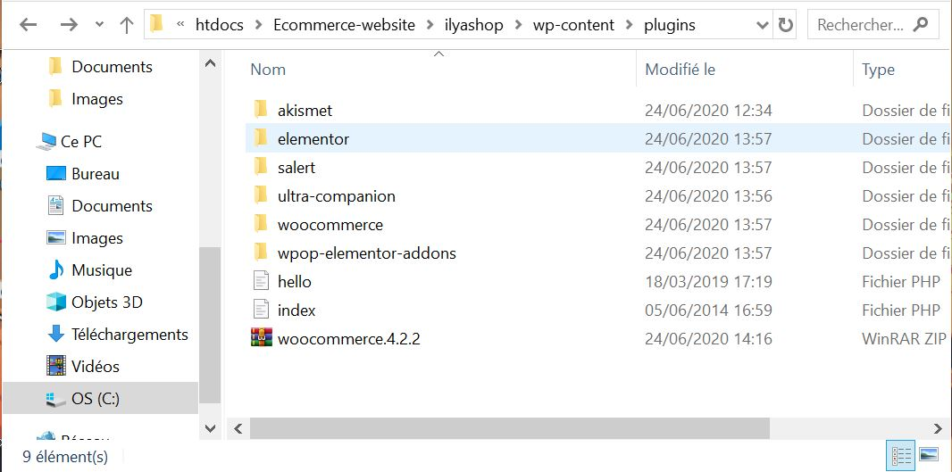

And i paste that file .rar in this folder after i extract it

So know when go to woo plugin :

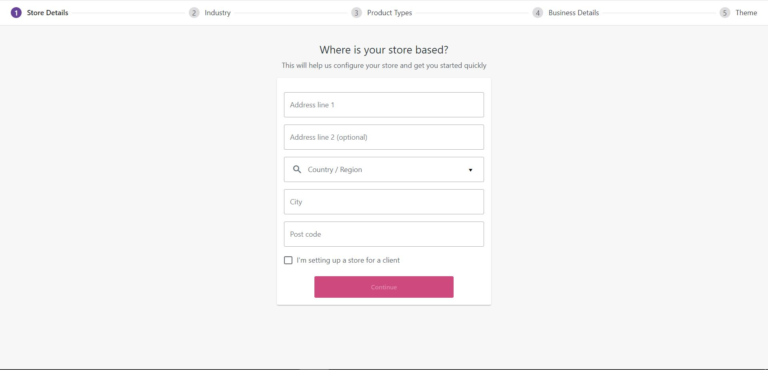

Here i was generate plugin befor use it

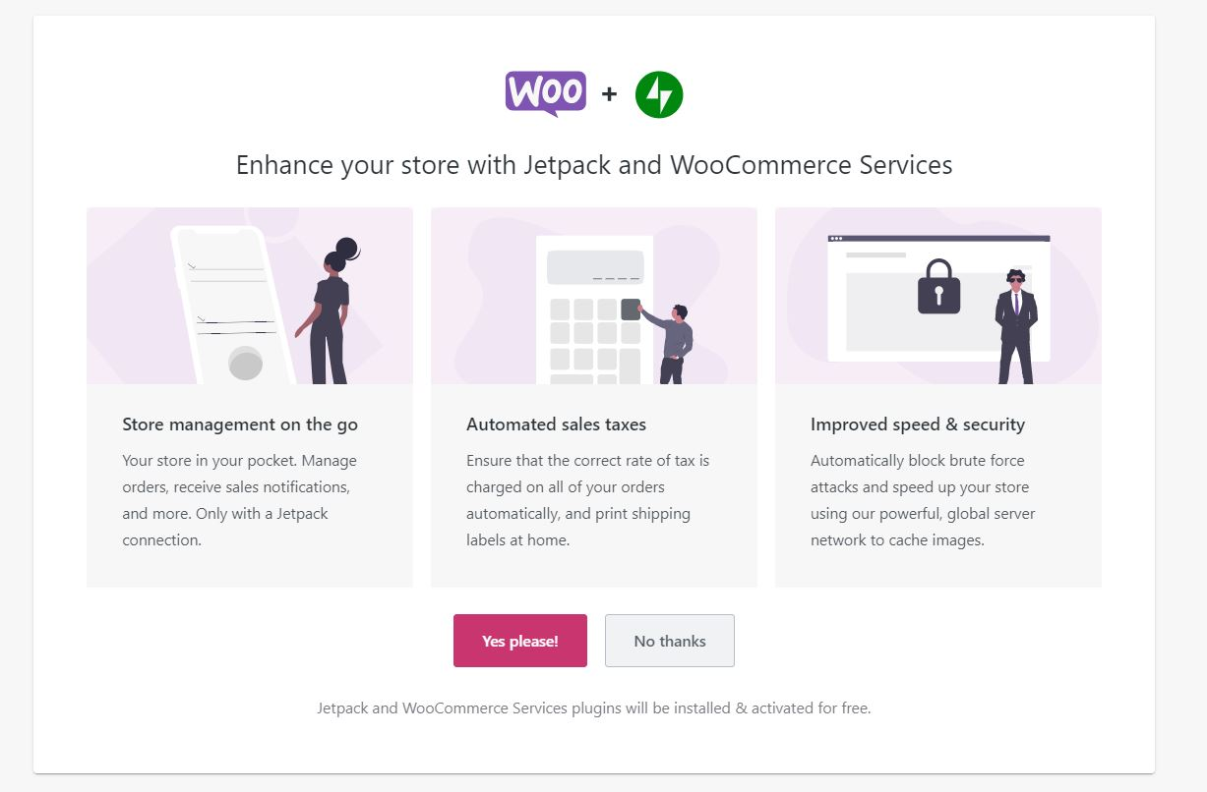

When cofig woo, woo require that you can accept to plugin Jatpack (This plugin is useful for security)

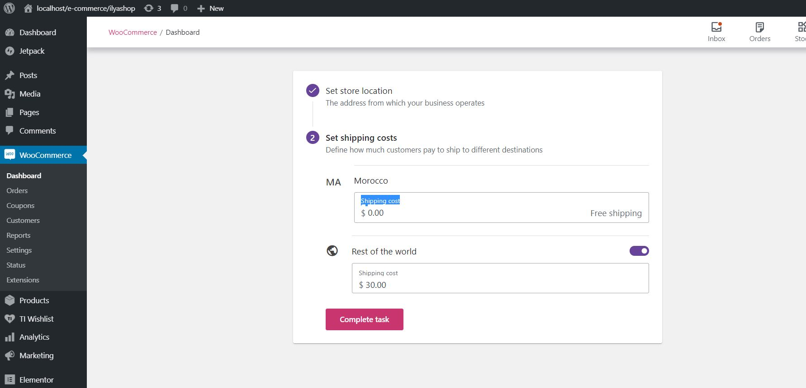

Here i config shipping methods

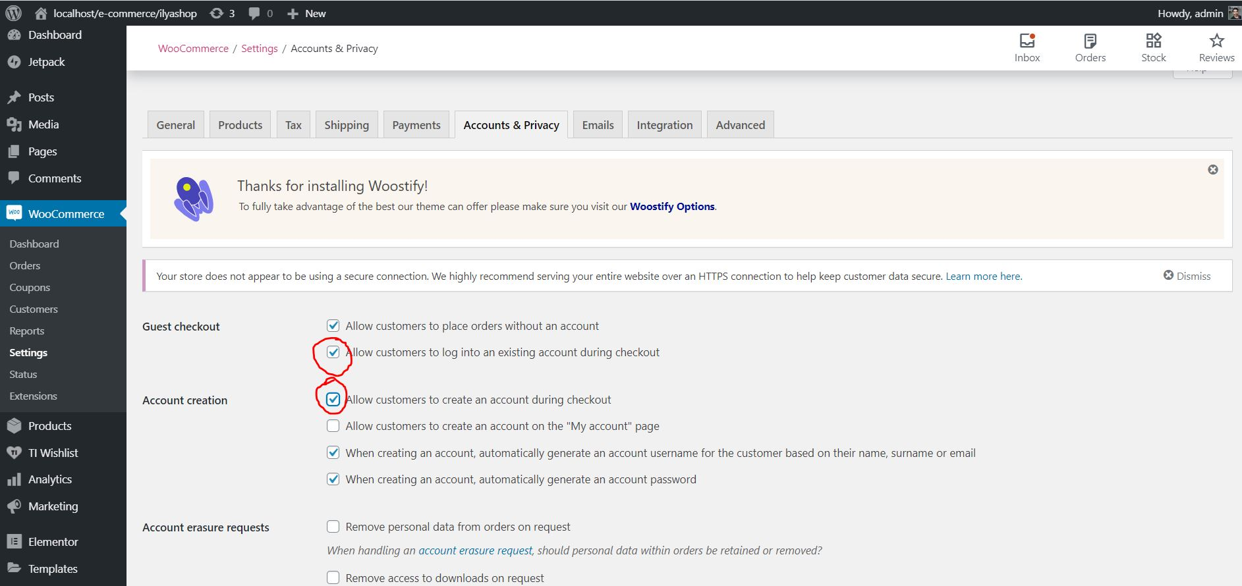

As you can see in This screen i checked in this two important choose

* The first one give an option for user if alredy has account in shop when checkout him order
* The second one give an option for new client to create account

**#6 wishlist plugin**

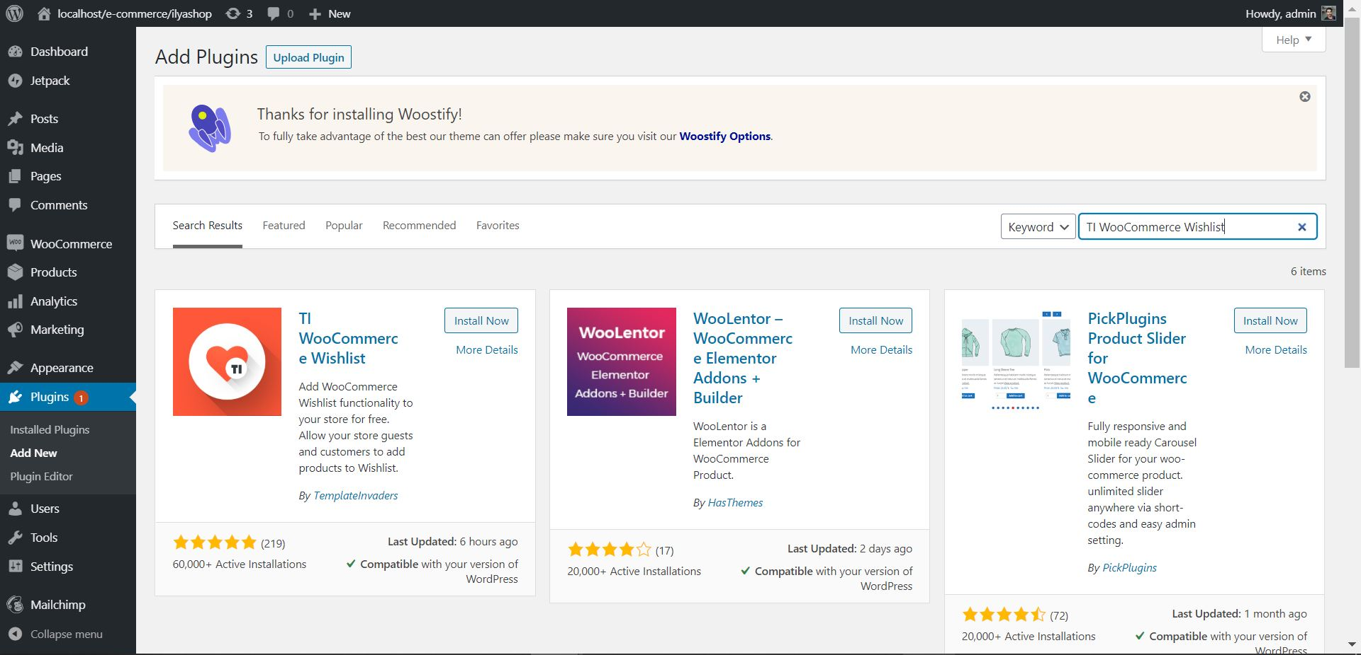

This plugin is good for people whos like any product in shop and do not mix it with cart

**#7 Elementor Plugin**

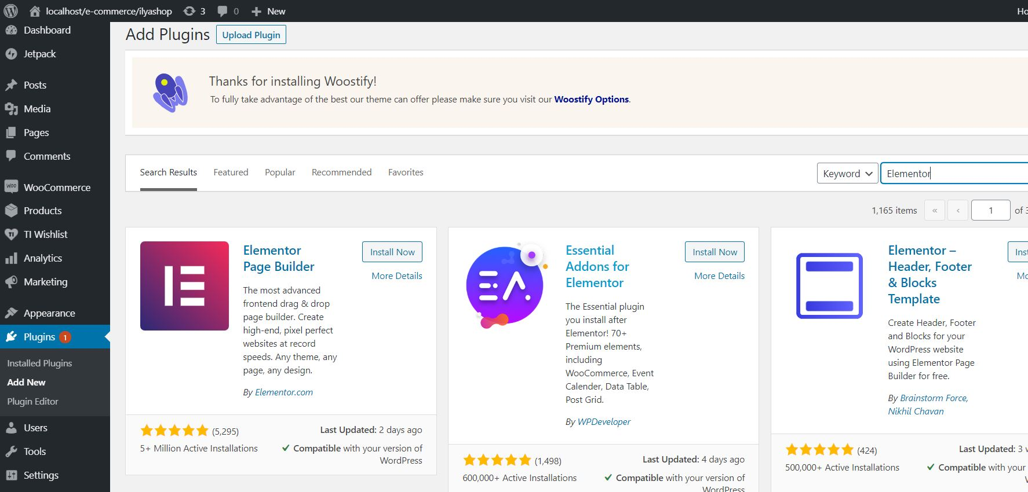

This plugin is helpful for make scratcher or edit on form of website

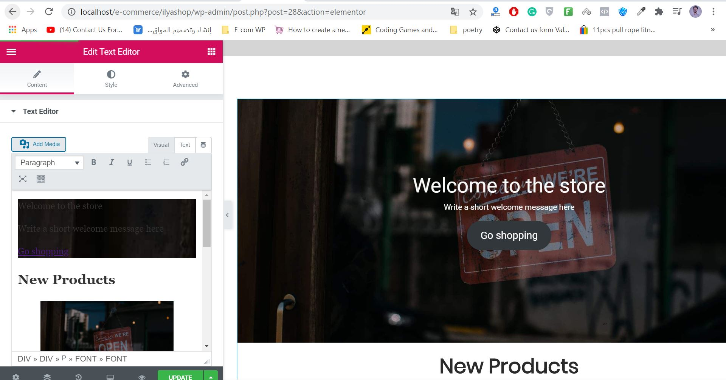

**#8 Add product**

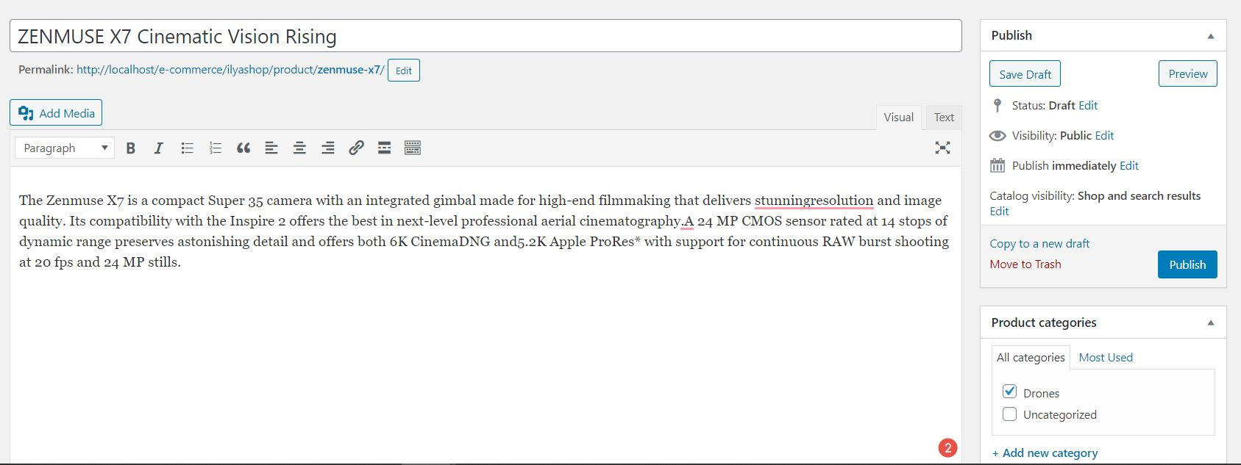

**#9 Add Coupon**

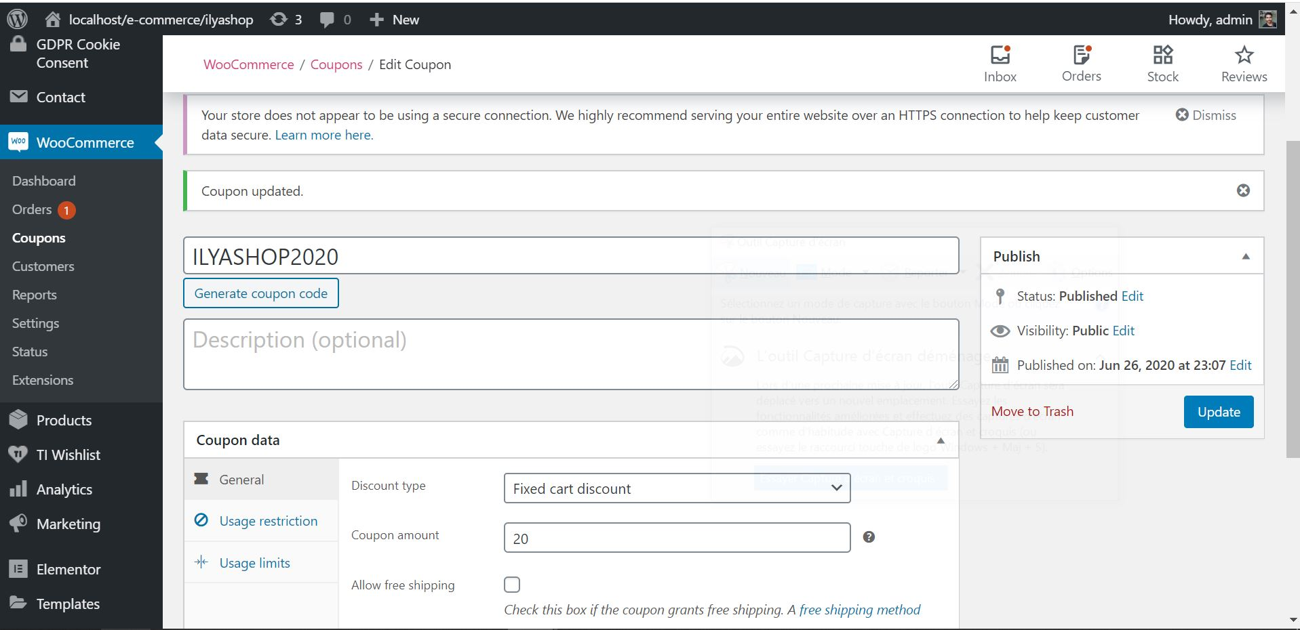

**#10 install GDPR plugin**

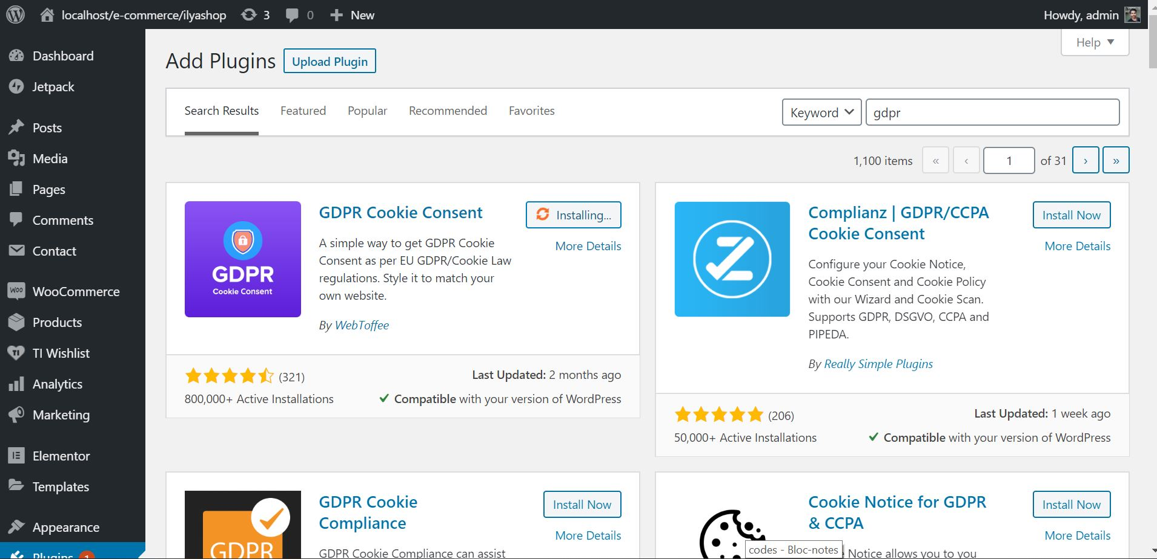

**#11 install Yoast SEO plugin**

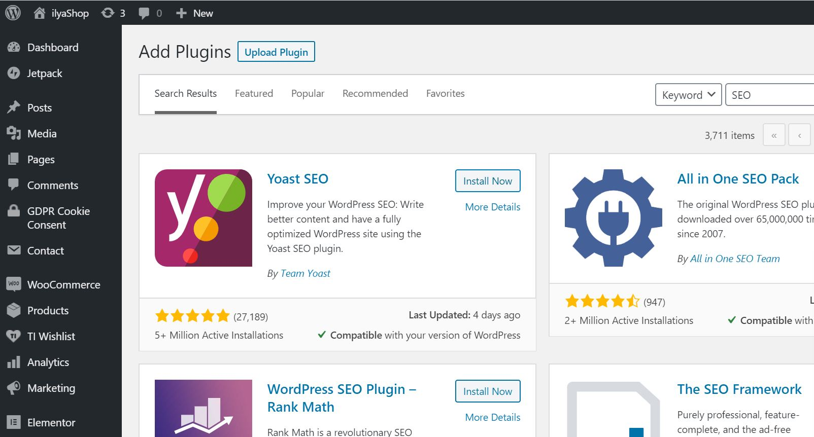

**#12 Multiple user role (Plugin below)**

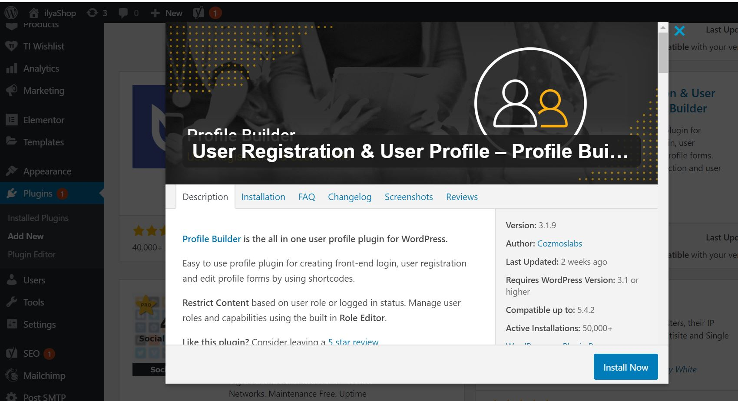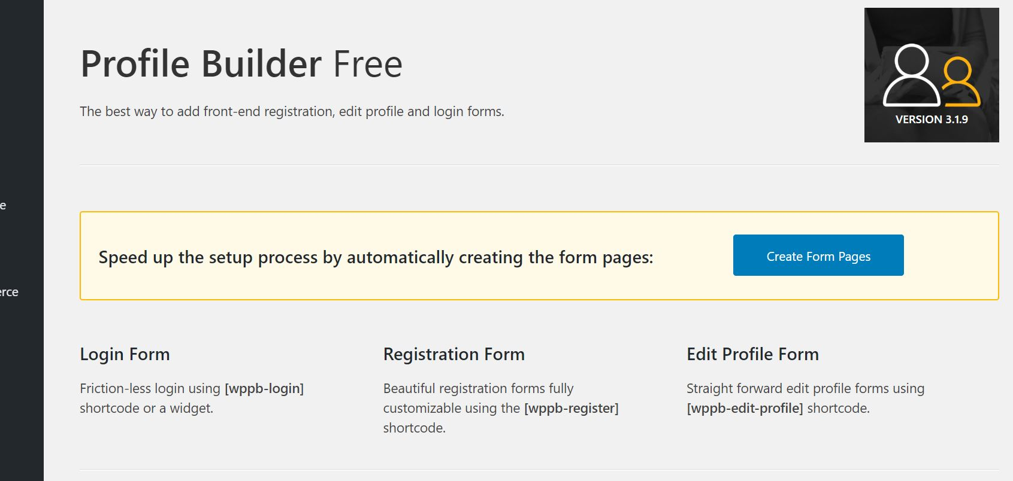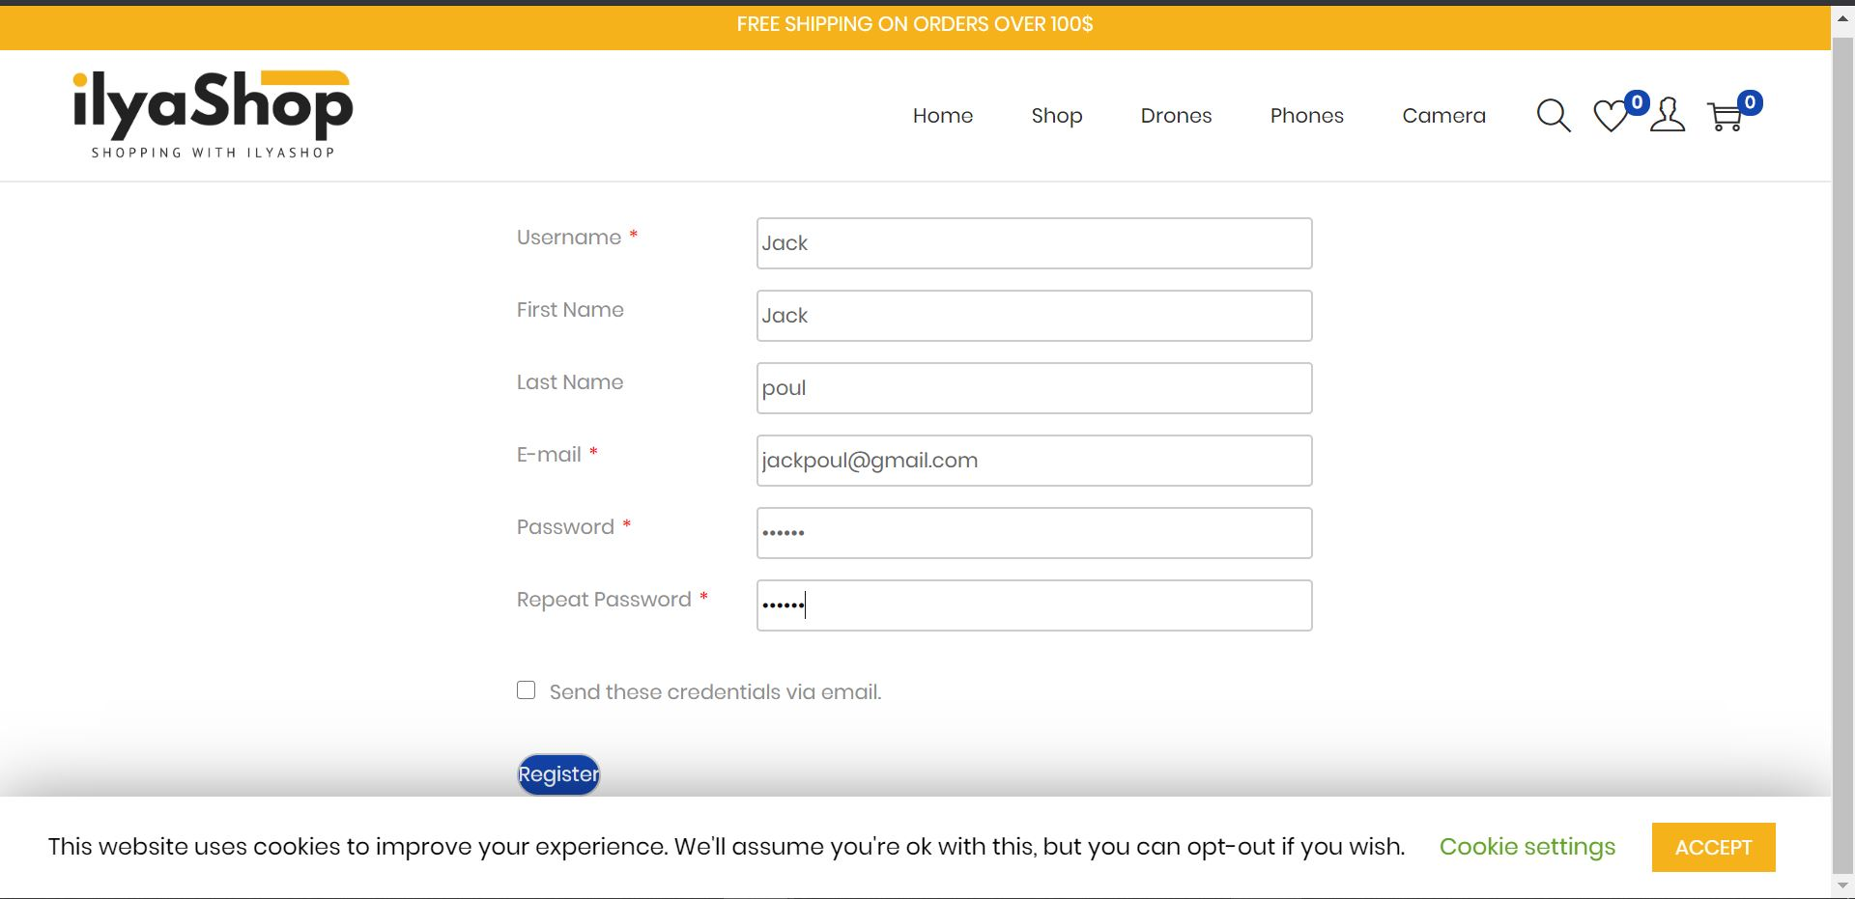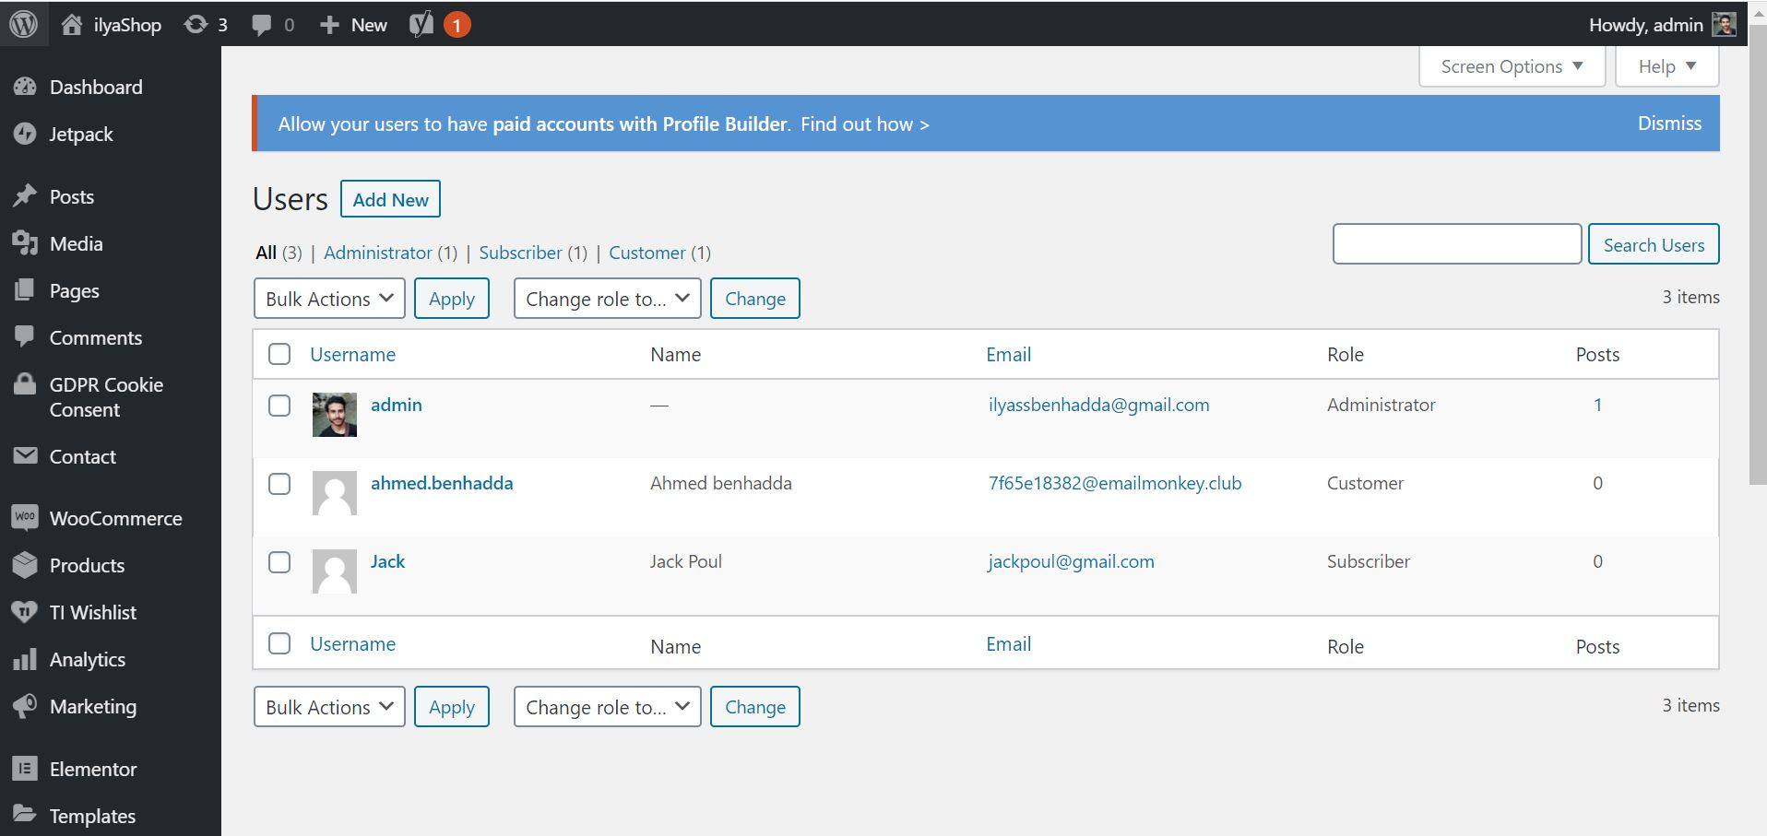

And i can in this dashbord modifed the role of users