目录
AI could create a perfect storm of climate misinformation 1
AI could create a perfect storm of climate misinformation 1
What is climate mis- and disinformation – and why should we care? 1
The neuroscience of false beliefs 1
How algorithms diffuse and amplify misinformation 2
Emotions and group dynamics around misinformation on social media 3
When health and climate misinformation overlap 3

AI could create a perfect storm of climate misinformation

AI could create a perfect storm of climate misinformation
We are in the midst of a transformation of the digital news ecosystem. The expansion of online social networks, the influence of recommender systems, increased automation, and new generative artificial intelligence (AI) tools are rapidly changing the speed and the way misinformation about climate change and sustainability issues moves around the world. Policymakers, researchers and the public need to combine forces to address the dangerous combination of opaque social media algorithms, polarizing social bots, and a new generation of AI-generated content.

What is climate mis- and disinformation – and why should we care?
Our living planet is facing a multitude of interacting crises. Climate change, the loss of biodiversity, inequality, pandemics, and war and conflict are just a few of them. In these times of turbulence, it is vital that decisions about our common future are well-grounded in science. False information and intentional attempts to manipulate public opinion pose serious risks to our joint capacities to create a safe and just future for all.

The neuroscience of false beliefs
What we believe is not only a result of our own reasoning, but also of the beliefs of people around us. Our brains are wired to consume information that is liked by our peers. That way, social reinforcers online – in the form of likes, comments and shares – can build a basis for what individuals believe to be true or false.


How algorithms diffuse and amplify misinformation
Digital platforms are designed to maximize engagement. Recommender systems play a key role as they shape digital social networks, and the flow of information. Weaknesses in their underlying algorithmic systems are already today being exploited to try to influence public opinion on climate and sustainability issues. Automation through social bots also play a role, although their impacts are contested.
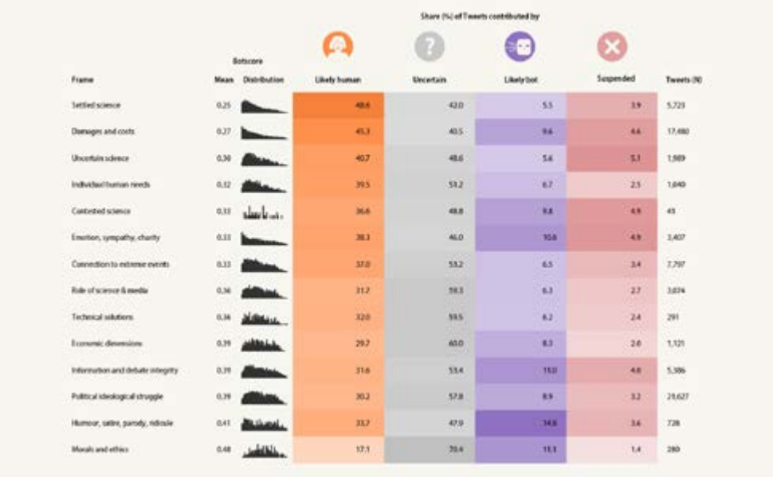

Emotions and group dynamics around misinformation on social media
Nuanced views and clean facts don’t generate clicks. Social networks are designed to speak to our emotions, and the more extreme the emotions, the better the content. But that does not mean that good arguments, education, and science communication are futile.

When health and climate misinformation overlap
Health and climate are two topics that often are affected by misand disinformation. Where the two overlap, a perfect storm for false claims can grow. Experiences from the “digital backlash” that followed the launch of the “planetary health diet” can teach us important lessons about what happens when health and climate misinformation act in tandem.

