Ian Leszczynski – Module 7 – Final Project Part 2

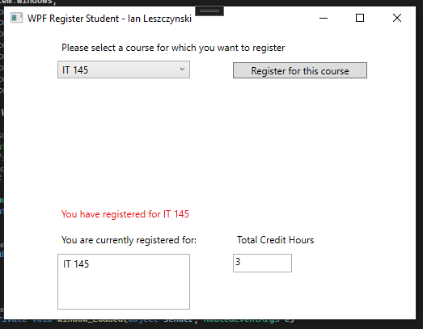

Registered for first course, confirmation message in label 3, course added to listBox and credit hours updated to 3

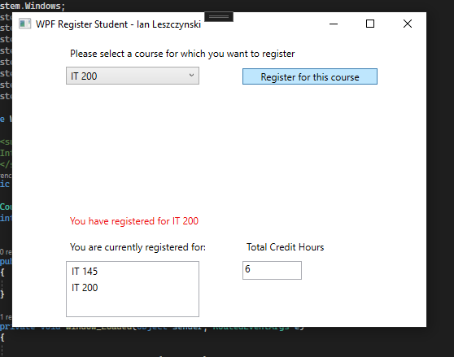

Registered for 2nd course, confirmation message in label3, course added to listBox and credit hours updated to 6

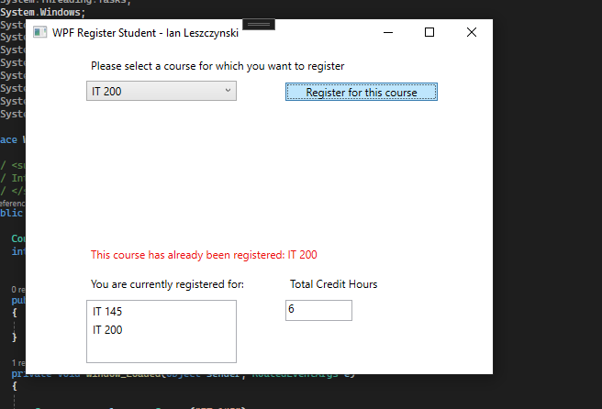

Attempted to add IT 200 a 2nd times, error message stating that user cannot add the same course twice, course not added to listBox and credit hours remain at 6

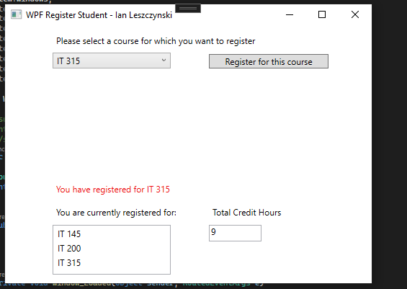

3rd course added. Label updated, listBox updated and credit hours updated to 9

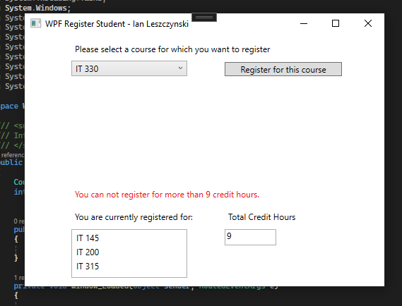

Attempted to add 4th course. Error message in label stating that 9 credit hours is the maxmimum, listBox and credit hours remain unchanged.

Code:

using System;

using System.Collections.Generic;

using System.Linq;

using System.Text;

using System.Threading.Tasks;

using System.Windows;

using System.Windows.Controls;

using System.Windows.Data;

using System.Windows.Documents;

using System.Windows.Input;

using System.Windows.Media;

using System.Windows.Media.Imaging;

using System.Windows.Navigation;

using System.Windows.Shapes;

namespace WPFRegisterStudent

{

/// <summary>

/// Interaction logic for MainWindow.xaml

/// </summary>

public partial class MainWindow : Window

{

Course choice;

int creditHours;

public MainWindow()

{

InitializeComponent();

}

private void Window_Loaded(object sender, RoutedEventArgs e)

{

Course course1 = new Course("IT 145");

Course course2 = new Course("IT 200");

Course course3 = new Course("IT 201");

Course course4 = new Course("IT 270");

Course course5 = new Course("IT 315");

Course course6 = new Course("IT 328");

Course course7 = new Course("IT 330");

this.comboBox.Items.Add(course1);

this.comboBox.Items.Add(course2);

this.comboBox.Items.Add(course3);

this.comboBox.Items.Add(course4);

this.comboBox.Items.Add(course5);

this.comboBox.Items.Add(course6);

this.comboBox.Items.Add(course7);

this.textBox.Text = "";

}

private void button_Click(object sender, RoutedEventArgs e)

{

choice = (Course)(this.comboBox.SelectedItem);

validateChoice(choice);

// TO DO - Create code to validate user selection (the choice object)

// and to display an error or a registation confirmation message accordinlgy

// Also update the total credit hours textbox if registration is confirmed for a selected course

}

private void validateChoice(Course choice) //method validates users choice

{

if (choice.IsRegisteredAlready()) //the already registered and creditHour check order seems interchangeable to me, I happened to do already registered first.

{

label3.Content = "This course has already been registered: " + choice.ToString();

return;

}

else

{

if (creditHours >= 9) //check if maximum number of credit hours has been reached (9)

{

label3.Content = "You can not register for more than 9 credit hours.";

return;

}

else //this branch reached if the course has not been registered already and the user is under 9 credit hours.

{

this.listBox.Items.Add(choice); //add course to listBox

choice.SetToRegistered(); //set course registered flag to true

label3.Content = "You have registered for " + choice.ToString(); //update confirmation label

creditHours += 3; //update number of credit hours

textBox.Text = creditHours.ToString(); //display credit hours

}

}

}

}

}