COMP3811: Computer Graphics Coursework 2 Interactive Animated Scenes with OpenGL Due Date: 22 December 2020, 5 pm Marc de Kamps November 9, 2020 Marking This coursework is summative and counts towards your final mark for 70 % (total coursework counts for 100 %)). Submission Instruction and Note on Plagiarism Submission should be done through the VLE by the due date. Submissions through the SSO will be ignored and result in 0 marks. Your submission should be in a single tar file that contains a report and source code. Ideally, source should must be provided with a Makefile and must compile and run on feng-linux. Where this is not possible, you should record a video demonstrating aspects of your coursework, and be prepared to provide a demo, showcasing your solution. The report is basis for assessment, with the source code as supporting evidence for assertions made in the report. Answer all the questions and provide the explanations that are asked for. Refer to your code in explanations, but do not provide answers like: ’see source code’. You are allowed to discuss ideas with colleagues. You must program independently and not base your submission on any other code than was provided during the tutorials, and textures which are in a tar file called textures.tar, which is located in the coursework 2 folder on the VLE, the same folder which contains this specification. Changing variable names in someone else’s code is not a good idea.

Creation of an Interactive Animated Scene using OpenGL Using Qt’s QGLWidget you will create an application that demonstrates the ability to render visual scenes using OpenGL. You are free, within some limits, to create a scene of your choice. Assessment will be based on the sophistication of the scene and scene elements as well as possibilities for user interaction. The scheme below sets out minimum requirements that must be met for grading in certain bands. Grading within a band is assessed on: coding style and commenting, explanation of the design choices and implementation in the report, and visual impact.

Grading within a band is assessed on: coding style and commenting, explanation of the design choices and implementation in the report, and visual impact.

Summary
This scene is based on the allegory of Plato’s cave. The allegory tells the story of prisoners who lived their entire life chained to the wall of a cave, force to look at the opposing wall. Behind the prisoners sat a large fire that projected the shadows of the various objects that passed in front of it onto the opposing wall. Given that the prisoner had spent the entirety of their life in the cave, the prisoners incorrectly mistook the projected shadows for the real objects that they represented and began naming the shadows. One day a prisoner is freed from his restraints and is able to move around the room. They see a fire which blinds them, making it hard for them to perceive the actual objects. Slowly their eyes begin to readjust and they leave the cave. Once again they are blinded by the sunlight but slowly their eyes begin to once again readjust. They see the real world filled with actual objects. The prisoner gains a new understanding of reality and the realisation shattered his prior notions causing a paradigm shift. Upon returning to the cave the freed prisoner is no longer able to communicate effectively with the chained prisoners due to each of them holding such different conceptions of reality. The chained prisoners then perceive the freed prisoner deranged from his journey.
The allegory isn’t supposed to be taken at face value presents an argument that reality cannot easily be determined via the five senses alone. It also serves to highlight the how individual can become trapped by their ignorance and the nature of truth.
The reason why I decided to recreate this story for this coursework is primarily because its emphasise on shadows. The basic structure of the scene is also well documented in the text and through various illustrations of it throughout time. There is a distinct inside (the cave) and outside (the world outside of the cave), this meant that I would be able to implement different types of lighting and experiment with terrain generation. It also allowed me to imbue my passion for philosophy with my computer science course. The usage of the computer model within the application, as well as the program qua a program also calls attention to the nature of reality via more model philosophical ideas such as simulation theory. To elaborate, the cave is connected to the exit through a tunnel. A computer terminal sits in the tunnel that displays the outside world. The prisoner would be tempted to view the terminal screen as a new reality after entering the tunnel. Once the prisoner has left tunnel they are then confronted with the real world. In fact all of this takes place within a simulation (the program). The program, existing in the real world, is a false reality with several other false realities embedded in it. This therefore begs the question ‘is this reality real?’

Explanation of the design choices
The project is implemented using Qt and OpenGL. Qt is used to facilitate the User Interface. A window is created that has various QWidgets as children. A new class was created named SceneWidget, that inherits QWidget, this is where the bulk of the program is implemented and where OpenGL is used to render the scene. To further break down and encapsulate the code, the SceneWidget contains a pointer to a “ShapeCreator” object. The ShapeCreator, in turn, has a pointer to a “TextureCreator” object. This structure allows for classes to access other variables and methods via it’s ‘children’. For example, if an index of a texture needed to be used my the SceneWidget widget it can be accessed using sceneWidget→shapeCreator→textureCreator->index;

coding style and commenting

40% - 50% Band
• 40%-50%: You must create a visual scene that demonstrates a reasonable complexity through instancing. Examples could be a group of buildings, constructed from cubes, body shapes constructed from cylinders and spheres and a combination thereof. Light and material properties 1 must be chosen that allow specular and diffusive light contributions to be recognised. You are allowed to use glut objects. The report must explain your design. Your scene must deviate substantially from the simple scenes that were provided during the tutorials.

Instancing
Instancing has been used throughout the project. The ShapeCreator class contains multiple methods that create various object. The scope of these shapes range from cuboids, spheres, and cylinders to more complex objects such as a gyroscope, terrain and trees. An example of instancing simple objects like the cuboids can be seen below in the image of the stairs:

The stairs are constructed from 15 cuboids. After each cuboid is rendered, the next one is rendered after translating by height and length of the previous step.

Perhaps a more intricate example of instancing occurring when drawing the gyroscope. The image below shows this object:


Frame

Bearing
Rotor

Gimbals
Axle
Axle

Base

The gyroscope is composed from tori and cylinders. A torus is used to create the frame, likewise the two gimbals are made from two scaled down tori. The bearings (of which there are four) and created using cylinders. In the same manner the axle, that runs through the inner gimbal, is made of a longer cylinder. The rotor is also a cylinder, however this time it is drawn using a smaller number of stacks and slices. This is to make it more obvious that it is, in fact, spinning. The base is also a cylinder (the call is to the same function), however this time the radii of the top and base a specified to be different make it into a truncated cone.

This example is used to demonstrate how more complex models can be built up through instancing simpler shapes – in this case tori and cylinders.

Another example of instancing is the three torches that are mounted to the wall of the tunnel. The model for the torch is composed of a cone (a cylinder with the base’s radius set to 0) and a plane that is animated by changing the texture with each frame of the program.



The last example of instancing I will give is of the two figurines. The models this time are imported from an OBJ file (I will go into more depth about this later in the report) and a cylinder is added to the base of the model. There vertex, UV and normal data of the OBJ is saved to memory once. The model is then instanced by calling the drawGeisha() method twice. Interestingly the shadows are just the same models redrawn after the colour has been set to black and a matrix projection is applied to them.

Specular and Diffusive lighting
There are 5 lights within the scene, the fire, three torches, and the sun. Each light has ambient, diffusive, and specular properties. Material properties have been set so the objects interact with the lighting and can display the ambient, diffusive, and specular contributions. The lights’ positions are set to where the emitting light source would be in the scene i.e. the position of the fire texture, the positions of the torches, and the position of where the sun sits in the sky box. The positions are described using homogenous coordinates. The last parameter of the lights’ positions, w, is set to 1 for each of the lights, this implies that the lights are positioned in the x, y, and z coordinates specified and the diffuse and specular calculations are based on the location of the light with respect to the gluLookAt coordinates.

Glut objects
Glut objects have been used throughout the scene. The glut object used are gluCylinder, gluDisk, and gluSphere. A smaller wrapper has been written for each Glut object so they easily created and textured. This means that a GLUquadric does not have to be manually called every time a Glut object is needed. It also means that the memory can be handled efficiently, guaranteeing that for every GLUquadric initialised a respective gluDeleteQuadric is called. This layer of abstraction may seem simple, but as the complexity of the scene increases methods like these ones make handling the program much easier. Two separate methods were created that create cylinders – createCylinder and createEdgeCylinder. The createCylinder method creates a glut cylinder, by default a glut cylinder has no top or base. This may be useful when only the curved portion of the cylinder is needed. By doing this the number of vertices in the scene is slightly reduced. The createEdgeCylinder method draws a cylinder in a similar fashion to createCylinder, however this time two disks are placed on either side to add a base and top to it. The glut disk has the number of slices and stacks and the glut cylinder guaranteeing that the disk will fit on the cylinder. As mentioned before this reduces the number of manual calls to gluCylinder and gluDisk and stops any errors caused by the shapes being transformed incorrectly. Usages of the glut objects can be seen in the trees (a sphere, and a cylinder), the gyroscope (its base is a edge cylinder and bearings are cylinders), the poles for the figurines (a cylinder), and the cones that make up the torches (a cylinder with a base of 0 and a top that is larger). The glut objects are textured by calling the gluQuadricTexture method – which automatically creates UV coordinates for the object and then binding the appropriate texture. The method gluQuadricNormals was used to generate the normals for each of the glut objects.

Explanation of Design
As mentioned before the program is split into four main classes, the window, the SceneWidget, the ShapeCreator, and the TextureCreator. The ShapeCreator class aims to create both simple and objects and complex objects that are composed of the simple objects. The objects can then be placed in the scene accordingly. This allows the shapes to be created with reference object coordinates and then the objects to be placed with respect to their world coordinates. This bottom up approach is what allowed me to create a fairly complex scene.
The main room of the cave was the first object created. Initially it was a scaled up cuboid. Tessellation was added to allow the diffusive and specular lighting to become more apparent (the lighting is calculated for each shape so each wall is therefore composed of many smaller rectangles). A door was then added to one of the walls by using an if statement that specified where the tessellated rectangle should not be drawn. This doorway was then fleshed out by duplicating the wall containing the door and offsetting it by two. Three planes were then drawn connecting the two walls to create a 3 dimensional doorway. This same process was applied to the north wall (in the -Z direction) to create the fireplace that surrounds the fire. Objects – that were defined in the ShapeCreator class – were then placed in the room. These objects are the two figurines and the fire. The fire is composed of 10 textured planes place close to one other.

Fire was particularly difficult to create in OpenGL, particle systems can be used but look fairly unrealistic. I also struggled to find a adequate fire animation under Creative Commons. To combat this, I created a fire animation in Adobe After Effects – a software that I am familiar with – using primarily fractal noise and turbulent displacement. I selected 20 consecutive frames that I liked and rendered then onto the ten textured planes according to what frame the program is on. This created a fire that loops every 20 frames. The After Effect composition was rendered to a PNG sequence. This means that each resulting image supports transparency. This is carried across to OpenGL by enabling blender after loading the images with an alpha channel.

After attempting to design some figurines myself, and being dissatisfied by there realism, I decided to import a model to OpenGL. A blender model was found online licensed under the Creative Commons license. To preprocess the model – making it suitable for usage in OpenGL – I triangulated the blender model and exported it as an OBJ file in blender. The OBJ file was exported with a list of vertex points, a list UV coordinates and related texture file information, a list of normals, and a list of faces composed of: 3 indices of vertices, 3 indices of UV coordinates and 3 indices of normals. Since the model was triangulated, each face was made up of 3 vertices. The file was opened and looped through. The vertex data was stored in a vector of arrays sized 3, the UV data was stored in a vector of arrays sized 2, and the normal data was stored in a vector of arrays sized 3. Each face is read from the file. A face is composed of 3 points in the form of 9 indices (three points each with one vertex, UV and normal value). The indices of the vertices, UVs, normals are recorded separately. The object file is not necessarily in order meaning all the vertex, UV, normal, and face data must be loaded before the vertices, UVs, and normals can be indexed. Once all the data has been obtained, a loop is created equal to the number of faces.

• 50%-60%: Your scene must fulfil all requirements for the 40 %-50 % band. Your scene must contain at least one element of user interaction, for example, a slider to manipulate viewing angles or a dialog box to set material or light properties.

50% - 60% Band
Elements of User Interaction
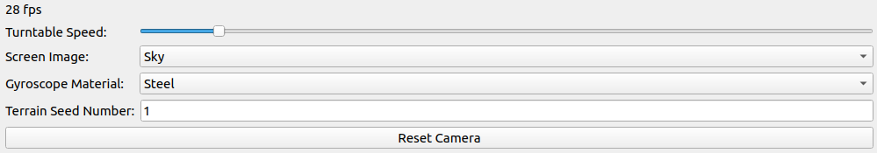

Various elements of users interaction are used. The top QSlider is a user adjustable slider that can be used to set the speed of rotation for the turntable that the gyroscope sits upon

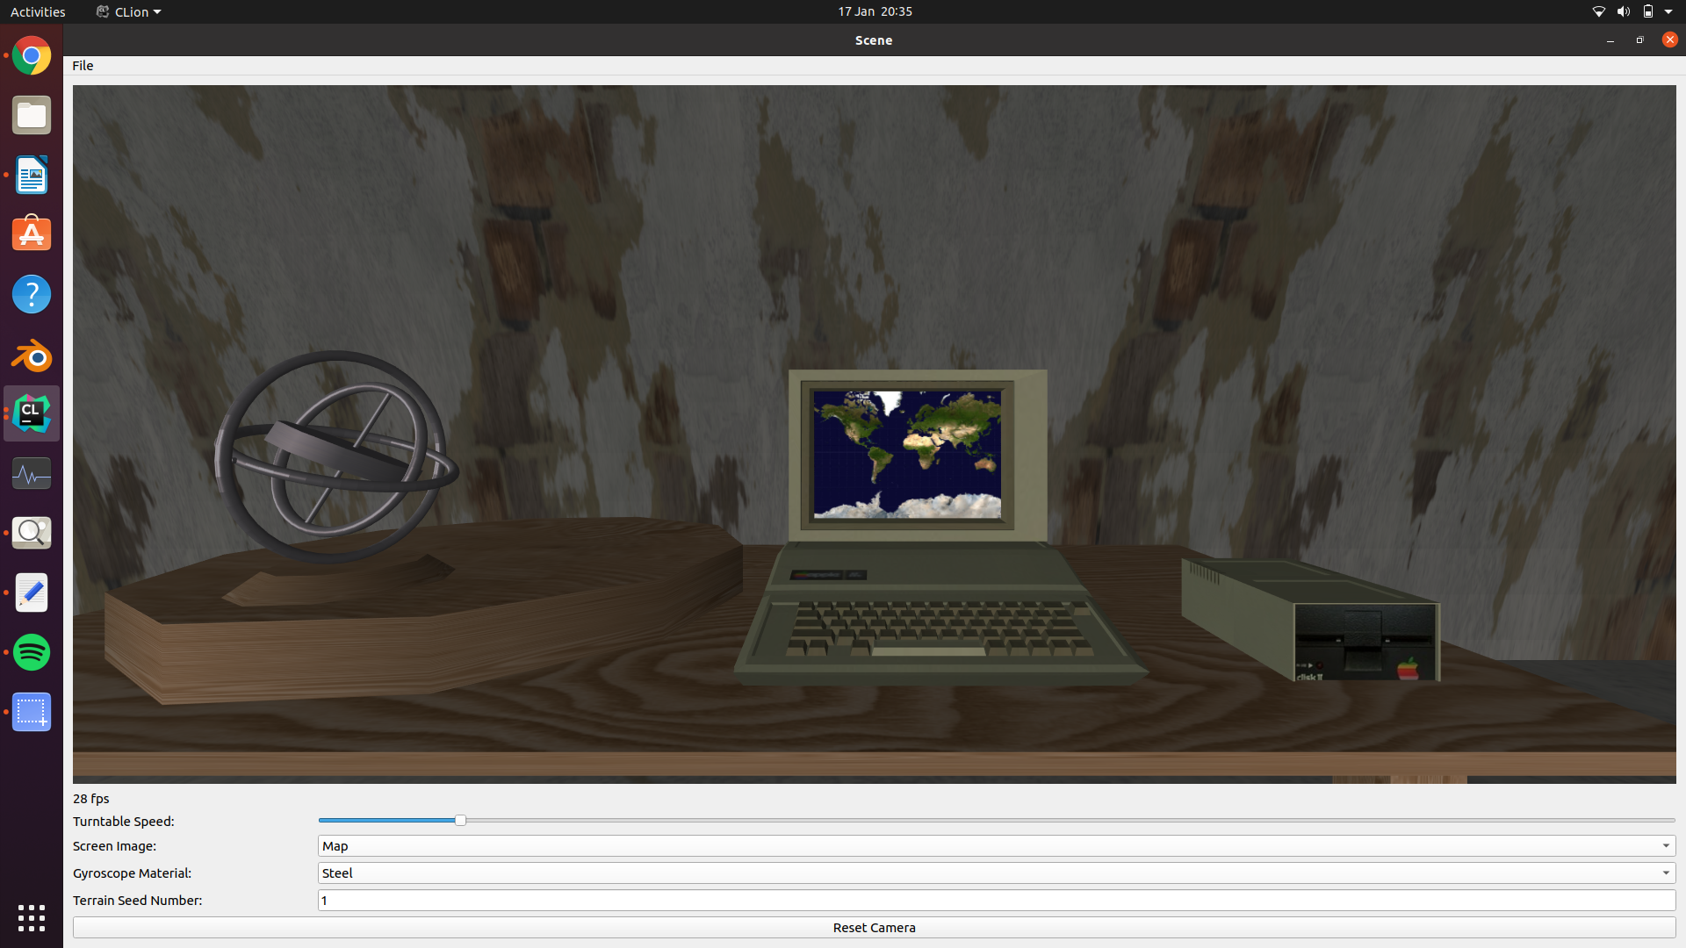
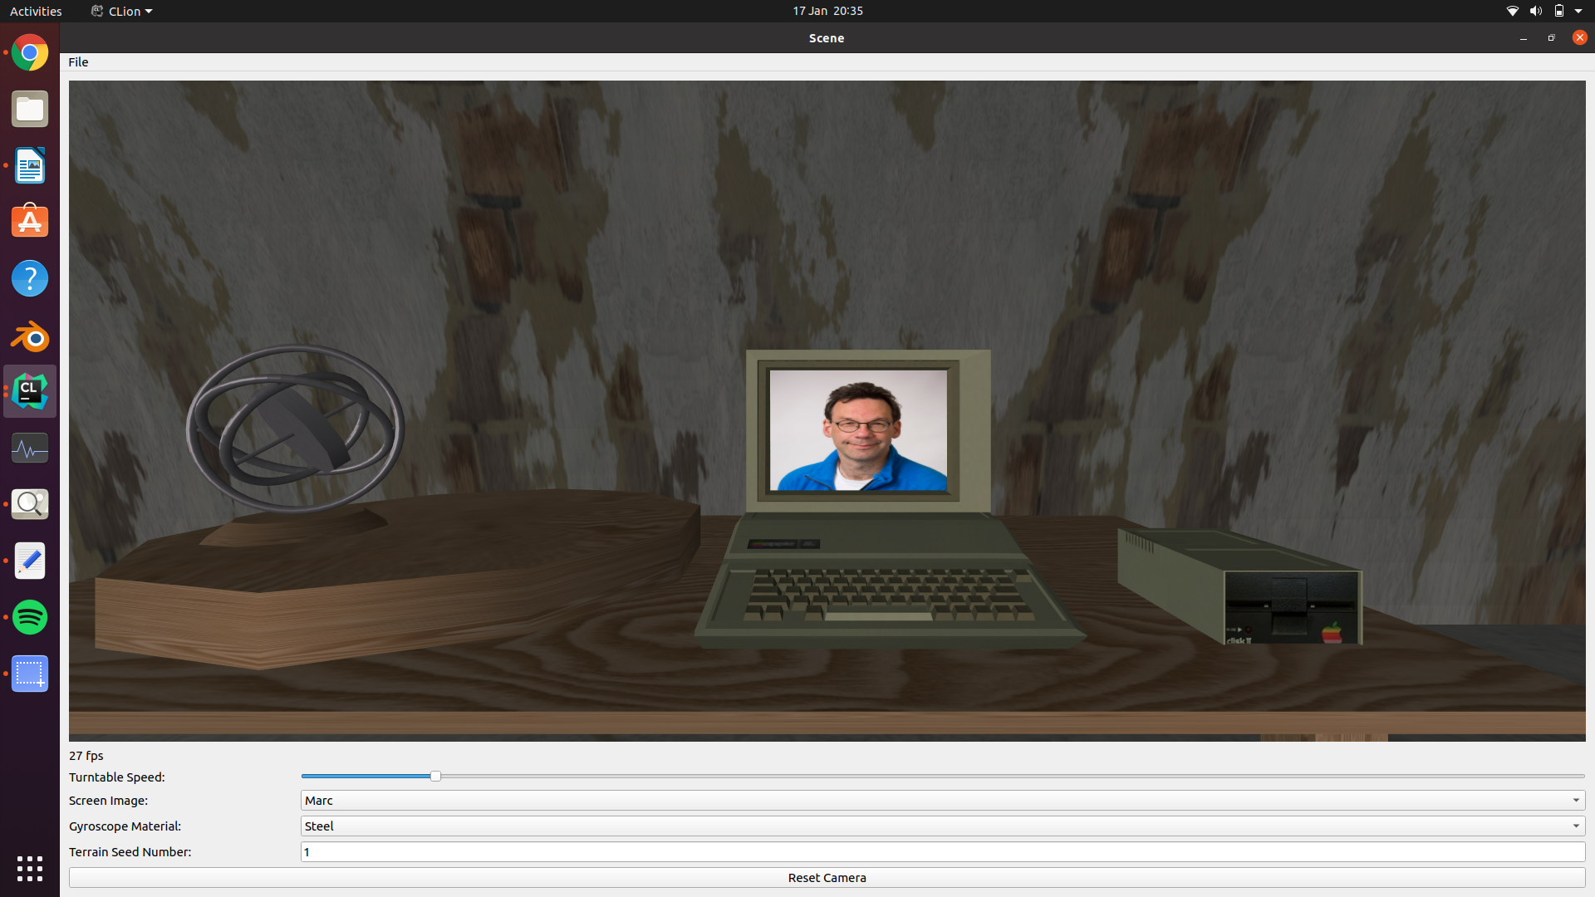

The second element is a QComboBox that allows users to select 3 options. Upon clicking an option the textured plane that sits in front of the PC – that acts as a screen – is changed. Here I have included the options to selected the compulsory textures for this coursework.

Likewise the 3rd element is another QComboBox that allows users to selected the textures used for the gyroscope.

The 4th element is the random seed used to generate the procedural terrain. The seed is used by srand() to set the various random heights at different points of the terrain and set the trees’ x, y, and z coordinates. Users can edit this seed within the program during run time. This will recall the heightsGenerated method and render a different terrain. Since srand() uses pseudo randomness, prior seeds can be reused to return to a user’s preferred terrain.

The “Reset Camera” button can be used by the user to place the camera back to its starting position.

All of these elements of user interaction were implemented using the same basic concept. First a connection is established between a QWidget and the SceneWidget. The connection allows a event listener to wait for the QWidget to emit a signal. Once the signal is emitted the the relevant slot is called in the SceneWidget which handles the event.

For example the PC screen’s texture is bound using a variable named selectedScreenIndex that is defined in the TextureCreator class.

Initially this variable is set to be equal to the first sky texture. Within the window class, a connection is established using QObject::connect(). This adds the event listener between the combo box’s signal – currentIndexChanged() – and the sceneWidget’s slot – changeScreenTexture(). The index is then passed to changeScreenTexture().

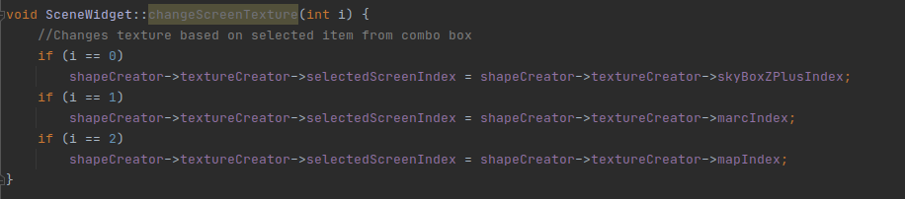
The changeScreenTexture slot then handles the event by changing the selectedScreenIndex variable to the relevant texture index based on the input from the QComboBox.

• 60%-70%: Your scene must fulfil all requirements for the lower bands, as well as contain an element of animation, for example rotating or spinning objects. The scene must contain at least one convex object that you have constructed from polygons. The scene must contain texture mapping. Some texture images will be provided in the tar file. They all must be used, but you are free to add your own.

60%-70% Band

Elements of animation

Convex objects

Texture mapping

• 70%-100%: Your scene must fulfil all requirements for the lower bands and contain an object that requires hierarchical modelling and displays motion in some of its parts. This object itself must move in a circular path through the scene. You must use various elements of user interaction, for example controls to set the radius or speed of the object, dialog boxes to control material properties, etc. Interaction purely by mouse of keyboard does not qualify as one of these elements. [35 marks] Two prizes will be made available: one for the visually most striking application, and one for the most garish one - preferably by design. Prize winners will be invited for coffee and cake of their choice. Please bear in mind that we have seen quite a few solar systems by now. Space scenes must be really striking to stand out. [35 marks total]

70%-100% Band

Hierarchical modelling

Additional features outside of scope
Version control
Procedural generation
Shadows
Blending
Frame Rates

