Hofmann Jonny

User guide

Last update : 03.11.2020

Division Technique du CEJEF

ILBSYS WPF



**Index**

Introduction 2

1 Vocabulary used 2

1.1 Host 2

1.2 Server 2

1.3 InfluxDB 2

1.4 Telegraf 2

2 What do you need ? 2

3 How to add a server 2

4 See the informations 4

5 Links 4

|  |  |
| --- | --- |
| ILBSYS WPF | Microsoft WPF Samples | How Not To Code |
| User guide# |

# Introduction

This document will explain you how to use the ILBSYS WPF program. This program is made to show informations about a Host like CPU usage, RAM usage, CPU usage over the last 24, how long it’s on and a lot more.

# Vocabulary used

## Host

What will be referenced as an host in this document will be a computer with Telegraf install.

## Server

What will be referenced as a Server in this document will be a computer which has an instance of InfluxDB installed to which we will connect to to get the informations about hosts.

## InfluxDB

InfluxDB is a database to easily save informations which are related to a given time like temperatures or CPU usage.

## Telegraf

Telegraf is a little programm that can be run on any computer to take informations about it and sen dit to InfluxDB to save.

# What do you need ?

To use this program you’ll need a computer which is running an instance of InfluxDB. InfluxDB is a time series Database which you can feed with information about your pc with a little program called Telegraf. All programs you need are linked in the Links section of this document.

# How to add a server

To add a server you have to click on the « + » icon near the server list.

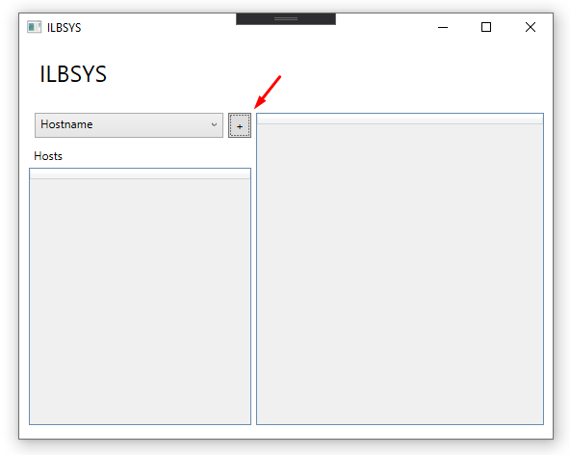

A little window will open where you have to add the name you want to give to the server and his address.

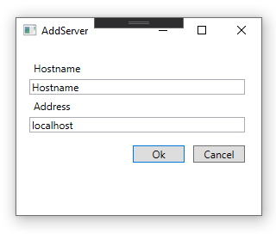

After you entered the informations, click on the OK.

You can when click on the server list and choose the server you want.

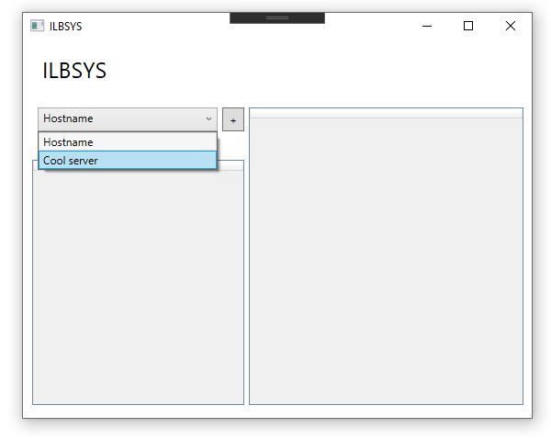

# See the informations

To see the informations from a host, after you added and selected a server, click on one of the hosts in the host list.

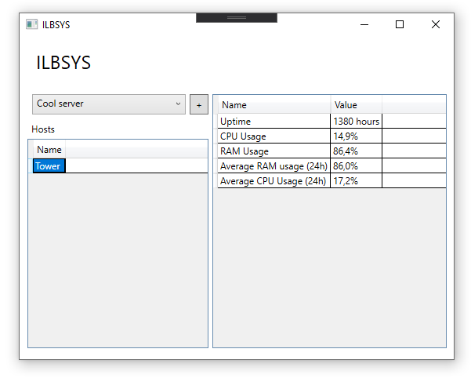

The information datagrid will automatically update and show you all the informations.

# Links

|  |  |
| --- | --- |
| **Description** | **Link** |
| Telegraph | [influxdata.com/time-series-platform/telegraf/](https://www.influxdata.com/time-series-platform/telegraf/) |
| InfluxDB | [influxdata.com](https://www.influxdata.com/) |