VCCS design

For this version of the JTS we are using the analog output of an ADC and a VCCS to control the actinic LED.

What is a VCCS?
VCCS stands for Voltage Controled Current Source. As the name suggests, it is a electronical circuit that lets you control a current proportionally to a voltage regardless of what load is connected to the output.

Why a VCCS?
We are using LED to produce actinic and detection light. However, a LED intensity is not linear with Voltage but with Current.
It is possible to either use a matrix of resistors and transistors to select light intensity where each resistor determines the current going through the LED.
Or we can use the analog output of an ADC, that outputs a voltage (from 0 to 10v with 32000 possibilities in between) and a VCCS. This lets the user select a large selection of light intensities with a simple circuit and software controlling the ADC. This design also permits actinic light patterns such as sine waves or anything else.
Alternatively, we can also use a PWM with a VCCS but this will be explored on a future version.

How to build a VCCS?

A simple VCCS is composed of the following components:
An differential or op amp, a MOSFET or BJT, a LED (or any current driven load) and a sense resistor (or shunt resistor).
R1 and R2 are optional.

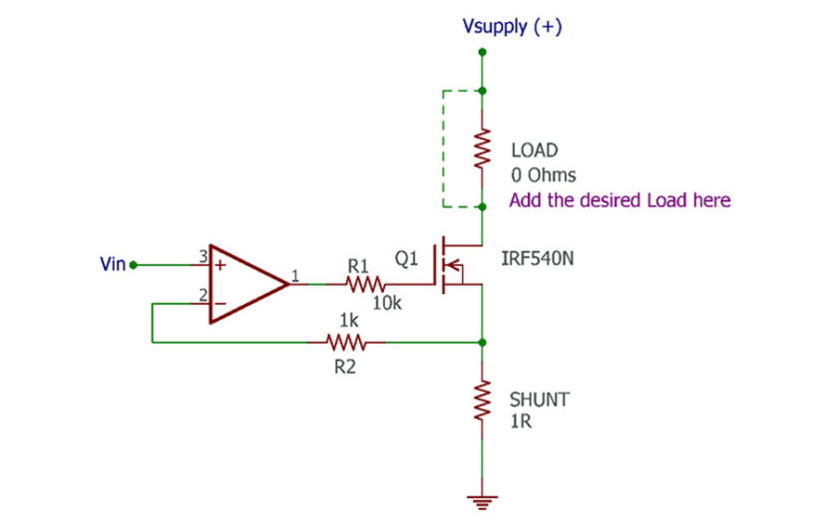

How does it work?
As it is with any amplifier, the circuit continuously compares the input voltage to the feedback loop.
The input voltage is regulated by the ADC in our case.
The feedback voltage is proportional to current going through it (V = I x R)
Any difference between the two will be corrected by the op amp.
The difference signal drives a transistor that acts as the variable current valve
The op-amp drives the transistor gate/base until the voltage across R_sense equals V_in, so:
I_out = V_in / R_sense

Important notes:
The LED supply should be powerful enough to drive the LED and Sense resistor.
For a given I_out, smaller R_sense gives a small V_sense and so a bigger SNR: For example, if you want 100 mA and R_sense = 1 Ω ➔ V_sense = 100 mV. But if R_sense = 0.01 Ω ➔ V_sense = only 1 mV.
For a given V_in, bigger R_sense gives better control but power loss.

Final Design for the JTS:

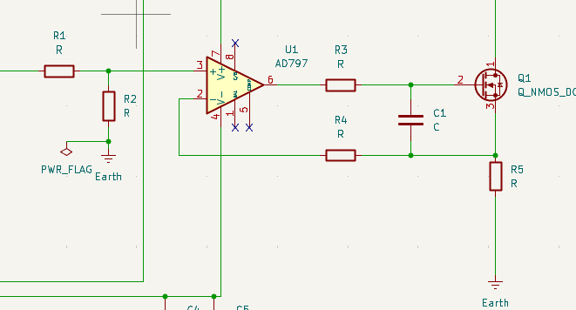

There are some differences with the basic design.
Voltage devider:

Constraints:
First of all, we are using a 48v generator with a 38v LED. The MOSFET uses up around 1-2V. This leaves around 8 volts of headroom for the sense resistor. If we send a 10v signal to V_in, the signal will saturate at 8v. Practically, during contruction, we have observed a saturation level for a signal around 3-4V.

Options:
We can either use a larger power supply or add a voltage devider on analog output to lower V_in.

Choice:
We are using a voltage devider that lowers the V_in by around 5. So 10v becomes 2v.

Reasons:
Both solutions are possible but we have chosen to use a voltage devider because it is simple to make and can be adapted to any power supply.

MOSFET :
The transistor being used is a N type Power MOSFET. It needs to be able to withstand at least 2 amps of current and needs a fast sw²itching time. The IRF540N fits perfectly for this circuit.

OP amp:
We are using the AD797 for this circuit because of its low voltage noise. We had many in stock at the time of making the circuit. It can be substituted for another op amp.

Sense resistor:
The sense resistor should be small enough to deliver enough power to actinic light and big enough so that the output signal has a good SNR. The maximum output should be saturating but there should also be enough low levels lights to perform certain experiments.
We have chosen 30ohms for this resistor because it fits well with our constraints.

C1 condensor
This condenser was added to filter out high frequency noise observed on the photodiode. These high frequency noises are probably due to the high impedance of the MOSFET gate that acts like a capacitance. Therefore, the MOSFET can open and close in a unpredictable manner. This problem was easily solved by adding a small capacitor between Gate and Source, filtering out large frequency noise.

R3 and R4 resistors
These resistors are not mandatory but they help with stability and avoid ringing.

