MySQL Workbench was primarily used to build the databases for this program. The KitchenApp needed several basic tables in a database in order for the program to run effectively. The tables were:

1. AINEET: hosts the ingredients in the kitchen
2. RESEPTIT: hosts the recipes in the program
3. OHJEET: this table links the recipes to its ingredients using foreign keys.
4. OSTOSLISTA: this database hosts the shopping list for the program.

See figure below:

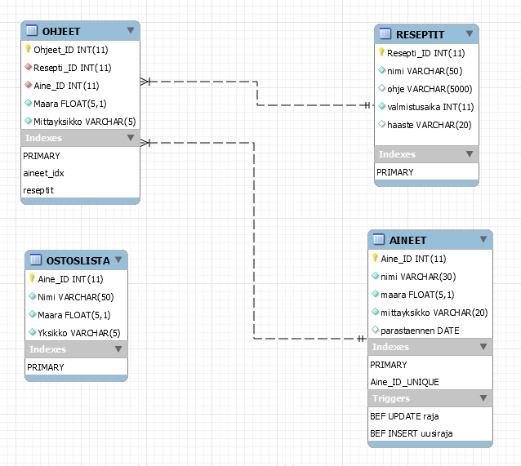

Kuva 7. Tietokanta kaavio

When a user selects a recipe from the app, the action calls the OHJEET table, which then the OHJEET table calls the ingredients that are tied to that recipe.