Chatbot

Table of Contents
1. Initial Settings 3
1.1. Create a new github repo 3
1.2. Clone an empty repo to a local computer 3
1.3. New NPM project 3
1.4. Telegram API credentials 3
1.5. dotenv 5
1.6. Index.js 5
1.7. Install package 6
1.8. First run 6

Initial Settings

Create a new github repo
https://github.com/ILopatenko/adekvat_chatik_bot.git

Clone an empty repo to a local computer

New NPM project
npm init -y
npm install telegram dotenv

Telegram API credentials
Go to https://my.telegram.org/
Use your phone number
https://my.telegram.org/apps – create a new app
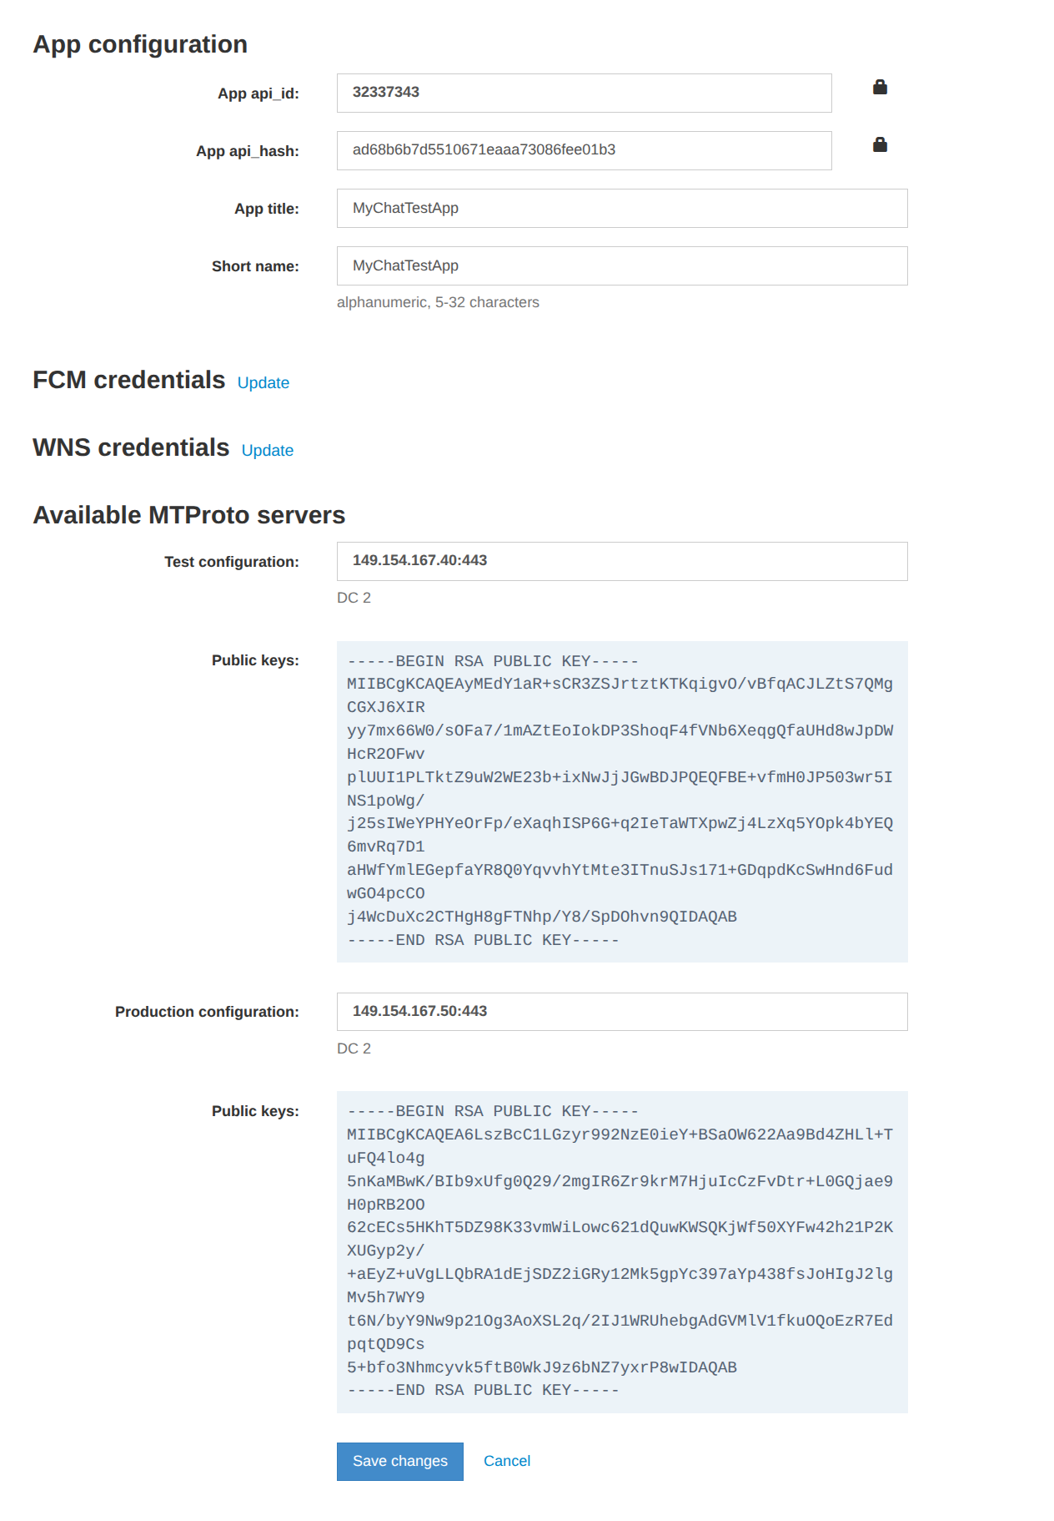
App api_id:
32337343
App api_hash:
ad68b6b7d5510671eaaa73086fee01b3

Test configuration:
149.154.167.40:443
-----BEGIN RSA PUBLIC KEY-----
MIIBCgKCAQEAyMEdY1aR+sCR3ZSJrtztKTKqigvO/vBfqACJLZtS7QMgCGXJ6XIR
yy7mx66W0/sOFa7/1mAZtEoIokDP3ShoqF4fVNb6XeqgQfaUHd8wJpDWHcR2OFwv
plUUI1PLTktZ9uW2WE23b+ixNwJjJGwBDJPQEQFBE+vfmH0JP503wr5INS1poWg/
j25sIWeYPHYeOrFp/eXaqhISP6G+q2IeTaWTXpwZj4LzXq5YOpk4bYEQ6mvRq7D1
aHWfYmlEGepfaYR8Q0YqvvhYtMte3ITnuSJs171+GDqpdKcSwHnd6FudwGO4pcCO
j4WcDuXc2CTHgH8gFTNhp/Y8/SpDOhvn9QIDAQAB
-----END RSA PUBLIC KEY-----

Production configuration:
149.154.167.50:443
-----BEGIN RSA PUBLIC KEY-----
MIIBCgKCAQEA6LszBcC1LGzyr992NzE0ieY+BSaOW622Aa9Bd4ZHLl+TuFQ4lo4g
5nKaMBwK/BIb9xUfg0Q29/2mgIR6Zr9krM7HjuIcCzFvDtr+L0GQjae9H0pRB2OO
62cECs5HKhT5DZ98K33vmWiLowc621dQuwKWSQKjWf50XYFw42h21P2KXUGyp2y/
+aEyZ+uVgLLQbRA1dEjSDZ2iGRy12Mk5gpYc397aYp438fsJoHIgJ2lgMv5h7WY9
t6N/byY9Nw9p21Og3AoXSL2q/2IJ1WRUhebgAdGVMlV1fkuOQoEzR7EdpqtQD9Cs
5+bfo3Nhmcyvk5ftB0WkJ9z6bNZ7yxrP8wIDAQAB
-----END RSA PUBLIC KEY-----

dotenv
Create a new file .env in the root folder of your project
API_ID=[API_ID]
API_HASH=[API_HASH]

Index.js
Create a main file index.js
require('dotenv').config();

const fs = require('fs');
const { TelegramClient } = require('telegram');
const { StringSession } = require('telegram/sessions');
const { NewMessage } = require('telegram/events');
const input = require('input');

const API_ID = Number(process.env.API_ID);
const API_HASH = process.env.API_HASH;
const OWNER_ID = '8910735441';

const SESSION_FILE = 'telegram.session';

let session = '';

if (fs.existsSync(SESSION_FILE)) {
session = fs.readFileSync(SESSION_FILE, 'utf8');
}

const client = new TelegramClient(new StringSession(session), API_ID, API_HASH, {
connectionRetries: 5,
});

async function main() {
await client.start({
phoneNumber: async () => await input.text('Phone number: '),
password: async () => await input.text('2FA password: '),
phoneCode: async () => await input.text('Telegram code: '),
onError: error => console.error(error),
});

fs.writeFileSync(SESSION_FILE, client.session.save());

const me = await client.getMe();

console.log('Connected!');
console.log(`Logged in as: ${me.firstName || ''}`);
console.log(`Telegram ID: ${me.id}`);
console.log(`Owner ID: ${OWNER_ID}`);
console.log('Waiting for messages...');

client.addEventHandler(async event => {
const message = event.message;

if (!message) {
return;
}

if (!message.isPrivate) {
return;
}

const senderId = message.senderId?.toString();

console.log(`Message from: ${senderId}`);

if (senderId !== OWNER_ID) {
await message.reply({
message: 'Ты Кто Такой?',
});
return;
}

if (!message.message) {
return;
}

console.log(`Owner: ${message.message}`);

await message.reply({
message: 'Привет! Я тебя вижу 👋',
});
}, new NewMessage({}));
}

main().catch(console.error);

Install package
npm install input

First run
Node index.js

